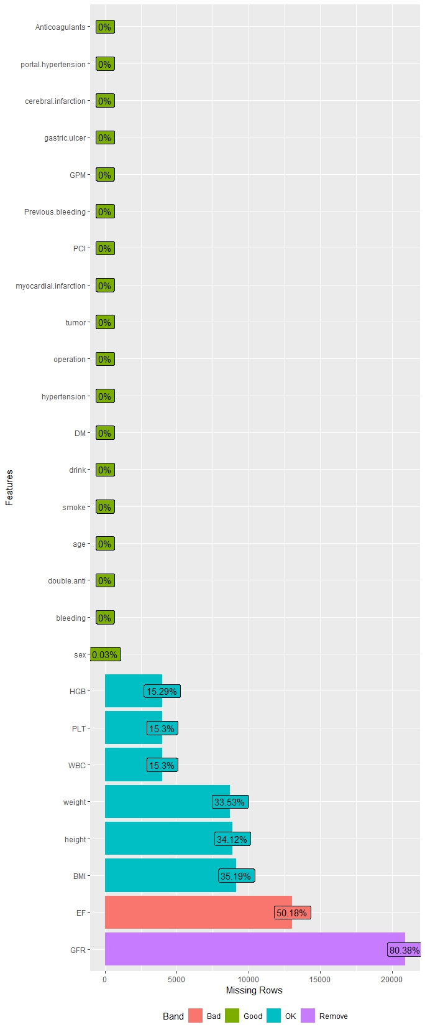
Appendix 1 Variables with missing information
Notes: GPM, Gastric protective medicine; PCI, Percutaneous Coronary Intervention; DM, Diabetes Mellitus; Double anti, dual antiplatelet therapy; HGB, hemoglobin; PLT, platelet count. WBC, White blood cell count; BMI, Body Mass Index; GFR, glomerular filtration rate; EF, cardiac ejection fraction.

