Supplementary Information
Delivery of avocado seed extract using novel charge-switchable mesoporous silica nanoparticles with galactose surface modified to target sorafenib-resistant hepatocellular carcinoma
¹Aalok Basu, ¹Arunsajee Sae-be, ¹Thanaphon Namporn, ²Orasa Suriyaphan, ³Pongtip Sithisarn, ¹Jiraporn Leanpolchareanchai, ¹Piyaporn Plommaithong, ¹Apichat Chatsukit, ⁴Khanit Sa-ngiamsuntorn, ⁵Parichart Naruphontjirakul, ^{1,6}Pakatip Ruenraroengsak
¹ Department of Pharmacy, Faculty of Pharmacy, Mahidol University, Bangkok, Thailand;
²Department of Food Chemistry, Faculty of Pharmacy, Mahidol University, Bangkok, Thailand;
³Department of Pharmacognosy, Faculty of Pharmacy, Mahidol University, Bangkok, Thailand;
⁴ Department of Biochemistry, Faculty of Pharmacy, Mahidol University, Bangkok, Thailand;
⁵Biological Engineering Program, Faculty of Engineering, King Mongkut’s University of Technology Thonburi, Bangkok, Thailand;
⁶Centre of Molecular Targeting and Integrated Drug Development, Faculty of Pharmacy, Mahidol University, Bangkok, Thailand

Correspondence: Pakatip Ruenraroengsak
Division of Pharmaceutical Technology, Department of Pharmacy, Faculty of Pharmacy, Mahidol University, 447 Sri-Ayuthaya Rd, Rajathevi, Bangkok, Thailand, 10400,
Phone: +66 (0) 987466661; Email: pakatip.rue@mahidol.ac.th

Supplementary Table 1. List of retention time in LC-MS chromatogram and tentative identification of secondary metabolites of avocado seed extract using references [1,2].
No. | Rt (min.) | MS (m/z) | Compound | Molecular formula
1 | 5.56 | 299.1137 | Chrysoeriol | C₁₆H₁₂O₆
2 | 6.01 | 337.0924 | 5-O-p-Coumaroylquinic acid | C₁₆H₁₈O₈
3 | 6.12 | 289.0708 | Catechin | C₁₅H₁₄O₆
4 | 6.34 | 353.0876 | 5-O-caffeoyl-quinic acid | C₁₆H₁₈O₉
5 | 6.36 | 180.9729 | Caffeic acid | C₉H₈O₄
6 | 6.93 | 289.0713 | Epicatechin | C₁₅H₁₄O₆
7 | 7.03 | 306.9378 | Gallocatechin | C₁₅H₁₄O₇
8 | 7.97 | 441.1767 | Catechin gallate | C₂₂H₁₈O₁₀
9 | 17.47 | 250.1447 | Gallic acid | C₇H₆O₅
10 | 30. 05 | 325.1832 | (+)-18-Methyl-eicosanoic acid | C₂₁H₄₂O₂

Supplementary Table 2. Hydrodynamic diameter and zeta potential values of nanoparticles at different levels of galactose conjugation
Galactose: Nanoparticle ratio | Size (nm; mean ±SD) | PDI (mean ±SD) | Zeta potential at 7.4 pH (mV; mean ±SD) | Zeta potential at 5.5 pH (mV; mean ±SD)
5: 1 | 336.2 ±11.10 | 0.427 ±0.09 | -35.0 ±2.74 | +2.12 ±0.16
2:1 | 312.4 ±5.31 | 0.414 ±0.03 | -35.6 ±3.71 | -1.93 ±0.29
1:1 | 290.7 ±2.05 | 0.367 ±0.02 | -34.7 ±0.50 | +4.66 ±0.09
1:2 | 224.6 ±2.46 | 0.256 ±0.02 | -18.2 ±0.32 | +10.3 ±0.61
1:5 | 220.4 ±3.28 | 0.271 ±0.04 | -3.94 ±0.34 | +13.76 ±1.51

Supplementary Table 3. Analysis parameters for cell uptake and cellular distribution using Harmony software (version 5.1) parameters.
Nuclei segmentation
Building block | Find Nuclei
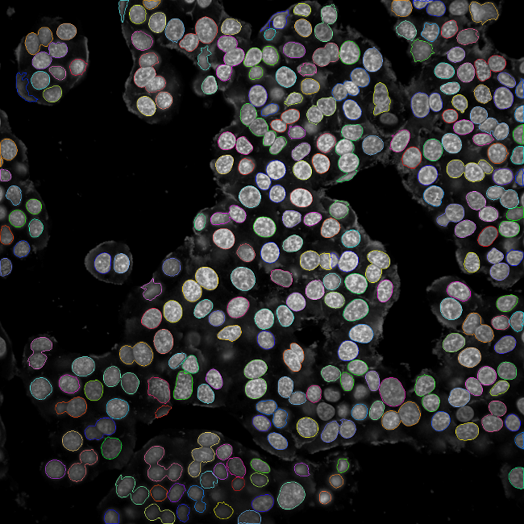
Channel | HOECHST 33342
Detection method | C
Common threshold | 0.2
Area | >35 µm²
Splitting coefficient | 20.4
Individual threshold | 0.3
Contrast | >0.1
Output population | Nuclei
Cytoplasm segmentation
Building block | Find Cytoplasm
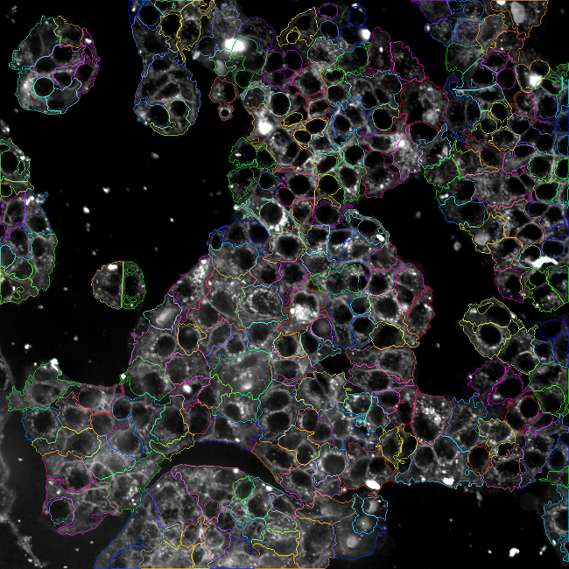
Channel | Alexa 647
Nuclei | Nuclei
Detection method | A
Individual threshold | 0.2
Nanoparticle detection inside nucleus
Building block | Find Spot
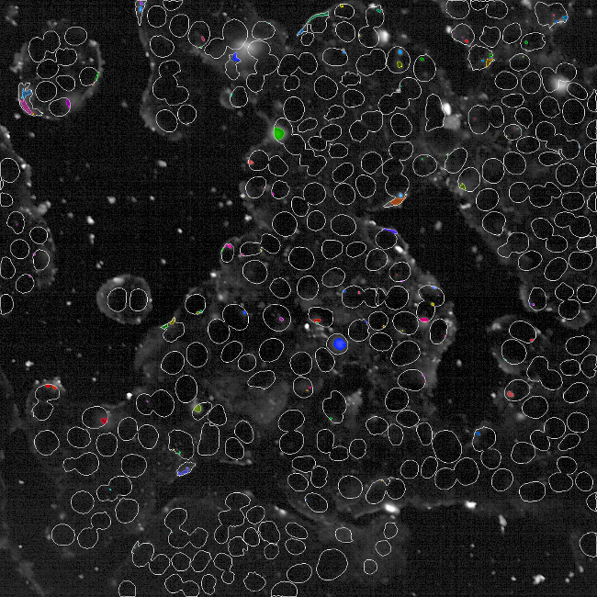
Channel | Fluorescein (FITC)
ROI | Nuclei
 | Nucleus
Method | B
Detection sensitivity | 0.56
Splitting sensitivity | 0.656
Output population | Nanoparticles in nucleus
Nanoparticle detection inside cytoplasm
Building block | Find Spot
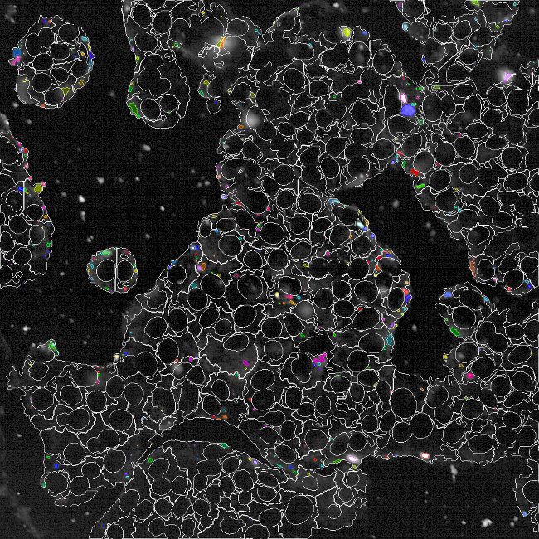
Channel | Fluorescein (FITC)
ROI | Nuclei
 | Nucleus
Method | B
Detection sensitivity | 0.56
Splitting sensitivity | 0.656
Output population | Nanoparticles in nucleus
Define Results
Method | Standard Output
Nanoparticles in nucleus- Number of objects | Object Count
Method | Standard Output
Nanoparticles in cytoplasm- Number of objects | Object Count

Supplementary Table 4. Analysis parameters for endosomal escape using Harmony software (version 5.1) parameters.
Endolyosome segmentation
Building block | Find Spots
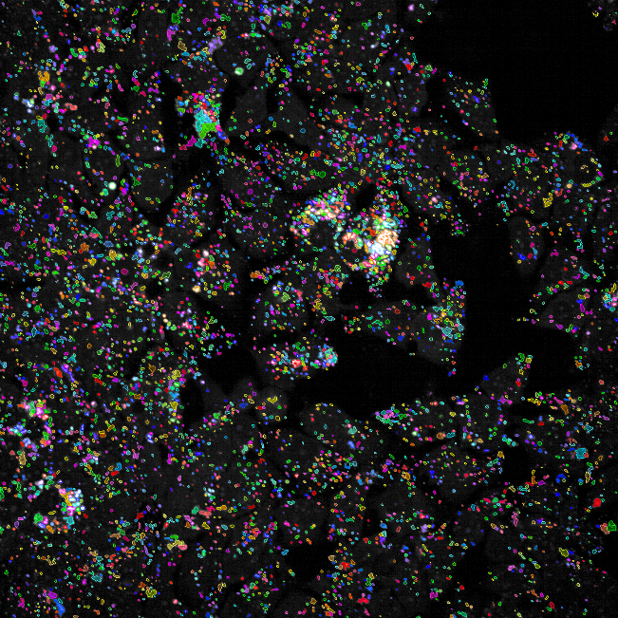
Channel | Acridine Orange
ROI | None
Detection method | B
Detection sensitivity | 0.5
Splitting sensitivity | 0.5
Splitting coefficient | 20.4
Calculate spot properties
Output population | Endosome
Cytoplasm segmentation
Building block | Find Cells
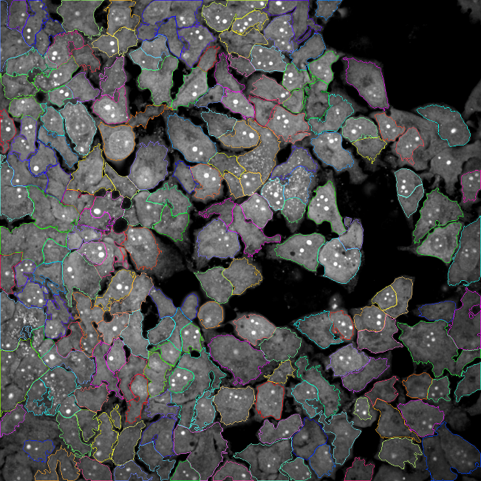
Channel | Fluorescein (FITC)
ROI | None
Detection method | M
Diameter | 40 µm
Splitting sensitivity | 0.4
Common threshold | 0.31
Output population | Cytosol
Endolysosome intensity
Building block | Calculate Intensity Properties
Channel | Acridine Orange
Population | Endosome
Region | Spot
Method | Standard
Property prefix | Intensity spot AO
Cytosol intensity
Building block | Calculate Intensity Properties
Channel | Fluorescein (FITC)
Population | Cytosol
Region | Cell
Method | Standard
Property prefix | Intensity cell fluorescein (FITC)
Define Results
Method | Formula outputs
Formula Output | a/b
Variable a | Endosome – number of objects
Variable b | Cytosol – number of objects
Output name | Endosome per cell

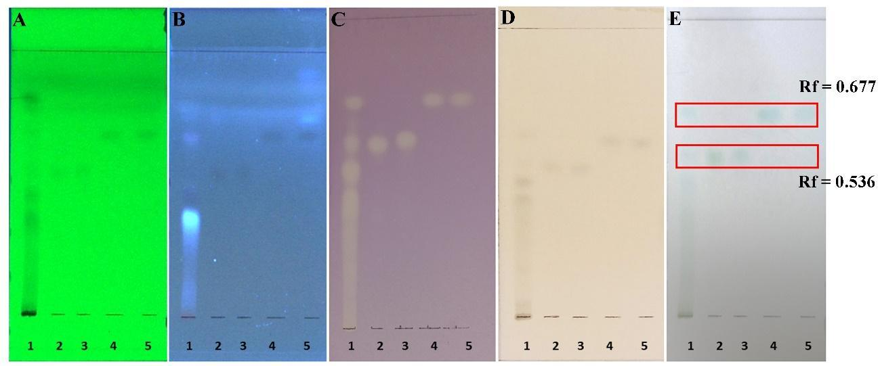
Supplementary Figure 1. Thin layer chromatogram of APE as visualized using (A) UV 254 nm and (B) UV 366 nm, before spraying with (C) DPPH reagent, (D) ferric chloride reagent, or (E) DMACA reagent. Standard no. 1=APE (30mg/ml); 2=Procyanidin B1; 3=Procyanidin B2; 4=Epicatechin; 5=Catechin.

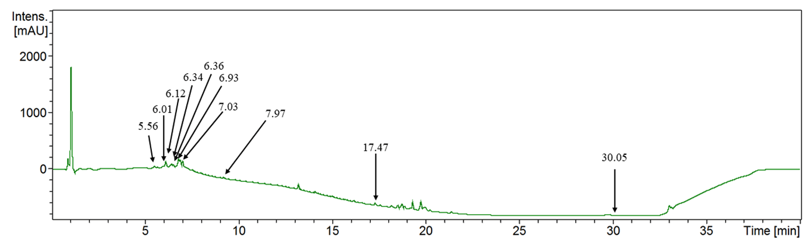Supplementary Figure 2. LC-MS (negative mode) chromatogram of avocado seed extract
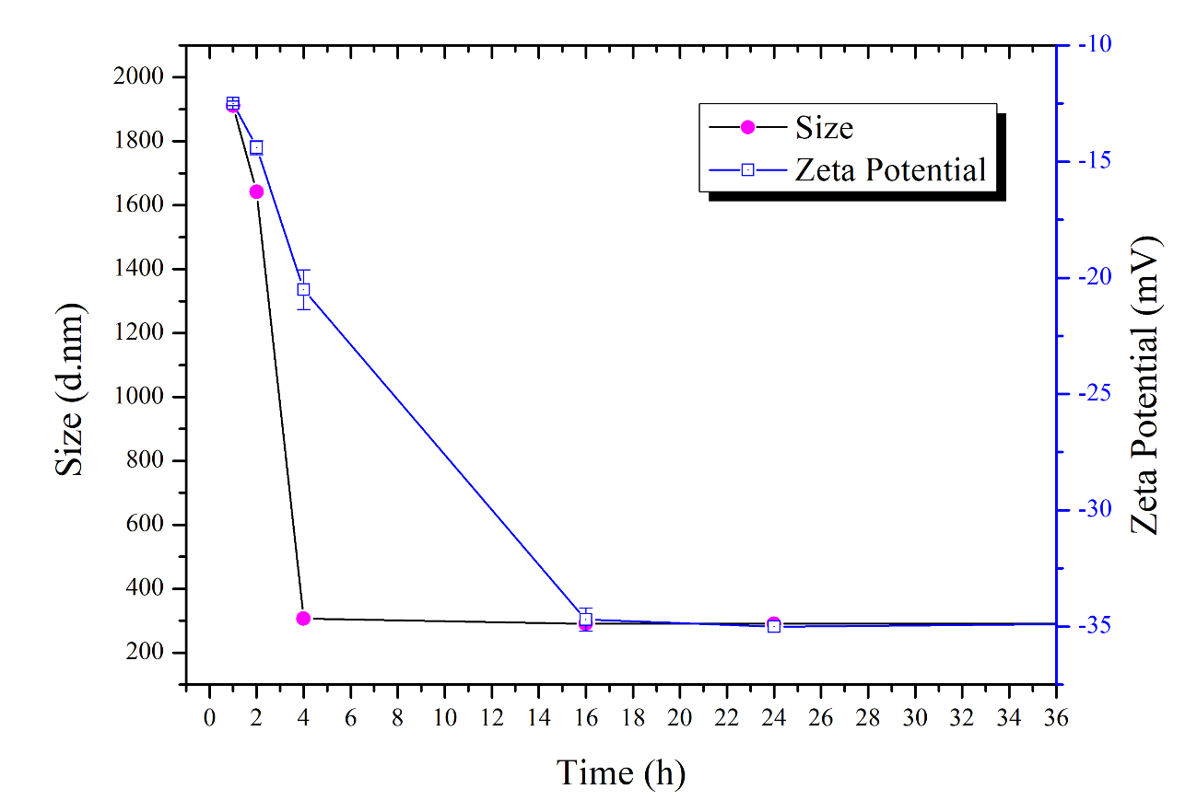
Supplementary Figure 3. Effect of time on size (hydrodynamic diameter) and zeta potential of nanoparticles during reductive amination with galactose. A galactose: nanoparticle ratio of 1:2 was used throughout, and the growth of galactose layer on nanoparticle surface was examined using dynamic light scattering. No significant change of size or zeta potential was observed after 16 h of reaction.
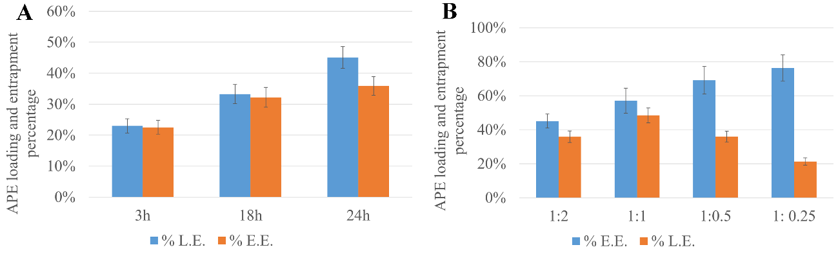
Supplementary Figure 4. Optimization APE of loading into nanoparticles (loading efficiency, %LE and entrapment efficiency, %EE) at (A) different time points (3, 18, 24 h), and (B) different nanoparticles-extract mass ratio (1:2, 1:1, 1:0.5, 1:0.25) at 24 h.
Supplementary Figure 5. Uptake of MSN-NH₂ (green) and GMSN (green) by HepG2, and SR5.0-HepG2 monitored over 24 h using high content imaging. Scale bar is 50 µm.

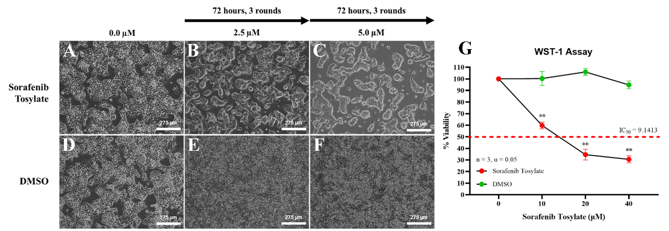
Supplementary Figure 6. Morphology of HepG2 cells during the sorafenib (SR)-resistant cell generation. HepG2 cells passaged with (A) 0.0 µM SR, followed by (B) 2.5 µM SR, and with (C) 5.0 µM SR. HepG2 cell treated with (D) the desired concentrations of DMSO containing 0 µM SR solution, (E) 2.5 µM SR and (F) 5.0 µM SR as a solubilizing agent were perform as substance control. (G) WST-1 assay for determining SR5.0-HepG2 cell viability at the different concentrations of sorafenib tosylate or 2 % (v/v) DMSO. Data are presented as mean ± SD (n = 3, *p < 0.05, **p < 0.01, ***p < 0.001).

References
1. Younis, I.Y.; Khattab, A.R.; Selim, N.M.; Sobeh, M.; Elhawary, S.S.; Bishbishy, M.H.E. Metabolomics-Based Profiling of 4 Avocado Varieties Using HPLC–MS/MS and GC/MS and Evaluation of Their Antidiabetic Activity. Sci. Rep. 2022, 12, 1–15, doi:10.1038/s41598-022-08479-4.
2. Rosero, J.C.; Cruz, S.; Osorio, C.; Hurtado, N. Analysis of Phenolic Composition of Byproducts (Seeds and Peels) of Avocado (Persea Americana Mill.) Cultivated in Colombia. Molecules 2019, 24, doi:10.3390/molecules24173209.

