Supplementary table1. Comparison of clinical baseline for predicting upper limb lymphedema based on random partitioning training and validation samples
Variables | Training cohort |  |  | P-value | Testing cohort |  |  | P-value
Variables | Overall(N=2212) | Yes(N=291) | No(N=1921) | P-value | Overall(N=948) | Yes(N=119) | No(N=829) | P-value
Sex (%)
male | 1099 (49.7) | 155 (53.3) | 944 (49.1) | 0.212 | 503 (53.1) | 72 (60.5) | 431 (52.0) | 0.101
female | 1113 (50.3) | 136 (46.7) | 977 (50.9) |  | 445 (46.9) | 47 (39.5) | 398 (48.0)
Age (median [IQR]),year | 43.00 [30.00, 56.00] | 44.00 [30.50, 56.00] | 42.00 [30.00, 56.00] | 0.169 | 43.00 [31.00, 57.00] | 42.00 [29.00, 56.00] | 44.00 [31.00, 57.00] | 0.267
BMI (median [IQR]),kg/m2 | 22.30 [20.90, 23.80] | 28.20 [26.35, 30.30] | 22.00 [20.70, 23.20] | <0.001 | 22.40 [21.00, 23.80] | 28.60 [26.45, 30.10] | 22.10 [20.80, 23.30] | <0.001
Diabetes (%)
yes | 1062 (48.0) | 149 (51.2) | 913 (47.5) | 0.268 | 456 (48.1) | 55 (46.2) | 401 (48.4) | 0.733
no | 1150 (52.0) | 142 (48.8) | 1008 (52.5) |  | 492 (51.9) | 64 (53.8) | 428 (51.6)
Hypertension (%)
yes | 862 (39.0) | 194 (66.7) | 668 (34.8) | <0.001 | 384 (40.5) | 85 (71.4) | 299 (36.1) | <0.001
no | 1350 (61.0) | 97 (33.3) | 1253 (65.2) |  | 564 (59.5) | 34 (28.6) | 530 (63.9)
TNM (%)
I~II | 1384 (62.6) | 110 (37.8) | 1274 (66.3) | <0.001 | 573 (60.4) | 39 (32.8) | 534 (64.4) | <0.001
IIIa | 828 (37.4) | 181 (62.2) | 647 (33.7) |  | 375 (39.6) | 80 (67.2) | 295 (35.6)
Site (%)
unilateral | 1385 (62.6) | 104 (35.7) | 1281 (66.7) | <0.001 | 568 (59.9) | 29 (24.4) | 539 (65.0) | <0.001
bilateral | 827 (37.4) | 187 (64.3) | 640 (33.3) |  | 380 (40.1) | 90 (75.6) | 290 (35.0)
Pathology (%)
invasive ductal carcinoma | 758 (34.3) | 99 (34.0) | 659 (34.3) | 0.862 | 336 (35.4) | 38 (31.9) | 298 (35.9) | 0.28
infiltrating lobular carcinoma | 738 (33.4) | 94 (32.3) | 644 (33.5) |  | 321 (33.9) | 48 (40.3) | 273 (32.9)
others | 716 (32.4) | 98 (33.7) | 618 (32.2) |  | 291 (30.7) | 33 (27.7) | 258 (31.1)
Tumor diameter (%),cm
≥2 | 1107 (50.0) | 150 (51.5) | 957 (49.8) | 0.626 | 469 (49.5) | 60 (50.4) | 409 (49.3) | 0.902
＜2 | 1105 (50.0) | 141 (48.5) | 964 (50.2) |  | 479 (50.5) | 59 (49.6) | 420 (50.7)
Differentiation (%)
medium to high | 756 (34.2) | 93 (32.0) | 663 (34.5) | 0.42 | 296 (31.2) | 35 (29.4) | 261 (31.5) | 0.873
low | 724 (32.7) | 92 (31.6) | 632 (32.9) |  | 341 (36.0) | 45 (37.8) | 296 (35.7)
undifferentiated | 732 (33.1) | 106 (36.4) | 626 (32.6) |  | 311 (32.8) | 39 (32.8) | 272 (32.8)
Surgery (%)
resection | 545 (24.6) | 76 (26.1) | 469 (24.4) | 0.718 | 232 (24.5) | 26 (21.8) | 206 (24.8) | 0.056
curative | 592 (26.8) | 74 (25.4) | 518 (27.0) |  | 233 (24.6) | 22 (18.5) | 211 (25.5)
extended radical | 534 (24.1) | 65 (22.3) | 469 (24.4) |  | 241 (25.4) | 29 (24.4) | 212 (25.6)
modified radical | 541 (24.5) | 76 (26.1) | 465 (24.2) |  | 242 (25.5) | 42 (35.3) | 200 (24.1)
LNMD (%)
I~II | 1445 (65.3) | 111 (38.1) | 1334 (69.4) | <0.001 | 601 (63.4) | 40 (33.6) | 561 (67.7) | <0.001
III | 767 (34.7) | 180 (61.9) | 587 (30.6) |  | 347 (36.6) | 79 (66.4) | 268 (32.3)
NLM (median [IQR]) | 14.00 [13.00, 15.00] | 14.00 [13.00, 15.00] | 14.00 [13.00, 15.00] | 0.86 | 14.00 [13.00, 15.00] | 14.00 [13.00, 15.00] | 14.00 [13.00, 15.00] | 0.935
Treatment (%)
yes | 896 (40.5) | 205 (70.4) | 691 (36.0) | <0.001 | 369 (38.9) | 74 (62.2) | 295 (35.6) | <0.001
no | 1316 (59.5) | 86 (29.6) | 1230 (64.0) |  | 579 (61.1) | 45 (37.8) | 534 (64.4)
Nurse (%)
yes | 1337 (60.4) | 107 (36.8) | 1230 (64.0) | <0.001 | 587 (61.9) | 40 (33.6) | 547 (66.0) | <0.001
no | 875 (39.6) | 184 (63.2) | 691 (36.0) |  | 361 (38.1) | 79 (66.4) | 282 (34.0)
Abbreviations: IQR= interquartile range; BMI= Body mass index;LNMD= Level of lymph node dissection;NLM= Number of lymph nodes cleaned.
Supplementary table2. Weight value of candidate variables for predicting upper limb lymphedema based on RFM algorithm
Variables | %IncMSE | IncNodePurity
Sex | 0.684428 | 0.676875
Age | -2.99844 | 3.56074
BMI | 294.7369 | 305.7381
Diabetes | -3.07312 | 0.558789
Hypertension | 10.48137 | 6.620482
TNM | 11.87809 | 4.643799
Site | 10.76328 | 7.972171
Pathology | -2.16472 | 0.9776
Tumor_diameter | -0.34829 | 0.570932
Differentiation | -1.12671 | 0.889622
Surgery | -2.55528 | 1.285458
LNMD | 8.582338 | 6.758799
NLM | -1.11832 | 1.581076
Treatment | 5.567921 | 6.103985
Nurse | 6.426691 | 4.637013
Abbreviations: IQR= interquartile range; BMI= Body mass index;LNMD= Level of lymph node dissection;NLM= Number of lymph nodes cleaned.

Supplementary figure1. Construction of upper limb lymphedema prediction model via ANNM. A. ANNM; B. Variable importance using connection weights. Notes. The formula of ANNM is as follows:θ=θ−η×∇ ( θ). J( θ) Among them η It's the learning rate, so（ θ). J( θ) Represents the gradient change of the loss function (i.e. J(θ)).
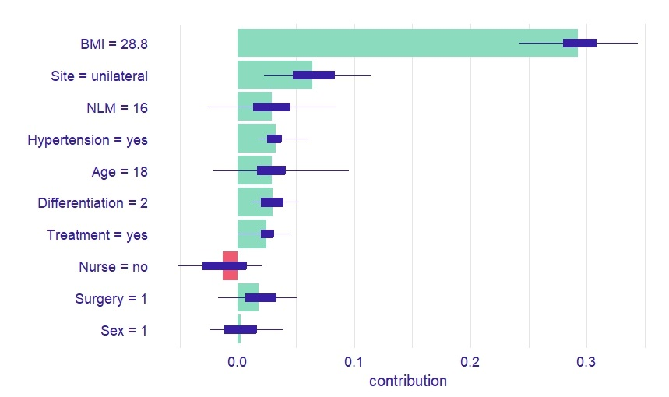
Supplementary figure2. Evaluation of the importance of random forest prediction parameters based on SHAP

