Supplementary Figure 1. Normal cecum, ascending colon, transverse colon, sigmoid colon, rectum. Superficial ulcers, erosions can be seen in descending colon with hyperemia and edema.
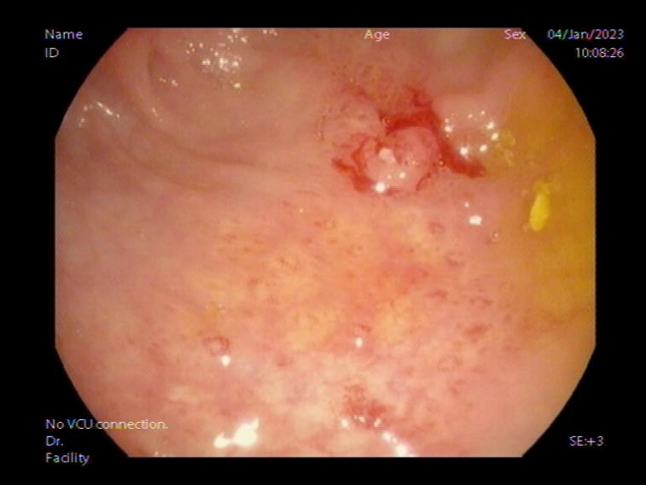
- Descending colon
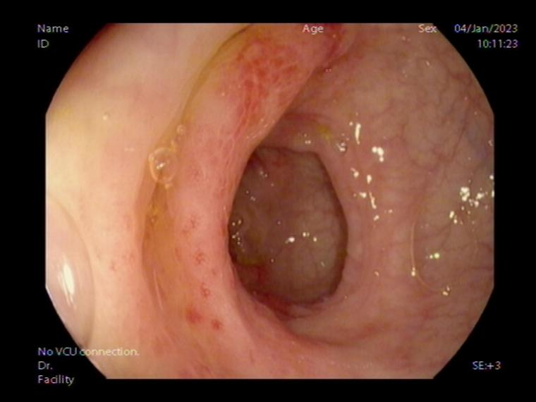
- Descending colon

Supplementary Figure 2. Normal cecum, ascending colon, transverse colon, rectum. Superficial ulcers can be seen in descending colon with white coating. The sigmoid colon is scattered with hyperemia, erosion and edema
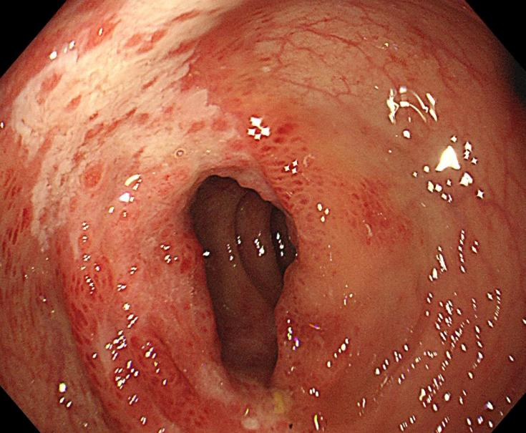
- Descending colon
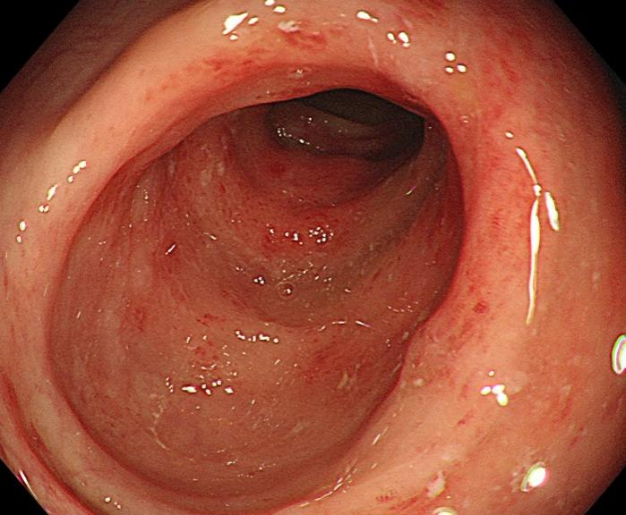
- Sigmoid colon

Supplementary Figure 3. Normal cecum, ascending colon, transverse colon, sigmoid colon, rectum. Multiple ulcers, erosion, hyperemia and edema can be seen in descending colon.

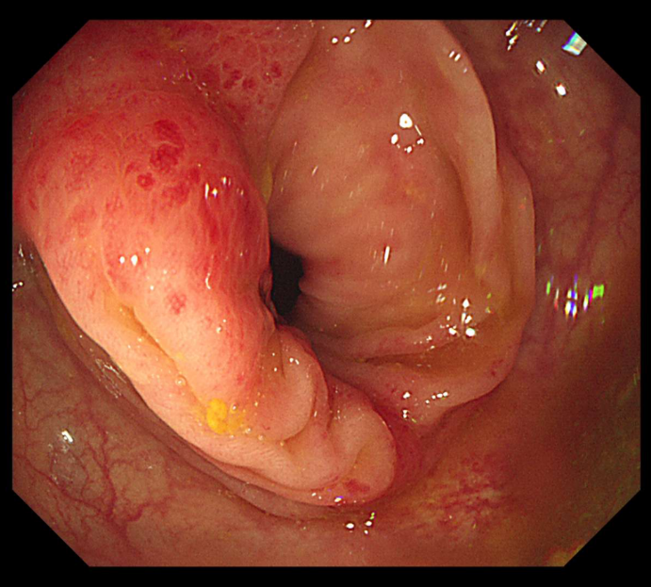
- Descending colon

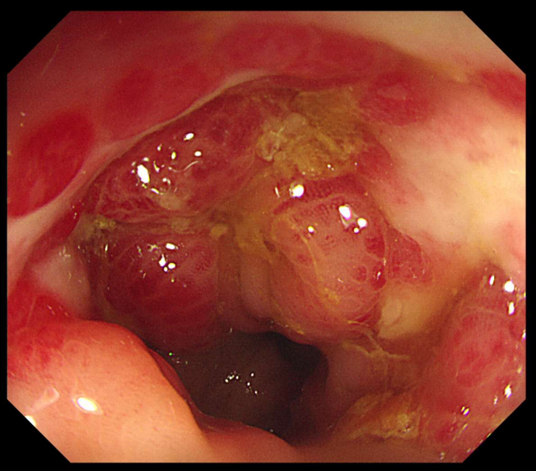
- Descending colon
Supplementary Figure 4. Normal cecum, ascending colon, transverse colon, rectum. Ulcers, necrosis, hemorrhage and edema can be seen in descending colon and sigmoid colon.

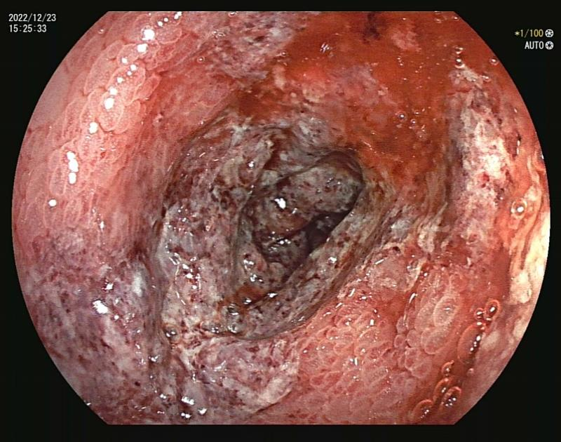
- Descending colon
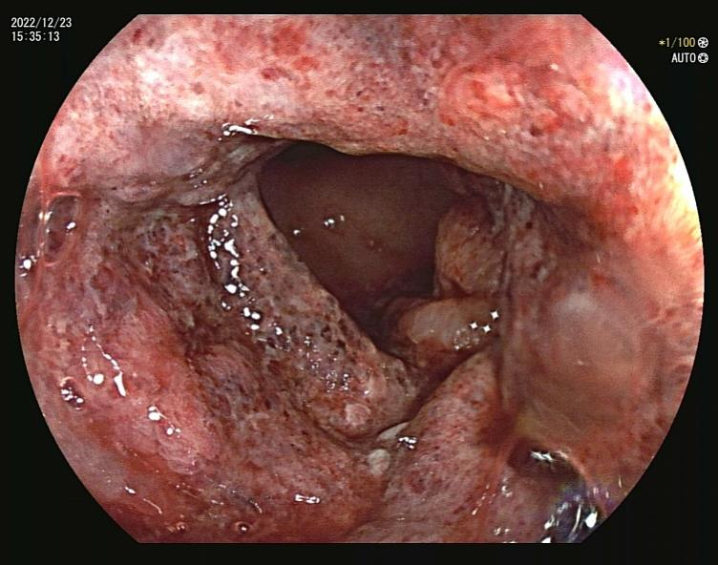
- Sigmoid colon

Supplementary Figure 5. Normal terminal ileum, ascending colon, transverse colon, sigmoid colon, rectum. Superficial ulcers, erosions can be seen in descending colon with hyperemia and edema.
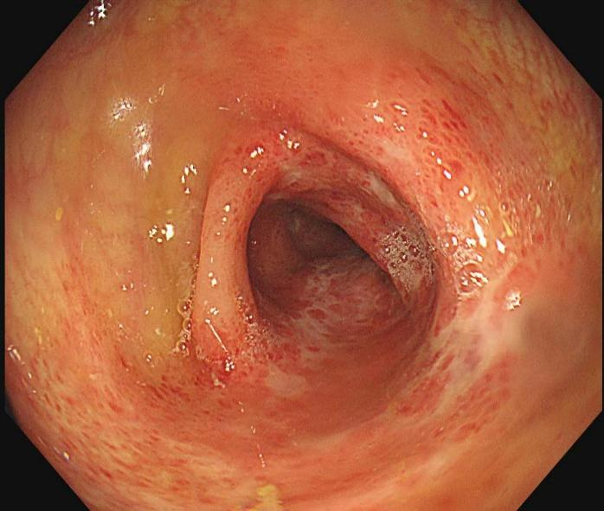
- Terminal ileum
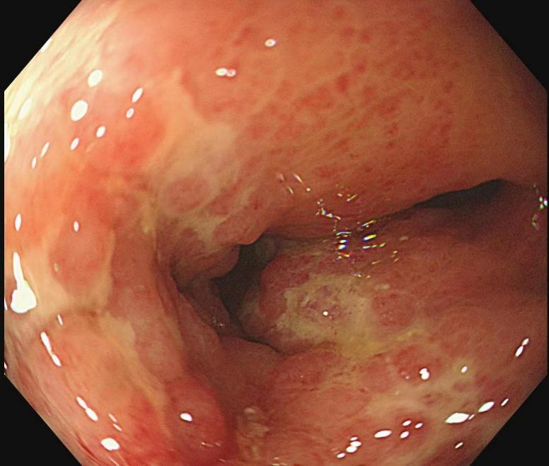
- Descending colon

Supplementary Figure 6. Normal cecum, ascending colon, sigmoid colon and rectum. Superficial ulcer erosions and white coating can be seen in transverse colon with hyperemia and edema. Scattered hyperemia can be seen in descending colon.
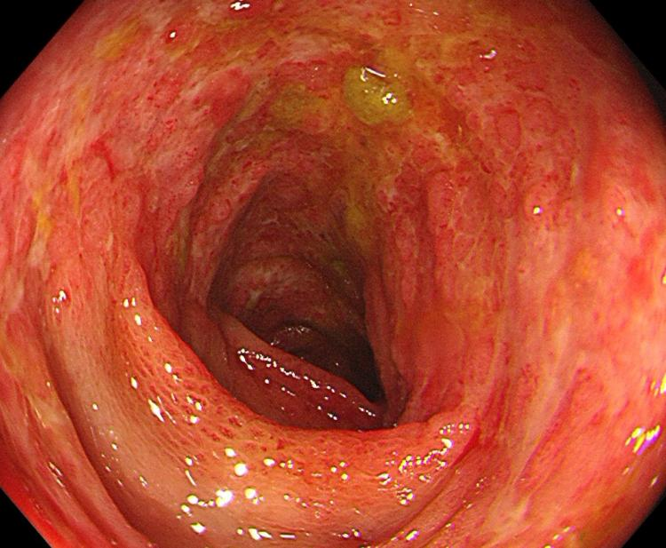
- Transverse colon
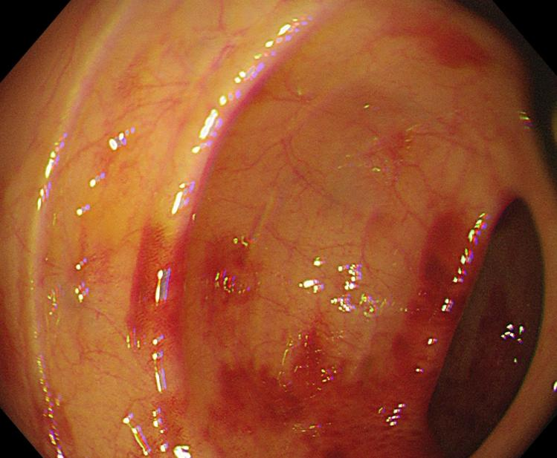
- Descending colon
Supplementary Figure 7. Normal ascending colon, transverse colon, sigmoid colon, and rectum. Superficial ulcers, erosions can be seen in descending colon and splenic flexure with hyperemia, edema and bleeding.
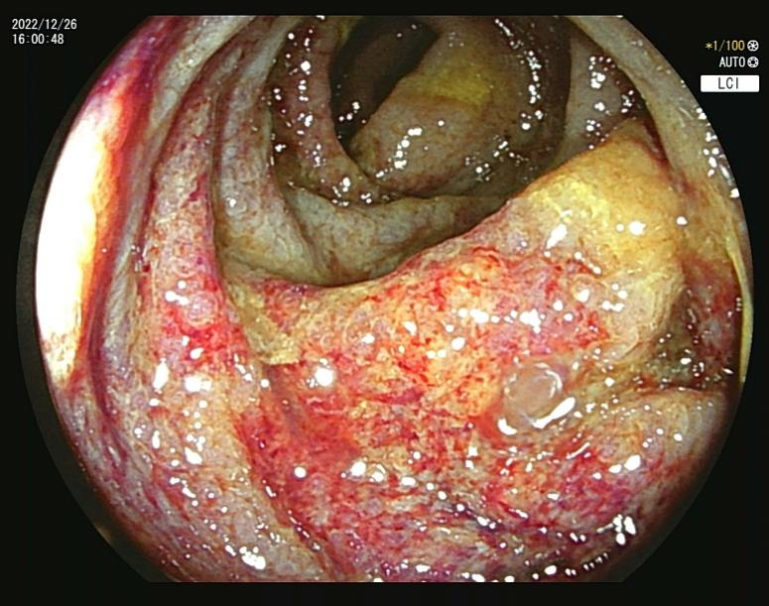
- Splenic flexure
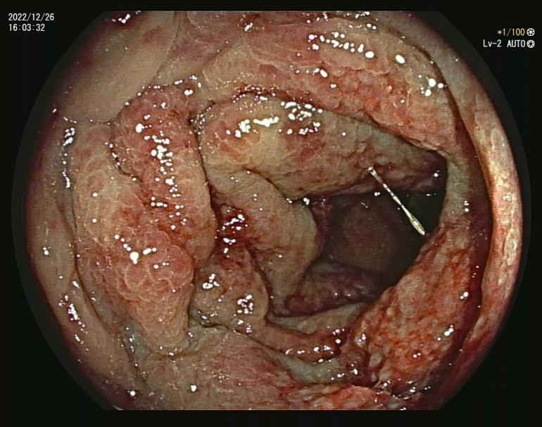
- Descending colon

Supplementary Figure 8. Normal cecum, ascending colon, transverse colon, descending colon and sigmoid colon. Multiple deep ulcers, erosion can be seen in the rectum with hyperemia and edema.

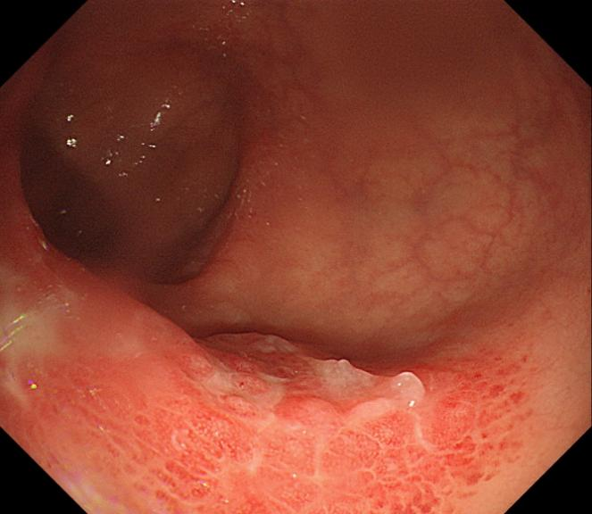
- Rectum
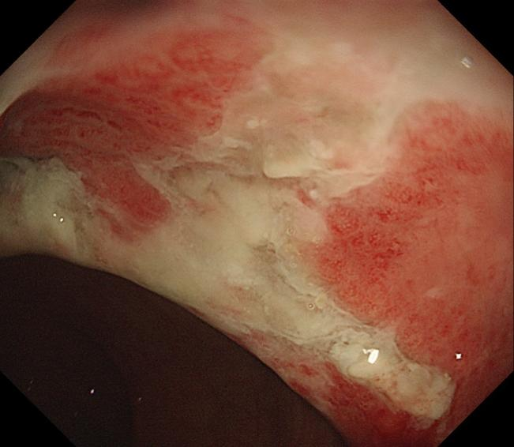
- Rectum

Supplementary Figure 9. Normal cecum, ascending colon, transverse colon, sigmoid colon and rectum. Ulcers, erosions with white coating can be seen in descending colon with hyperemia and edema.

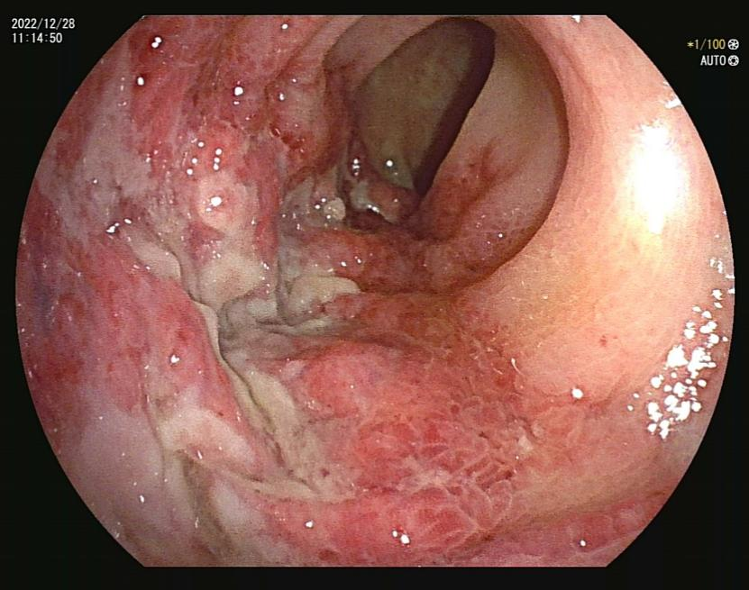
- Descending colon
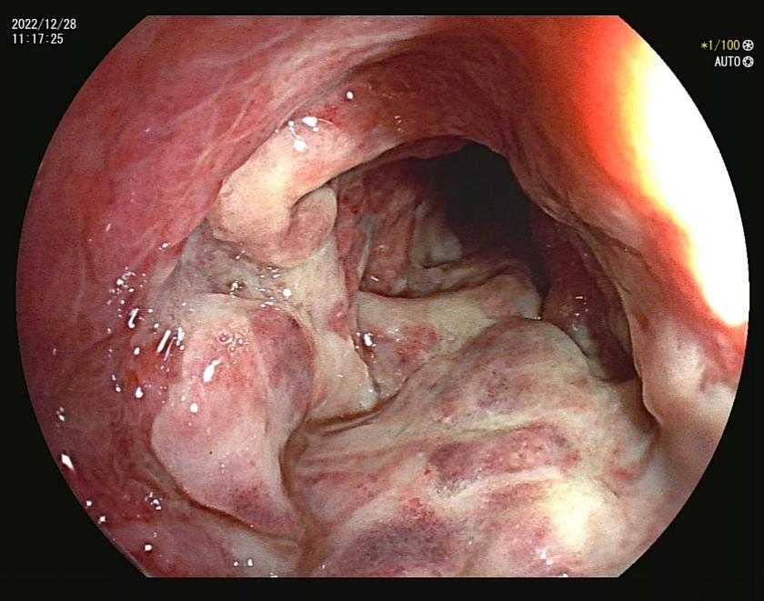
- Descending colon
Supplementary Figure 10. Normal cecum, ascending colon, transverse colon, rectum. Ulcer, hemorrhage, edema and hyperemia can be seen in descending colon and sigmoid colon
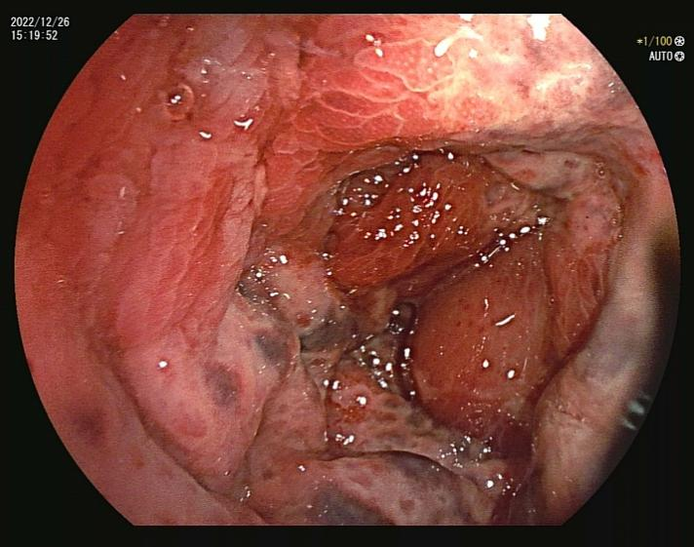
- Descending colon
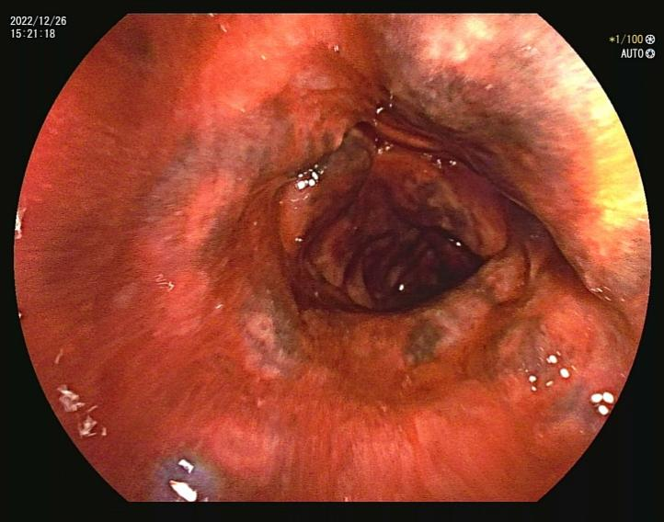
- Sigmoid colon

Supplementary Figure 11. Normal cecum, ascending colon, transverse colon, sigmoid colon and rectum. Superficial ulcers can be seen in descending colon with hyperemia and edema, bleeding after touch.

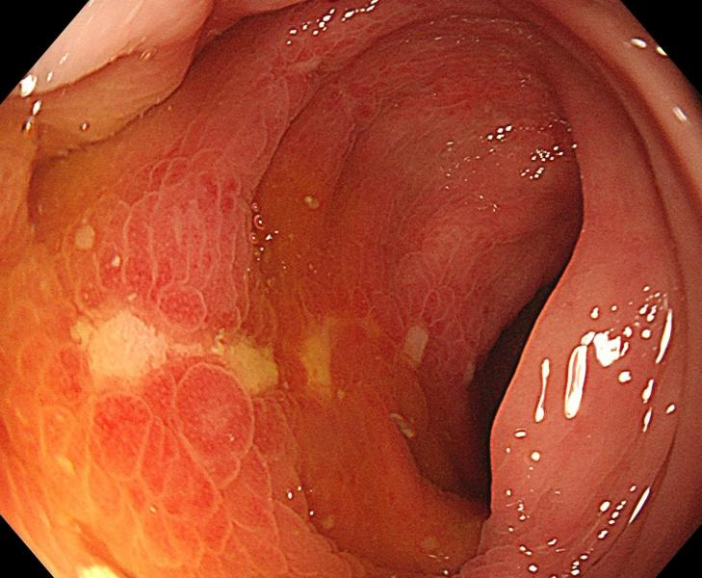
- Descending colon
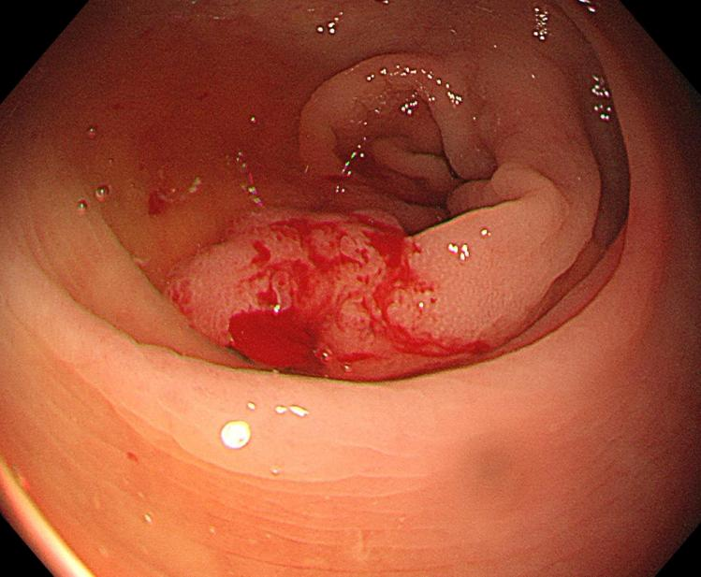
- Descending colon

Supplementary Figure 12. Normal cecum, ascending colon, transverse colon, sigmoid colon, rectum. Superficial ulcers can be seen in descending colon with hyperemia and edema.
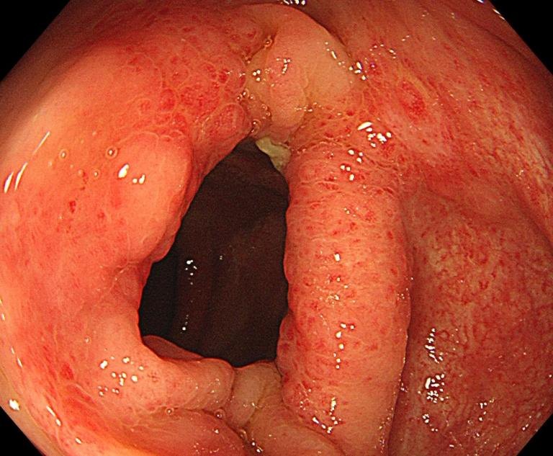
- Descending colon
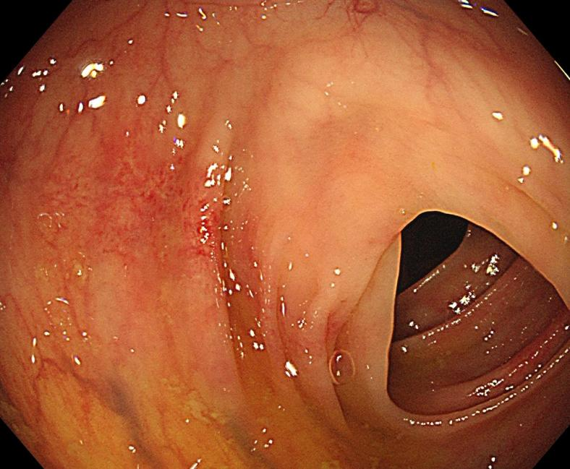
- Descending colon

