Supplement

International Classification of Diseases, Tenth Revision code for conditions incompatible with a COPD diagnosis
Medical conditions incompatible with a COPD diagnosis included any conditions that are related to lung or bronchial developmental anomalies, degenerative processes (cystic fibrosis, pulmonary fibrosis), pulmonary resection, or other significant respiratory disorders other than COPD that can interfere with clinical COPD diagnosis or substantially change the natural history of the disease.

Supplementary Figure 1: PDC calculation by treatment type.
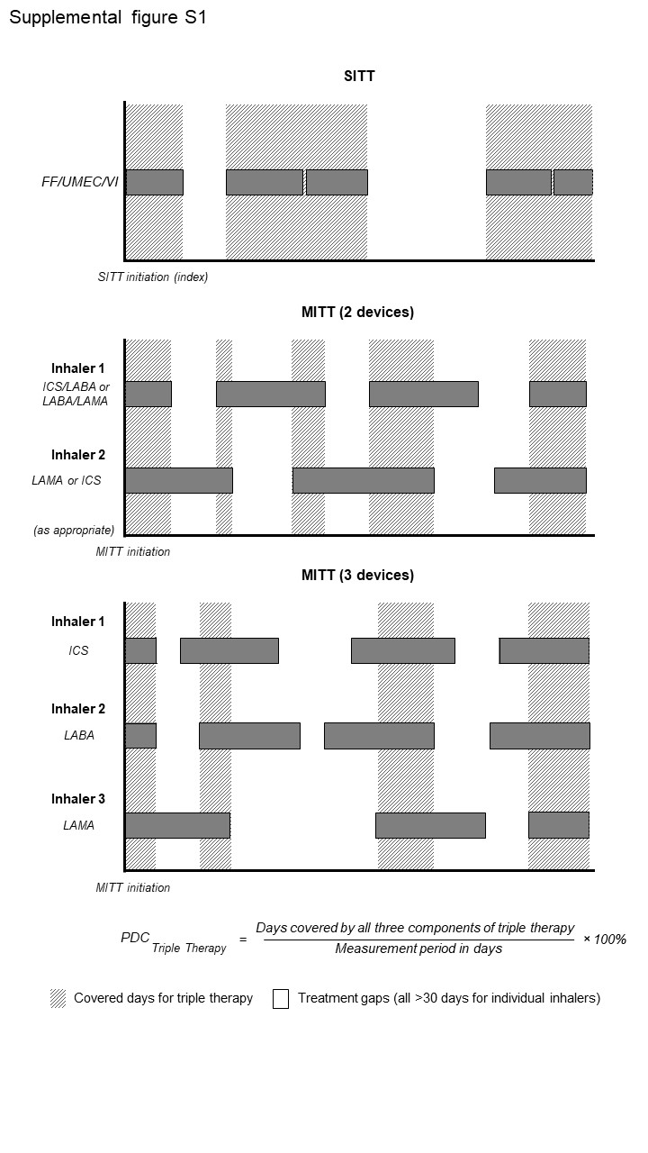
Abbreviations: FF/UMEC/VI, fluticasone furoate/umeclidinium/vilanterol; ICS, inhaled corticosteroids; LABA, long-acting β2 agonist; LAMA, long-acting muscarinic antagonist; MITT, multiple-inhaler triple therapy; PDC, proportion of days covered; SITT, single-inhaler triple therapy.
Supplementary Figure 2: Patient attrition.
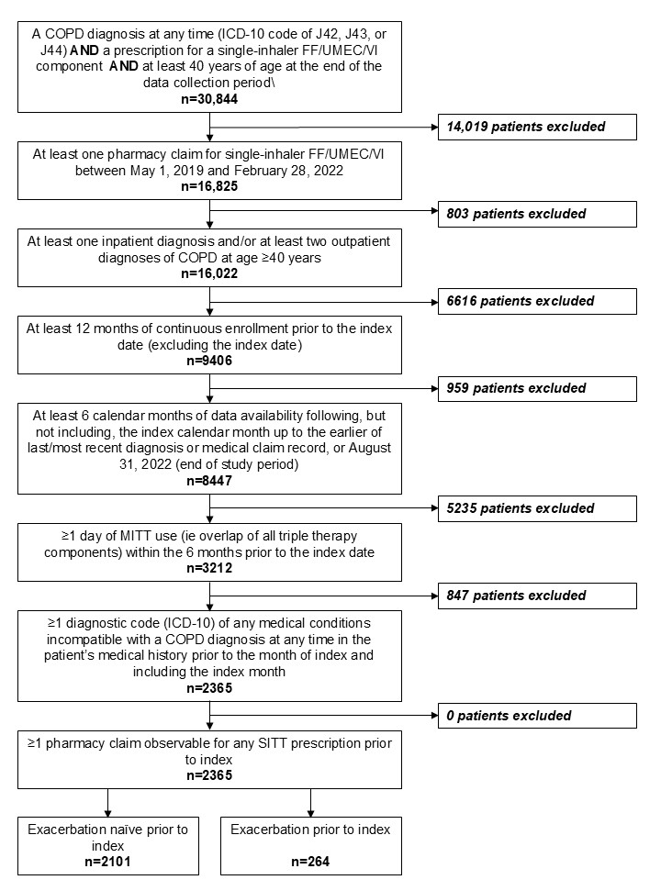
Abbreviations: COPD, chronic obstructive pulmonary disease; FF/UMEC/VI, fluticasone furoate/umeclidinium/vilanterol; ICD-10, International Classification of Diseases, Tenth Revision; MITT, multiple-inhaler triple therapy; SITT, single-inhaler triple therapy.
Supplementary Figure 3: Proportion of patients with ≥1 overall, moderate, and severe COPD exacerbation in the 6 months pre- and post-switch from MITT to FF/UMEC/VI (N=1,225); 30-day permissible gap (sensitivity analysis).
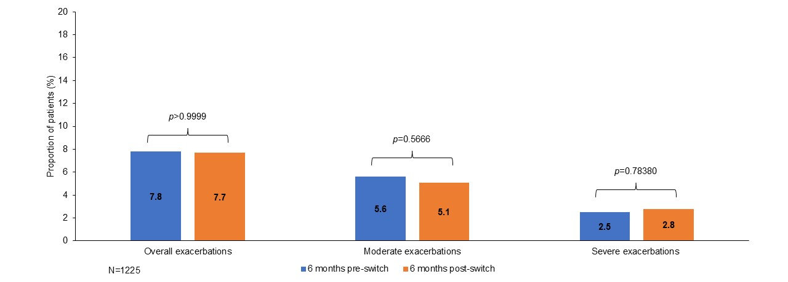
Abbreviations: COPD, chronic obstructive pulmonary disease; FF/UMEC/VI, fluticasone furoate/umeclidinium/vilanterol; MITT, multiple-inhaler triple therapy.

Supplementary Figure 4: Proportion of patients with ≥1 overall, moderate, and severe COPD exacerbation in the 6 months pre- and post-switch from MITT to FF/UMEC /VI (N=1,332); 60-day permissible gap (sensitivity analysis).
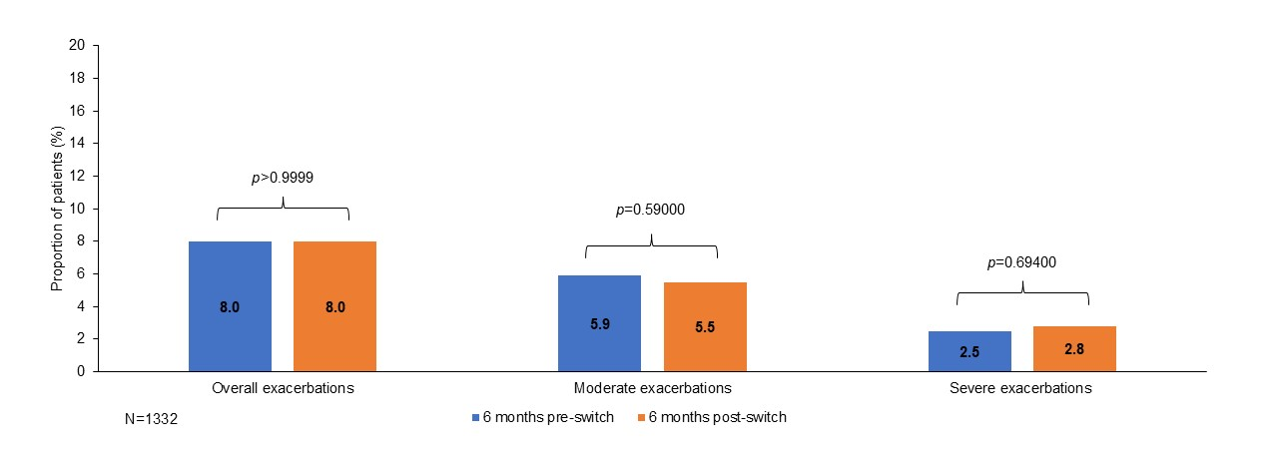
Abbreviations: COPD, chronic obstructive pulmonary disease; FF/UMEC/VI, fluticasone furoate/umeclidinium/vilanterol; MITT, multiple-inhaler triple therapy.

Supplementary Figure 5: Proportion of patients with ≥1 overall, moderate, and severe COPD exacerbation in the 6 months pre- and post-switch from MITT to FF/UMEC /VI (N=1,369); 90-day permissible gap (sensitivity analysis).
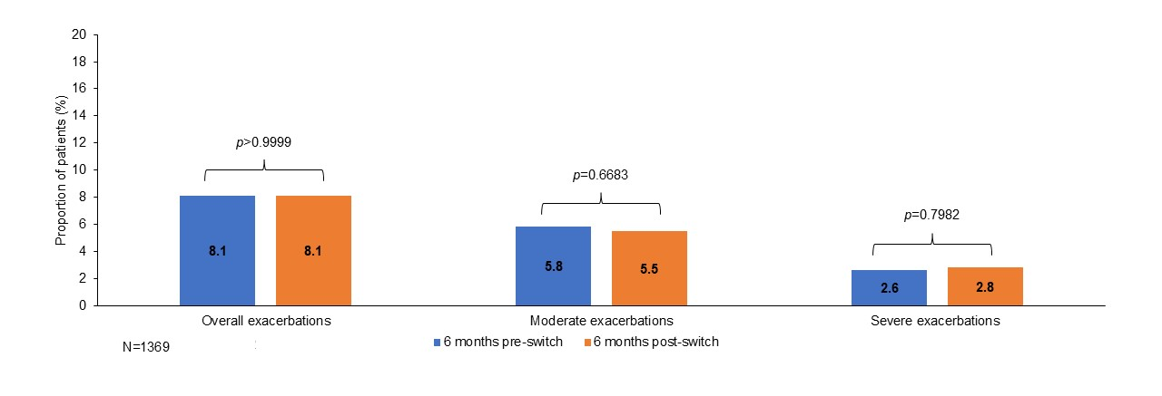
Abbreviations: COPD, chronic obstructive pulmonary disease; FF/UMEC/VI, fluticasone furoate/umeclidinium/vilanterol; MITT, multiple-inhaler triple therapy.

Supplementary Figure 6: Proportion of patients with ≥1 overall, moderate, and severe COPD exacerbation in the 6 months pre- and post-switch from MITT to FF/UMEC/VI (N=2,365); 28 days prior to the treatment switch removed (sensitivity analysis).
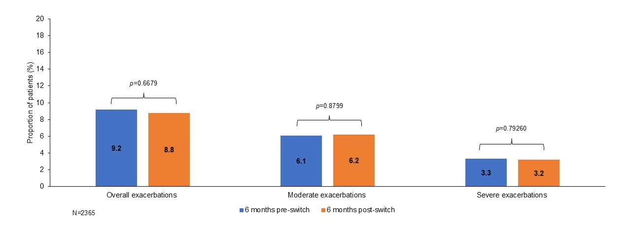
Abbreviations: COPD, chronic obstructive pulmonary disease; FF/UMEC/VI, fluticasone furoate/umeclidinium/vilanterol; MITT, multiple-inhaler triple therapy.

Supplementary Figure 7: COPD exacerbation rate in the 6 months pre- and post-switch from MITT to FF/UMEC/VI; 30-day permissible gap (sensitivity analysis).
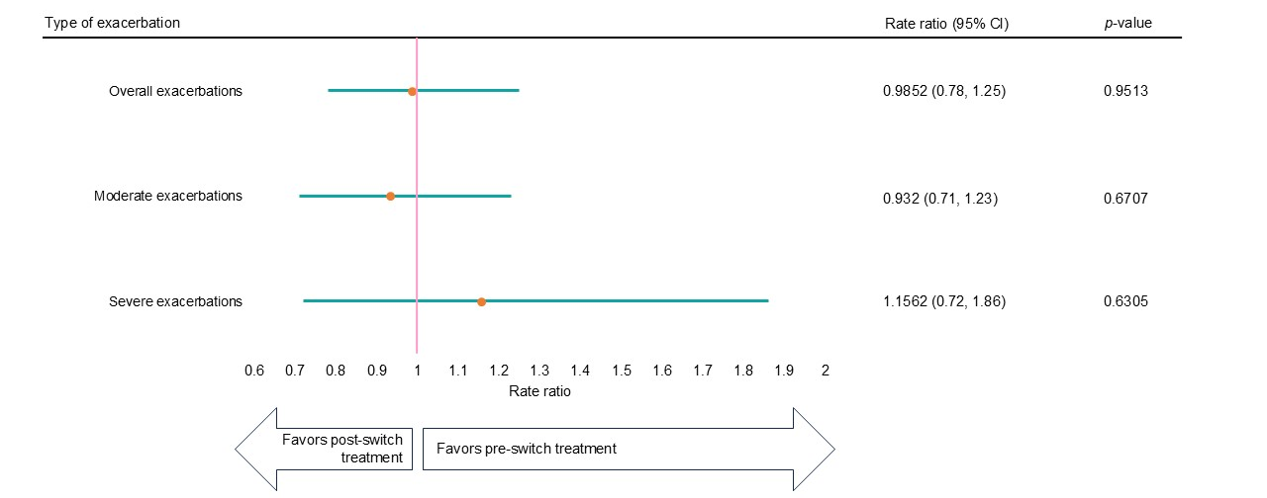
Notes: Rate ratio <1 indicates lower risk post-switch.
Abbreviations: CI, confidence interval; COPD, chronic obstructive pulmonary disease; FF/UMEC/VI, fluticasone furoate/umeclidinium/vilanterol; MITT, multiple-inhaler triple therapy.

Supplementary Figure 8: COPD exacerbation rate in the 6 months pre- and post-switch from MITT to FF/UMEC/VI; 60-day permissible gap (sensitivity analysis).
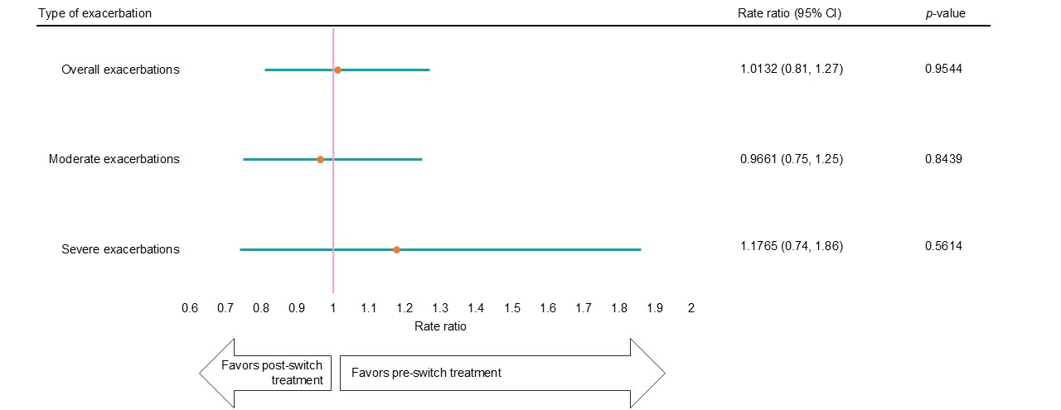

Notes: Rate ratio <1 indicates lower risk post-switch.
Abbreviations: CI, confidence interval; COPD, chronic obstructive pulmonary disease; FF/UMEC/VI, fluticasone furoate/umeclidinium/vilanterol; MITT, multiple-inhaler triple therapy.
Supplementary Figure 9: COPD exacerbation rate in the 6 months pre- and post-switch from MITT to FF/UMEC/VI; 90-day permissible gap (sensitivity analysis).
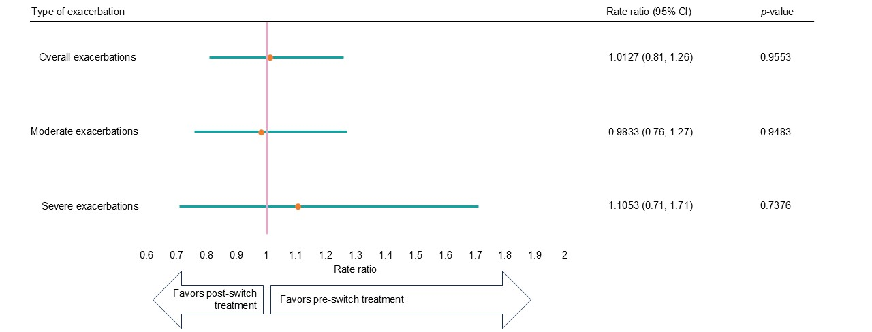
Notes: Rate ratio <1 indicates lower risk post-switch.
Abbreviations: CI, confidence interval; COPD, chronic obstructive pulmonary disease; FF/UMEC/VI, fluticasone furoate/umeclidinium/vilanterol; MITT, multiple-inhaler triple therapy.

Supplementary Figure 10: COPD exacerbation rate in the 6 months pre- and post-switch from MITT to FF/UMEC/VI; 28 days prior to the treatment switch removed (sensitivity analysis).
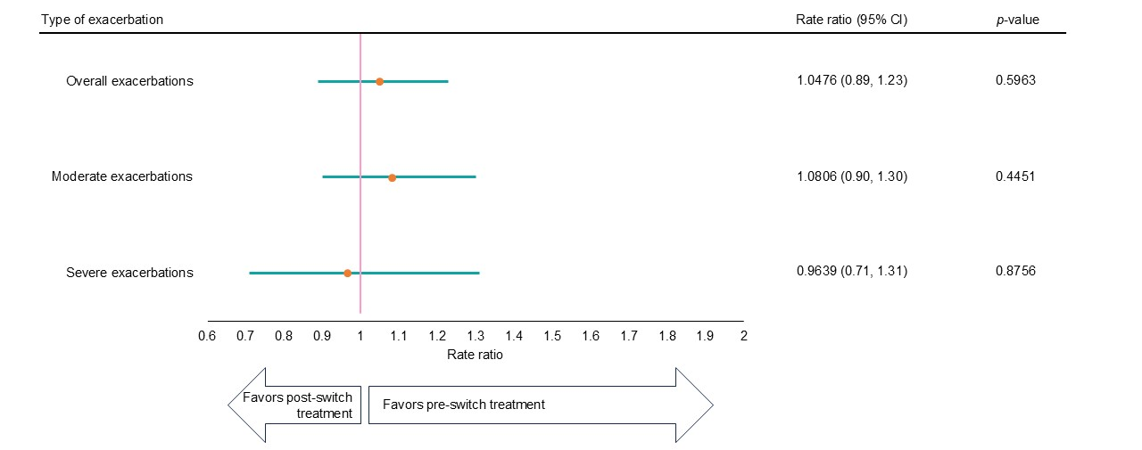
Notes: Rate ratio <1 indicates lower risk post-switch.
Abbreviations: CI, confidence interval; COPD, chronic obstructive pulmonary disease; FF/UMEC/VI, fluticasone furoate/umeclidinium/vilanterol; MITT, multiple-inhaler triple therapy.

Supplementary Table 1 Number and incidence rates of COPD exacerbations in the 6 months pre- and post-switch from MITT to FF/UMEC/VI: total population (N=2365) and patients with ≥1 exacerbation while receiving MITT (n=264).
 | 6 months  pre-switch | 6 months  post-switch
Total population (N=2365)
Overall (moderate-to-severe) exacerbations  Number of events  Time at risk, days  Incidence rate (PPPY) | 359  425,700  0.0008 | 308  425,700  0.0007
Moderate COPD exacerbations  Number of events  Time at risk, days  Incidence rate (PPPY) | 241  425,700  0.0006 | 228  425,700  0.0005
Severe COPD exacerbations  Number of events  Time at risk, days  Incidence rate (PPPY) | 118  425,700  0.0003 | 80  425,700  0.0002
Patients with ≥1 exacerbation while receiving MITT (n=264)
Overall (moderate-to-severe) exacerbations  Number of events  Time at risk, days  Incidence rate (PPPY) | 359  48,217  0.0074 | 171  48,217  0.0035
Moderate COPD exacerbations  Number of events  Time at risk, days  Incidence rate (PPPY) | 241  48,217  0.0050 | 147  48,217  0.0030
Severe COPD exacerbations  Number of events  Time at risk, days  Incidence rate (PPPY) | 118  48,217  0.0024 | 24  48,217  0.0005

Abbreviations: COPD, chronic obstructive pulmonary disease; FF/UMEC/VI, fluticasone furoate/umeclidinium/vilanterol; MITT, multiple-inhaler triple therapy; PPPY, per person per year.

