Supporting Table S1. The RNA-SEQ databases information
GEO no. | Species | Strain | Platforms | Description
GSE46408 | Homo sapiens | primary | Agilent-014850 Whole Human Genome Microarray 4x44K G4112F | The tissues from 6 primary hepatocellular carcinomas and their corresponding nontumourous liver parenchyma
GSE146049 | Homo sapiens | NASH to HCC | Illumina HumanHT-12 V4.0 expression beadchip | The tissues from 5 patients with HCC were included (3 male/ 2 female) from the tumor and from nontumorous tissue.
GSE50579 | Homo sapiens | HBV/ HCV/ alcohol/  Cryptogenic/ genetic hemochromatosis/  Alpha-1 antitrypsin deficiency to HCC | Agilent-028004 SurePrint G3 Human GE 8x60K Microarray | The tissues from 10 normal tissue and 67 hepatocellular carcinoma(HBV (n=8), HCV (n=9), alcohol (n=10), cryptogenic (n=11), genetic hemochromatosis (n=3), Alpha-1 antitrypsin deficiency (n=2), HCC-Grad: G1-G3(n=24))
GSE115018 | Homo sapiens | primary | Agilent-067406 Human CBC lncRNA + mRNA microarray V4.0 | The tissues from 12 hepatocellular carcinomas and the para cancerous normal tissues of 2 cm away from the cancer tissue
GSE101685 | Homo sapiens | primary | [HG-U133_Plus_2] Affymetrix Human Genome U133 Plus 2.0 Array | The tissues from 8 normal tissue and 24 hepatocellular carcinoma Taiwanese patients with stage T1, T3a, T3b

Supporting Table S2. 100 genes across five databases

Number | Gene | Number | Gene | Number | Gene | Number | Gene
1 | AADAT | 26 | CYP2B6 | 51 | LPA | 76 | RAP2A
2 | ANGPTL6 | 27 | DBH | 52 | LYVE1 | 77 | RCAN1
3 | ASPM | 28 | DLGAP5 | 53 | MARCO | 78 | RFWD2
4 | BAIAP2 | 29 | DTL | 54 | MCM6 | 79 | RFX5
5 | BPGM | 30 | ECM1 | 55 | MDK | 80 | RMI2
6 | CAP2 | 31 | EGR1 | 56 | MECOM | 81 | SHBG
7 | CCDC34 | 32 | FAHD2A | 57 | MELK | 82 | SHMT1
8 | CCNB2 | 33 | FCN3 | 58 | MT1E | 83 | SMYD3
9 | CDC25C | 34 | FOXO1 | 59 | MT1F | 84 | STEAP3
10 | CDCA5 | 35 | GMNN | 60 | MT1G | 85 | STMN1
11 | CDK1 | 36 | GOLPH3L | 61 | MT1H | 86 | SUB1
12 | CDKN3 | 37 | GPC3 | 62 | MT1M | 87 | TARBP1
13 | CDT1 | 38 | GPSM2 | 63 | MT1X | 88 | TBC1D7
14 | CELSR3 | 39 | GSTZ1 | 64 | NPC1L1 | 89 | TMEM106C
15 | CENPF | 40 | HAMP | 65 | NTF3 | 90 | TMEM38B
16 | CENPM | 41 | HEY1 | 66 | NUSAP1 | 91 | TOP2A
17 | CEP41 | 42 | HMMR | 67 | OIP5 | 92 | TRMT12
18 | CLEC1B | 43 | ID2 | 68 | OIT3 | 93 | TSEN15
19 | CLEC4G | 44 | IGFALS | 69 | PBK | 94 | TTF2
20 | CNDP1 | 45 | IL1RAP | 70 | PEA15 | 95 | UBAP2L
21 | CRHBP | 46 | ITGA6 | 71 | PLVAP | 96 | UBE2T
22 | CSRNP1 | 47 | ITIH4 | 72 | PRC1 | 97 | UHRF1
23 | CXCL14 | 48 | ITLN1 | 73 | PTH1R | 98 | VIPR1
24 | CXCL2 | 49 | KLHL12 | 74 | PTTG1 | 99 | ZNF322
25 | CYP26A1 | 50 | LCAT | 75 | RACGAP1 | 100 | ZWINT

 | GSE101685 |  | GSE50579 |  | GSE115018 |  | GSE46408 |  | GSE146049 |  | Expression
Gene name | adj.P.Val | logFC | adj.P.Val | logFC | adj.P.Val | logFC | adj.P.Val | logFC | adj.P.Val | logFC | up
ASPM | 0.000000000126 | 4.5729801 | 0.00333 | 2.2766044 | 0.0000238 | 3.27789183 | 0.0002444 | 4.857997 | 0.00120227 | 1.7 | up
CDKN3 | 0.000000201 | 3.5667717 | 0.00186 | 2.9423859 | 0.0000601 | 3.31142601 | 0.0000833 | 5.283524 | 0.00279753 | 1.3 | up
DTL | 0.0000000360 | 4.0260034 | 0.00320 | 2.6345474 | 0.000169 | 3.26187693 | 0.0019088 | 3.1315203 | 0.00736053 | 0.868 | up
CCNB2 | 0.0000000179 | 3.1286988 | 0.000112 | 3.7015563 | 0.000772 | 2.73422702 | 0.0002338 | 4.3422688 | 0.00473754 | 1.09 | up
ZWINT | 0.00000000210 | 3.7323006 | 0.0199 | 1.7153335 | 0.000596 | 2.55982104 | 0.0034964 | 3.3807027 | 0.01647617 | 0.713 | up
RACGAP1 | 0.0000000194 | 3.5723467 | 0.000375 | 2.2193912 | 0.000569 | 2.52630236 | 0.0013843 | 3.9029779 | 0.00393227 | 0.963 | up
PBK | 0.000000298 | 3.979068 | 0.00462 | 2.7034982 | 0.000154 | 2.63826791 | 0.0006155 | 5.2251072 | 0.00228278 | 0.635 | up
HMMR | 0.000000334 | 3.6010453 | 0.00106 | 2.6127262 | 0.000109 | 3.09277396 | 0.0006737 | 3.8367202 | 0.00166691 | 1.2 | up
TOP2A | 0.0000000000473 | 4.7443196 | 0.0466 | 2.2054571 | 0.0000507 | 3.66710731 | 0.0003012 | 5.5304897 | 0.00216994 | 1.85 | up
NUSAP1 | 0.0000333 | 2.9997824 | 0.0123 | 1.6272244 | 0.013 | 1.50213219 | 0.0027817 | 2.9633817 | 0.00161794 | 1.48 | up
CDK1 | 0.00000000155 | 3.3834163 | 0.00301 | 2.7858543 | 0.000369 | 2.96539516 | 0.0002338 | 4.9943732 | 0.0053674 | 1.02 | up
DLGAP5 | 0.00000000918 | 3.442391 | 0.0135 | 2.3372414 | 0.000155 | 1.97617579 | 0.0003012 | 5.0737187 | 0.00808636 | 0.75 | up

Supporting Table S3. The list of 12 core genes in indicated GSE data

Supporting Figure S1.Expression of key genes in CHOL from TCGA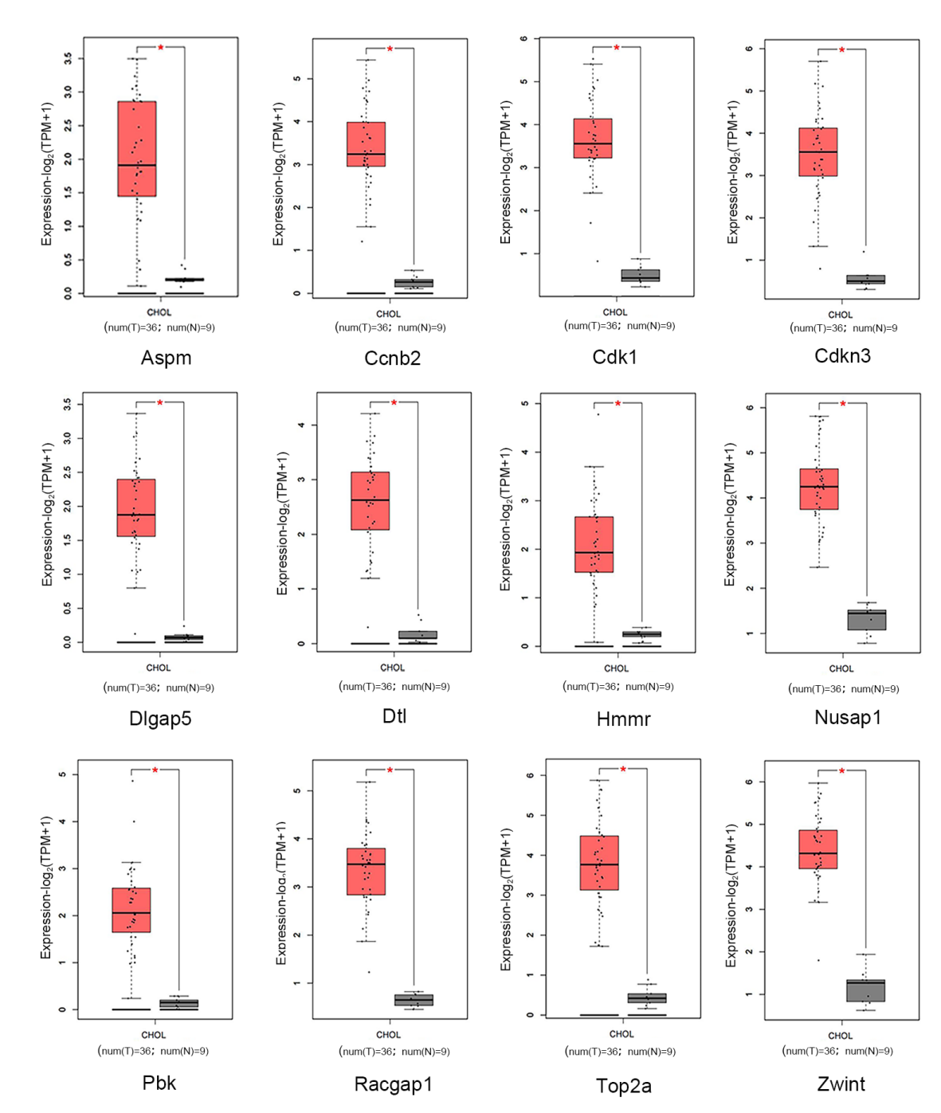
mRNA expression analysis of Aspm, Ccnb2, Cdk1, Cdkn3, Dlgap5, Dtl, Hmmr, Nusap1, Pbk, Racgap1, Top2a, Zwint in CHOL from TCGA. Red represents tumor tissue, and gray represents normal tissue. *P<0.01.

Supporting Figure S2.Expression of CDK1 and DLGAP5
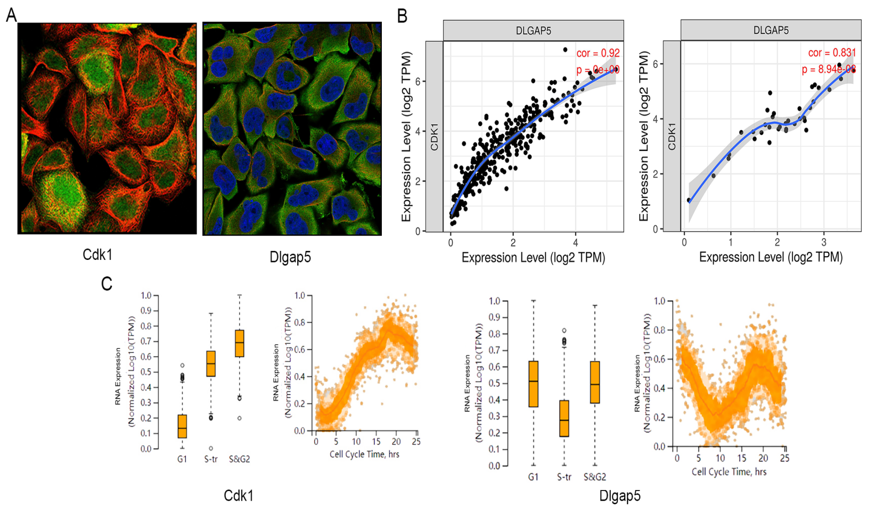
(A) Immunofluorescence staining of CDK1 and DLGAP5 in liver cancer. Nuclei, blue; microtubules, red; target protein, green. (B) Relative expression of CDK1 and DLGAP5 in LICH and CHOL. (C) RNA expression of CDK1 and DLGAP5 in different time of cell cycle.

