SUPPLEMENTARY APPENDIX
Supplementary Table 1. Thresholds for defining greater versus lesser disease burden.
Disease Burden Measure | Greater Burden | Lesser Burden
DLQI¹¹ | >5 | ≤5
VAS itch¹⁴ | ≥30 | <30
VAS skin pain¹² | ≥45 | <45
VAS fatigue¹⁶ | ≥50 | <50
EQ-5D-3Lª | Moderate or extreme problems | No problems
WPAI, activities impairment | >0 | 0
PGA-VAS^{13,15,17} | ≥20 | <20
ªThe 5 subscale dimensions were mobility, self-care, usual activities, pain/discomfort, and anxiety/depression.
Abbreviations: DLQI, Dermatology Life Quality Index; EQ-5D-3L, 3-level EQ-5D; PGA-VAS, Patient Global Assessment visual analog scale; VAS, visual analog scale; WPAI, Work Productivity and Activity Impairment questionnaire.

Supplementary Table 2. Percentages of patients who switched to biologic treatment in each patient-reported disease burden and HRQoL indicator group.
Disease Burden Measure | Total,ª n (%)^{b} | Switchers, n (%)^{c}
DLQI
≤5 | 428 (50.5) | 111 (25.9)
>5 | 419 (49.5) | 211 (50.4)
VAS itch
<30 | 390 (46.1) | 85 (21.8)
≥30 | 456 (53.9) | 236 (51.8)
VAS skin pain
<45 | 657 (77.8) | 207 (31.5)
≥45 | 187 (22.2) | 113 (60.4)
VAS fatigue
<50 | 553 (65.4) | 168 (30.4)
≥50 | 293 (34.6) | 153 (52.2)
EQ-5D-3L mobility problems
None | 640 (75.7) | 236 (36.9)
Moderate/extreme | 205 (24.3) | 86 (42.0)
EQ-5D-3L self-care problems
None | 789 (93.5) | 296 (37.5)
Moderate/extreme | 55 (6.5) | 25 (45.5)
EQ-5D-3L usual activities problems
None | 609 (72.1) | 213 (35.0)
Moderate/extreme | 236 (27.9) | 109 (46.2)
EQ-5D-3L pain and discomfort
None | 403 (47.7) | 126 (31.3)
Moderate/extreme | 442 (52.3) | 195 (44.1)
EQ-5D-3L anxiety/depression
None | 561 (66.4) | 191 (34.0)
Moderate/extreme | 284 (33.6) | 131 (46.1)
WPAI activities impairment
None | 332 (39.7) | 75 (22.6)
Moderate/extreme | 505 (60.3) | 246 (48.7)
PGA-VAS
<20 | 248 (29.3) | 34 (13.7)
≥20 | 597 (70.7) | 288 (48.2)
ªSample sizes may not sum to 848 owing to missing data.
^{b}Percentage of patients in each disease burden category.
^{c}Percentage of patients in each disease burden category who switched to a biologic treatment.
Abbreviations: DLQI, Dermatology Life Quality Index; EQ-5D-3L, 3-level EQ-5D; HRQoL, health-related quality of life; PGA-VAS, Patient Global Assessment visual analog scale; VAS, visual analog scale; WPAI, Work Productivity and Activity Impairment questionnaire.

Supplementary Table 3. Unadjusted odds ratios of switching to biologic therapy, estimated with models specific to each measure or subscale.

Disease Burden Measure | OR | 95% CI | P
DLQI >5 | 2.90 | 2.17, 3.87 | <0.001
VAS itch ≥30 | 3.85 | 2.84, 5.21 | <0.001
VAS skin pain ≥45 | 3.32 | 2.37, 4.65 | <0.001
VAS fatigue ≥50 | 2.50 | 1.87, 3.35 | <0.001
Mobility problemsª | 1.24 | 0.90, 1.70 | 0.193
Self-care problemsª | 1.39 | 0.80, 2.41 | 0.243
Usual activitiesª | 1.60 | 1.18, 2.17 | 0.003
Pain and discomfortª | 1.74 | 1.31, 2.30 | <0.001
Anxiety/depressionª | 1.66 | 1.24, 2.22 | <0.001
WPAI, activities impairment | 3.25 | 2.39, 4.44 | <0.001
PGA-VAS ≥20 | 5.87 | 3.95, 8.72 | <0.001
ªMeasured by the EQ-5D-3L.
Abbreviations: CI, confidence interval; DLQI, Dermatology Life Quality Index; EQ-5D-3L, 3-level EQ-5D; OR, odds ratio; PGA-VAS, Patient Global Assessment visual analog scale; VAS, visual analog scale; WPAI, Work Productivity and Activity Impairment questionnaire.

Supplementary Table 4. Reasons for switching to biologic treatment in patients with plaque psoriasis from the CorEvitas Psoriasis Registry.
Reason for Switching | Patients, n (%)  N=323 | Days From Initiation,  Median (IQR)ª
Safety
Major side effect | 1 (0.3) | –
Effectiveness
Active disease | 294 (91.0) | 103 (48, 169)
Alternative MOA | 5 (1.5) | 129 (79, 208)
Improve tolerability | 4 (1.2) | –
Improve adherence | 4 (1.2) | –
Other
Patient request | 11 (3.4) | 56 (38, 103)
Other reasons | 3 (0.9) | –
Drug administration | 1 (0.3) | –
ªMedian and IQR restricted in cells with ≤5 patients.
Abbreviations: IQR, interquartile range; MOA, mechanism of action.

Supplementary Table 5. Unadjusted odds ratios of switching to biologic therapy, estimated with models specific to each measure or subscale.

 | PASI ≤2 (n=330) |  |  |  | PASI ≤4 (n=507)
Disease Burden Measure | OR | 95% CI | P | OR |  | 95% CI | P
DLQI >5 | 1.91 | 1.05, 3.49 | 0.034 | 2.53 |  | 1.67, 3.83 | <0.001
VAS itch ≥30 | 4.70 | 2.48, 8.92 | <0.001 | 4.50 |  | 2.87, 7.03 | <0.001
VAS skin pain ≥45 | 3.91 | 1.90, 8.07 | <0.001 | 3.88 |  | 2.36, 6.39 | <0.001
VAS fatigue ≥50 | 2.50 | 1.36, 4.59 | 0.003 | 2.58 |  | 1.69, 3.94 | <0.001
Mobility problemsª | 1.36 | 0.69, 2.67 | 0.379 | 1.30 |  | 0.81, 2.07 | 0.271
Self-care problemsª | 1.69 | 0.53, 5.41 | 0.375 | 1.34 |  | 0.54, 3.31 | 0.529
Usual activitiesª | 2.21 | 1.19, 4.11 | 0.012 | 2.11 |  | 1.36, 3.25 | <0.001
Pain and discomfortª | 1.65 | 0.90, 2.99 | 0.103 | 2.13 |  | 1.40, 3.25 | <0.001
Anxiety/depressionª | 1.92 | 1.05, 3.52 | 0.035 | 2.25 |  | 1.48, 3.42 | <0.001
WPAI, activities impairment | 2.24 | 1.22, 4.14 | 0.010 | 3.06 |  | 1.96, 4.77 | <0.001
PGA-VAS ≥20 | 5.66 | 2.57, 12.46 | <0.001 | 6.20 |  | 3.53, 10.88 | <0.001

ªMeasured by the EQ-5D-3L.
Abbreviations: CI, confidence interval; DLQI, Dermatology Life Quality Index; EQ-5D-3L, 3-level EQ-5D; OR, odds ratio; PASI, Psoriasis Area and Severity Index Score; PGA-VAS, Patient Global Assessment visual analog scale; VAS, visual analog scale; WPAI, Work Productivity and Activity Impairment questionnaire.

Supplementary Figure 1. Adjusted associations (aOR and 95% CI) for patient-reported outcome measures and switching to biologic treatment in patients with PASI scores ≤2 (n=330), estimated with models specific to each measure or subscale.ª
ªVariables adjusted for included age, sex, race, ethnicity, work status, body mass index, psoriasis duration, psoriatic arthritis, number of nonbiologic systemics used before the study period began, history of psoriasis in difficult-to-treat areas, and disease severity as measured by body surface area involvement, Psoriasis Area and Severity Index score, and Investigator’s Global Assessment score.
^{b}Measured by the EQ-5D-3L.
Abbreviations: aOR, adjusted odds ratio; CI, confidence interval; DLQI, Dermatology Life Quality Index; EQ-5D-3L, 3-level EQ-5D; PASI, Psoriasis Area and Severity Index; PGA-VAS, Patient Global Assessment visual analog scale; VAS, visual analog scale; WPAI, Work Productivity and Activity Impairment questionnaire.

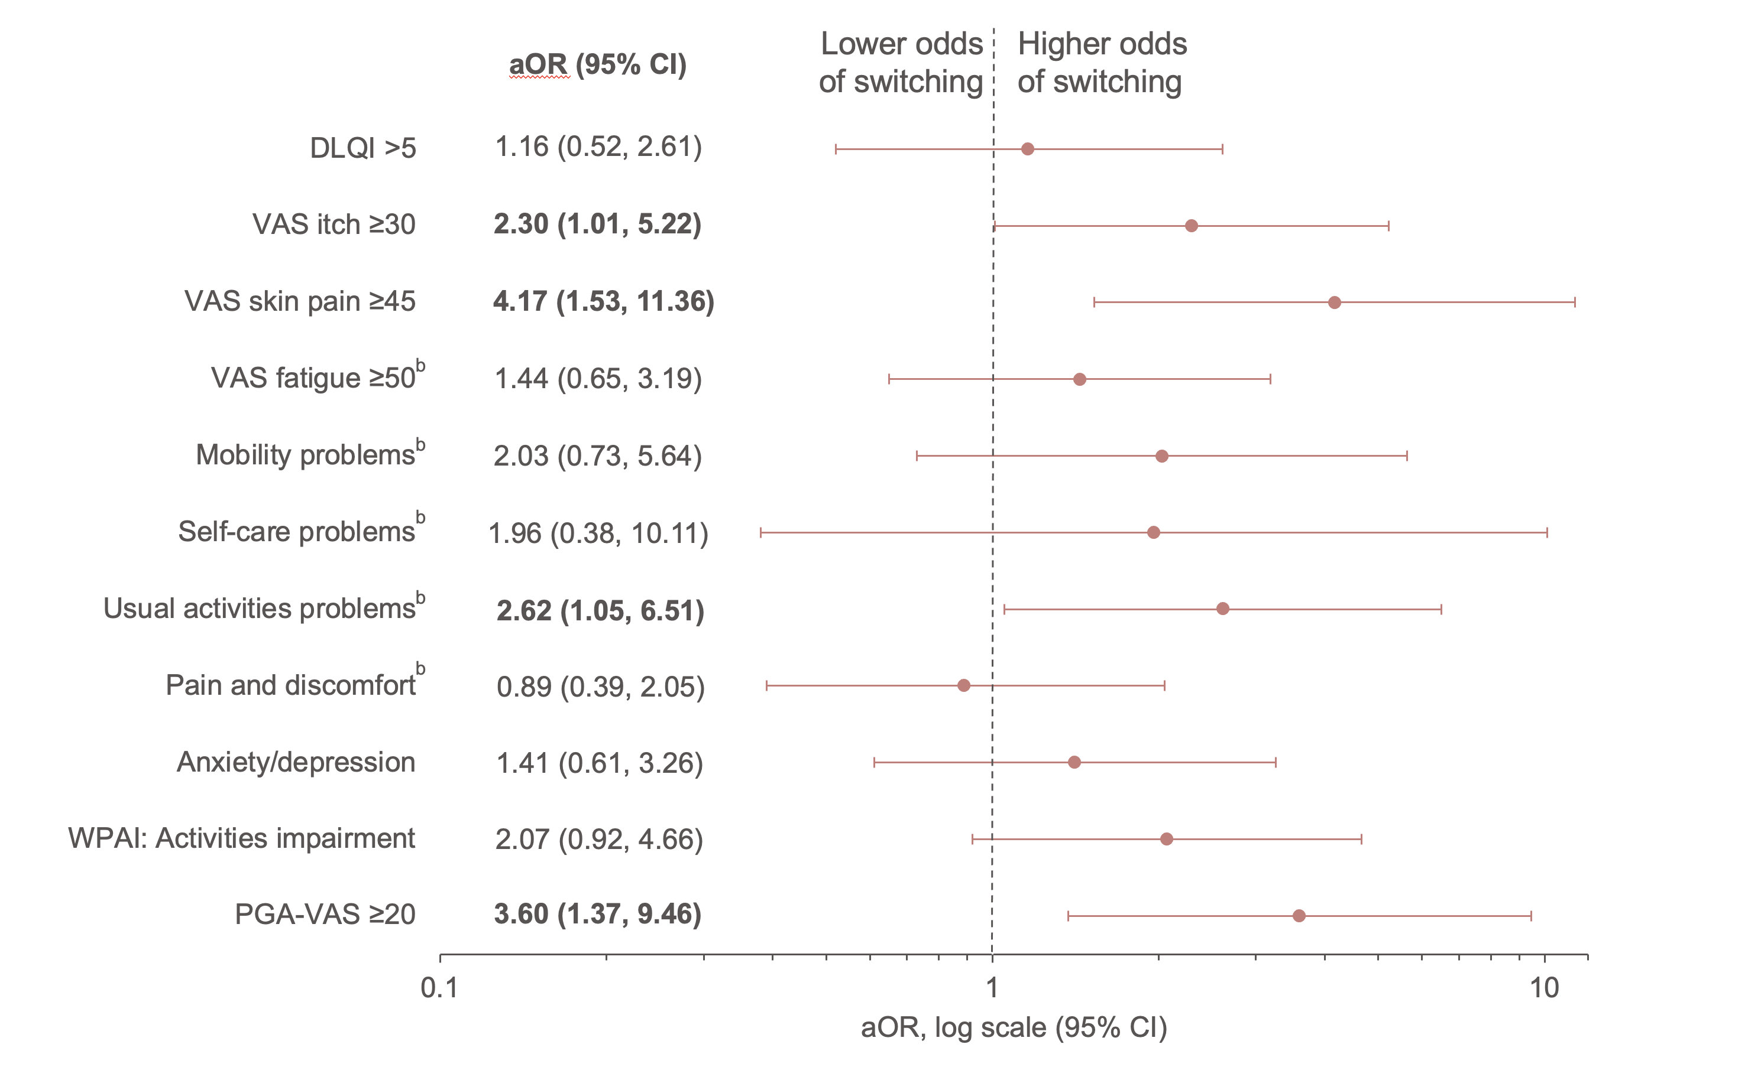

Supplementary Figure 2. Adjusted associations (aOR and 95% CI) for patient-reported outcome measures and switching to biologic treatment in patients with PASI scores ≤4 (n=507), estimated with models specific to each measure or subscale.ª
ªVariables adjusted for included age, sex, race, ethnicity, work status, body mass index, psoriasis duration, psoriatic arthritis, number of nonbiologic systemics used before the study period began, history of psoriasis in difficult-to-treat areas, and disease severity as measured by body surface area involvement, Psoriasis Area and Severity Index score, and Investigator’s Global Assessment score.
^{b}Measured by the EQ-5D-3L.
Abbreviations: aOR, adjusted odds ratio; CI, confidence interval; DLQI, Dermatology Life Quality Index; EQ-5D-3L, 3-level EQ-5D; PASI, Psoriasis Area and Severity Index; PGA-VAS, Patient Global Assessment visual analog scale; VAS, visual analog scale; WPAI, Work Productivity and Activity Impairment questionnaire.

