Supplementary Tables
Supplementary Table 1: Details on statistic tests for each measurement
Measurement  (Experimental Group Subset) | Timepoint (Weeks) | Statistical test | Variables | n per group  (total number of mice)
Body weight (no surgery) | 0, 10, 13 | Mixed ANOVA | Week * diet * sex * genotype | 3-9 (57)
Body weight (HFD) | 10, 13 | Mixed ANOVA | Week * surgery * sex * genotype | 1-8 (55)
Glucose tolerance metrics: AUC, max. peak, and baseline (no surgery)ª | 0, 10, 12 | Mixed ANOVA | Week * diet * sex * genotype | 2-7 (41)
Glucose tolerance metrics: AUC, max. peak, and baseline (HFD)ª | 12 | ANOVA | Surgery * sex | 2-7 (27)
Serum metabolic marker: insulin (no surgery) | 13 | T-test | Diet | 3, 7 (10)
Serum metabolic markers: C-peptide, ghrelin, GLP-1, leptin, and PYY (no surgery)ª | 13 | ANOVA | Diet * sex | 4-10 (28)
Serum metabolic markers: C-peptide, ghrelin, GLP-1, leptin, and PYY (HFD, excludes VSG-operated mice)ª | 13 | ANOVA | Surgery * genotype | 3-5 (18)
Mean percent peribronchial trichrome area (no surgery) | 13 | ANOVA | Diet * intranasal treatment | 5-10 (29)
Mean percent peribronchial trichrome area (HFD) | 13 | ANOVA | Surgery * Intranasal treatment | 2-5 (24)
Lung Histology scores: H&E and PAS (no surgery)ª | 13 | ANOVA | Diet * intranasal treatment * genotype | 2-5 (29)
Lung Histology scores: H&E and PAS (HFD)ª | 13 | ANOVA | Intranasal treatment * surgery | 2-5 (24)
Relative abundance BALF immune cells: eosinophils, epithelial cells, lymphocytes, macrophages, and neutrophilsª | 13 | Wilcoxon rank sum test | Intranasal treatment | 21, 22 (43)
Lung tissue alpha diversity metrics: Faith’s PD, observed richness, and Shannon diversity index (no surgery)ª | 10, 13 | Mixed ANOVA | Week * intranasal treatment * genotype | 2-4 (26)
Lung tissue alpha diversity metrics: Faith’s PD, observed richness, and Shannon diversity index (HFD only)ª | 13 | ANOVA | Surgery * intranasal treatment | 1-7 (23)
Fecal microbiome alpha diversity metrics: Faith’s PD, observed richness, and Shannon diversity index(no surgery)ª | 0, 10, 13 | Mixed ANOVA | Diet * week * genotype | 4-15 (58)
Fecal microbiome alpha diversity metrics: Faith’s PD, observed richness, and Shannon diversity index (HFD only)ª | 13 | ANOVA | Surgery * sex * genotype | 12-17 (45)
Lung tissue beta diversity metrics: UniFrac and weighted UniFrac distances (no surgery) | 10, 13 | PERMANOVA | Intranasal treatment * genotype | 5-8 (26)
Lung tissue beta diversity metrics: UniFrac and weighted UniFrac distances (HFD) | 13 | PERMANOVA | Surgery | 5-12 (23)
Fecal microbiome beta diversity metrics: UniFrac and weighted UniFrac distances (no surgery) | 0, 10, 13 | PERMANOVA | Diet * genotype * week | 4-15 (58)
Fecal microbiome beta diversity metrics: UniFrac and weighted UniFrac distances (HFD) | 13 | PERMANOVA | Surgery * genotype | 4-9 (45)
Lung tissue taxa (no surgery)^{b} | 10, 13 | DESeq2 & ANCOM II | Intranasal treatment * diet | 4-8 (26)
Lung tissue taxa (HFD only)^{b} | 13 | DESeq2 & ANCOM II | Intranasal treatment + surgery | 1-7 (23)
Fecal taxa (no surgery)^{b} | 0, 10, 13 | DESeq2 & ANCOM II | Diet * week + genotype | 4-15 (58)
Fecal taxa (HFD only)^{b} | 13 | DESeq2 & ANCOM II | Surgery * genotype | 4-9 (45)

Notes: * denotes testing for interactive effects whereas + denotes testing for additive effects only. ªSince there were multiple metrics, statistical test was run for each metric and p-values were adjusted with Holm correction. ^{b}Only taxa that were identified as significant by both tools (Holm-corrected p<0.05 for both) were considered significant.
Abbreviations: HFD, high fat diet; ANOVA, analysis of variance; AUC, area under the curve; GLP-1, glucagon-like peptide-1; PYY, peptide YY; VSG, vertical sleeve gastrectomy; H&E, hematoxylin and eosin; PAS, Periodic acid-Schiff; BALF, bronchoalveolar lavage fluid; PD, phylogenetic distance; PERMANOVA, permutational analysis of variance; DESeq2, differential expression analysis for sequence count data 2; ANCOM II, analysis of compositions of microbiomes II
Supplementary Table 2: Significant microbial taxon—host health metric correlations based on Spearman’s rank correlation
Taxon | Health metric | ρ | BH-adjusted p-values | n (Mouse) | n (Fecal pellets) | Rank | Significance
Actinobacteriota | Baseline glucose | -0.37 | 1.10E-03 | 58 | 95 | Phylum | **
Actinobacteriota | Body Weight | -0.36 | 1.80E-05 | 90 | 178 | Phylum | ****
Actinobacteriota | Glucose AUC | -0.5 | 5.00E-06 | 58 | 95 | Phylum | ****
Actinobacteriota | Glucose max. peak | -0.51 | 3.70E-06 | 58 | 95 | Phylum | ****
Actinobacteriota | Serum GLP-1 | 0.41 | 3.20E-02 | 38 | 38 | Phylum | *
Actinobacteriota | Serum leptin | -0.46 | 1.30E-02 | 38 | 38 | Phylum | *
Proteobacteria | Baseline glucose | -0.43 | 1.00E-04 | 58 | 95 | Phylum | ***
Proteobacteria | Body Weight | -0.4 | 2.40E-06 | 90 | 178 | Phylum | ****
Proteobacteria | Glucose AUC | -0.49 | 7.30E-06 | 58 | 95 | Phylum | ****
Proteobacteria | Glucose max. peak | -0.52 | 2.40E-06 | 58 | 95 | Phylum | ****
Proteobacteria | Serum GLP-1 | 0.51 | 4.60E-03 | 38 | 38 | Phylum | **
Proteobacteria | Serum PYY | 0.41 | 2.70E-02 | 38 | 38 | Phylum | *
Proteobacteria | Serum ghrelin | 0.65 | 9.70E-05 | 38 | 38 | Phylum | ****
Proteobacteria | Serum leptin | -0.6 | 3.40E-04 | 38 | 38 | Phylum | ***
Verrucomicrobiota | Baseline glucose | -0.32 | 6.80E-03 | 58 | 95 | Phylum | **
Verrucomicrobiota | Body Weight | -0.34 | 3.80E-05 | 90 | 178 | Phylum | ****
Verrucomicrobiota | Glucose AUC | -0.28 | 1.90E-02 | 58 | 95 | Phylum | *
Verrucomicrobiota | Glucose max. peak | -0.29 | 1.60E-02 | 58 | 95 | Phylum | *
Verrucomicrobiota | Serum GLP-1 | 0.42 | 2.30E-02 | 38 | 38 | Phylum | *
Verrucomicrobiota | Serum ghrelin | 0.39 | 4.10E-02 | 38 | 38 | Phylum | *
Actinobacteria | Baseline glucose | -0.33 | 4.70E-03 | 58 | 95 | Class | **
Actinobacteria | Body Weight | -0.37 | 9.50E-06 | 90 | 178 | Class | ****
Actinobacteria | Glucose AUC | -0.44 | 7.90E-05 | 58 | 95 | Class | ****
Actinobacteria | Glucose max. peak | -0.48 | 1.70E-05 | 58 | 95 | Class | ****
Actinobacteria | Serum GLP-1 | 0.53 | 2.50E-03 | 38 | 38 | Class | **
Actinobacteria | Serum ghrelin | 0.49 | 5.90E-03 | 38 | 38 | Class | **
Actinobacteria | Serum leptin | -0.49 | 5.80E-03 | 38 | 38 | Class | **
Coriobacteriia | Baseline glucose | -0.37 | 1.00E-03 | 58 | 95 | Class | **
Coriobacteriia | Body Weight | -0.19 | 3.20E-02 | 90 | 178 | Class | *
Coriobacteriia | Glucose AUC | -0.5 | 4.60E-06 | 58 | 95 | Class | ****
Coriobacteriia | Glucose max. peak | -0.41 | 2.30E-04 | 58 | 95 | Class | ***
Gammaproteobacteria | Baseline glucose | -0.43 | 1.00E-04 | 58 | 95 | Class | ***
Gammaproteobacteria | Body Weight | -0.4 | 2.40E-06 | 90 | 178 | Class | ****
Gammaproteobacteria | Glucose AUC | -0.49 | 7.30E-06 | 58 | 95 | Class | ****
Gammaproteobacteria | Glucose max. peak | -0.52 | 2.40E-06 | 58 | 95 | Class | ****
Gammaproteobacteria | Serum GLP-1 | 0.5 | 4.80E-03 | 38 | 38 | Class | **
Gammaproteobacteria | Serum PYY | 0.42 | 2.60E-02 | 38 | 38 | Class | *
Gammaproteobacteria | Serum ghrelin | 0.65 | 9.70E-05 | 38 | 38 | Class | ****
Gammaproteobacteria | Serum leptin | -0.6 | 3.40E-04 | 38 | 38 | Class | ***
Verrucomicrobiae | Baseline glucose | -0.32 | 6.80E-03 | 58 | 95 | Class | **
Verrucomicrobiae | Body Weight | -0.34 | 3.80E-05 | 90 | 178 | Class | ****
Verrucomicrobiae | Glucose AUC | -0.28 | 1.90E-02 | 58 | 95 | Class | *
Verrucomicrobiae | Glucose max. peak | -0.29 | 1.60E-02 | 58 | 95 | Class | *
Verrucomicrobiae | Serum GLP-1 | 0.42 | 2.30E-02 | 38 | 38 | Class | *
Verrucomicrobiae | Serum ghrelin | 0.39 | 4.10E-02 | 38 | 38 | Class | *
Bifidobacteriales | Baseline glucose | -0.33 | 4.70E-03 | 58 | 95 | Order | **
Bifidobacteriales | Body Weight | -0.38 | 3.70E-06 | 90 | 178 | Order | ****
Bifidobacteriales | Glucose AUC | -0.44 | 8.80E-05 | 58 | 95 | Order | ****
Bifidobacteriales | Glucose max. peak | -0.47 | 1.90E-05 | 58 | 95 | Order | ****
Bifidobacteriales | Serum GLP-1 | 0.52 | 3.40E-03 | 38 | 38 | Order | **
Bifidobacteriales | Serum ghrelin | 0.43 | 1.90E-02 | 38 | 38 | Order | *
Bifidobacteriales | Serum leptin | -0.53 | 2.90E-03 | 38 | 38 | Order | **
Burkholderiales | Baseline glucose | -0.44 | 9.20E-05 | 58 | 95 | Order | ****
Burkholderiales | Body Weight | -0.39 | 2.40E-06 | 90 | 178 | Order | ****
Burkholderiales | Glucose AUC | -0.49 | 7.00E-06 | 58 | 95 | Order | ****
Burkholderiales | Glucose max. peak | -0.52 | 2.40E-06 | 58 | 95 | Order | ****
Burkholderiales | Serum GLP-1 | 0.5 | 5.00E-03 | 38 | 38 | Order | **
Burkholderiales | Serum PYY | 0.4 | 3.60E-02 | 38 | 38 | Order | *
Burkholderiales | Serum ghrelin | 0.63 | 1.40E-04 | 38 | 38 | Order | ***
Burkholderiales | Serum leptin | -0.61 | 3.10E-04 | 38 | 38 | Order | ***
Clostridia UCG-014 | Body Weight | -0.2 | 2.10E-02 | 90 | 178 | Order | *
Clostridia UCG-014 | Serum leptin | -0.42 | 2.40E-02 | 38 | 38 | Order | *
Coriobacteriales | Baseline glucose | -0.38 | 9.90E-04 | 58 | 95 | Order | ***
Coriobacteriales | Body Weight | -0.19 | 3.20E-02 | 90 | 178 | Order | *
Coriobacteriales | Glucose AUC | -0.5 | 4.50E-06 | 58 | 95 | Order | ****
Coriobacteriales | Glucose max. peak | -0.41 | 2.30E-04 | 58 | 95 | Order | ***
Oscillospirales | Body Weight | 0.35 | 3.10E-05 | 90 | 178 | Order | ****
Oscillospirales | Glucose AUC | 0.41 | 2.20E-04 | 58 | 95 | Order | ***
Oscillospirales | Glucose max. peak | 0.4 | 3.40E-04 | 58 | 95 | Order | ***
Oscillospirales | Serum GLP-1 | -0.4 | 3.60E-02 | 38 | 38 | Order | *
Oscillospirales | Serum ghrelin | -0.49 | 6.90E-03 | 38 | 38 | Order | **
Oscillospirales | Serum leptin | 0.54 | 2.40E-03 | 38 | 38 | Order | **
Peptostreptococcales-Tissierellales | Glucose AUC | 0.26 | 3.20E-02 | 58 | 95 | Order | *
Peptostreptococcales-Tissierellales | Glucose max. peak | 0.28 | 2.10E-02 | 58 | 95 | Order | *
Atopobiaceae | Baseline glucose | -0.38 | 6.80E-04 | 58 | 95 | Family | ***
Atopobiaceae | Body Weight | -0.32 | 1.40E-04 | 90 | 178 | Family | ***
Atopobiaceae | Glucose AUC | -0.47 | 2.20E-05 | 58 | 95 | Family | ****
Atopobiaceae | Glucose max. peak | -0.37 | 9.90E-04 | 58 | 95 | Family | ***
Atopobiaceae | Serum GLP-1 | 0.51 | 4.70E-03 | 38 | 38 | Family | **
Atopobiaceae | Serum ghrelin | 0.45 | 1.50E-02 | 38 | 38 | Family | *
Atopobiaceae | Serum leptin | -0.53 | 2.40E-03 | 38 | 38 | Family | **
Bifidobacteriaceae | Baseline glucose | -0.33 | 4.80E-03 | 58 | 95 | Family | **
Bifidobacteriaceae | Body Weight | -0.38 | 4.10E-06 | 90 | 178 | Family | ****
Bifidobacteriaceae | Glucose AUC | -0.43 | 9.80E-05 | 58 | 95 | Family | ****
Bifidobacteriaceae | Glucose max. peak | -0.47 | 2.00E-05 | 58 | 95 | Family | ****
Bifidobacteriaceae | Serum GLP-1 | 0.52 | 3.40E-03 | 38 | 38 | Family | **
Bifidobacteriaceae | Serum ghrelin | 0.44 | 1.80E-02 | 38 | 38 | Family | *
Bifidobacteriaceae | Serum leptin | -0.53 | 2.80E-03 | 38 | 38 | Family | **
Enterococcaceae | Body Weight | 0.35 | 3.00E-05 | 90 | 178 | Family | ****
Enterococcaceae | Glucose max. peak | 0.26 | 3.10E-02 | 58 | 95 | Family | *
Enterococcaceae | Serum GLP-1 | -0.52 | 3.50E-03 | 38 | 38 | Family | **
Enterococcaceae | Serum PYY | -0.43 | 2.20E-02 | 38 | 38 | Family | *
Enterococcaceae | Serum ghrelin | -0.48 | 7.60E-03 | 38 | 38 | Family | **
Enterococcaceae | Serum leptin | 0.59 | 5.30E-04 | 38 | 38 | Family | ***
Lactobacillaceae | Body Weight | -0.23 | 8.90E-03 | 90 | 178 | Family | **
Lactobacillaceae | Glucose AUC | -0.3 | 9.80E-03 | 58 | 95 | Family | **
Lactobacillaceae | Serum ghrelin | 0.41 | 3.10E-02 | 38 | 38 | Family | *
Muribaculaceae | Baseline glucose | -0.33 | 4.90E-03 | 58 | 95 | Family | **
Muribaculaceae | Body Weight | -0.5 | 7.60E-10 | 90 | 178 | Family | ****
Muribaculaceae | Glucose AUC | -0.53 | 1.90E-06 | 58 | 95 | Family | ****
Muribaculaceae | Glucose max. peak | -0.54 | 1.80E-06 | 58 | 95 | Family | ****
Muribaculaceae | Serum C-peptide | -0.52 | 6.10E-03 | 34 | 34 | Family | **
Muribaculaceae | Serum ghrelin | 0.52 | 3.60E-03 | 38 | 38 | Family | **
Muribaculaceae | Serum leptin | -0.66 | 8.80E-05 | 38 | 38 | Family | ****
Peptostreptococcaceae | Body Weight | 0.22 | 1.10E-02 | 90 | 178 | Family | *
Peptostreptococcaceae | Glucose AUC | 0.33 | 4.80E-03 | 58 | 95 | Family | **
Peptostreptococcaceae | Glucose max. peak | 0.37 | 1.10E-03 | 58 | 95 | Family | **
Peptostreptococcaceae | Serum GLP-1 | -0.45 | 1.50E-02 | 38 | 38 | Family | *
Peptostreptococcaceae | Serum PYY | -0.42 | 2.40E-02 | 38 | 38 | Family | *
Prevotellaceae | Baseline glucose | -0.27 | 2.20E-02 | 58 | 95 | Family | *
Prevotellaceae | Body Weight | -0.38 | 3.70E-06 | 90 | 178 | Family | ****
Prevotellaceae | Glucose AUC | -0.37 | 1.10E-03 | 58 | 95 | Family | **
Prevotellaceae | Glucose max. peak | -0.43 | 1.20E-04 | 58 | 95 | Family | ***
Prevotellaceae | Serum GLP-1 | 0.64 | 1.00E-04 | 38 | 38 | Family | ***
Prevotellaceae | Serum ghrelin | 0.57 | 9.30E-04 | 38 | 38 | Family | ***
Prevotellaceae | Serum leptin | -0.64 | 1.00E-04 | 38 | 38 | Family | ***
Streptococcaceae | % eosinophils in BALF | -0.58 | 1.30E-02 | 43 | 43 | Family | *
Streptococcaceae | Baseline glucose | 0.29 | 1.50E-02 | 58 | 95 | Family | *
Streptococcaceae | Body Weight | 0.46 | 3.10E-08 | 90 | 178 | Family | ****
Streptococcaceae | Glucose AUC | 0.36 | 1.50E-03 | 58 | 95 | Family | **
Streptococcaceae | Glucose max. peak | 0.42 | 1.70E-04 | 58 | 95 | Family | ***
Streptococcaceae | Serum GLP-1 | -0.48 | 8.50E-03 | 38 | 38 | Family | **
Streptococcaceae | Serum ghrelin | -0.62 | 2.40E-04 | 38 | 38 | Family | ***
Streptococcaceae | Serum leptin | 0.61 | 2.80E-04 | 38 | 38 | Family | ***
Sutterellaceae | Baseline glucose | -0.44 | 8.80E-05 | 58 | 95 | Family | ****
Sutterellaceae | Body Weight | -0.39 | 2.40E-06 | 90 | 178 | Family | ****
Sutterellaceae | Glucose AUC | -0.5 | 6.30E-06 | 58 | 95 | Family | ****
Sutterellaceae | Glucose max. peak | -0.52 | 2.40E-06 | 58 | 95 | Family | ****
Sutterellaceae | Serum GLP-1 | 0.5 | 5.00E-03 | 38 | 38 | Family | **
Sutterellaceae | Serum PYY | 0.4 | 3.60E-02 | 38 | 38 | Family | *
Sutterellaceae | Serum ghrelin | 0.63 | 1.40E-04 | 38 | 38 | Family | ***
Sutterellaceae | Serum leptin | -0.61 | 3.10E-04 | 38 | 38 | Family | ***
[Eubacterium] coprostanoligenes group | Body Weight | -0.37 | 9.00E-06 | 90 | 178 | Family | ****
[Eubacterium] coprostanoligenes group | Glucose AUC | -0.32 | 5.50E-03 | 58 | 95 | Family | **
[Eubacterium] coprostanoligenes group | Serum C-peptide | -0.42 | 3.70E-02 | 34 | 34 | Family | *
[Eubacterium] coprostanoligenes group | Serum GLP-1 | 0.55 | 1.40E-03 | 38 | 38 | Family | **
[Eubacterium] coprostanoligenes group | Serum ghrelin | 0.63 | 1.50E-04 | 38 | 38 | Family | ***
[Eubacterium] coprostanoligenes group | Serum leptin | -0.63 | 1.40E-04 | 38 | 38 | Family | ***
Acetatifactor | Body Weight | 0.28 | 7.30E-04 | 90 | 178 | Genus | ***
Acetatifactor | Glucose max. peak | 0.28 | 1.90E-02 | 58 | 95 | Genus | *
Acetatifactor | Serum GLP-1 | -0.49 | 5.80E-03 | 38 | 38 | Genus | **
Acetatifactor | Serum ghrelin | -0.65 | 8.90E-05 | 38 | 38 | Genus | ****
Acetatifactor | Serum leptin | 0.56 | 1.10E-03 | 38 | 38 | Genus | **
Bifidobacterium | Baseline glucose | -0.34 | 3.80E-03 | 58 | 95 | Genus | **
Bifidobacterium | Body Weight | -0.39 | 2.80E-06 | 90 | 178 | Genus | ****
Bifidobacterium | Glucose AUC | -0.44 | 7.30E-05 | 58 | 95 | Genus | ****
Bifidobacterium | Glucose max. peak | -0.48 | 1.10E-05 | 58 | 95 | Genus | ****
Bifidobacterium | Serum GLP-1 | 0.52 | 3.20E-03 | 38 | 38 | Genus | **
Bifidobacterium | Serum ghrelin | 0.44 | 1.70E-02 | 38 | 38 | Genus | *
Bifidobacterium | Serum leptin | -0.53 | 2.50E-03 | 38 | 38 | Genus | **
Butyricicoccus | Body Weight | -0.21 | 1.80E-02 | 90 | 178 | Genus | *
Butyricicoccus | Glucose max. peak | -0.3 | 1.20E-02 | 58 | 95 | Genus | *
Butyricicoccus | Serum leptin | -0.38 | 5.00E-02 | 38 | 38 | Genus | *
Candidatus Arthromitus | Body Weight | -0.3 | 3.30E-04 | 90 | 178 | Genus | ***
Candidatus Arthromitus | Glucose AUC | -0.3 | 1.00E-02 | 58 | 95 | Genus | *
Candidatus Arthromitus | Glucose max. peak | -0.33 | 4.80E-03 | 58 | 95 | Genus | **
Candidatus Arthromitus | Serum GLP-1 | 0.49 | 5.90E-03 | 38 | 38 | Genus | **
Candidatus Arthromitus | Serum ghrelin | 0.44 | 1.60E-02 | 38 | 38 | Genus | *
Candidatus Arthromitus | Serum leptin | -0.41 | 2.70E-02 | 38 | 38 | Genus | *
Coriobacteriaceae UCG-002 | Baseline glucose | -0.39 | 5.60E-04 | 58 | 95 | Genus | ***
Coriobacteriaceae UCG-002 | Body Weight | -0.32 | 1.10E-04 | 90 | 178 | Genus | ***
Coriobacteriaceae UCG-002 | Glucose AUC | -0.48 | 1.70E-05 | 58 | 95 | Genus | ****
Coriobacteriaceae UCG-002 | Glucose max. peak | -0.38 | 6.80E-04 | 58 | 95 | Genus | ***
Coriobacteriaceae UCG-002 | Serum GLP-1 | 0.5 | 4.80E-03 | 38 | 38 | Genus | **
Coriobacteriaceae UCG-002 | Serum ghrelin | 0.47 | 1.00E-02 | 38 | 38 | Genus | **
Coriobacteriaceae UCG-002 | Serum leptin | -0.55 | 1.40E-03 | 38 | 38 | Genus | **
HT002 | Body Weight | -0.26 | 2.70E-03 | 90 | 178 | Genus | **
HT002 | Glucose AUC | -0.34 | 3.10E-03 | 58 | 95 | Genus | **
HT002 | Glucose max. peak | -0.29 | 1.60E-02 | 58 | 95 | Genus | *
Lachnospiraceae UCG-001 | Baseline glucose | -0.41 | 2.20E-04 | 58 | 95 | Genus | ***
Lachnospiraceae UCG-001 | Body Weight | -0.36 | 1.30E-05 | 90 | 178 | Genus | ****
Lachnospiraceae UCG-001 | Glucose AUC | -0.4 | 3.80E-04 | 58 | 95 | Genus | ***
Lachnospiraceae UCG-001 | Glucose max. peak | -0.44 | 8.80E-05 | 58 | 95 | Genus | ****
Lachnospiraceae UCG-001 | Serum GLP-1 | 0.42 | 2.30E-02 | 38 | 38 | Genus | *
Lachnospiraceae UCG-001 | Serum ghrelin | 0.62 | 2.30E-04 | 38 | 38 | Genus | ***
Lachnospiraceae UCG-001 | Serum leptin | -0.65 | 9.00E-05 | 38 | 38 | Genus | ****
Lactococcus | Baseline glucose | 0.31 | 8.50E-03 | 58 | 95 | Genus | **
Lactococcus | Body Weight | 0.47 | 2.00E-08 | 90 | 178 | Genus | ****
Lactococcus | Glucose AUC | 0.46 | 3.80E-05 | 58 | 95 | Genus | ****
Lactococcus | Glucose max. peak | 0.52 | 2.40E-06 | 58 | 95 | Genus | ****
Lactococcus | Serum C-peptide | 0.41 | 4.30E-02 | 34 | 34 | Genus | *
Lactococcus | Serum GLP-1 | -0.54 | 2.20E-03 | 38 | 38 | Genus | **
Lactococcus | Serum ghrelin | -0.68 | 3.10E-05 | 38 | 38 | Genus | ****
Lactococcus | Serum leptin | 0.68 | 2.70E-05 | 38 | 38 | Genus | ****
Muribaculum | Baseline glucose | -0.39 | 5.80E-04 | 58 | 95 | Genus | ***
Muribaculum | Body Weight | -0.44 | 1.10E-07 | 90 | 178 | Genus | ****
Muribaculum | Glucose AUC | -0.5 | 4.60E-06 | 58 | 95 | Genus | ****
Muribaculum | Glucose max. peak | -0.52 | 2.40E-06 | 58 | 95 | Genus | ****
Muribaculum | Serum C-peptide | -0.54 | 3.90E-03 | 34 | 34 | Genus | **
Muribaculum | Serum GLP-1 | 0.45 | 1.50E-02 | 38 | 38 | Genus | *
Muribaculum | Serum ghrelin | 0.49 | 6.30E-03 | 38 | 38 | Genus | **
Muribaculum | Serum leptin | -0.69 | 2.10E-05 | 38 | 38 | Genus | ****
Parasutterella | Baseline glucose | -0.43 | 9.80E-05 | 58 | 95 | Genus | ****
Parasutterella | Body Weight | -0.4 | 2.40E-06 | 90 | 178 | Genus | ****
Parasutterella | Glucose AUC | -0.49 | 7.30E-06 | 58 | 95 | Genus | ****
Parasutterella | Glucose max. peak | -0.52 | 2.40E-06 | 58 | 95 | Genus | ****
Parasutterella | Serum GLP-1 | 0.5 | 5.50E-03 | 38 | 38 | Genus | **
Parasutterella | Serum PYY | 0.38 | 4.40E-02 | 38 | 38 | Genus | *
Parasutterella | Serum ghrelin | 0.63 | 1.40E-04 | 38 | 38 | Genus | ***
Parasutterella | Serum leptin | -0.61 | 3.20E-04 | 38 | 38 | Genus | ***
Prevotellaceae NK3B31 group | Baseline glucose | -0.31 | 8.50E-03 | 58 | 95 | Genus | **
Prevotellaceae NK3B31 group | Body Weight | -0.42 | 6.00E-07 | 90 | 178 | Genus | ****
Prevotellaceae NK3B31 group | Glucose AUC | -0.37 | 1.30E-03 | 58 | 95 | Genus | **
Prevotellaceae NK3B31 group | Glucose max. peak | -0.33 | 4.00E-03 | 58 | 95 | Genus | **
Prevotellaceae NK3B31 group | Serum C-peptide | -0.41 | 3.80E-02 | 34 | 34 | Genus | *
Prevotellaceae NK3B31 group | Serum GLP-1 | 0.62 | 2.40E-04 | 38 | 38 | Genus | ***
Prevotellaceae NK3B31 group | Serum ghrelin | 0.64 | 1.30E-04 | 38 | 38 | Genus | ***
Prevotellaceae NK3B31 group | Serum leptin | -0.66 | 5.60E-05 | 38 | 38 | Genus | ****
Prevotellaceae UCG-001 | Baseline glucose | -0.26 | 3.20E-02 | 58 | 95 | Genus | *
Prevotellaceae UCG-001 | Body Weight | -0.36 | 1.00E-05 | 90 | 178 | Genus | ****
Prevotellaceae UCG-001 | Glucose AUC | -0.36 | 1.60E-03 | 58 | 95 | Genus | **
Prevotellaceae UCG-001 | Glucose max. peak | -0.46 | 3.10E-05 | 58 | 95 | Genus | ****
Prevotellaceae UCG-001 | Serum GLP-1 | 0.62 | 2.20E-04 | 38 | 38 | Genus | ***
Prevotellaceae UCG-001 | Serum PYY | 0.38 | 4.70E-02 | 38 | 38 | Genus | *
Prevotellaceae UCG-001 | Serum ghrelin | 0.54 | 2.40E-03 | 38 | 38 | Genus | **
Prevotellaceae UCG-001 | Serum leptin | -0.63 | 1.40E-04 | 38 | 38 | Genus | ***
Rikenella | Baseline glucose | 0.3 | 1.20E-02 | 58 | 95 | Genus | *
Rikenella | Body Weight | 0.34 | 4.20E-05 | 90 | 178 | Genus | ****
Rikenella | Glucose AUC | 0.41 | 2.40E-04 | 58 | 95 | Genus | ***
Rikenella | Glucose max. peak | 0.42 | 1.60E-04 | 58 | 95 | Genus | ***
Rikenella | Serum ghrelin | -0.57 | 1.20E-03 | 38 | 38 | Genus | **
Rikenella | Serum leptin | 0.73 | 1.00E-05 | 38 | 38 | Genus | ****
Rikenellaceae RC9 gut group | % eosinophils in BALF | -0.52 | 3.60E-02 | 43 | 43 | Genus | *
Rikenellaceae RC9 gut group | Baseline glucose | 0.3 | 9.50E-03 | 58 | 95 | Genus | **
Rikenellaceae RC9 gut group | Body Weight | 0.41 | 1.40E-06 | 90 | 178 | Genus | ****
Rikenellaceae RC9 gut group | Glucose AUC | 0.41 | 3.00E-04 | 58 | 95 | Genus | ***
Rikenellaceae RC9 gut group | Glucose max. peak | 0.46 | 2.70E-05 | 58 | 95 | Genus | ****
Rikenellaceae RC9 gut group | Serum GLP-1 | -0.42 | 2.30E-02 | 38 | 38 | Genus | *
Rikenellaceae RC9 gut group | Serum ghrelin | -0.43 | 2.20E-02 | 38 | 38 | Genus | *
Rikenellaceae RC9 gut group | Serum leptin | 0.66 | 7.00E-05 | 38 | 38 | Genus | ****
Romboutsia | Body Weight | 0.22 | 1.20E-02 | 90 | 178 | Genus | *
Romboutsia | Glucose AUC | 0.33 | 4.80E-03 | 58 | 95 | Genus | **
Romboutsia | Glucose max. peak | 0.37 | 1.10E-03 | 58 | 95 | Genus | **
Romboutsia | Serum GLP-1 | -0.45 | 1.50E-02 | 38 | 38 | Genus | *
Romboutsia | Serum PYY | -0.42 | 2.40E-02 | 38 | 38 | Genus | *
Tuzzerella | Baseline glucose | 0.38 | 9.60E-04 | 58 | 95 | Genus | ***
Tuzzerella | Body Weight | 0.46 | 3.10E-08 | 90 | 178 | Genus | ****
Tuzzerella | Glucose AUC | 0.5 | 4.60E-06 | 58 | 95 | Genus | ****
Tuzzerella | Glucose max. peak | 0.52 | 2.40E-06 | 58 | 95 | Genus | ****
Tuzzerella | Serum ghrelin | -0.58 | 6.90E-04 | 38 | 38 | Genus | ***
Tuzzerella | Serum leptin | 0.68 | 3.10E-05 | 38 | 38 | Genus | ****
Tyzzerella | Baseline glucose | -0.29 | 1.30E-02 | 58 | 95 | Genus | *
Tyzzerella | Body Weight | -0.38 | 4.30E-06 | 90 | 178 | Genus | ****
Tyzzerella | Glucose AUC | -0.28 | 1.60E-02 | 58 | 95 | Genus | *
Tyzzerella | Glucose max. peak | -0.34 | 3.20E-03 | 58 | 95 | Genus | **
Tyzzerella | Serum ghrelin | 0.41 | 2.80E-02 | 38 | 38 | Genus | *

Notes: Relative abundance of fecal microbial taxa identified as differentially abundant (ANCOM II and DESeq2, Holm-adjusted p<0.05 for both) were correlated with select host metadata using Spearman’s rank correlation. The host metadata correlated were: body weight, glucose tolerance metrics, serum metabolic markers excluding insulin, percentages of BALF eosinophils and neutrophils, and lung histology scores and peribronchial trichrome area. Only significant correlations (Benjamini-Hochberg adjusted p<0.05) are listed with Spearman’s rank correlation coefficient (ρ). Significance: *p<0.05; **p≤0.01; ***p≤0.001; ****p≤0.0001.
Abbreviations: BH, Benjamini-Hochberg; AUC, area under the curve; GLP-1, glucagon-like peptide 1; PYY, protein YY

Supplementary Figures
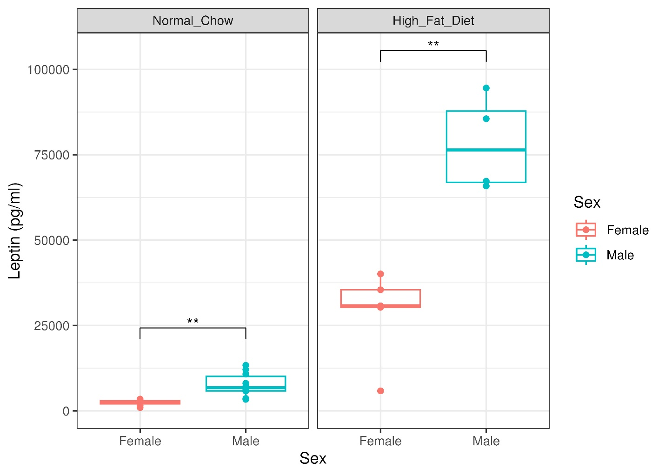
Supplementary Figure 1: In mice that did not undergo surgery, male mice have significantly higher circulating leptin levels than female counterparts for both normal chow and high fat diets. Data are shown by sex and diet (n=4-10 per group). Significance is based on t-test with Holm adjustment. **: p<0.01.

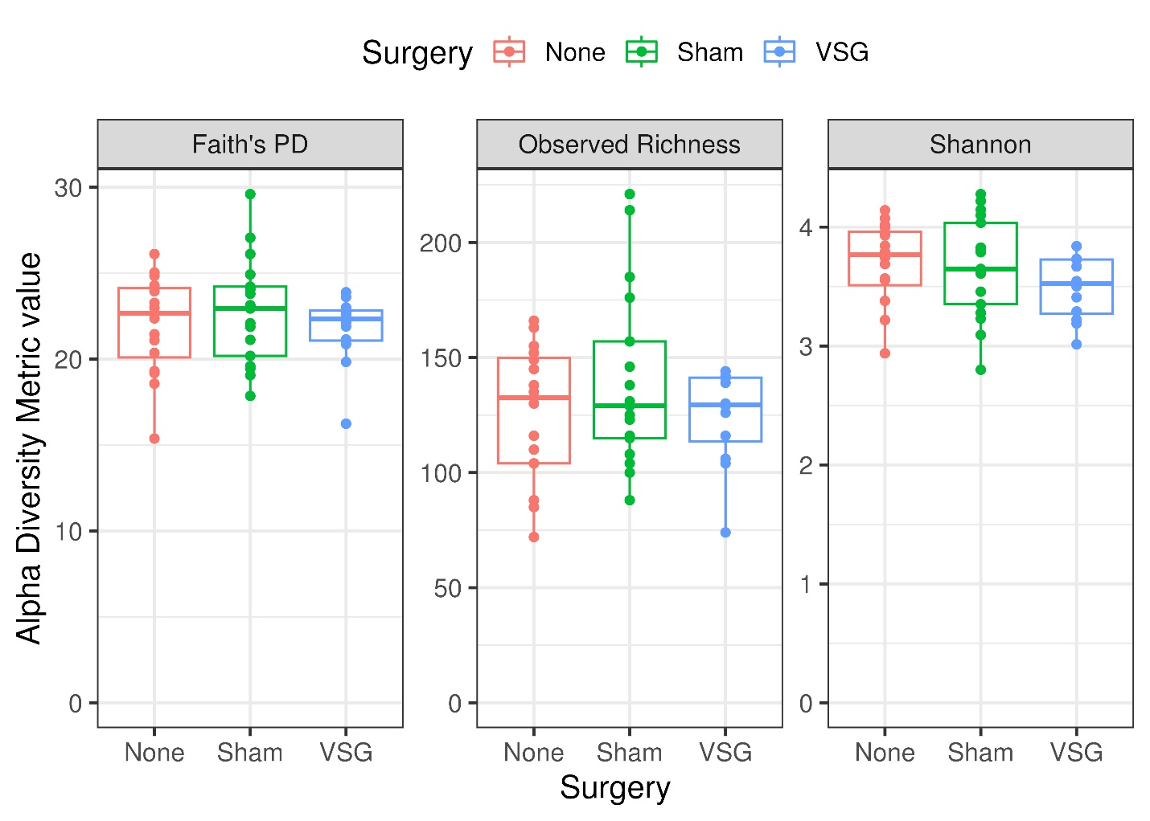
Supplementary Figure 2: In mice fed on a HFD, fecal microbiome alpha diversity metrics did not differ significantly between surgery groups at post-surgery timepoint of week 13 (n=12-17 per group; ANOVA, Holm-adjusted p>0.05). Faith’s PD: Faith’s phylogenetic diversity.

