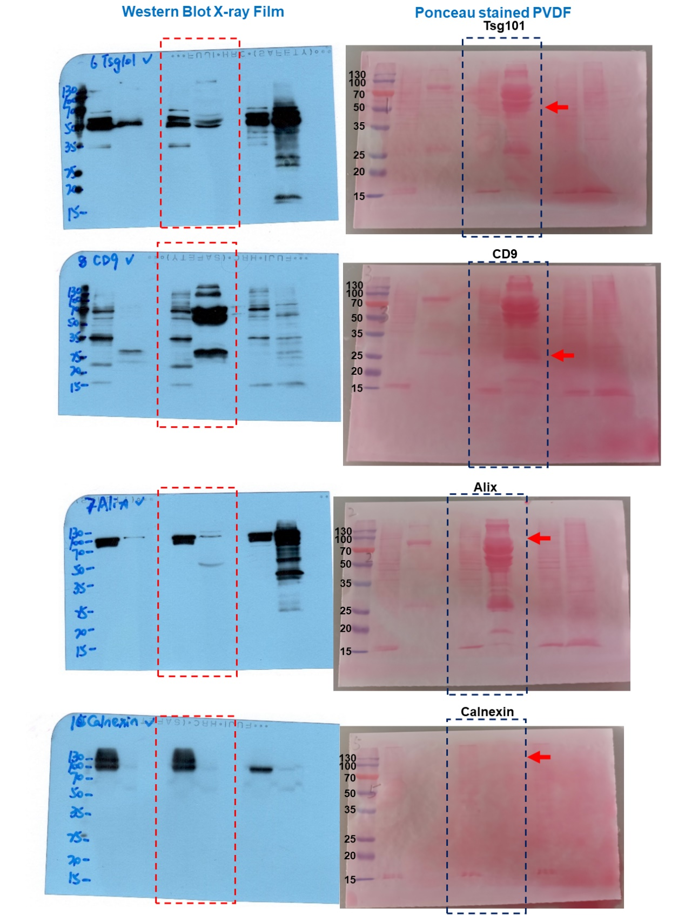
Supplementary Figure

Supplementary Figure1. The original film exposure results and Ponceau stained PVDF membrane of Figure 4C.

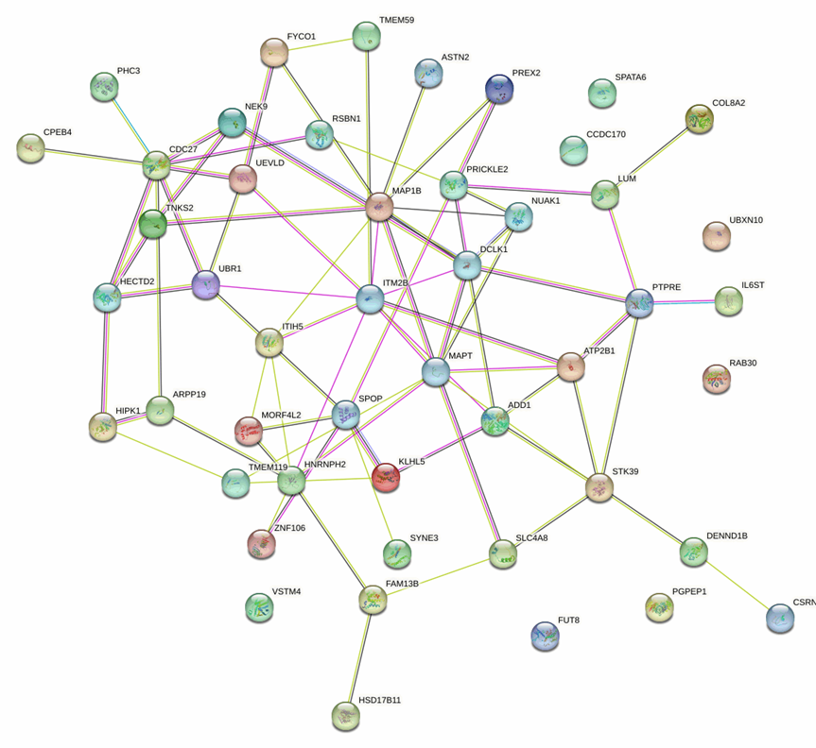

Supplementary Figure2. PPI network composed of 48 potential target genes related to BC prognosis.

