Supporting information for

A graphene-based lipid modulation nanoplatform for synergetic lipid starvation/chemo/photothermal therapy of oral squamous cell carcinoma
Author Names： Ran Li ^{a, b,# *}, Yanwei Li ^{a, b*}, Zijian Song ^{a, b}, Yixuan Gu ^{a, b}, Xiaofeng Jiao ^{a, b}, Chaoqiong Wan ^{a, b}, Tiantian Liu ^{a, b}, Rongrong Zhang ^{a, b}, Ruifang Gao ^{a, b}, Xiangyu Wang ^{a, b#}
Author Address: a Shanxi Province Key Laboratory of Oral Diseases Prevention and New Materials, Shanxi Medical University School and Hospital of Stomatology, Taiyuan 030001, China
b Department of Pediatric and Preventive Dentistry, Shanxi Medical University School and Hospital of Stomatology, Taiyuan 030001, China
* Ran Li and *Yanwei Li contributed equally to this work.
Corresponding Author:
Ran Li - E-mail: lraner@163.com.
Xiangyu Wang - E-mail: wangxiangyu76@163.com.

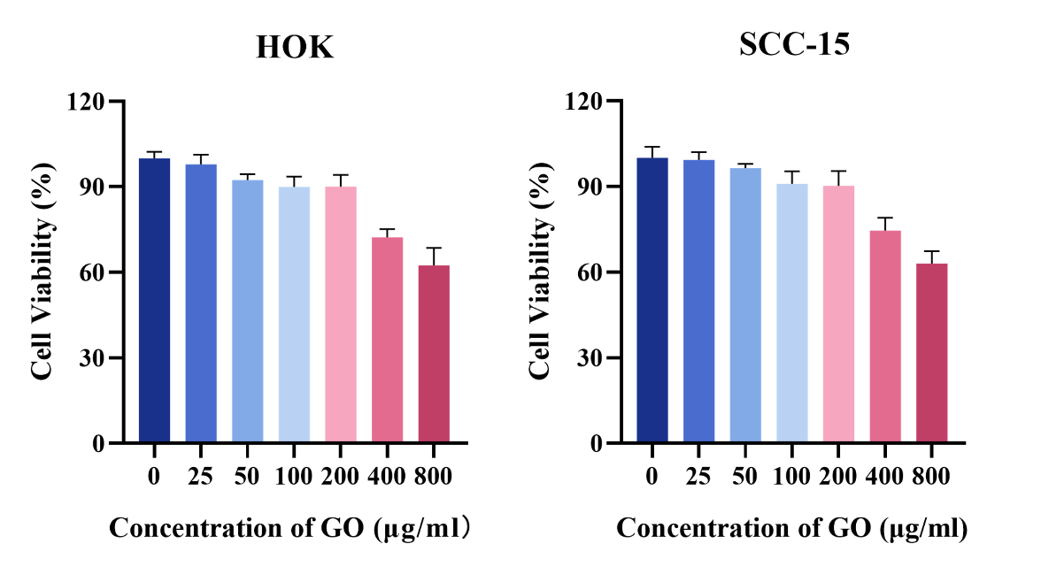
Figure S1. Viability of HOK and SCC-15 cells after incubation with NGO for 24h. (mean ± S.D. n = 5.)
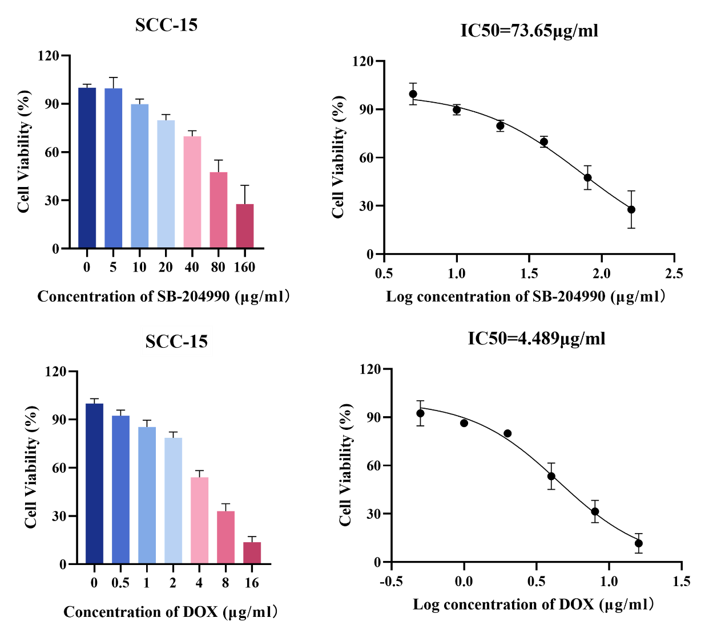
Figure S2. Cell viability and IC₅₀ profiles of SCC-15 cells after 24 hours of co-incubation with SB-204990 and DOX. (mean ± S.D. n = 5.)

Figure S3. Images of NGO, NS, and NSD dissolved in PBS and FBS for different time periods.

Figure S4. Comparison of tumor volume in each group after 12 days of treatment. (mean ± S.D. n = 3. *P<0.05, **P<0.01, ***P<0.001, ****P<0.0001. Closest to error bars * refers to comparison with PBS group)

