Supplementary material
Engineered Biomimetic Nanoparticles-Mediated Targeting Delivery of Allicin against Myocardial Ischemia-Reperfusion Injury by Inhibiting Ferroptosis
Minghui Li^{†1}, Jiabi Wu^{†1}, Tao Yang¹, Yuhang Zhao¹, Ping Ren¹, Lingling Chang², Pilong Shi¹, Jing Yang¹, Yuhang Liu², Xiaolei Li³, Peng Wang^{2*}, Yonggang Cao^{1*}
¹Department of Pharmaceutics, Harbin Medical University, Heilongjiang 163319, China
² Department of Physiology, Harbin Medical University, Heilongjiang 163319, China
³ Department of Pathology, Jiangsu College of Nursing，Jiangsu 223003, China
†These authors contributed equally to this work
*Corresponding author:
Peng Wang: wangpeng810122@126.com
Xinyang Road 39, Gaoxin District, Daqing, Heilongjiang, People’s Republic of China
Yonggang Cao: caoyonggang@hmudq.edu.cn
Xinyang Road 39, Gaoxin District, Daqing, Heilongjiang, People’s Republic of China

Shear stress and analysis of shear adaptation

Shear stress and analysis of shear adaptation were conducted. Briefly, CMECs were cultured under the condition of 10 dyn/cm². Based on cell morphology and orientation, Photoshop CS7.0 was used to quantify shear adaptation from phase contrast images. The definition of full shear adapted was a majority of 60% of all cells oriented within equal or greater than 75% of the cells elongated (when their length-to-width ratio > 2) and an angle of ≤ 30°.
Oxidative stress measurements

To determine whether AL@MSNs@NM reduces oxidative stress, the enzymatic activities of superoxide dismutase (SOD), Mn-SOD, Cu/Zn-SOD, catalase (CAT), and glutathione peroxidase (GSH-PX), the level of glutathione (GSH) and malondialdehyde (MDA) were evaluated with different detection kits according to the manufacturer's instructions (Jian Cheng Bioengineering Institute, China).
Cell death assays

Cell death was assessed using the trypan blue exclusion method. In this assay, cells were stained with trypan blue, and the number of trypan blue-positive (dead) and trypan blue-negative (viable) cells were carefully counted using a haemocytometer.

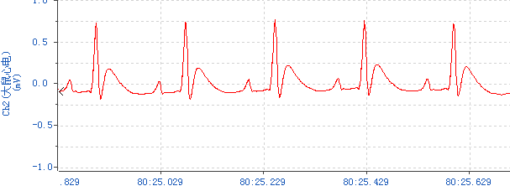
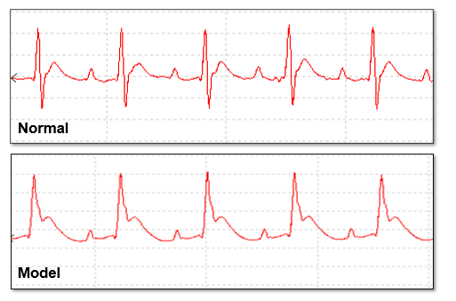

AL@MSNs@NM

Supplementary Figure S1. The electrocardiograms of normal and model and AL@MSNs@NM rat.

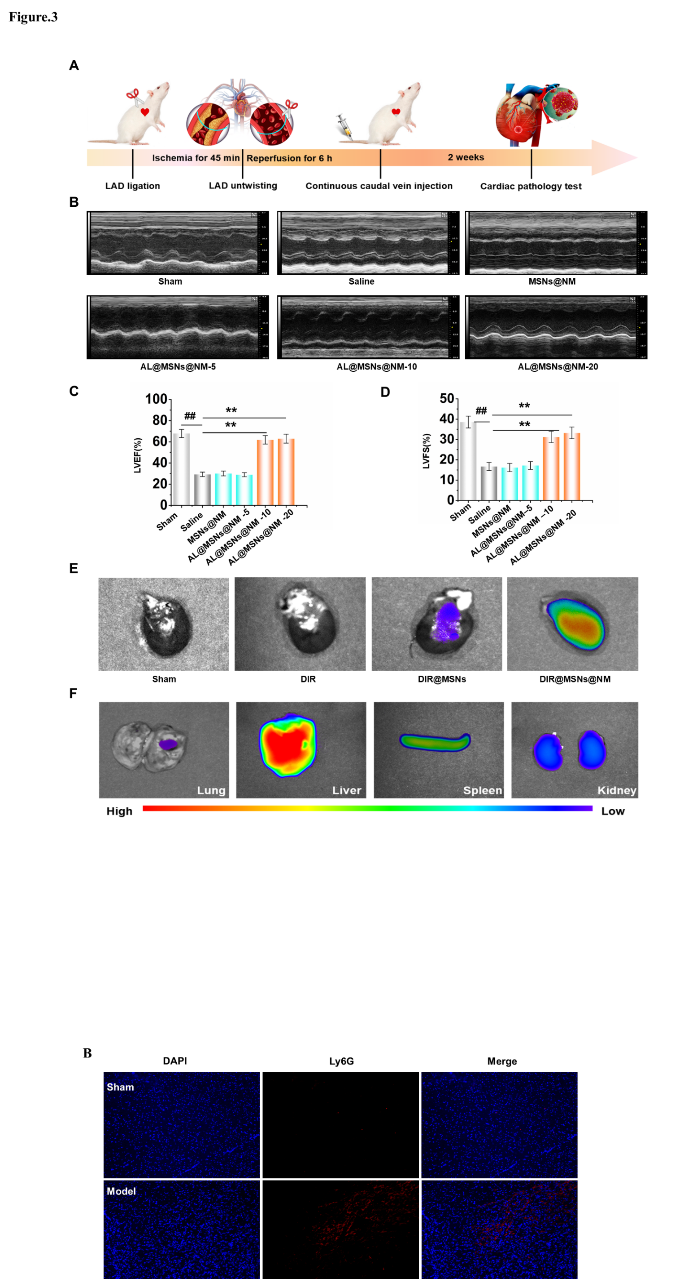

Supplementary Figure S2. Distribution of Ly6G-positive neutrophils was assessed by immunoﬂuorescence (red), and cell nuclei were identiﬁed using DAPI (blue).

Supplementary Figure S3. (A-G) The activities of SOD, Mn-SOD, CuZn-SOD, GSH-PX, CAT, and levels of GSH and MDA were detected from the sham and model group, respectively.Data were represented by means ± SD (n=6). ##P<0.01 vs. sham group; **P<0.01 vs. model group.

