Supplementary Material
Resveratrol-loaded versatile nanovesicle for alopecia therapy via comprehensive strategies

1. Experimental section

1.1 Metabolism experiments of RES and MNX in skin homogenate
The dorsal skin of Kunming mice (20 ~ 25g) was excised and homogenized using 40% PEG400 solution. Then, 2.3 mL of RES or MNX solution (obtained 150 μg drugs) was incubated with 0.7 mL of the skin homogenate at 37 ℃ for 24 h. Then, 0.2 mL of the mixture was collected and mixed with methanol, at 0, 2, 4, 6, 8, 12, and 24 h, the amount of the drug was analyzed by HPLC. Taking 0 h concentration as 100%, the curve of drug concentration with time was drawn.

1.2 Cytotoxicity assay
DPCs were seeded into a 96-well plate at a density of 2.5×10³ cells/well, after attachment, the DPCs were treated with MNX, RES, PPD-Lip@MNX, and PPD-Lip@RES, respectively. After 48 h, the cell viability was quantified using the MTT assay.
Similarly, HUVECs were seeded at a density of 3×10³ cells per well into a 96-well plate and cultured until adherence. Subsequently, they were exposed to DMEM/F12 medium supplemented with various concentrations of MNX, RES, PPD-Lip@MNX, and PPD-Lip@RES. After 48 h, the cell viability was measured via MTT assay.

1.3 Quantitative real-time PCR analysis in vivo
The dorsal skin of mice was separated, and the total RNA from the skin was extracted and reverse transcription was performed according to the manufacturers’ instructions. Subsequently, the mRNA expression levels of β-catenin, VEGF, Wnt3a, fibroblast growth factors-5 (FGF-5), bone morphogenetic proteins (BMP2), dickopff-1 (DKK-1), and transforming growth factor-1 (TGF-β1) was examined. The primer sequences utilized can be found in Table S1.
Table S1 DNA sequence of primer pairs used for quantitative real-time PCR in dorsal skin of mice
Gene | Forward primer | Reverse primer
GAPDH | ATGACCACAGTCCATGCCATCAT | TGTTGAAGTCGCAGGAGACAACCT
β-catenin | CGTGAAATTCTTGGCTATTACAAC | AGACAGACAGCACCTTCAGCA
VEGF | GAGGTCAAGGCTTTTGAAGGC | CTGTCCTGGTATTGAGGGTGG
Wnt3a | GCAGAGGGCATCAAAATC | CTGTTGTTGATGGTGGTG
FGF-5 | TGTGTCTCAGGGGATTGTAGG | AGCTGTTTTCTTGGAATCTCTCC
BMP2 | CTTCAGTGATGTGGGGTGGA | TGGTTAGTGGAGTTCAGGTGGT
DKK-1 | CTCATCAATTCCAACGCGATCA | GCCCTCATAGAGAACTCCCG
TGF-β1 | CCACCTGCAAGACCATCGAC | CTGGCGAGCCTTAGTTTGGAC

2. Result section
Table S2 Encapsulation efficacy and drug loading of PPD-Lip@RES
RES: PPD: phospholipid | RES dosage (%) | EE (%) | DL (%)
0.2: 1: 3 | 4.8 | 80.76±0.22 | 3.85±0.01
0.4: 1: 3 | 9.1 | 92.62±0.48 | 8.42±0.04
0.8: 1: 3 | 16.7 | 92.40±0.47 | 15.43±0.08
1: 1: 3 | 20.0 | 87.41±0.97 | 17.48±0.19

Table S3 Encapsulation efficacy and drug loading of PPD-Lip@MNX
MNX: PPD: phospholipid | MNX dosage (%) | EE (%) | DL (%)
0.2: 1: 3 | 4.8 | 87.15±0.06 | 4.18±0.01
0.4: 1: 3 | 9.1 | 87.34±0.15 | 7.95±0.01
0.8: 1: 3 | 16.7 | 86.70±0.13 | 14.48±0.02
1: 1: 3 | 20.0 | 87.10±0.04 | 17.42±0.01

Table S4 Particle size, PDI and zeta potential of PPD-Lip@RES in different dispersion media
Dispersion media | Mean size (nm) | PDI | Zeta potential (mV)
H₂O | 121.5±2.49 | 0.19±0.026 | -12.6±0.47
PBS | 120.2±2.44 | 0.17±0.059 | -12.7±0.20
DMEM+10%FBS | 119.4±1.71 | 0.18±0.027 | -12.7±0.27

Table S5 Particle size, PDI and zeta potential of PPD-Lip@MNX in different dispersion media
Dispersion media | Mean size (nm) | PDI | Zeta potential (mV)
H₂O | 149.7±3.50 | 0.25±0.028 | -10.80±0.58
PBS | 153.1±1.91 | 0.24±0.026 | -8.26±0.66
DMEM+10%FBS | 157.4±1.89 | 0.24±0.021 | -8.00±0.32
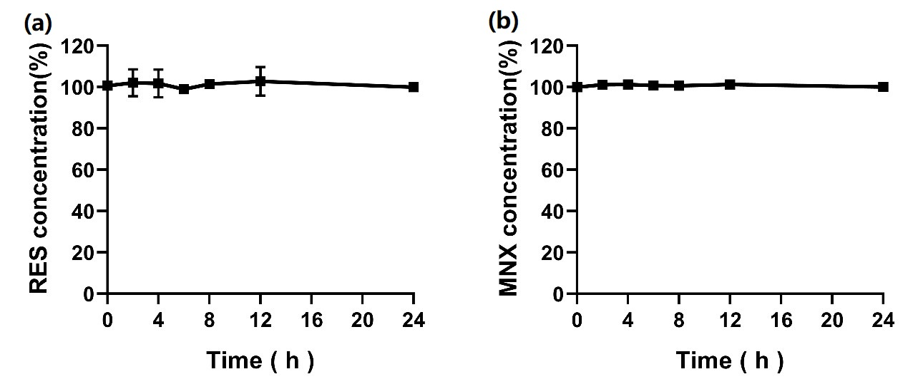
Figure S1 Stability of RES (a) and MNX (b) in skin homogenate.

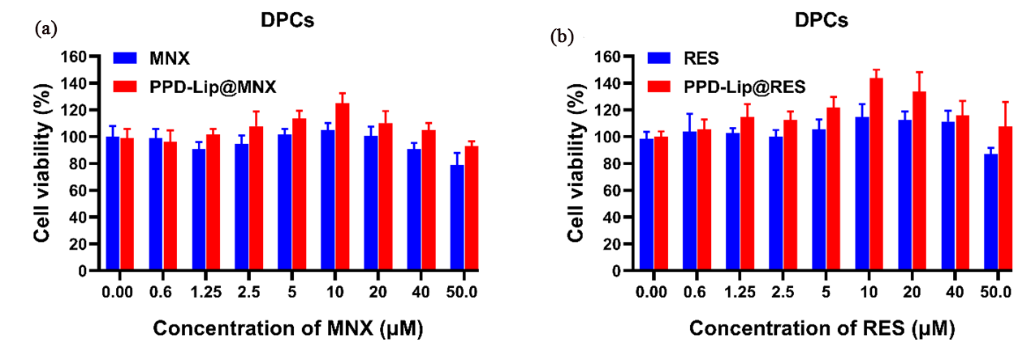
Figure S2 Cell viability of DPCs after treatment with different formulations.

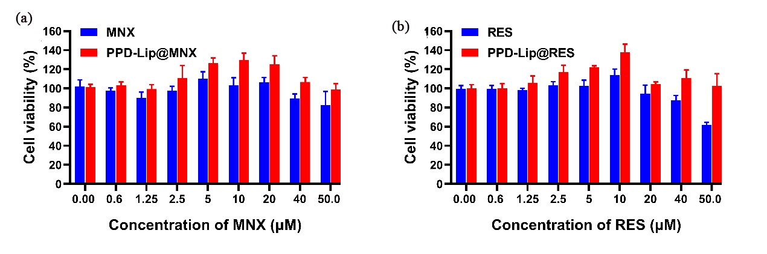
Figure S3 Cell viability of HUVECs after treatment with different formulations.

Figure S4 Cell viability of DPCs treated with different concentrations of H₂O_{2.} *P < 0.05 vs 0.0, **P < 0.01 vs 0.0，***P < 0.001 vs 0.0

Figure S5 Dorsal skin color of TE mice at the experiment endpoint (n=5).

Figure S6 Dorsal skin color of AGA mice at the experiment endpoint (n=5).

Figure S7 DHE staining of dorsal skin in AGA mice, scale bar = 200 μm.

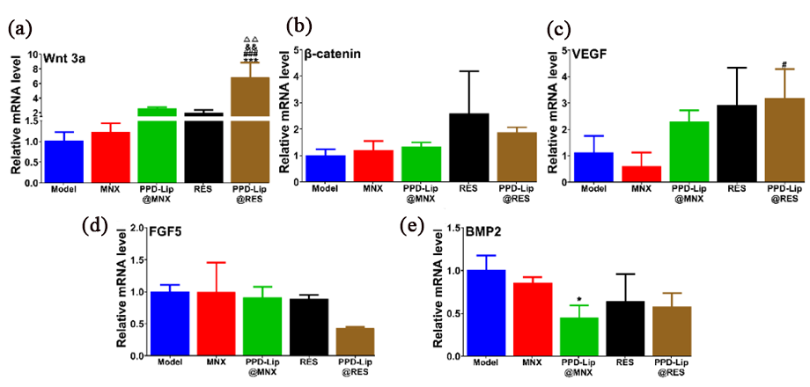
Figure S8 The mRNA expression levels of Wnt3a (a), β-catenin (b), VEGF (c), FGF-5 (d), and BMP2 (e) in the dorsal skin of TE mice. *P < 0.05, ***P < 0.001 vs Model. #P < 0.05, ###P < 0.001 vs MNX. &&P < 0.01 vs PPD-Lip@MNX, △△P < 0.01 vs RES.

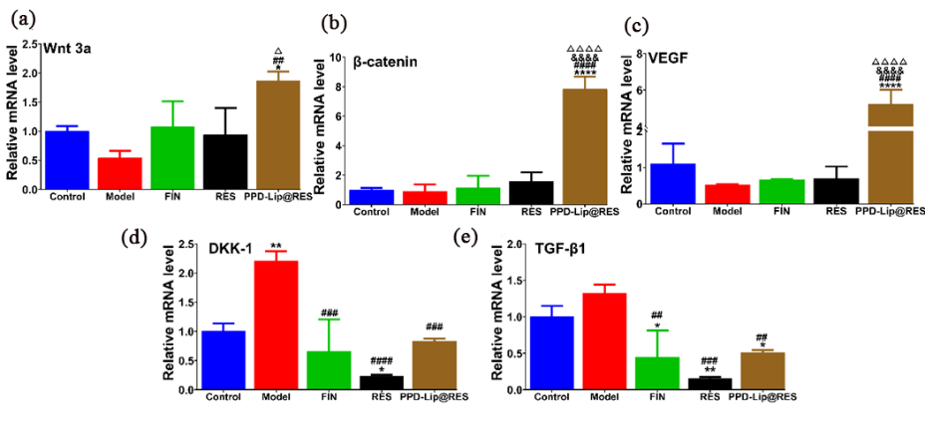
Figure S9 The mRNA expression levels of Wnt3a (a), β-catenin (b), VEGF (c), DKK-1 (d), and TGF-β1 (e) in the dorsal skin of AGA mice. *P < 0.05, **P < 0.01 vs Control. ****P < 0.0001 vs Control. ##P < 0.01 vs Model. ###P < 0.001 vs Model. ####P < 0.0001 vs Model. &&&&P < 0.0001 vs FIN. △P<0.05, △△△△P < 0.0001 vs RES.

