Supplemental Figure Legends

Supplemental Figure 1 Example inpatient S.C.O.P.E. scenario: individual with no existing diagnosis of schizophrenia presenting with first episode.

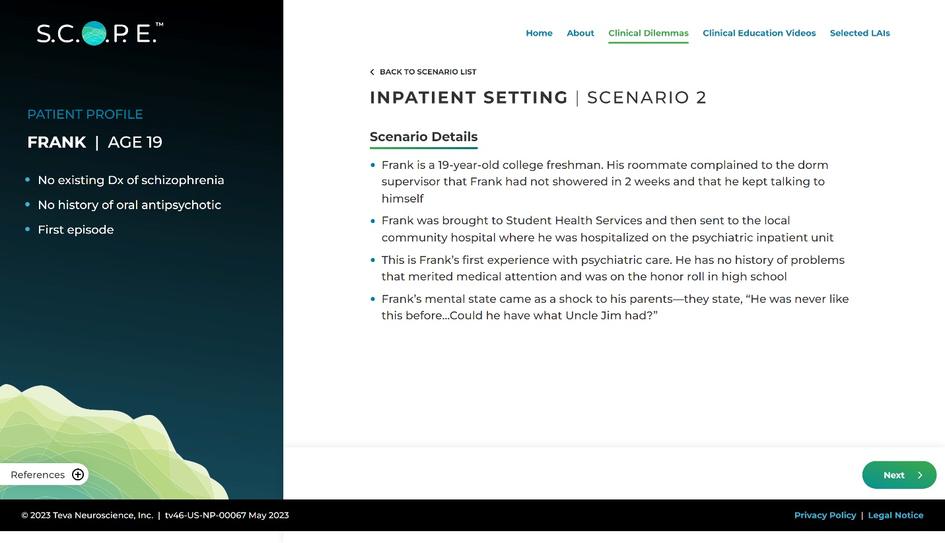
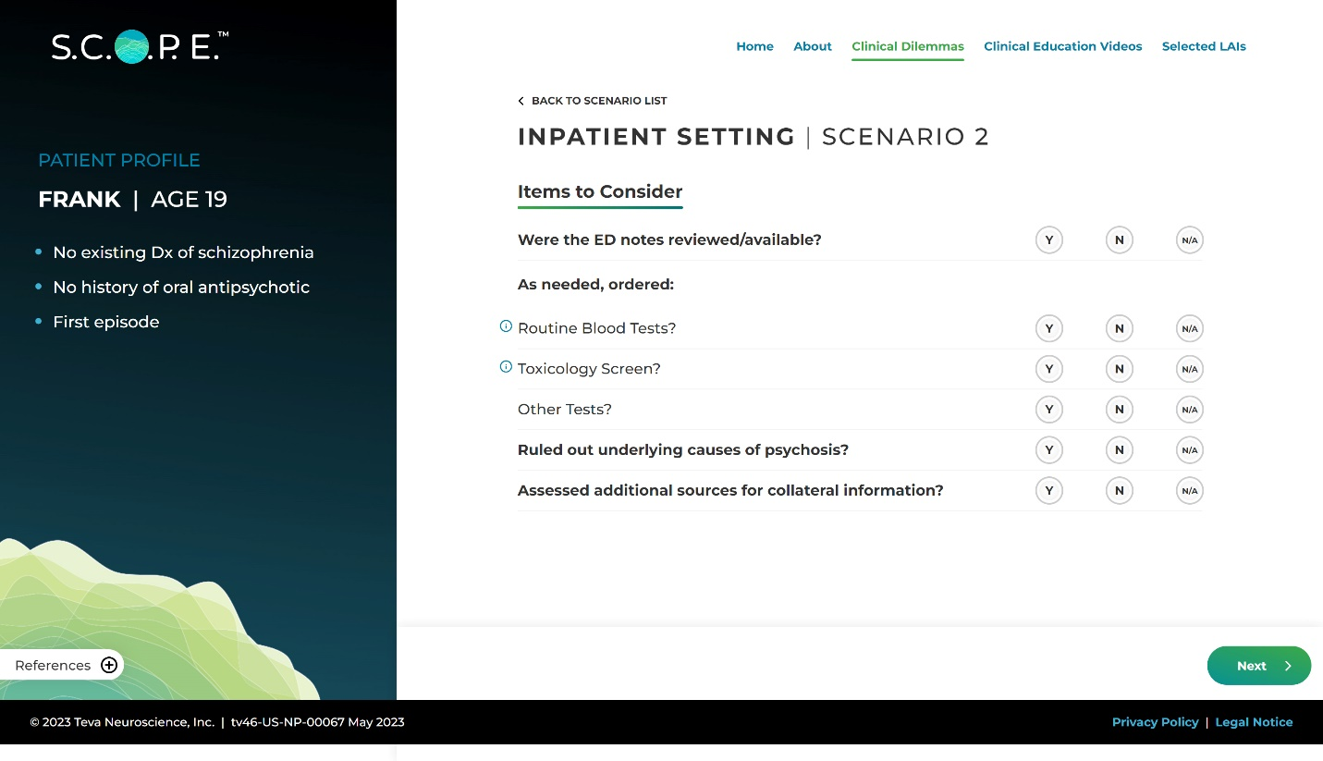
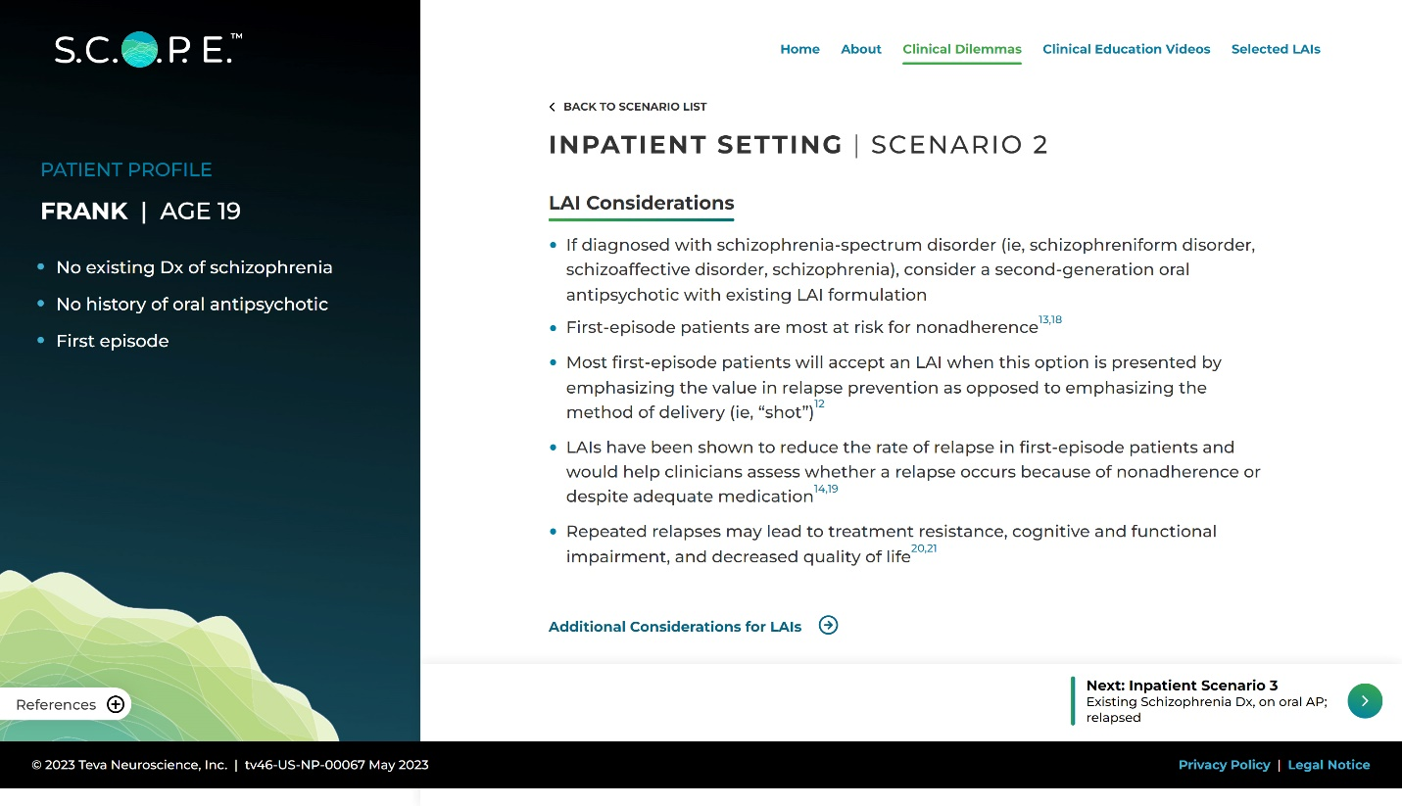
Abbreviations: Dx, diagnosis; ED, emergency department; LAI, long-acting injectable antipsychotic; S.C.O.P.E, Schizophrenia Clinical Outcome Scenarios and Patient–Provider Engagement.

Supplemental Figure 2 Example outpatient S.C.O.P.E. scenario: existing schizophrenia diagnosis and substance use.
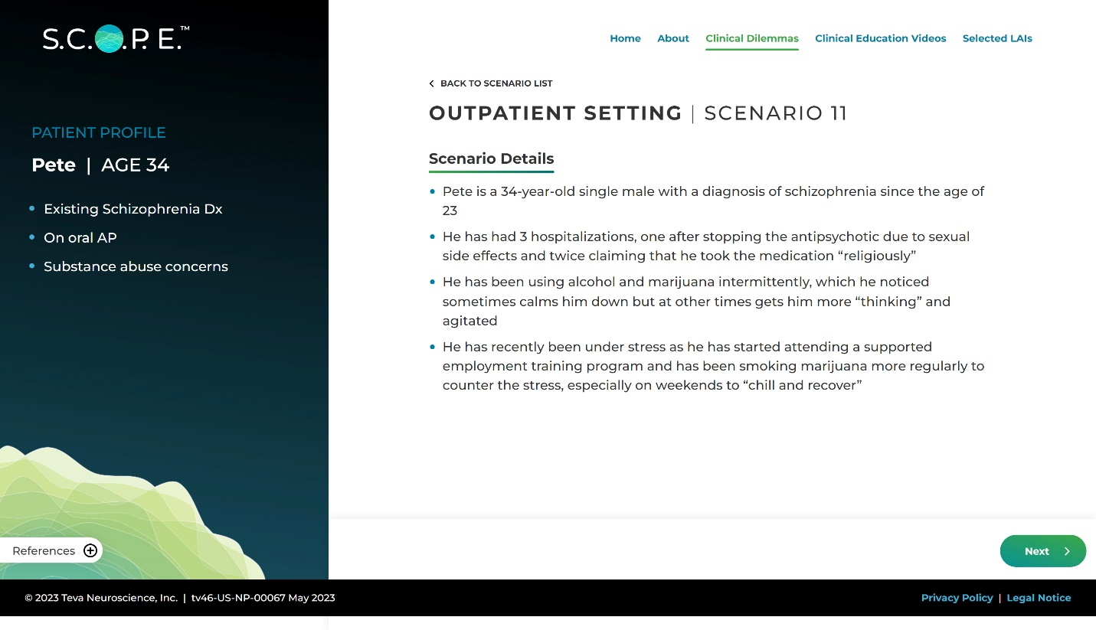

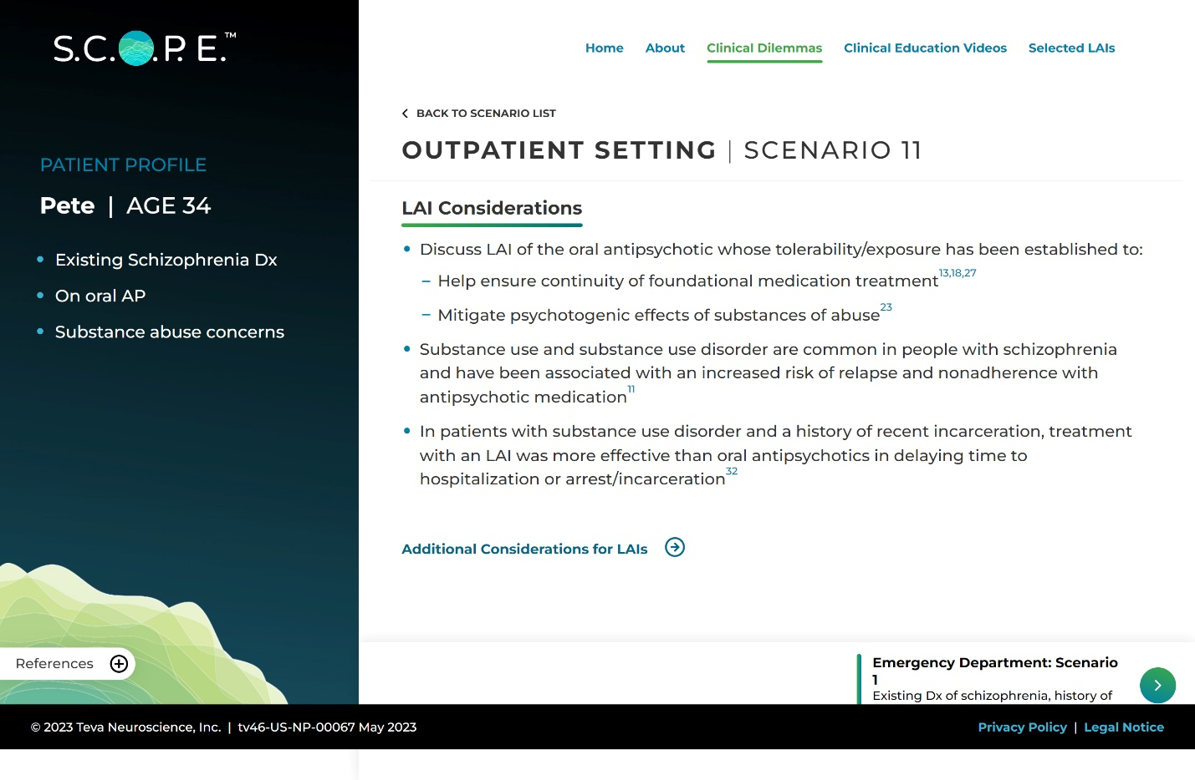
Abbreviations: AP, antipsychotic; Dx, diagnosis; ED, emergency department; LAI, long-acting injectable antipsychotic; S.C.O.P.E, Schizophrenia Clinical Outcome Scenarios and Patient–Provider Engagement.

Supplemental Figure 3 Example S.C.O.P.E. clinical education video - acute episode following treatment discontinuation, (A) parent and (B) social worker.
- Parent
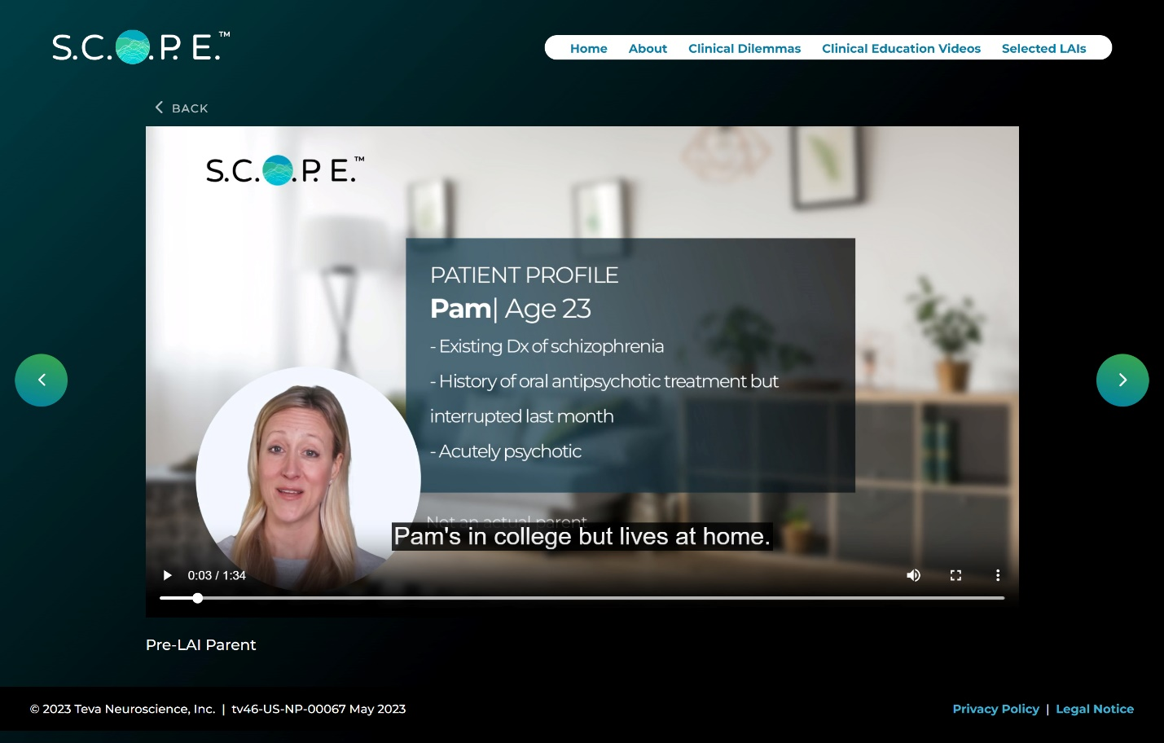

- Social worker
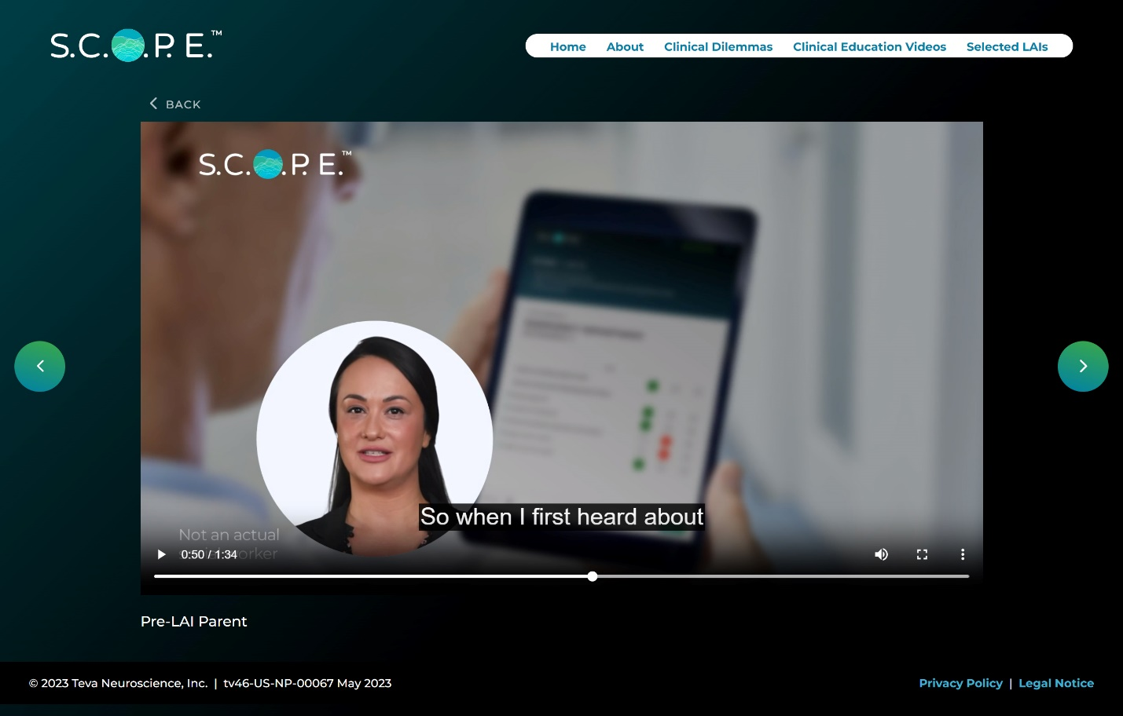
Abbreviations: Dx, diagnosis; LAI, long-acting injectable antipsychotic; S.C.O.P.E, Schizophrenia Clinical Outcome Scenarios and Patient–Provider Engagement.

Supplemental Figure 4 Example S.C.O.P.E. clinical education video – history of nonadherence, (A) patient and (B) case manager.
- Patient
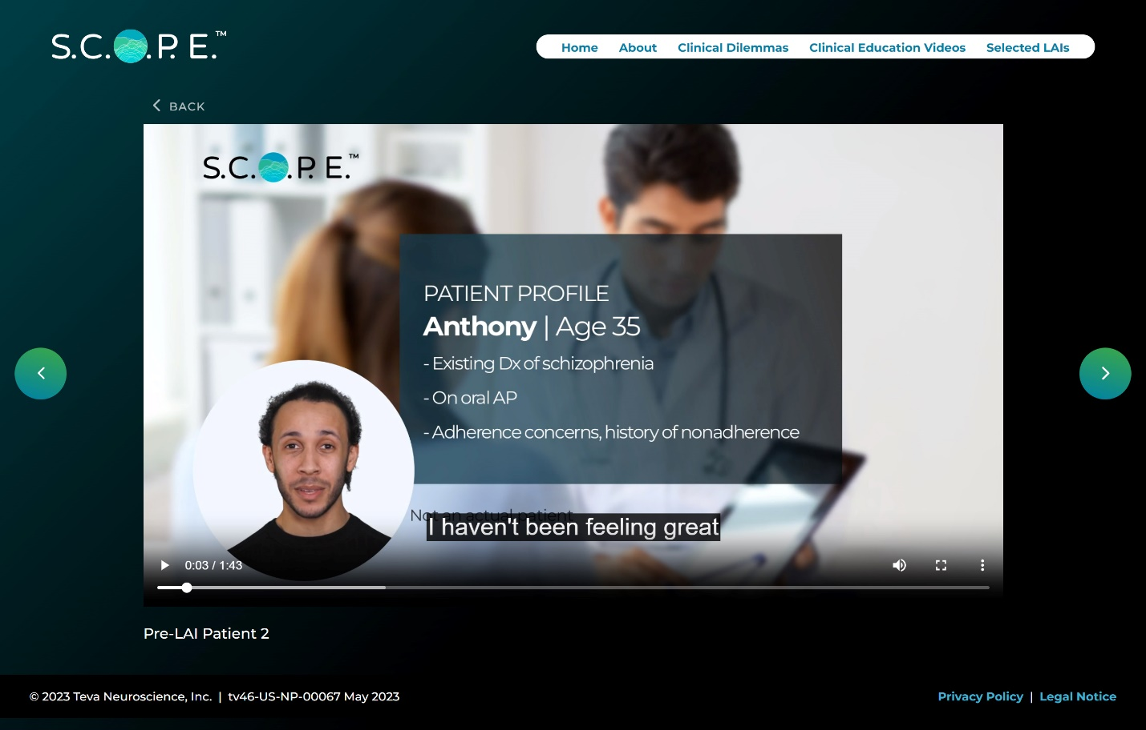

- Case manager
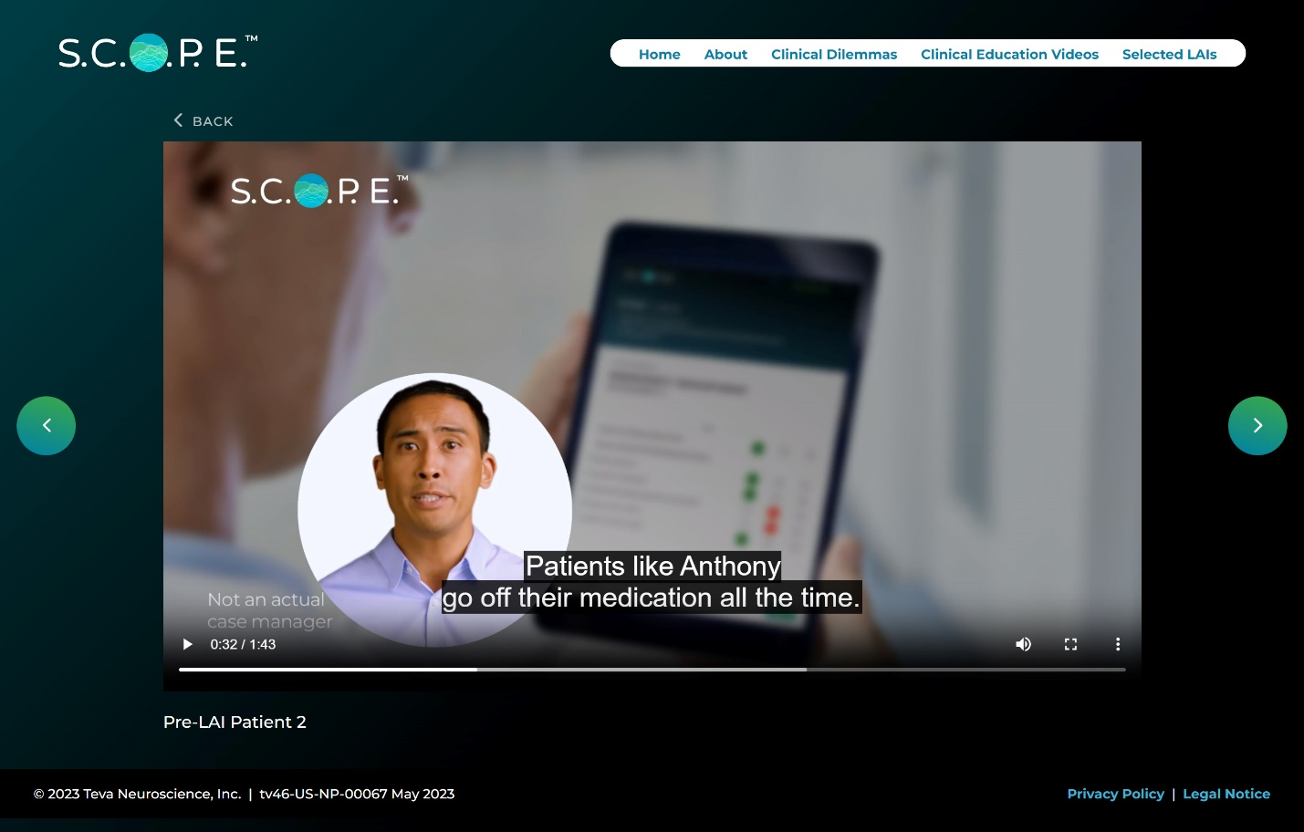
Abbreviations: AP, antipsychotic; Dx, diagnosis; LAI, long-acting injectable antipsychotic; S.C.O.P.E, Schizophrenia Clinical Outcome Scenarios and Patient–Provider Engagement.

