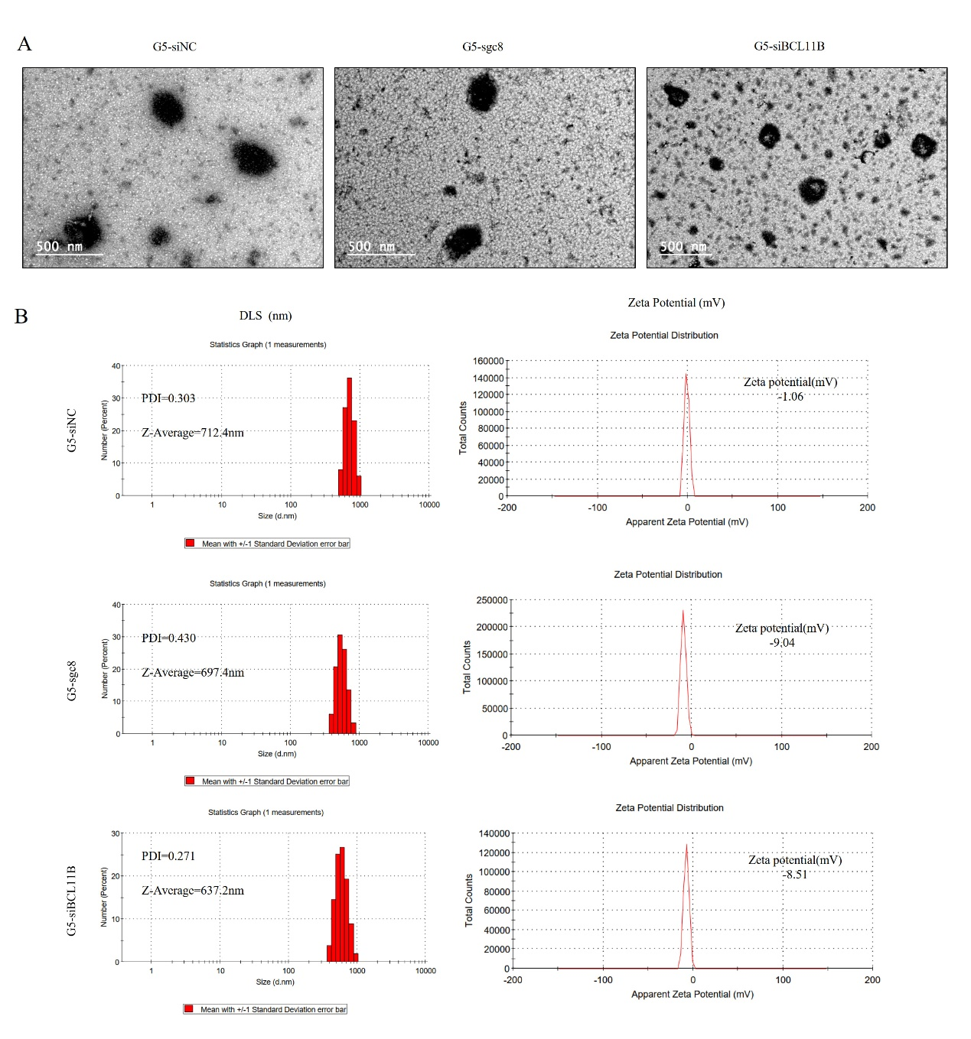
Supplementary Figure 1. Representative size distributions, TEM images, and zeta potential measurements of G5 nanoparticles are shown. A. TEM images of G5-sgc8, G5-siNC, and G5-siBCL11B nanoparticles. B. Particle size, PDI, and zeta potential measurements of G5-sgc8, G5-siNC, and G5-siBCL11B nanoparticles as determined by DLS and zeta potential analysis.
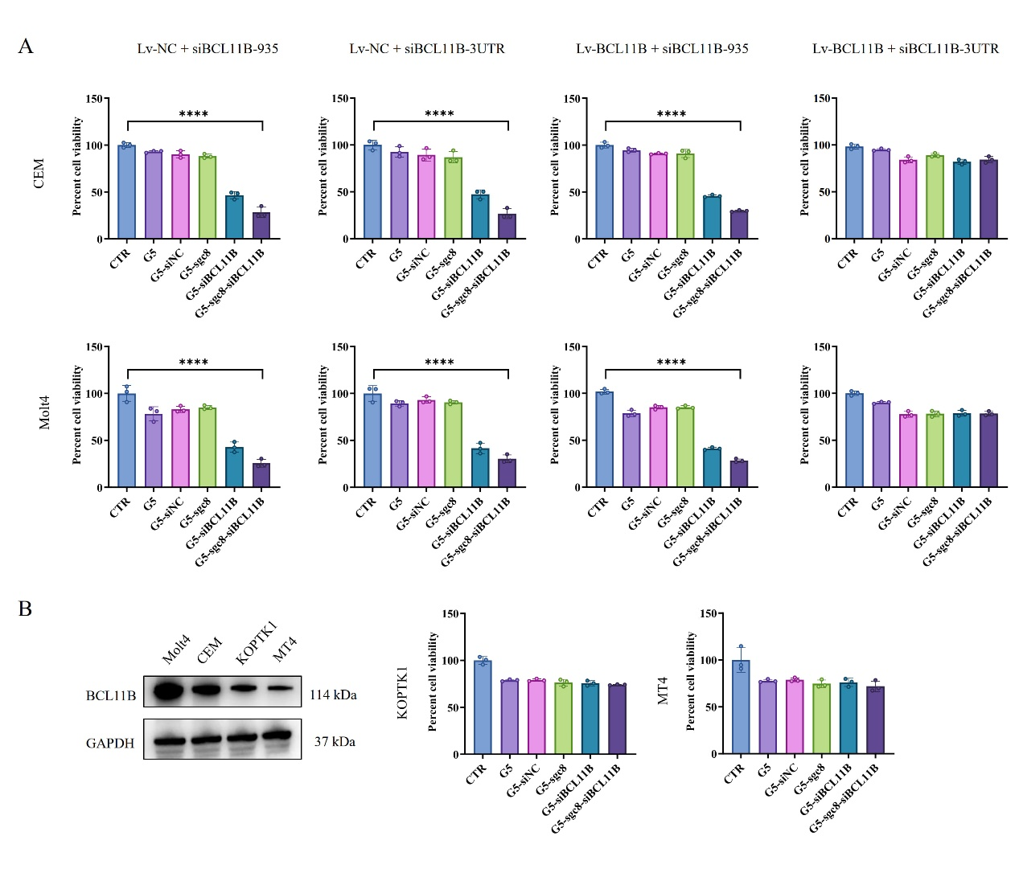
Supplementary Figure 2. The suppressive effect of G5-sgc8-siBCL11B in T-ALL cells is specifically attributed to its targeting of BCL11B. A. CCK-8 assay results evaluating the targeting of the CDS region or 3' UTR by siBCL11B in CEM and Molt4 cells, which were transfected with either Lv-NC or Lv-BCL11B (overexpressing BCL11B lacking the 3' UTR). B. CCK-8 assay results for T-ALL cell lines with low BCL11B expression treated with G5, G5-siNC, G5-sgc8, G5-siBCL11B, or G5-sgc8-siBCL11B nanoparticles.

