Supplementary Material

Table of Content:

Spectroscopic data of IND-LPC (5)
Figure S1. ¹H NMR spectrum (600 MHz, CDCl₃:CD₃OD) of IND-LPC
Figure S2. ¹³C NMR spectrum (150 MHz, CDCl₃:CD₃OD) of IND-LPC
Figure S3. HSQC spectrum (600 MHz, CDCl₃:CD₃OD) of IND-LPC
Figure S4. ³¹P spectrum (243 MHz, CDCl₃:CD₃OD) of IND-LPC

Spectroscopic data of IND-PA-PC (6)
Figure S5. ¹H NMR spectrum (600 MHz, CDCl₃:CD₃OD) of IND-PA-PC
Figure S6. ¹³C NMR spectrum (150 MHz, CDCl₃:CD₃OD) of IND-PA-PC
Figure S7. HSQC spectrum (600 MHz, CDCl₃:CD₃OD) of IND-PA-PC
Figure S8. ³¹P spectrum (243 MHz, CDCl₃:CD₃OD) of IND-PA-PC

Spectroscopic data of IND-SA-PC (7)
Figure S9. ¹H NMR spectrum (600 MHz, CDCl₃:CD₃OD) of IND-SA-PC
Figure S10. ¹³C NMR spectrum (150 MHz, CDCl₃:CD₃OD) of IND-SA-PC
Figure S11. HSQC spectrum (600 MHz, CDCl₃:CD₃OD) of IND-SA-PC
Figure S12. ³¹P spectrum (243 MHz, CDCl₃:CD₃OD) of IND-SA-PC

Spectroscopic data of IND-OA-PC (8)
Figure S13. ¹H NMR spectrum (600 MHz, CDCl₃:CD₃OD) of IND-OA-PC
Figure S14. ¹³C NMR spectrum (150 MHz, CDCl₃:CD₃OD) of IND-OA-PC
Figure S15. HSQC spectrum (600 MHz, CDCl₃:CD₃OD) of IND-OA-PC
Figure S16. ³¹P spectrum (243 MHz, CDCl₃:CD₃OD) of IND-OA-PC

Spectroscopic data of PA-IND-PC (18)
Figure S17. ¹H NMR spectrum (600 MHz, CDCl₃:CD₃OD) of PA-IND-PC
Figure S18. ¹³C NMR spectrum (150 MHz, CDCl₃:CD₃OD) of PA-IND-PC
Figure S19. HSQC spectrum (600 MHz, CDCl₃:CD₃OD) of PA-IND-PC
Figure S20. ³¹P spectrum (243 MHz, CDCl₃:CD₃OD) of PA-IND-PC

Spectroscopic data of SA-IND-PC (19)
Figure S21. ¹H NMR spectrum (600 MHz, CDCl₃:CD₃OD) of SA-IND-PC
Figure S22. ¹³C NMR spectrum (150 MHz, CDCl₃:CD₃OD) of SA-IND-PC
Figure S23. HSQC spectrum (600 MHz, CDCl₃:CD₃OD) of SA-IND-PC
Figure S24. ³¹P spectrum (243 MHz, CDCl₃:CD₃OD) of SA-IND-PC

Spectroscopic data of OA-IND-PC (20)
Figure S25. ¹H NMR spectrum (600 MHz, CDCl₃:CD₃OD) of OA-IND-PC
Figure S26. ¹³C NMR spectrum (150 MHz, CDCl₃:CD₃OD) of OA-IND-PC
Figure S27. HSQC spectrum (600 MHz, CDCl₃:CD₃OD) of OA-IND-PC
Figure S28. ³¹P spectrum (243 MHz, CDCl₃:CD₃OD) of OA-IND-PC

Supplementary information 1
1-Indomethacinoyl-2-hydroxy-sn-glycero-3-phosphocholine (IND-LPC) (5)

Colorless waxy product, yield 31%, TLC R_{f} = 0.13 (CHCl₃:MeOH:H₂O, 65:25:4, v/v/v). ¹H NMR (600 MHz, CDCl₃:CD₃OD, 2:1, v/v) δ: 2.31 (s, 3H, CH₃-2'''), 3.16 (s, 9H, N(CH₃)₃), 3.59 (m, 2H, CH₂-β), 3.72 (s, 2H, CH₂-2'), 3.81 (s, 4H, -OCH₃ and -OH), 3.88 (m, 1H, H-2), 3.96 (m, 2H, CH₂-3), 4.16 (m, 2H, CH₂-1), 4.26 (m, 2H, CH₂-α), 6.65 (m, 1H, H-6'''), 6.87 (m, 1H, H-7'''), 6.95 (m, 1H, H-4'''), 7.47-7.48 (m, 2H, H-4'' and H-6''), 7.63-7.64 (m, 2H, H-3'' and H-7''). ¹³C NMR (150 MHz, CDCl₃:CD₃OD, 2:1, v/v) δ: 13.01 (CH₃-2'''), 29.76 (C-2'), 53.94 (N(CH₃)₃), 55.59 (-OCH₃), 59.42 (C-α), 65.44 (C-1), 66.16 (C-β), 67.15 (C-2), 68.35 (C-3), 101.41 (C-4'''), 111.64 (C-6'''), 112.58 (C-3'''), 114.89 (C-7'''), 129.15 (C-4'' and C-6''), 130.69 (C-7a'''), 130.84 (C-2''), 131.10 (C-3'' and 7''), 133.75 (C-2'''), 135.95 (C-4a'''), 139.41 (C-5''), 156.08 (C-5'''), 168.75 (C-1''), 171.28 (C-1'). ³¹P NMR (243 MHz, CDCl₃:CD₃OD, 2:1, v/v) δ: – 0.60. ESI-MS m/z calculated for C₂₇H₃₄ClN₂O₉P: [M+H]⁺ 597.1769. Found 597.1774.

1-Indomethacinoyl-2-hydroxy-sn-glycero-3-phosphocholine (IND-LPC) (5)

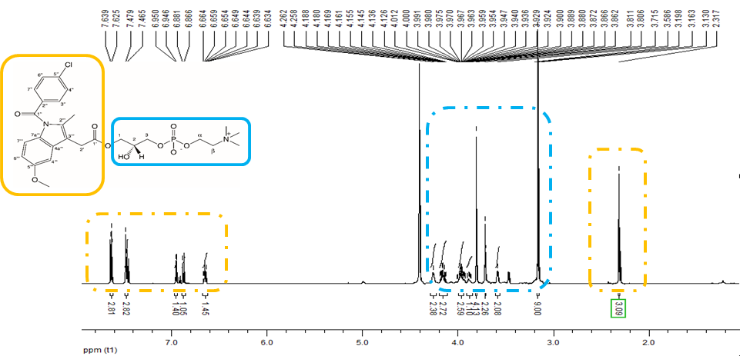
Figure S1. ¹H NMR spectrum (600 MHz, CDCl₃:CD₃OD) of IND-LPC.

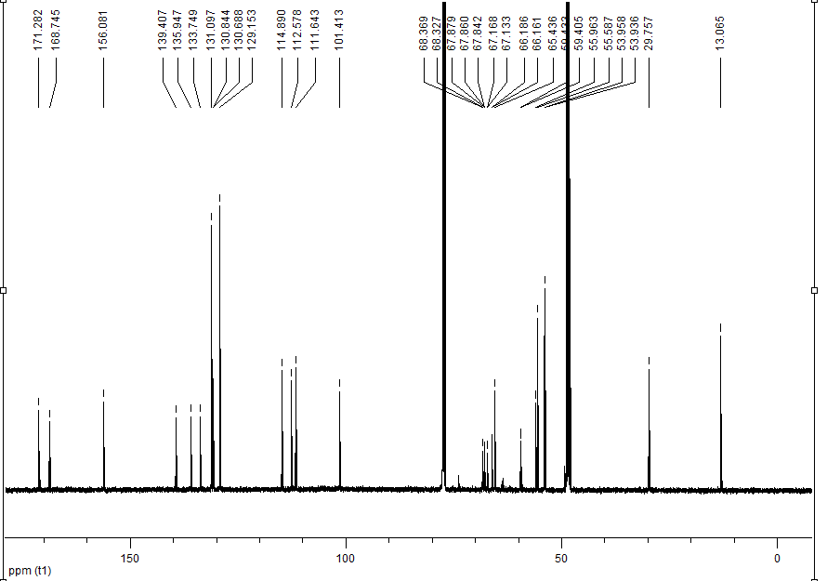

Figure S2. ¹³C NMR spectrum (150 MHz, CDCl₃:CD₃OD) of IND-LPC.

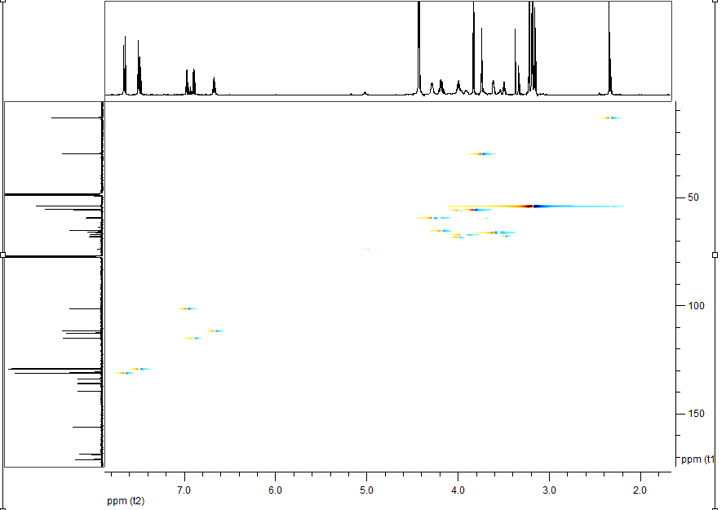
Figure S3. HSQC spectrum (600 MHz, CDCl₃:CD₃OD) of IND-LPC.

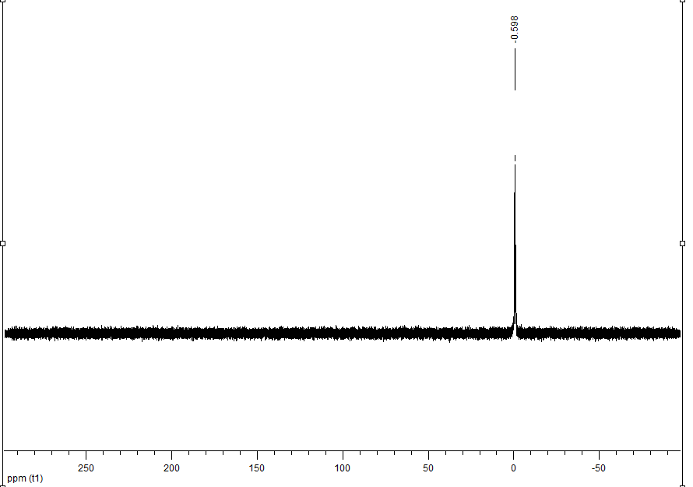
Figure S4. ³¹P spectrum (243 MHz, CDCl₃:CD₃OD) of IND-LPC.

Supplementary information 2
1-Indomethacinoyl-2-palmitoyl-sn-glycero-3-phosphocholine (IND-PA-PC) (6)
Light yellow waxy product, yield 50%, TLC R_{f} = 0.28 (CHCl₃: MeOH: H₂O, 65:25:4, v/v/v). ¹H NMR (600 MHz, CDCl₃:CD₃OD, 2:1, v/v) δ: 0.71 (t, J = 6.8 Hz, 3H, CH₃(CH₂)₁₃CH₂C(O)), 1.09 (m, 26H, CH₃(CH₂)₁₃CH₂C(O)), 2.13-2.31 (m, 5H, CH₃(CH₂)₁₃CH₂C(O), CH₃-2'''), 3.05 (s, 9H, N(CH₃)₃), 3.18 (m, 2H, CH₂-β), 3.22 (m, 5H, H-2' and -OCH₃), 3.46 (m, 2H, CH₂-3), 3.53 (m, 1H, one of H-1), 3.67 (m, 2H, CH₂-α), 3.68 (m, 2H, one of H-1), 5.06 (m, 1H, H-2), 6.56 (m, 1H, H-6'''), 6.72 (m, 1H, H-7'''), 6.88 (m, 1H, H-4'''), 7.32-7.35 (m, 2H, H-4'' and H-6''), 7.49-7.53 (m, 2H, H-3'' and H-7''). ¹³C NMR (150 MHz, CDCl₃:CD₃OD, 2:1, v/v) δ: 13.88 (CH₃-2''' and CH₃(CH₂)₁₃CH₂C(O)), 29.03, 29.26, 29.49, 29.54, 29.56, 29.58, 29.59, 34.06, 39.85 CH₃(CH₂)₁₄C(O)), 31.84 (C-2'), 53.96 (N(CH₃)₃), 55.04 (-OCH₃), 57.62 (C-α), 59.35 (C-1), 62.21 (C-3), 64.44 (C-β), 66.2 (C-2), 106.98 (C-4''' and C-6'''), 112.44 (C-3'''), 114.80 (C-7'''), 128.64 (C-4'' and C-6''), 129.12 (C-7a''' and C-2''), 131.09 (C-3'' and C-7''), 133.77 (C-2'''), 136.04 (C-4a'''), 139.39 (C-5''), 155.97 (C-5'''), 168.72 (C-1''), 170.90 (C-1'), 173.93 ((CH₃(CH₂)₁₃CH₂C(O)). ³¹P NMR (243 MHz, CDCl₃:CD₃OD, 2:1, v/v) δ: – 5.37. ESI-MS m/z calculated for C₄₃H₆₄ClN₂O₁₀P: [M+H]⁺ 835.4066. Found 835.4065.

1-Indomethacinoyl-2-palmitoyl-sn-glycero-3-phosphocholine (IND-PA-PC) (6)

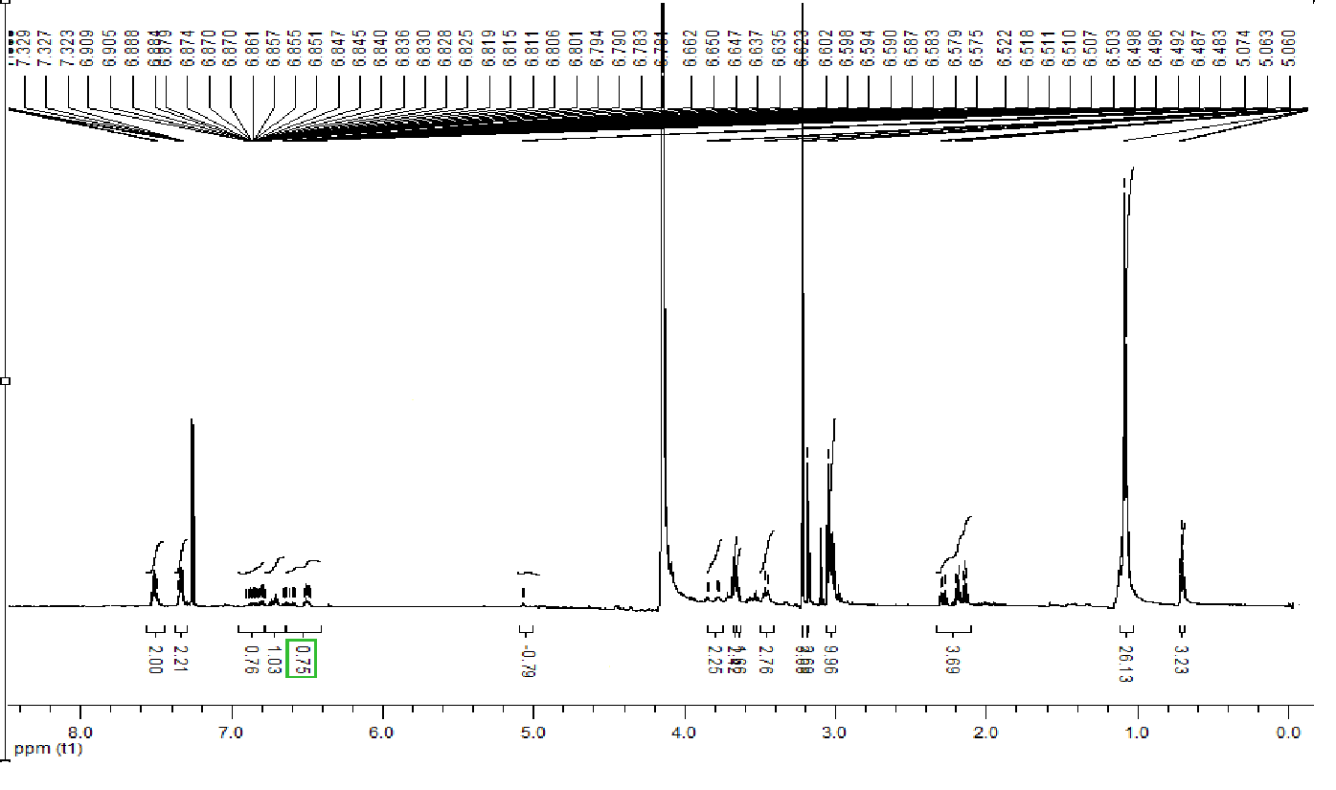
Figure S5. ¹H NMR spectrum (600 MHz, CDCl₃:CD₃OD) of IND-PA-PC.

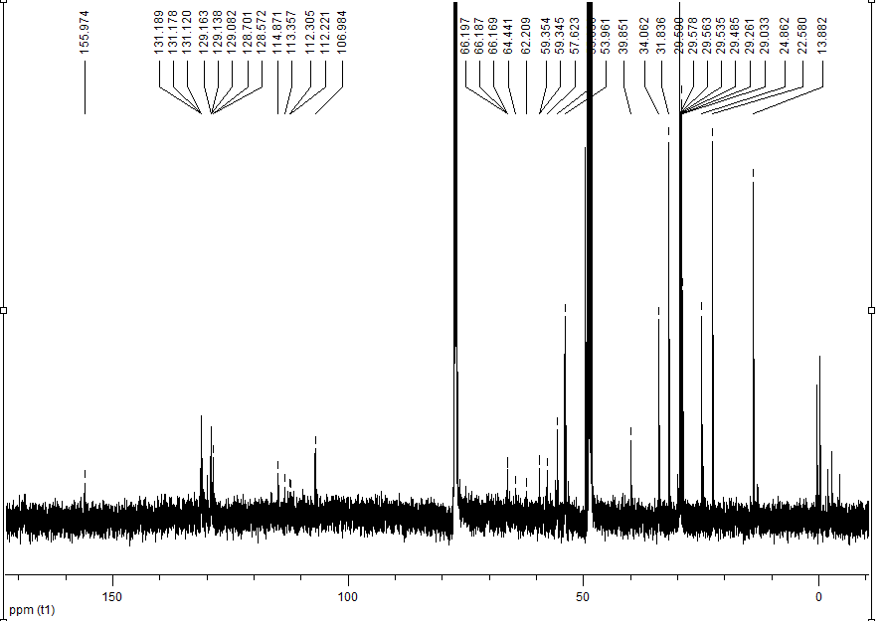
Figure S6. ¹³C NMR spectrum (150 MHz, CDCl₃:CD₃OD) of IND-PA-PC.

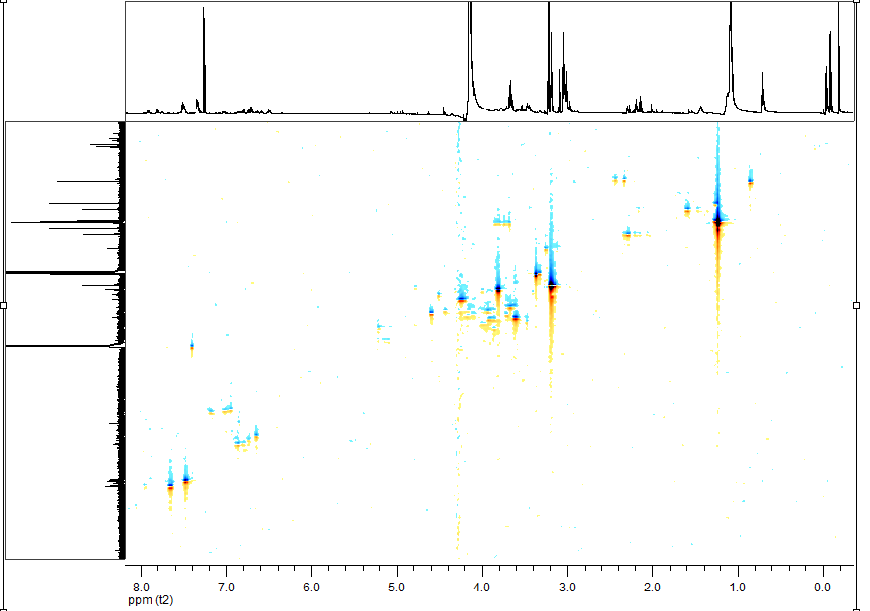
Figure S7. HSQC spectrum (600 MHz, CDCl₃:CD₃OD) of IND-PA-PC.

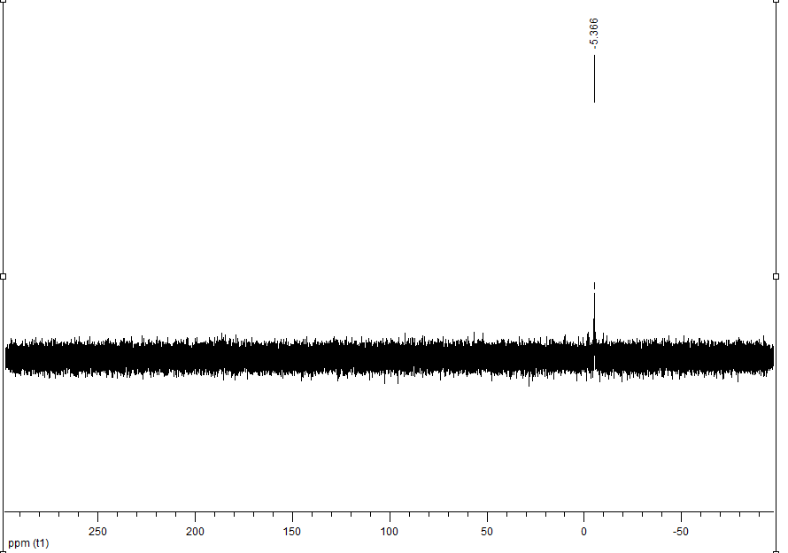
Figure S8. ³¹P spectrum (243 MHz, CDCl₃:CD₃OD) of IND-PA-PC.

Supplementary information 3
1-Indomethacinoyl-2-stearoyl-sn-glycero-3-phosphocholine (IND-SA-PC) (7)
Light yellow waxy product, yield 34%. TLC R_{f} = 0.30 (CHCl₃: MeOH: H₂O, 65:25:4, v/v/v). ¹H NMR (600 MHz, CDCl₃:CD₃OD, 2:1, v/v) δ: 0.65 (t, J = 6.4 Hz, 3H, CH₃(CH₂)₁₆C(O)), 1.03 (m, 32H, CH₃(CH₂)₁₆C(O)), 2.13 (s, 3H, CH₃-2'''), 2.97 (s, 9H, N(CH₃)₃), 3.40-3.43 (m, 2H, CH₂-β), 3.48-3.55 (m, 2H, H-2'), 3.62 (m, 3H, -OCH₃), 3.73-3.79 (m, 2H, CH₂-3), 3.93 (m, 1H, one of H-1), 4.03 (m, 2H, CH₂-α), 4.39 (m, 2H, one of H-1), 5.01 (m, 1H, H-2), 6.45 (m, 1H, H-6'''), 6.61 (m, 1H, H-7'''), 6.79 (m, 1H, H-4'''), 7.28-7.29 (m, 2H, H-4'' i H-6''), 7.43-7.48 (m, 2H, H-3'' i H-7''). ¹³C NMR (150 MHz, CDCl₃:CD₃OD, 2:1, v/v) δ: 13.81 (CH₃-2''' and CH₃(CH₂)₁₆C(O)), 29.01, 29.12, 29.25, 29.33, 29.46, 29.54, 29.59, 34.02 CH₃(CH₂)₁₄C(O)), 31.82 (C-2'), 53.92 (N(CH₃)₃), 55.57 (C-α), 59.35 (C-1), 63.39 (C-3), 63.78 (C-β), 66.18 (C-2), 111.50 (C-4''' i C-6'''), 112.33 (C-3'''), 114.87 (C-7'''), 128.62 (C-4'' and C-6''), 129.16 (C-7a''' and C-2''), 131.11 (C-3'' and C-7''), 133.71 (C-2'''), 136.03 (C-4a'''), 139.44 (C-5''), 156.05 (C-5'''), 168.69 (C-1''), 171.12 (C-1'), 173.71 ((CH₃(CH₂)₁₃CH₂C(O)). ³¹P NMR (243 MHz, CDCl₃:CD₃OD, 2:1, v/v) δ: – 4.86. ESI-MS m/z calculated for C₄₅H₆₈ClN₂O₁₀P: [M+H]⁺ 863,4379. Found 863.4368.

1-Indomethacinoyl-2-stearoyl-sn-glycero-3-phosphocholine (IND-SA-PC) (7)

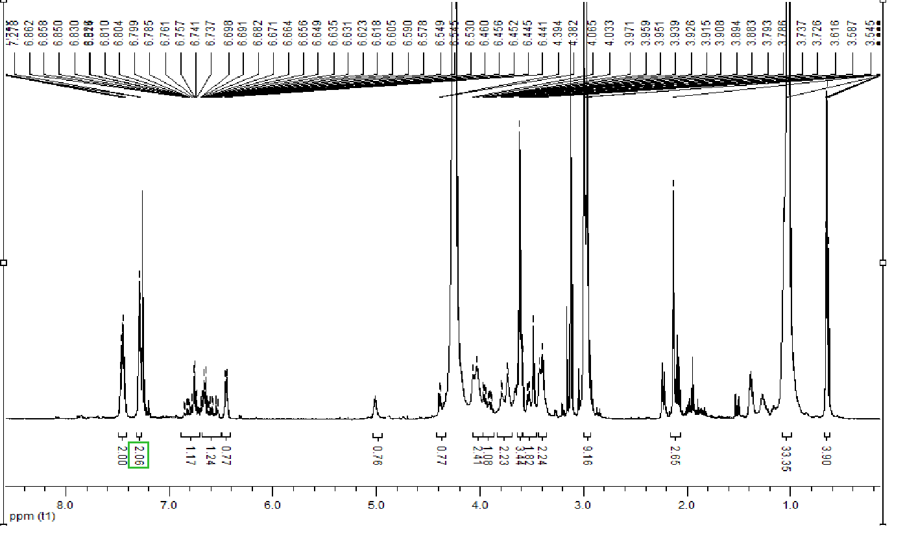
Figure S9. ¹H NMR spectrum (600 MHz, CDCl₃:CD₃OD) of IND-SA-PC.

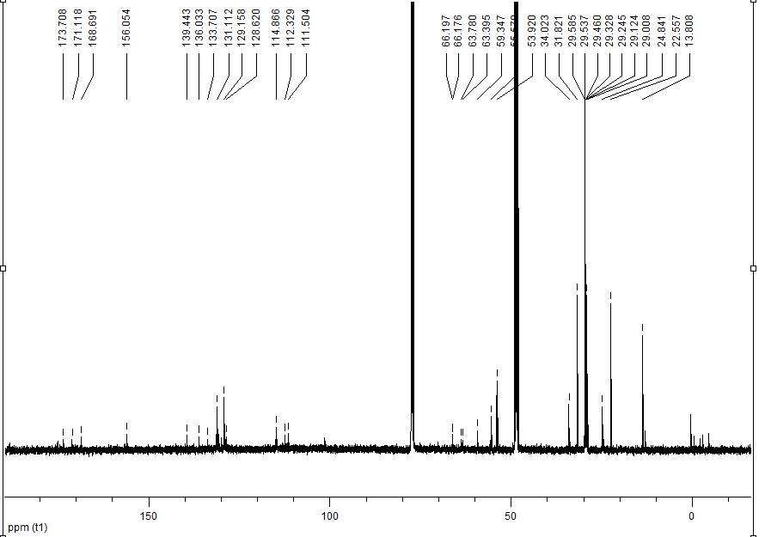
Figure S10. ¹³C NMR spectrum (150 MHz, CDCl₃:CD₃OD) of IND-SA-PC.

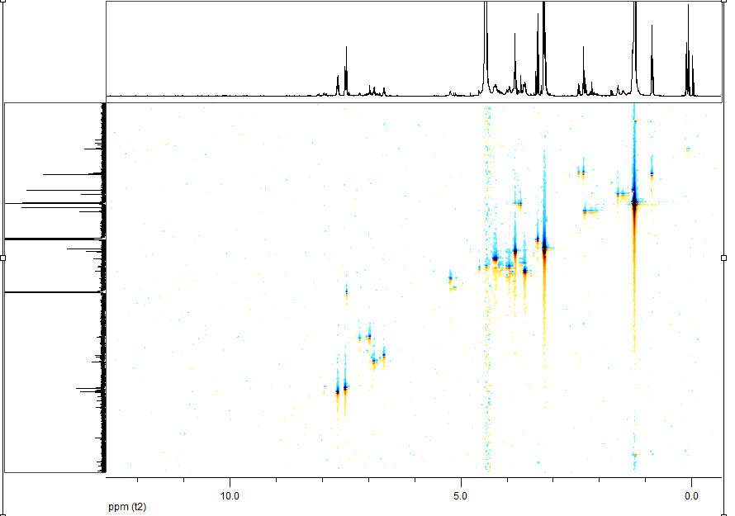
Figure S11. HSQC spectrum (600 MHz, CDCl₃:CD₃OD) of IND-SA-PC.
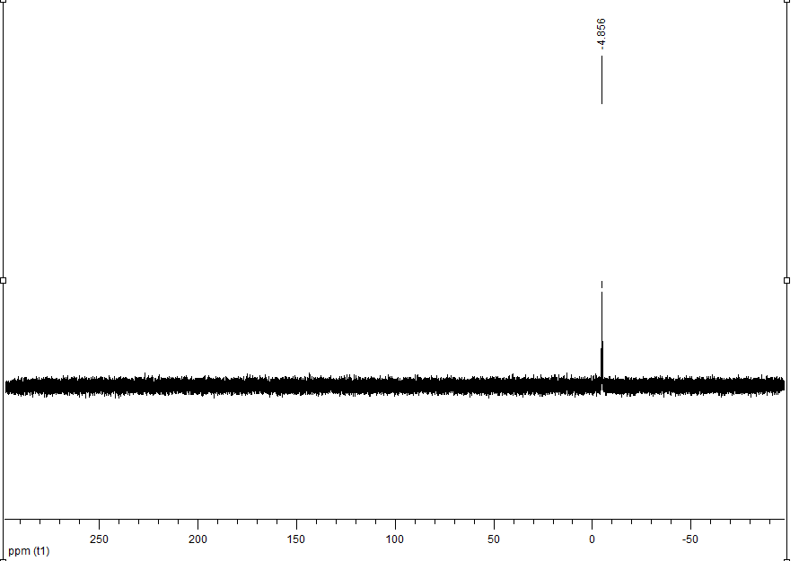
Figure S12. ³¹P spectrum (243 MHz, CDCl₃:CD₃OD) of IND-SA-PC.

Supplementary information 4
1-Indomethacinoyl-2-oleoyl-sn-glycero-3-phosphocholine (IND-OA-PC) (8)
Light yellow waxy product, yield 25%, TLC R_{f} = 0.38 (CHCl₃: MeOH: H₂O, 65:25:4, v/v/v).
¹H NMR (600 MHz, CDCl₃:CD₃OD, 2:1, v/v) δ: 0.84 (t, J = 6.8 Hz, 3H, CH₃(CH₂)₁₆C(O)), 1.25-1.29 (m, 24H, CH₃(CH₂)₇ CHCH(CH₂)₇C(O)), 1.98 (m, 2H, C(O)CH₂CH₂-), 2.08-2.22 (m, 2H, C(O)CH₂CH₂-), 2.34 (s, 3H, CH₃-2'''), 3.17 (s, 9H, N(CH₃)₃), 3.59-3.63 (m, 2H, CH₂-β), 3.69 (s, 2H, H-2'), 3.83 (s, 3H, -OCH₃), 3.94-3.96 (m, 2H, CH₂-3), 4.16 (m, 1H, one of H-1), 4.24 (m, 2H, CH₂-α), 4.44 (m, 2H, one of H-1), 5.22 (m, 1H, H-2), 5.30-5.32 (m, 2H, CH=CH), 6.65 (m, 1H, H-6'''), 6.97 (m, 1H, H-7'''), 6.97 (m, 1H, H-4'''), 7.48-7.50 (m, 2H, H-4'' and H-6''), 7.65-7.67 (m, 2H, H-3'' and H-7''). ¹³C NMR (150 MHz, CDCl₃:CD₃OD, 2:1, v/v) δ: 13.08 and 13.79 (CH₃-2''' and CH₃(CH₂)₇CHCH(CH₂)₇C(O)), 24.63 (CH₃(CH₂)7CHCH(CH₂)₅CH₂CH₂C(O)), 22.55, 27.05, 28.97, 29.04, 29.07, 29.19, 29.21, 29.40, 29.60, 29.64, 31.80 (CH₃(CH₂)7CHCH(CH₂)₅CH₂CH₂C(O)), 29.97 (C-2'), 33.68 (CH₃(CH₂)7CHCH(CH₂)₅CH₂CH₂C(O)), 53.94 (N(CH₃)₃), 55.56 (-OCH₃), 59.15 (C-α), 62.28 (C-1), 63.82 (C-3), 66.25 (C-β), 71.20 (C-2), 101.53 (C-4'''), 111.57 (C-6''') , 112.39 (C-3'''), 114.85 (C-7'''), 129.16 (C-4'' and C-6''), 129.59 and 129.90 (CH=CH), 130.63 and 130.83 (C-7a''' and C-2''), 131.10 (C-3'' and C-7''), 133.73 (C-2'''), 136.00 (C-4a'''), 139.45 (C-5''), 156.09 (C-5'''), 168.70 (C-1''), 170.62 (C-1'), 173.76 CH₃(CH₂)₇CHCH(CH₂)₇C(O)), ³¹P NMR (243 MHz, CDCl₃:CD₃OD, 2:1, v/v) δ: – 0.90. ESI-MS m/z calculated for C₄₅H₆₆ClN₂O₁₀P: [M+H]⁺ 861,4222. Found 861.4225.
1-Indomethacinoyl-2-oleoyl-sn-glycero-3-phosphocholine (IND-OA-PC) (8)

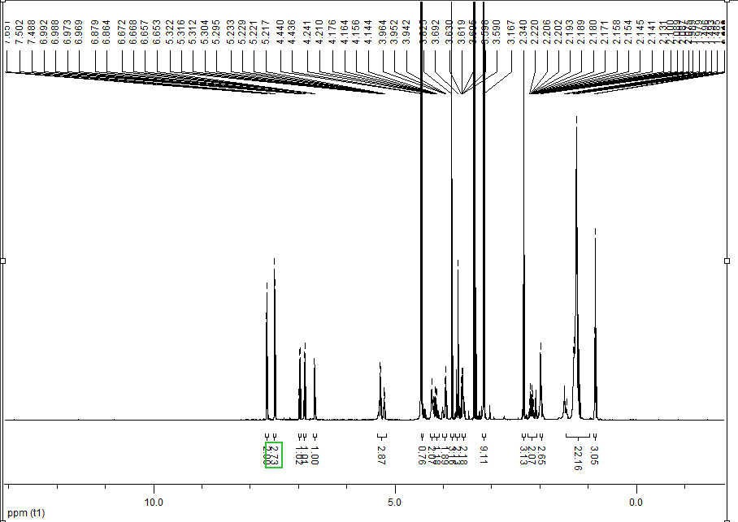
Figure S13. ¹H NMR spectrum (600 MHz, CDCl₃:CD₃OD) of IND-OA-PC.

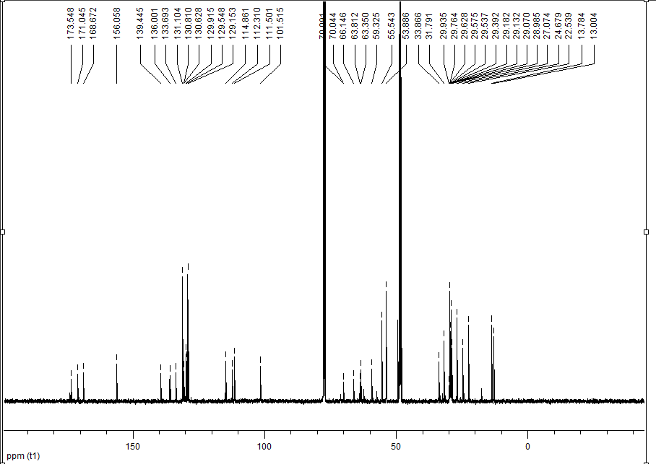
Figure S14. ¹³C NMR spectrum (150 MHz, CDCl₃:CD₃OD) of IND-OA-PC.

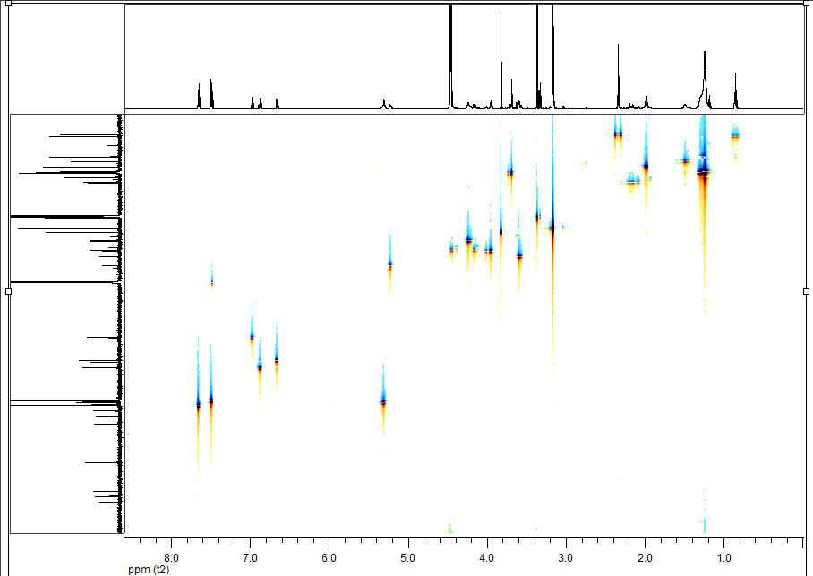
Figure S15. HSQC spectrum (600 MHz, CDCl₃:CD₃OD) of IND-OA-PC.

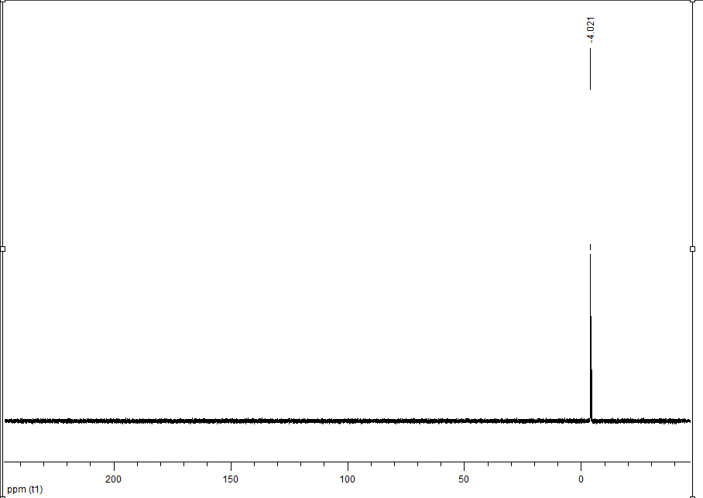
Figure S16. ³¹P spectrum (243 MHz, CDCl₃:CD₃OD) of IND-OA-PC.
Supplementary information 5
1-Palmitoyl-2-indomethacinoyl-sn-glycero-3-phosphocholine (PA-IND-PC) (18)
Light yellow waxy product, yield 45%. TLC R_{f} = 0.3 (CHCl₃: MeOH: H₂O, 65:25:4, v/v/v). ¹H NMR (600 MHz, CDCl₃:CD₃OD, 2:1, v/v) δ: 0.56 (t, J = 6.8 Hz, 3H, CH₃(CH₂)₁₃CH₂C(O)), 0.95 (m, 24H, CH₃CH₂(CH₂)₁₂CH₂C(O)), 1.02 (m, 2H, CH₃CH₂(CH₂)₁₂CH₂C(O)), 2.0 (t, J = 6.8 Hz, 3H, CH₃(CH₂)₁₃CH₂C(O)), 2.05 (s, 3H, CH₃-2'''), 2.89 (s, 9H, N(CH₃)₃), 3.30 (m, 2H, CH₂-β), 3.44 (s, 2H, CH₂-2'), 3.53 (s, 3H, -OCH₃), 3.72 (m, 2H, CH₂-3), 3.82 (dd, J = 12.1, 2.8 Hz, 1H, one of H-1), 3.93 (m, 2H, CH₂-α), 4.1 (dd, J = 12.1, 2.8 Hz, 1H, one of H-1), 4.94 (m, 1H, H-2), 6.37 (m, 1H, H-6'''), 6.60 (m, 1H, H-7'''), 6.70 (m, 1H, H-4'''), 7.20-7.21 (m, 2H, H-4'' and H-6''), 7.35-7.37 (m, 2H, H-3'' and H-7''). ¹³C NMR (150 MHz, CDCl₃:CD₃OD, 2:1, v/v) δ: 12.92 (CH₃-2'''), 13.66 (CH₃(CH₂)₁₃CH₂C(O)), 28.96, 29.08, 29.12, 29.21, 29.28, 29.52, 29.53, 31.79, 33.59, (CH₃CH₂(CH₂)₁₁CH₂CH₂C(O)), 33.92 (CH₃(CH₂)₁₃CH₂C(O)), 31.79 (C-2'), 53.80 (N(CH₃)₃), 55.44 (-OCH₃), 59.37 (C-α), 62.36 (C-1), 63.84 (C-3), 65.52 (C-β), 66.13 68.37 (C-2), 101.63 (C-4'''), 111.42 (C-6'''), 112.44 (C-3'''), 114.80 (C-7'''), 128.64 (C-4'' and C-6''), 129.12 (C-7a''' i C-2''), 131.09 (C-3'' and 7''), 133.77 (C-2'''), 136.04 (C-4a'''), 139.39 (C-5''), 156.10 (C-5'''), 168.72 (C-1''), 170.90 (C-1'), 173.93 ((CH₃(CH₂)₁₃CH₂C(O)). ³¹P NMR (243 MHz, CDCl₃:CD₃OD, 2:1, v/v) δ: – 4.68. ESI-MS m/z calculated for C₄₃H₆₄ClN₂O₁₀P: [M+H]⁺ 835,4066. Found 835.4069.

1-Palmitoyl-2-indomethacinoyl-sn-glycero-3-phosphocholine (PA-IND-PC) (18)

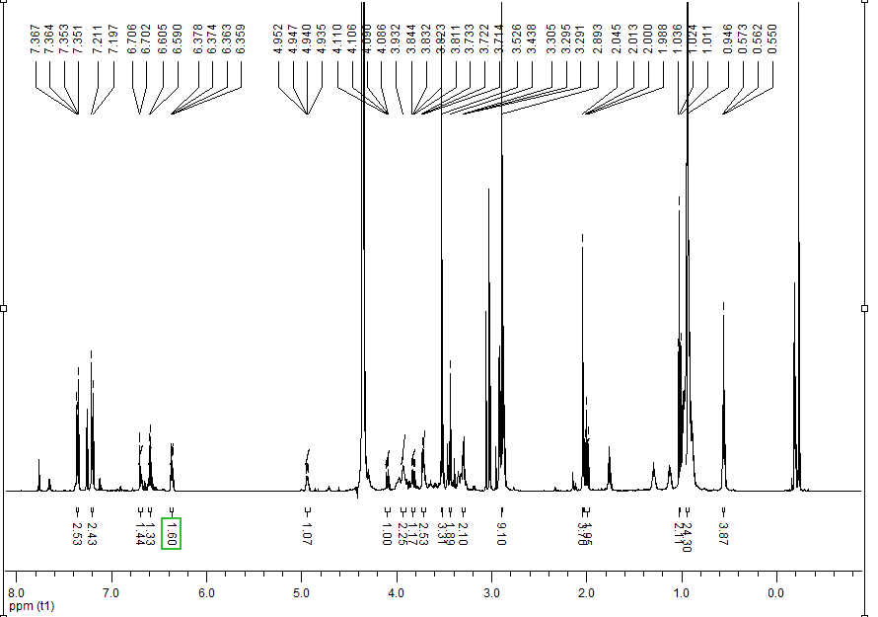
Figure S17. ¹H NMR spectrum (600 MHz, CDCl₃:CD₃OD) of PA-IND-PC.
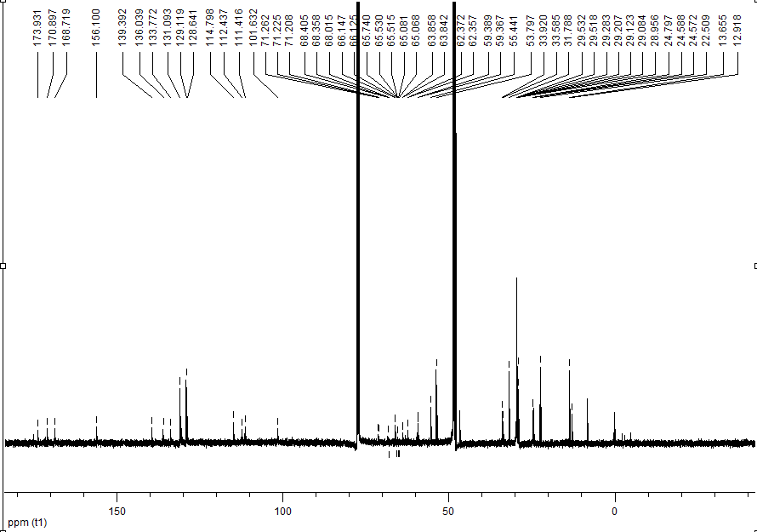
Figure S18. ¹³C NMR spectrum (150 MHz, CDCl₃:CD₃OD) of PA-IND-PC.

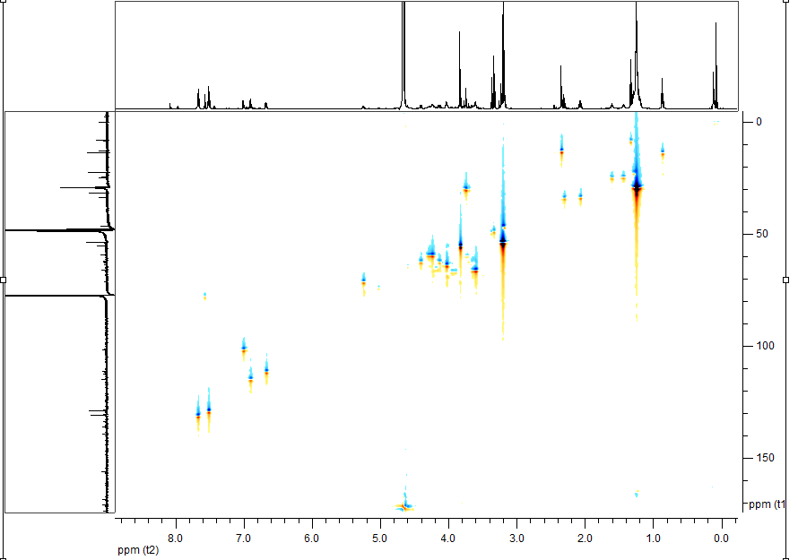
Figure S19. HSQC spectrum (600 MHz, CDCl₃:CD₃OD) of PA-IND-PC.
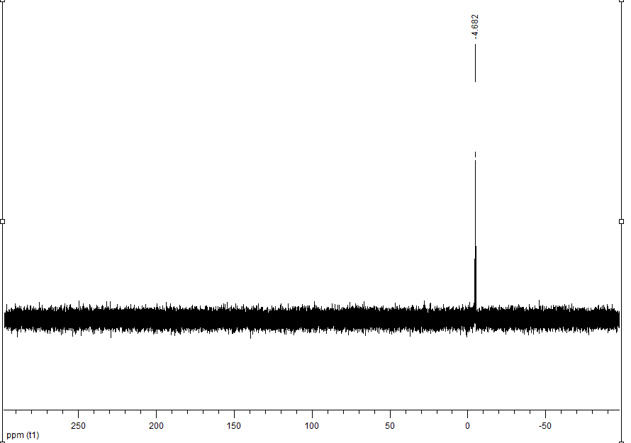
Figure S20. ³¹P spectrum (243 MHz, CDCl₃:CD₃OD) of PA-IND-PC.

Supplementary information 6
1-Stearoyl-2-indomethacinoyl-sn-glycero-3-phosphocholine (SA-IND-PC) (19)
Light yellow waxy product, yield 26%. TLC R_{f} = 0.3 (CHCl₃: MeOH: H₂O, 65:25:4, v/v/v). ¹H NMR (600 MHz, CDCl₃:CD₃OD, 2:1, v/v) δ: 0.70 (t, J = 6.8 Hz, 3H, CH₃(CH₂)₁₃CH₂C(O)), 1.08 (m, 30H, CH₃(CH₂)₁₅CH₂C(O)), 2.12-2.19 (m, 4H, CH₃(CH₂)₁₃CH₂C(O), CH₃-2'''), 3.01 (s, 9H, N(CH₃)₃), 3.45 (m, 2H, CH₂-β), 3.52 (m, 1H, CH₂-2'), 3.66 (s, 3H, -OCH₃), 3.81 (m, 2H, CH₂-3), 3.94-4.15 (m, 5H, CH₂-1, CH₂-α), 5.06 (m, 1H, H-2), 6.50 (m, 1H, H-6'''), 6.71 (m, 1H, H-7'''), 6.81 (m, 1H, H-4'''), 7.32-7.34 (m, 2H, H-4'' and H-6''), 7.49-7.50 (m, 2H, H-3'' and H-7''). ¹³C NMR (150 MHz, CDCl₃:CD₃OD, 2:1, v/v) δ: 13.04 (CH₃-2'''), 13.87 (CH₃(CH₂)₁₃CH₂C(O)), 29.03, 29.14, 29.26, 29.35, 29.49, 29.53, 29.56, 29.58, 29.61 (CH₃CH₂(CH₂)₁₁CH₂CH₂C(O)), 34.06 (CH₃(CH₂)₁₃CH₂C(O)), 31.84 (C-2'), 53.95 (N(CH₃)₃), 55.63 (-OCH₃), 59.38 (C-α), 62.45 (C-1), 63.84 (C-3), 65.52 (C-β), 66.18 (C-2), 101.36 (C-4'''), 111.62 (C-6'''), 112.49 (C-3'''), 114.90 (C-7'''), 128.70 (C-4'' and C-6''), 129.17 (C-7a''' and C-2''), 131.13 (C-3'' and 7''), 133.78 (C-2'''), 135.93 (C-4a'''), 139.42 (C-5''), 156.01 (C-5'''), 168.71 (C-1''), 174.06 (C-1'), 175.11 ((CH₃(CH₂)₁₃CH₂C(O)). ³¹P NMR (243 MHz, CDCl₃:CD₃OD, 2:1, v/v) δ: – 4.67. ESI-MS m/z calculated for C₄₅H₆₈ClN₂O₁₀P: [M+H]⁺ 863.4379. Found 863.4368.
1-Stearoyl-2-indomethacinoyl-sn-glycero-3-phosphocholine (SA-IND-PC) (19)

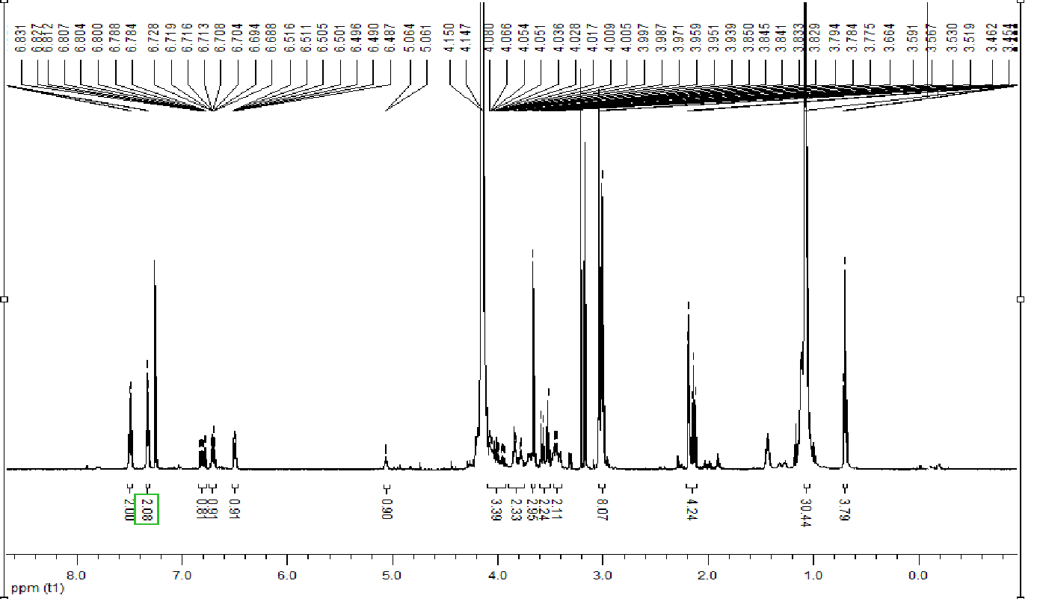
Figure S21. ¹H NMR spectrum (600 MHz, CDCl₃:CD₃OD) of SA-IND-PC.

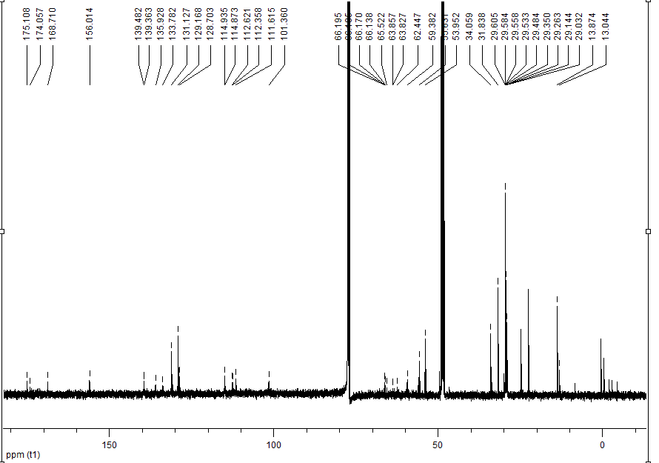
Figure S22. ¹³C NMR spectrum (150 MHz, CDCl₃:CD₃OD) of SA-IND-PC.

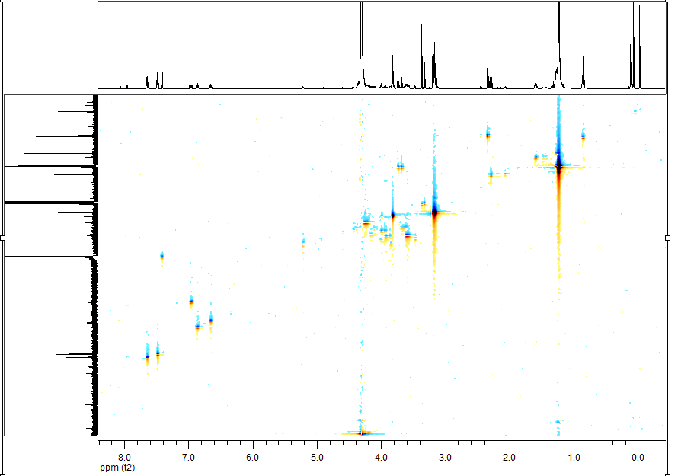
Figure S23. HSQC spectrum (600 MHz, CDCl₃:CD₃OD) of SA-IND-PC.

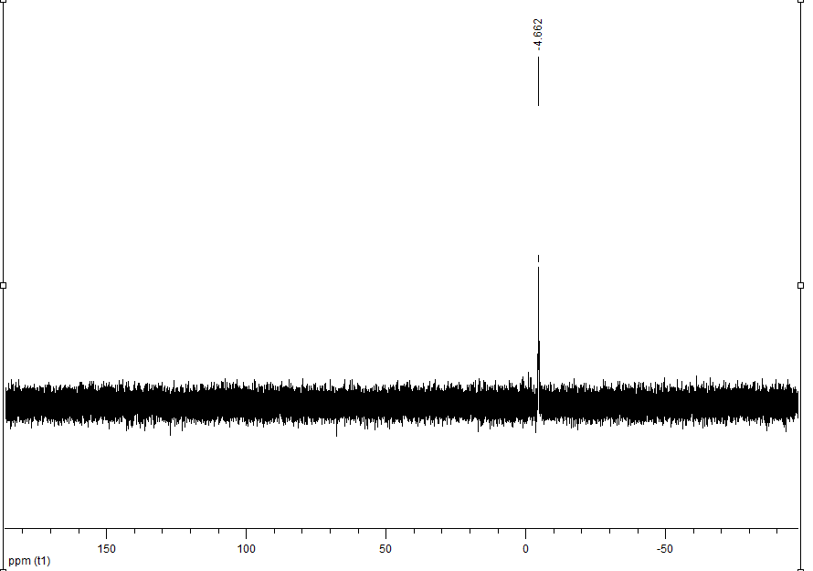
Figure S24. ³¹P spectrum (243 MHz, CDCl₃:CD₃OD) of SA-IND-PC.

Supplementary information 7
1-Oleoyl-2-indomethacinoyl-sn-glycero-3-phosphocholine (OA-IND-PC) (20)

Light yellow waxy product, yield 65%, TLC R_{f} = 0.29 (CHCl₃: MeOH: H₂O, 65:25:4, v/v/v).
¹H NMR (600 MHz, CDCl₃:CD₃OD, 2:1, v/v) δ: 0.87 (t, J = 6.8 Hz, 3H, CH₃(CH₂)₁₆C(O)), 1.24-1.30 (m, 24H, CH₃(CH₂)₇ CHCH(CH₂)₇C(O)), 1.99 (m, 2H, C(O)CH₂CH₂-), 2.11-2.13 (m, 2H, C(O)CH₂CH₂-), 2.34 (s, 3H, CH₃-2'''), 3.17 (s, 9H, N(CH₃)₃), 3.53-3.54 (m, 2H, CH₂-β), 3.73 (s, 2H, H-2'), 3.84 (s, 3H, -OCH₃), 4.03-4.06 (m, 2H, CH₂-3), 4.14 (m, 1H, one of H-1), 4.18 (m, 2H, CH₂-α), 4.41 (m, 2H, one of H-1), 5.25 (m, 1H, H-2), 5.31-5.33 (m, 2H, CH=CH), 6.68 (m, 1H, H-6'''), 6.93 (m, 1H, H-7'''), 7.00 (m, 1H, H-4'''), 7.49-7.51 (m, 2H, H-4'' and H-6''), 7.66-7.67 (m, 2H, H-3'' and H-7''). ¹³C NMR (150 MHz, CDCl₃:CD₃OD, 2:1, v/v) δ: 13.00 and 13.78 (CH₃-2''' and CH₃(CH₂)₇CHCH(CH₂)₇C(O)), 24.68 (CH₃(CH₂)7CHCH(CH₂)₅CH₂CH₂C(O)), 22.54, 27.07, 28.99, 29.07, 29.13, 29.18, 29.39, 29.58, 29.63, 29.94, 31.79 (CH₃(CH₂)7CHCH(CH₂)₅CH₂CH₂C(O)), 29.76 (C-2'), 33.87 (CH₃(CH₂)7CHCH(CH₂)₅CH₂CH₂C(O)), 53.89 (N(CH₃)₃), 55.54 (-OCH₃), 59.33 (C-α), 63.35 (C-1), 63.81 (C-3), 66.15 (C-β), 70.09 (C-2), 101.52 (C-4'''), 111.50 (C-6''') , 112.31 (C-3'''), 114.86 (C-7'''), 129.15 (C-4'' and C-6''), 129.55 and 129.91 (CH=CH), 130.63 and 130.81 (C-7a''' and C-2''), 131.10 (C-3'' and C-7''), 133.69 (C-2'''), 136.00 (C-4a'''), 139.45 (C-5''), 156.06 (C-5'''), 168.67 (C-1''), 171.05 (C-1'), 173.55 CH₃(CH₂)₇CHCH(CH₂)₇C(O)), ³¹P NMR (243 MHz, CDCl₃:CD₃OD, 2:1, v/v) δ: – 4.02. ESI-MS m/z calculated for C₄₅H₆₆ClN₂O₁₀P: [M+H]⁺ 861,4222. Found 861.4225.

1-Oleoyl-2-indomethacinoyl-sn-glycero-3-phosphocholine (OA-IND-PC) (20)

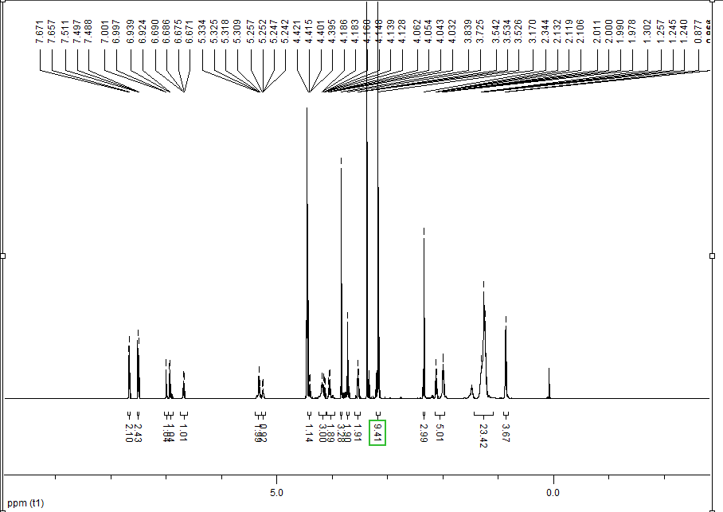
Figure S25. ¹H NMR spectrum (600 MHz, CDCl₃:CD₃OD) of OA-IND-PC.

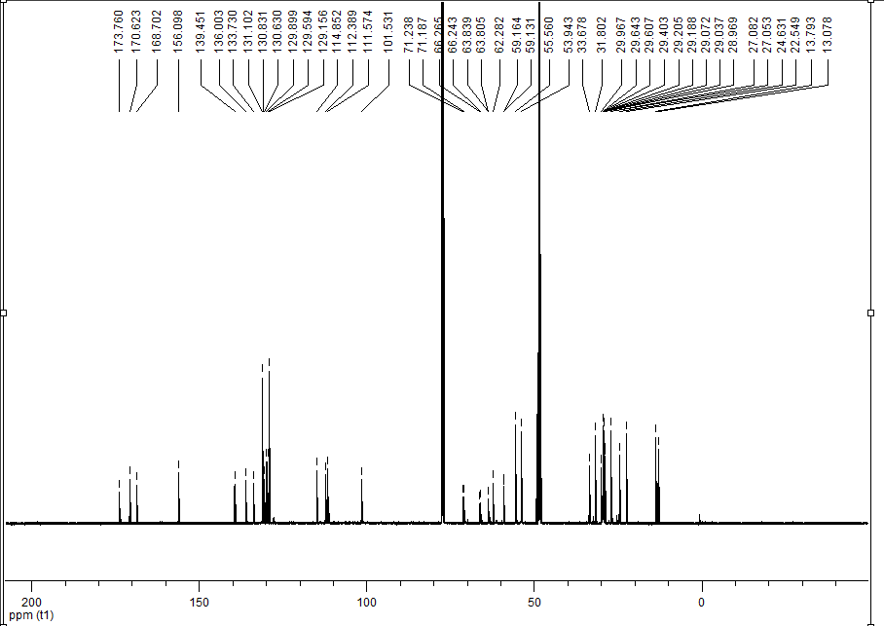
Figure S26. ¹³C NMR spectrum (150 MHz, CDCl₃:CD₃OD) of OA-IND-PC.

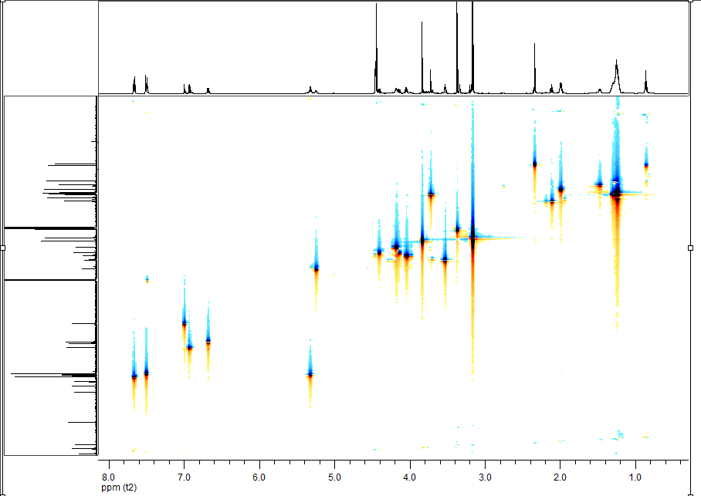
Figure S27. HSQC spectrum (600 MHz, CDCl₃:CD₃OD) of OA-IND-PC.

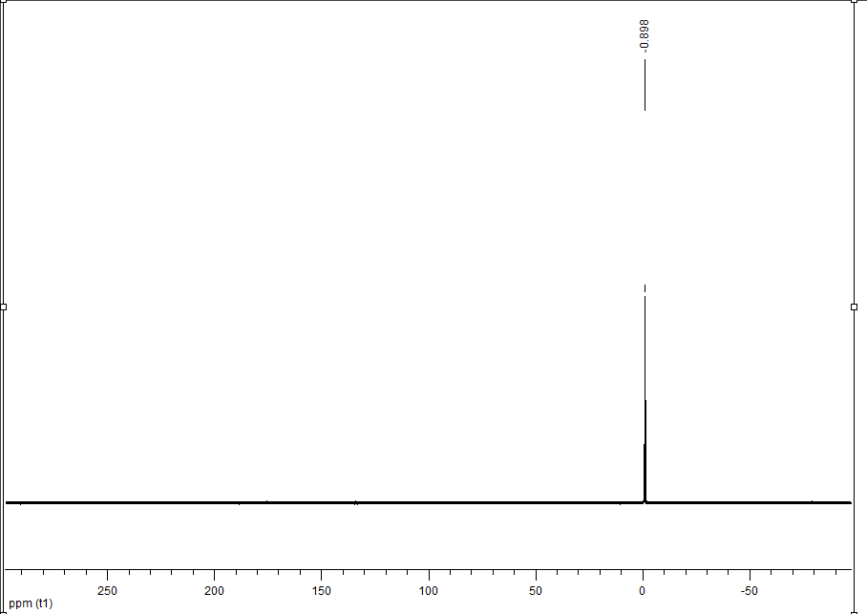
Figure S28. ³¹P spectrum (243 MHz, CDCl₃:CD₃OD) of OA-IND-PC.

