Supplementary data:
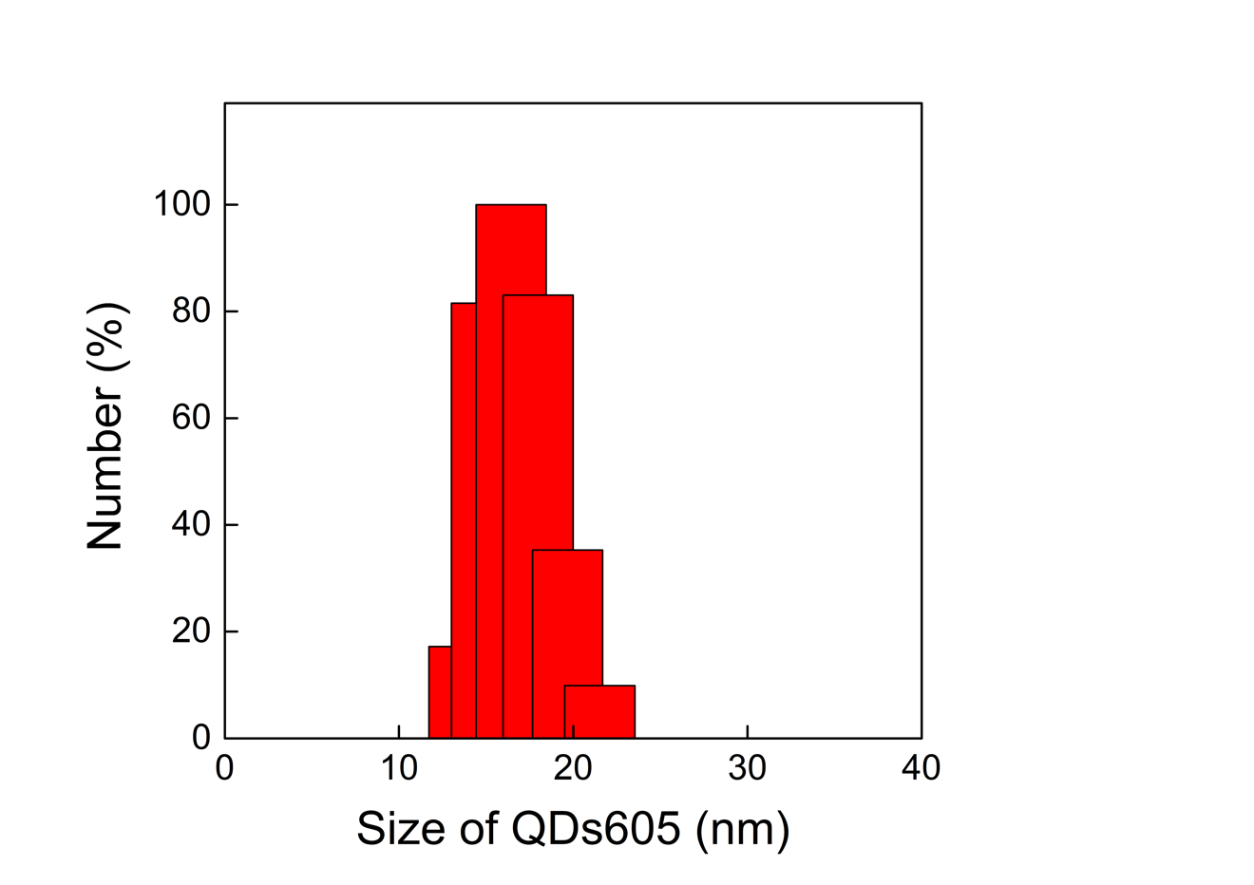
Supplemental Figure 1. Quantum dot conjugate size registration with Edinburgh spectrometer. Excitation slit: 15nm; Emission slit: 15nm; Excitation 405 nm. Size distribution measured with dynamic light scattering.

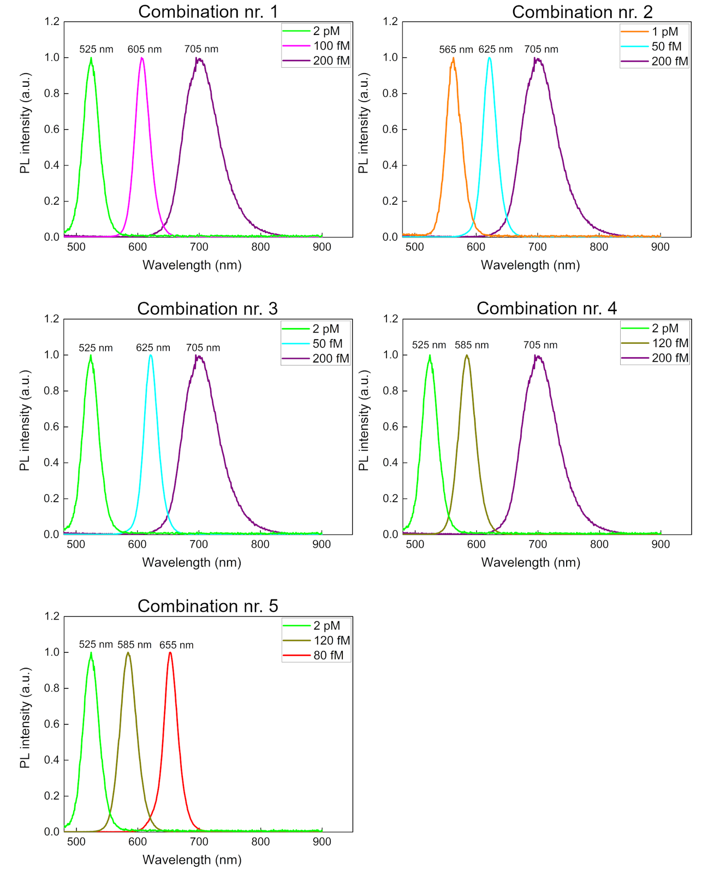
Supplemental Figure 2. Five different fluorescence spectra combinations that could be applied for multiplexed detection using three QDs, spectra ranging between 525 nm and 705 nm Detection with Edinburgh spectrometer, 405nm excitation wavelength.
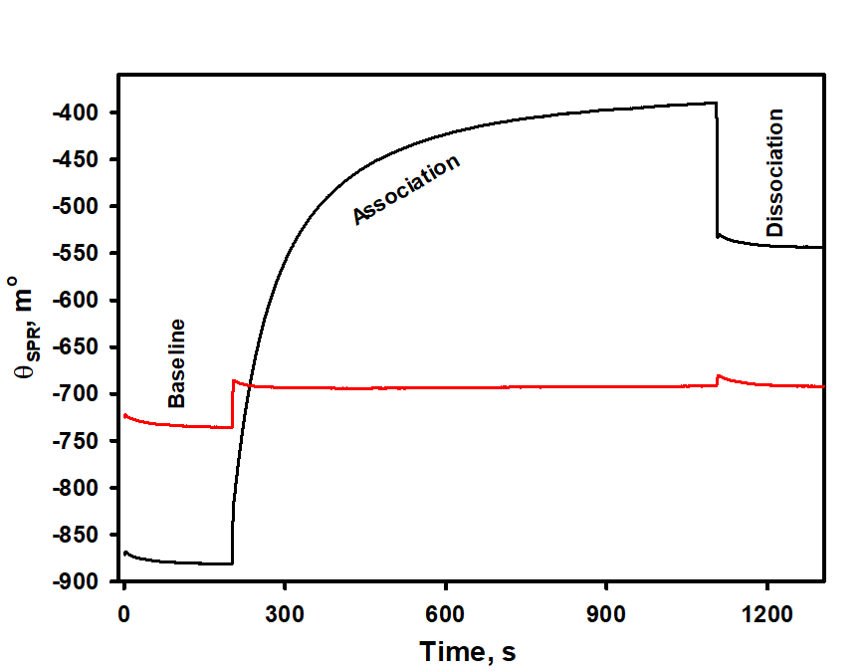
Supplemental figure 3. Real-time SPR sensograms recorded during the interaction of immobilized biotinylated anti-COMP 17C10 antibodies with streptavidin-coated QD625 in the first channel of the SPR cuvette (black line) and the non-specific interaction of immobilized anti-COMP 17C10 antibodies with streptavidin-coated QD625 in the second channel of the SPR cuvette (red line). Experimental conditions: 200.46 nM biotinylated anti-COMP 17C10 antibodies and 200.46 nM anti-COMP 17C10 antibodies in 10 mM sodium acetate buffer (pH 4.5), 20.0 nM streptavidin-coated QD625 in 10 mM PBS (pH 7.4).

