Supplementary figure 1
Materials and Methods
Safranin O -Fast Green Staining
After dewaxing, the sections were immersed in Fast Green staining solution for 3 minutes, followed by washing with distilled water for 1 minute. Then, they were differentiated in 1% acetic acid for 1 minute and stained with Safranin O solution for 2 minutes. Finally, the sections were washed with distilled water for 1 minute and observed for morphological changes after mounting with neutral resin.

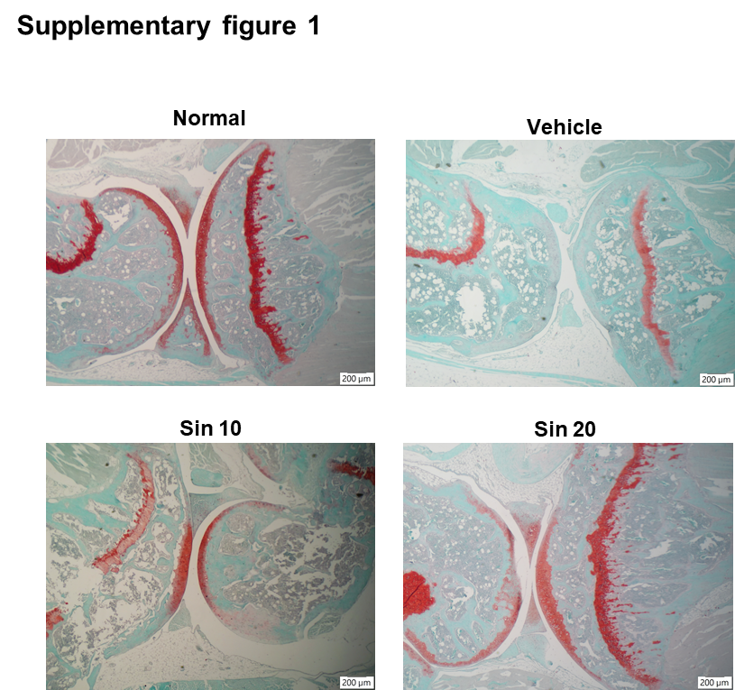
Supplementary figure 1
Safranin O-Fast Green Staining of CIA Symptoms Following Sinulariolide Treatment.
Safranin O-Fast Green stained tissue sections from sinulariolide-treated and vehicle-treated mice with CIA on day 42 (Magnification 40×, scale bar, 200 μm).

Supplementary figure 2
Materials and Methods
Data Collection for Rheumatoid Arthritis (RA) Genes
To investigate gene associations with Rheumatoid Arthritis (RA), we conducted searches across seven major genomic databases: Pharos, OpenTarget, GWAS Catalog, GeneCard, DisGeNet, Comparative Toxicogenomics Database (CTD), and DrugBank. The keyword “Rheumatoid Arthritis” was used to filter relevant genes from each database.
Data Collection for Sinulariolide Genes
Similarly, to investigate genes associated with the compound Sinulariolide, we performed searches using the keyword “Sinulariolide” in four primary databases: SWISS Target, SuperPred, TargetNet, and GeneCards.
Network Pharmacology Data Analysis
The collected gene data for RA and Sinulariolide were systematically analyzed to determine any common elements. 438 overlapping genes between the RA and Sinulariolide datasets were identified. Gene Ontology (GO) enrichment and Kyoto Encyclopedia of Genes and Genomes (KEGG) pathway enrichment analyses were performed on the overlapping genes to explore potential biological pathways shared between RA and Sinulariolide.

Result
Network Pharmacology Reveals Potential Pathways Targeted by Sinulariolide in Rheumatoid Arthritis
Through the data collected across multiple databases, a substantial number of genes associated with rheumatoid arthritis (RA) were identified, with GeneCards providing the most extensive collection of 6,786 genes. For Sinulariolide, the highest number of relevant genes was found in TargetNet, totaling 617 genes. Notably, there are 438 common genes between the RA-related gene set and the Sinulariolide-related gene set (Supplementary Figure 2A), suggesting that Sinulariolide may target molecular pathways involved in the pathogenesis of RA.

To further explore the interactions among these 438 genes, we imported them into the STRING database to create a protein-protein interaction (PPI) network. The analysis results from STRING were then imported into Cytoscape 3.10.1 to investigate how the targets interact with one another. The top ten major targets were identified based on "degree" centrality in CytoHubba (Supplementary Figure 2B).

To determine the biological activities of these genes, Gene Ontology (GO) analysis was performed using gene annotation and functional databases. The GO enrichment analysis revealed that the top associated terms for the shared genes included "response to chemical," "cellular response to chemical stimulus," and "regulation of biological quality" (Supplementary Figure 2C). These terms suggest that Sinulariolide may influence various biological responses related to chemical stimuli and cellular homeostasis, both of which are critical processes in the pathogenesis of RA.

Additionally, we conducted a Kyoto Encyclopedia of Genes and Genomes (KEGG) pathway enrichment analysis on the shared genes. Several key signaling pathways related to inflammation and immune response were identified, including the T cell receptor, TNF signaling, IL-17 signaling, MAPK and NF-κB signaling pathway (Supplementary Figure 2D).

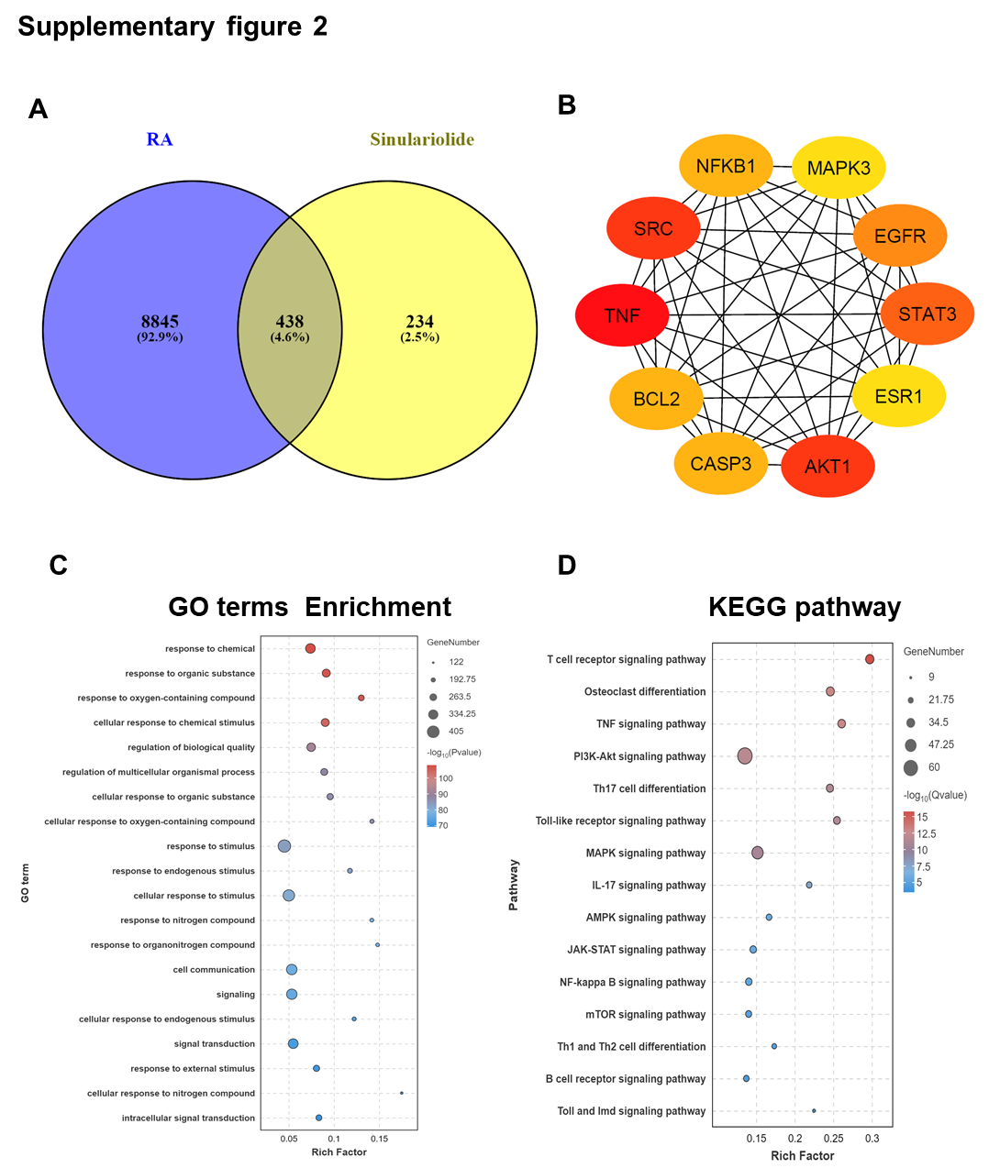
Supplementary figure 2
Screening of potential gene targets for Sinulariolide in the RA.
(A) Venn diagram illustrating the identification of 438 common genes associated with both RA and Sinulariolide. From these 438 genes, (B) the top 10 genes were selected and visualized for further analysis. (C) Gene Ontology (GO) enrichment analysis showing the top 20 enriched terms across Biological Process (BP), Molecular Function (MF), and Cellular Component (CC). (D) KEGG pathway analysis highlighting the top 15 enriched pathways associated with the identified gene targets.

