Supplementary Table S1. Baseline characteristics of the participants lost to follow-up and study participants
Variables | Total  (n=3089) | Study participants (n=2788) | Participants lost to follow-up (n=301) | Statistics | P value
Maleª | 1285(41.60) | 1171(42.00) | 114(37.87) | 1.03 | 0.310
Age (year)ª |  |  |  | 0.15 | 0.878
60-69 | 1816(58.79) | 1633(58.57) | 183(60.80)
70-79 | 947(30.66) | 877(31.46) | 70(23.26)
≥80 | 326(10.55) | 278(9.97) | 48(15.95)
Baseline general information
BMI (kg/m²)ª |  |  |  | -1.25 | 0.212
<18.5 | 150(4.86) | 119(4.27) | 31(10.30)
18.5-23.9 | 1392(45.06) | 1270(45.55) | 122(40.53)
24.0-27.9 | 1188(38.46) | 1074(38.52) | 114(37.87)
>27.9 | 359(11.62) | 325(11.66) | 34(11.30)
HDL (mmol/L)^{b} | 1.54(1.30,1.83) | 1.54(1.30,1.83) | 1.58(1.31,1.85) | 1.16 | 0.246
LDL (mmol/L)^{b} | 3.01(2.45,3.60) | 3.01(2.44,3.60) | 3.04(2.60,3.64) | 1.05 | 0.294
Cholesterol (mmol/L)^{b} | 5.11(4.41,5.76) | 5.10(4.40,5.75) | 5.16(4.60,5.85) | 1.26 | 0.209
Triglycerides (mmol/L)^{b} | 1.40(1.07,1.90) | 1.40(1.09,1.90) | 1.37(1.02,1.90) | -0.51 | 0.614
Disease history
Hypertension (Yes)ª | 383(12.40) | 346(12.41) | 37(12.29) | 0.00 | 0.953
Diabetes (Yes)ª | 143(4.63) | 128(4.59) | 15(4.98) | 0.09 | 0.758
Fatty liverª |  |  |  | 2.49 | 0.476
No | 1531(49.56) | 1383(49.61) | 148(49.17)
Trendy | 631(20.43) | 560(20.09) | 71(23.59)
Mild | 341(11.04) | 311(11.15) | 30(9.97)
Moderate | 586(18.97) | 534(19.15) | 52(17.28)
Kidney stone (Yes)ª | 130(4.21) | 124(4.45) | 6(1.99) | 4.06 | 0.044
Baseline urine tests
Proteinuria (Yes)ª | 181(5.86) | 164(5.88) | 17(5.65) | 0.03 | 0.869
Urine pHª |  |  |  | 2.76 | 0.252
<6 | 1716(55.55) | 1538(55.16) | 178(59.14)
6-7 | 1319(42.70) | 1203(43.15) | 116(38.54)
>7 | 54(1.75) | 47(1.69) | 7(2.33)
eGFR (ml/min/1.73m²)ª |  |  |  | 0.48 | 0.787
<60 | 277(8.97) | 247(8.86) | 30(9.97)
60-90 | 2084(67.47) | 1885(67.61) | 199(66.11)
>90 | 728(23.57) | 656(23.53) | 72(23.92)
Serum uric acid (μmol/L)ª |  |  |  | 8.50 | 0.004
<360 | 2289(74.10) | 2087(74.86) | 202(67.11)
≥360 | 800(25.90) | 701(25.14) | 99(32.89)
Abbreviations: eGFR, estimated glomerular filtration rate; BMI, body mass index; HDL, high-density lipoprotein; LDL, low-density lipoprotein.
ª Categorical variables, expressed as n(%);
^{b} Continuous variable, expressed as the median (IQR).

Supplementary Table S2. Univariate analysis of elevated blood uric acid at the one-year follow-up in the development cohort
Variables | Total  (N=2287) | Elevated blood uric acid, n (%) | Statistics | P value
Sex |  |  | 53.41 | <0.001
Male | 925 | 109(11.78)
Female | 1362 | 52(3.82)
BMI (kg/m²) |  |  | 19.97 | <0.001
<18.5 | 100 | 4(4.00)
18.5-23.9 | 1024 | 50(4.88)
24.0-27.9 | 895 | 76(8.49)
>27.9 | 268 | 31(11.57)
HDL (mmol/L) |  |  | 22.90 | <0.001
<1.5 | 1035 | 102(9.86)
≥1.5 | 1252 | 59(4.71)
Disease history
Hypertension |  |  | 5.27 | 0.022
Yes | 281 | 29(10.32)
No | 2006 | 132(6.58)
Diabetes |  |  | 4.40 | 0.036
Yes | 97 | 12(12.37)
No | 2190 | 149(6.80)
Fatty liver |  |  | 11.58 | 0.009
No | 1165 | 68(5.84)
Trendy | 440 | 27(6.14)
Mild | 243 | 20(8.23)
Moderate | 439 | 46(10.48)
Baseline urine tests
Proteinuria |  |  | 22.13 | <0.001
Yes | 126 | 22(17.46)
No | 2161 | 139(6.43)
eGFR (ml/min/1.73m²) |  |  | 51.83 | <0.001
<60 | 200 | 38(19.00)
60-90 | 1560 | 102(6.54)
>90 | 527 | 21(3.98)
Serum uric acid (μmol/L) |  |  | 207.31 | <0.001
<360 | 1737 | 47(2.71)
≥360 | 550 | 114(20.73)
Abbreviations: eGFR, estimated glomerular filtration rate; BMI, body mass index; HDL, high-density lipoprotein.
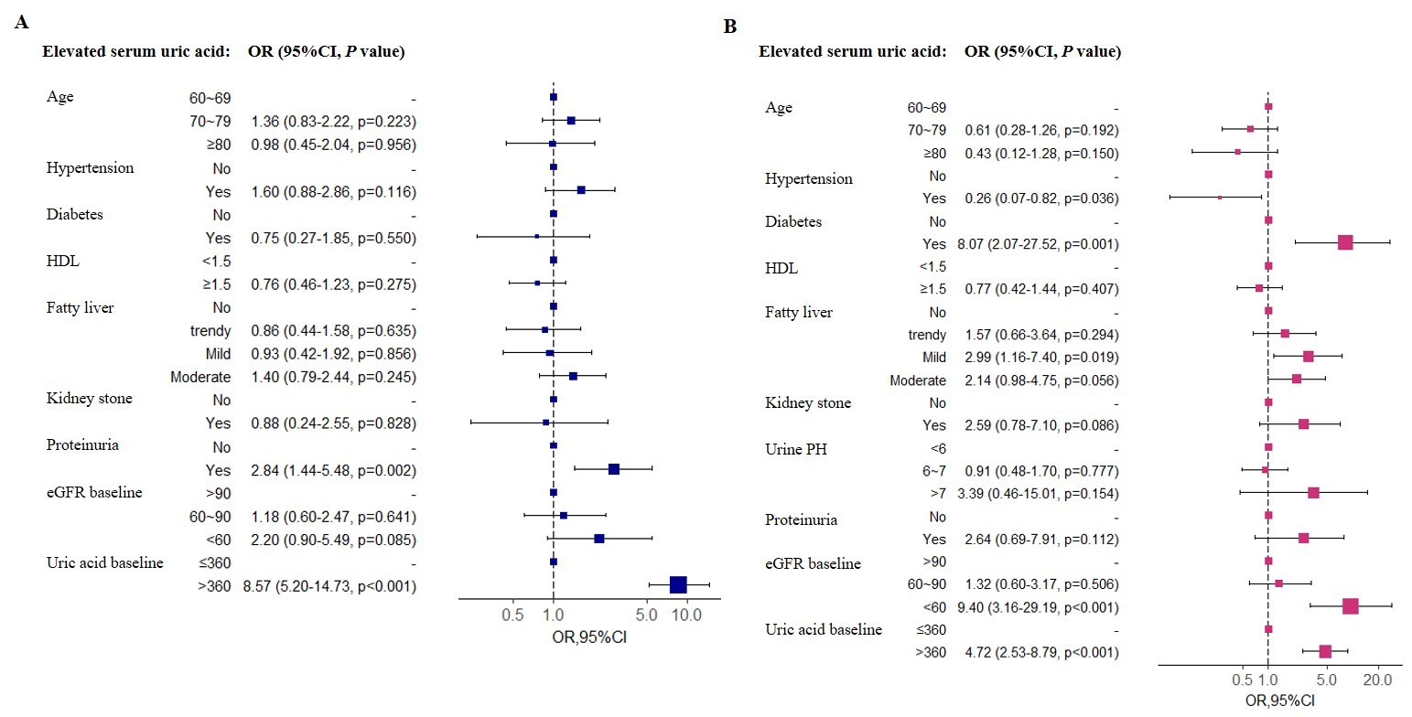
Supplementary Figure 1A. Forest plot of the associations between various factors and elevated serum uric acid levels according to multivariate logistic regression analysis in the male cohort
Supplementary Figure 1B. Forest plot of the associations between the predictors and elevated serum uric acid levels according to multivariate logistic regression analysis in the female cohort
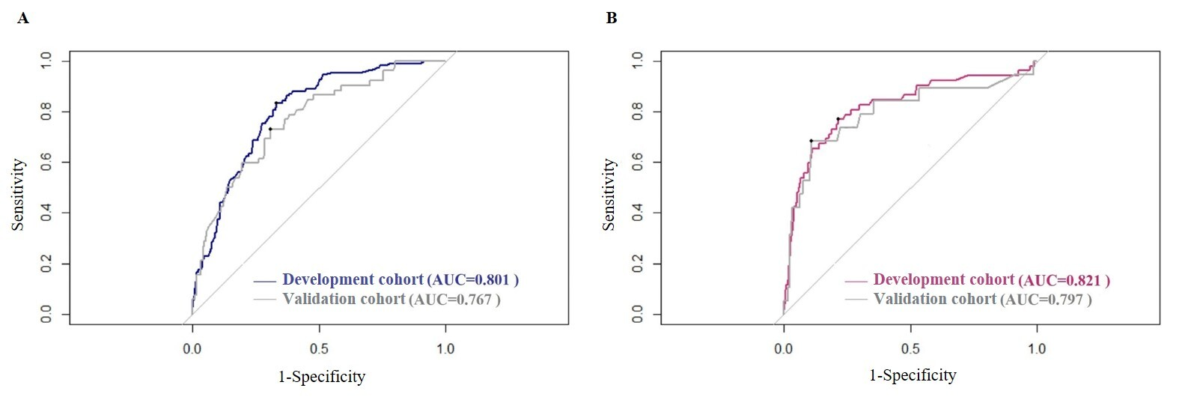
Supplementary Figure 2A. Receiver operating characteristic curve of the prediction performance of each algorithm in the male cohort
Supplementary Figure 2B. Receiver operating characteristic curve of the prediction performance of each algorithm in the female cohort

