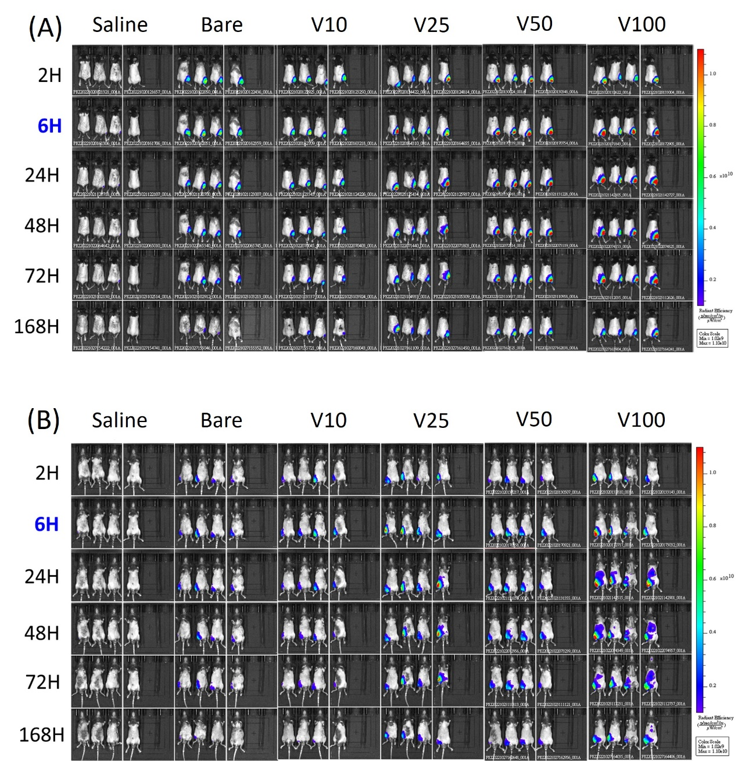
Figure 1S. Biodistribution of OVA-sVLNP using an in vivo image system (IVIS). (A) Fluorescence at the dorsal side of mice (the injection sites) was captured by IVIS. (B) Fluorescence at the ventral side of mice (the lymph node sites) was captured by IVIS.
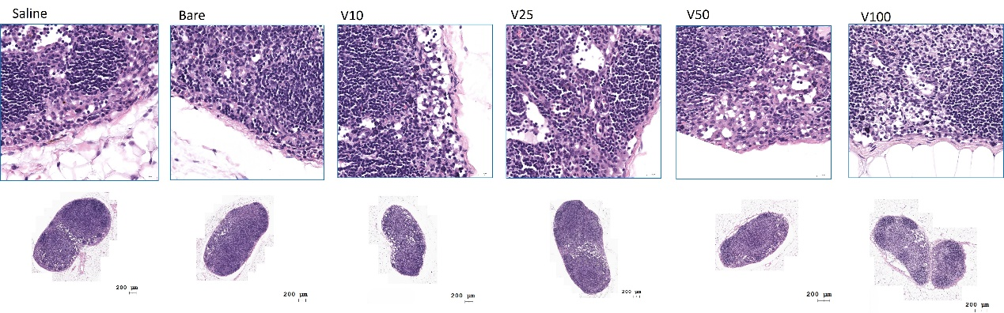Figure 2S. H&E staining sections from the lymph nodes of each group were used to assess immunotoxicity.

Table 1S. The formulation characteristics of ovalbumin spiked virus-like PLGA nanoparticles (OVA-sVLNP) prepared at a fixed PLGA amount of 12.5 mg with addition of 1:1 weight ratio of Lecithin to PLGA and various weight of DSPE-PEG2000-MAL and ratios of DSPE-PEG2000-Mal to OVA.
DSPE-PEG2000-Mal (mg) | DSPE-PEG2000-Mal: OVA  (M) | Size (nm) | PDI
0.266 | 1：1 | 253.07 ± 5.3 | 0.336 ± 0.02
0.420 | 1：1 | 230.87 ± 4.4 | 0.319 ± 0.01
0.589 | 1：1 | 222.53 ± 2.1 | 0.282 ± 0.02
0.266 | 1：3 | 229.93 ± 2.4 | 0.308 ± 0.01
0.420 | 1：3 | 219.13 ± 8.2 | 0.280 ± 0.02
0.589 | 1：3 | 218.70 ± 2.3 | 0.275 ± 0.01
0.798 | 1：1 | 206.5 ± 21.2 | 0.295 ± 0.09
1.261 | 1：1 | 198.8 ± 32.2 | 0.342 ± 0.014
1.766 | 1：1 | 193.8 ± 11.9 | 0.307 ± 0.04
0.798 | 1：3 | 240.6 ± 5.71 | 0.364 ± 0.031
1.261 | 1：3 | 237.8 ± 8.76 | 0.354 ± 0.073
1.766 | 1：3 | 209.4 ± 2.98 | 0.311 ± 0.075

Table 2S. Physical characteristics of maleimide virus like PLGA nanoparticles (MAL-VLNP). Data are presented as the mean ± SD (n = 3).
Group | Size (nm) | PDI | Residual maleimide (%) | Decorative maleimide (mg)
L-MAL-VLNP | 183.86 ± 8.0 | 0.223 ± 0.05 | 32.32 ± 3.33 | 0.26 ± 0.03
M-MAL-VLNP | 159.77 ± 17.6 | 0.151 ± 0.02 | 32.64 ± 1.73 | 0.41 ± 0.02
H-MAL-VLNP | 160.33 ± 13.3 | 0.164 ± 0.04 | 34.96 ± 0.49 | 0.62 ± 0.01

Table 3S. Physical characteristics of ovalbumin spiked virus like PLGA nanoparticles (OVA-sVLNP). Data are presented as the mean ±SD (n = 3).
Group | Size (nm) | PDI | ζ (mV) | Ovalbumin (mg) | Yield ratio (%)
L-OVA-sVLNP | 206.5 ± 21.2 | 0.295 ± 0.09 | -28.4 ± 5.03 | 4.48 ± 1.28 | 37.83 ± 3.3
M-OVA-sVLNP | 198.8 ± 32.2 | 0.342 ± 0.14 | -29.4 ± 8.18 | 6.84 ± 1.85 | 36.56 ± 5.1
H-OVA-sVLNP | 193.8 ± 11.9 | 0.307 ± 0.04 | -39.6 ± 10.16 | 9.59 ± 0.26 | 37.76 ± 0.7
PDI: Polydispersity index; ζ(mV): Zeta potential.

Table 4S. IHC scoring of mouse lymph nodes (n = 3).
Group | Saline | V10 | V25 | V50 | V100
CXCL 3  (T-cell chemokine) | 1+ | 1+ | 3+ | 2+ | 2+
CXCL 13  (B-cell chemokine) | 0 | 0 | 0 | 0 | 0

