Supplementary Materials

Table S1 α diversity index between the control and SD group before SD
α diversity index | C-0d | SD-0d | p-value
shannon | 4.180 | 5.265 | 0.001
simpson | 0.843 | 0.914 | 0.003
chao1 | 740.134 | 960.842 | 0.003
ace | 754.533 | 989.242 | 0.002
C-0d, the control group before SD. SD-0d, the SD group before SD. p-value was obtained with Wilcoxon test.

(a) (b) (c)
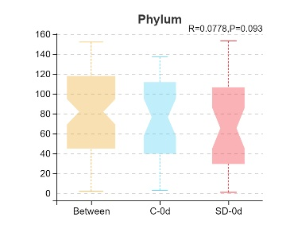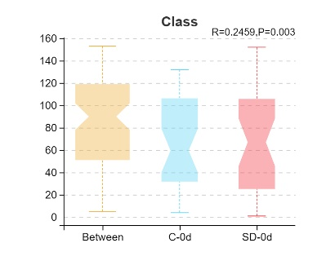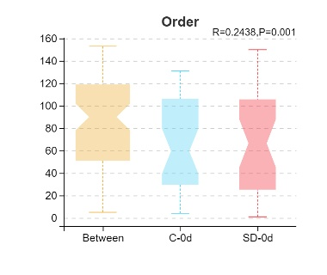
(d) (e)
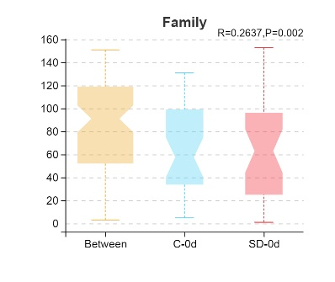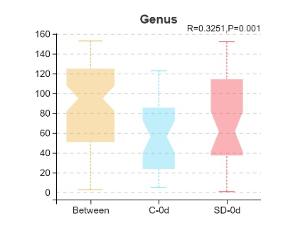
Figure S1 Analysis of similarities (Anosim) test based on Bray–Curtis distances between SD (SD-0d) and control (C-0d) groups before SD at (a)phylum(p=0.093, R=0.0778), (b)class(p=0.003, R=0.2459), (c)order(p=0.001, R=0.2438), (d)family(p=0.002, R=0.2637) and (e)genus(p=0.001, R=0.3251) levels.

(a) (b) (c)
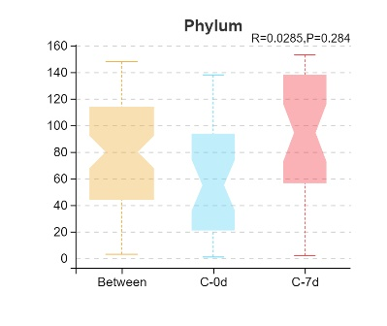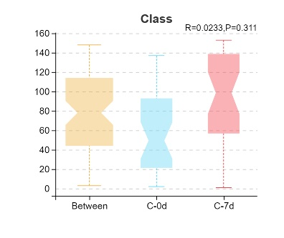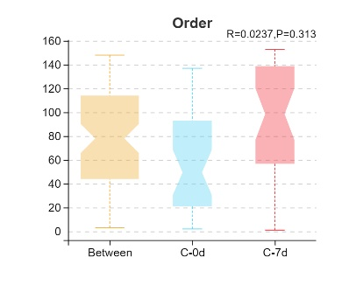
(d) (e)
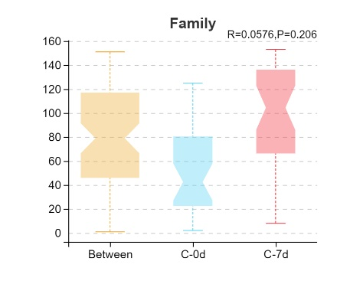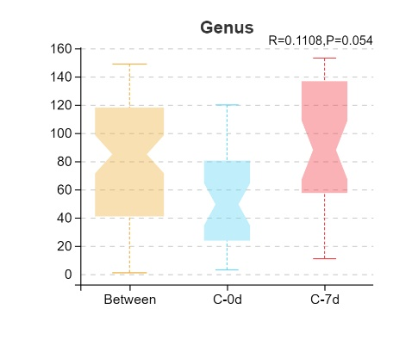
Figure S2 Anosim test based on Bray–Curtis distances between control groups before(C-0d) and after(C-7d) SD at (a)phylum(p=0.284, R=0.0285), (b)class(p=0.311, R=0.0233), (c)order(p=0.313, R=0.0237), (d)family(p=0.206, R=0.0576) and (e)genus(p=0.054, R=0.1108) levels.

(a) (b)
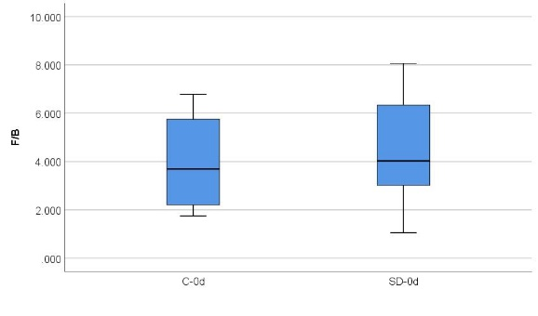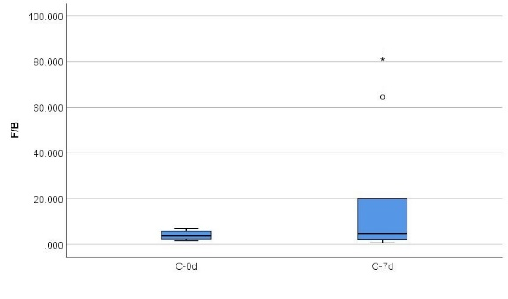
Figure S3(a) Comparison of the Firmicutes/Bacteroidetes(F/B) ratios between C-0d and SD-0d groups (U=44, p=0.796, Mann-Whitney U test). (b) Comparison of the F/B ratios between C-0d and C-7d groups (U=48, p=0.546, Mann-Whitney U test). Boxes represent the interquartile ranges. Lines inside the boxes denote medians. The circle and asterisk are outliers.

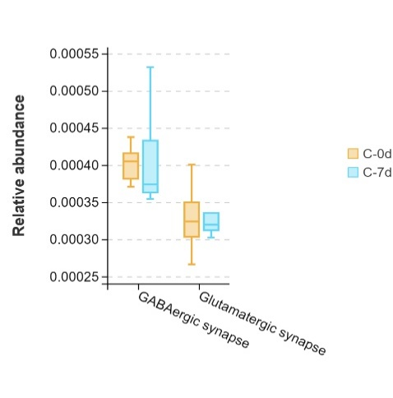
Figure S4 Comparison of the gut microbial abundance of KEGG pathways between C-0d and C-7d groups by Wilcoxon test (GABAergic synapses, q=0.452; glutamatergic synapses, q=0.948). q-value, p-value after adjusted. Boxes represent the interquartile ranges. Lines inside the boxes denote medians.

