Supplementary Figure
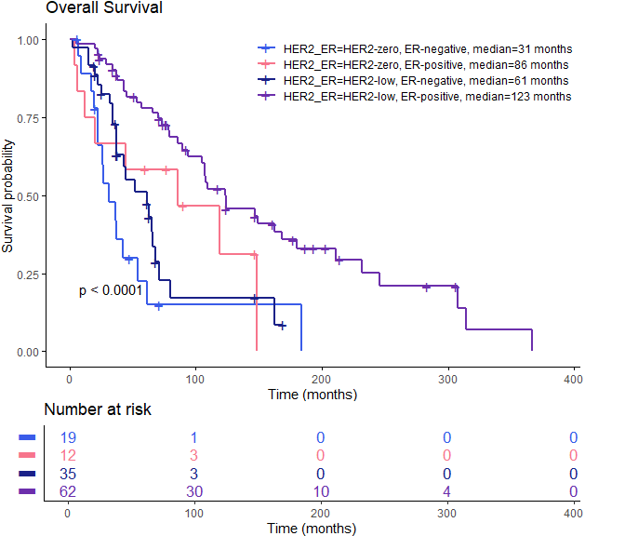

Pairwise Kaplan-Meier Comparison p-values
 | HER2-zero, ER-negative | HER2-zero, ER-positive | HER2-low, ER-negative
HER2-low, ER-positive | 2.3×10⁻⁶ | 0.15 | 2.5×10⁻⁴
HER2-low, ER-negative | 0.17 | 0.49
HER2-zero, ER-positive | 0.28

Figure S1: Kaplan-Meier survival analysis of HER2-low and HER2 negative groups subdivided by ER status for all patients in the cohort.

