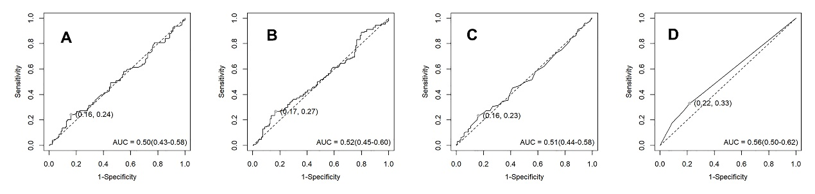
Supplementary Figure 1: ROC curves for each inflammatory parameter. A. AUC for NLR was 0.504 (0.43-0.58). B. AUC for PLR was 0.523 (0.45-0.6). C. AUC for MLR was 0.508 (0.44-0.58). D. AUC for ICPI was 0.559 (0.5-0.62). NLR: Neutrophil- to- Lymphocyte Ratio; PLR: Platelet-Lymphocyte Ratio; MLR: Monocyte- Lymphocyte Ratio; ICPI: Inflammation-Combined Prognostic Index.

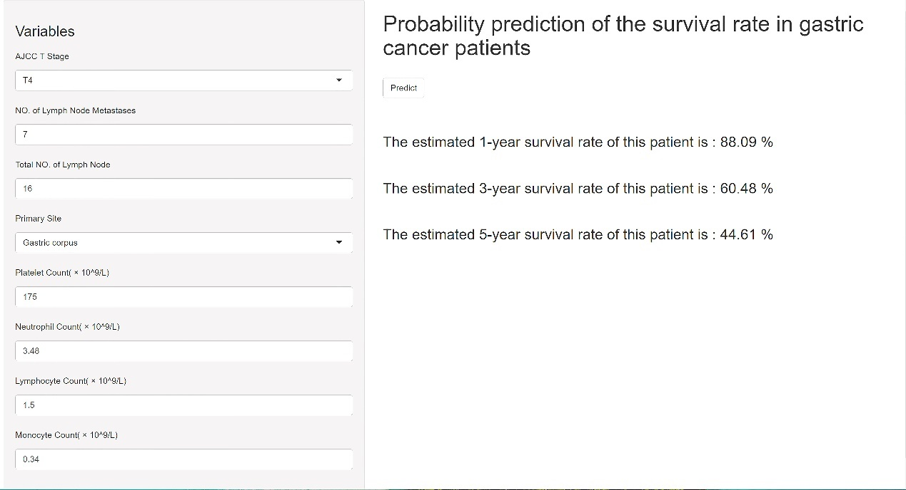
Supplementary Figure 2: Web calculator based on predictive modeling. For example, a patient with gastric corpus cancer who has an AJCC T-stage of T4, a positive lymph node count of 7, a total lymph node count of 16, a platelet count of 175×10^9/L, a neutrophil count of 3.48×10^9/L, a lymphocyte count of 1.5×10^9/L, and a monocyte count of 0.34×10^9/L. After entering the above parameters into the calculator and clicking on [Predict], the patient's 1-year survival rate can be predicted to be roughly 88.09%, the 3-year survival rate to be roughly 60.48%, and the 5-year survival rate to be just 44.61%.

SUPPLEMENTARY TABEL1: Baseline characteristics of two groups of patients after grouping
Characteristics | Overall  N = 876 | Training cohort  N = 613 | Validation cohort  N = 263 | p-value
SurvivalStatus |  |  |  | 0.4
death | 210 (24%) | 142 (23%) | 68 (26%)
survival | 666 (76%) | 471 (77%) | 195 (74%)
SurvivalDays | 1,079 (561, 1,696) | 1,063 (533, 1,712) | 1,091 (600, 1,675) | >0.9
Ethnic (%) |  |  |  | 0.9
hans | 866 (99%) | 606 (99%) | 260 (99%)
miao | 2 (0.2%) | 1 (0.2%) | 1 (0.4%)
tu | 8 (0.9%) | 6 (1.0%) | 2 (0.8%)
Gender (%) |  |  |  | 0.3
female | 276 (32%) | 187 (31%) | 89 (34%)
male | 600 (68%) | 426 (69%) | 174 (66%)
Age, median (IQR) | 66 (58, 72) | 66 (58, 72) | 66 (58, 72) | 0.9
Marital status (%) |  |  |  | 0.5
married | 869 (99%) | 609 (99%) | 260 (99%)
single | 2 (0.2%) | 1 (0.2%) | 1 (0.4%)
widowed | 5 (0.6%) | 3 (0.5%) | 2 (0.8%)
Underlying diseases (%) |  |  |  | >0.9
0 | 610 (70%) | 427 (70%) | 183 (70%)
1 | 193 (22%) | 136 (22%) | 57 (22%)
2 | 65 (7.4%) | 45 (7.3%) | 20 (7.6%)
3 | 6 (0.7%) | 4 (0.7%) | 2 (0.8%)
4 | 2 (0.2%) | 1 (0.2%) | 1 (0.4%)
BMI, median (IQR) | 22.6 (20.4, 24.6) | 22.7 (20.4, 24.6) | 22.5 (20.6, 24.2) | 0.4
Tumor size, median (IQR) | 3.00 (2.00, 4.00) | 3.00 (2.00, 4.00) | 2.50 (1.65, 4.00) | 0.13
Histological differentiation (%) |  |  |  | 0.5
Well differentiated | 13 (1.5%) | 10 (1.6%) | 3 (1.1%)
Moderately differentiated | 193 (22%) | 143 (23%) | 50 (19%)
Poorly differentiated | 615 (70%) | 421 (69%) | 194 (74%)
Unclassified | 55 (6.3%) | 39 (6.4%) | 16 (6.1%)
Pathological classification (%) |  |  |  | 0.6
adenocarcinoma | 725 (83%) | 510 (83%) | 215 (82%)
mucinous carcinoma | 17 (1.9%) | 12 (2.0%) | 5 (1.9%)
signet-ring cell carcinoma | 93 (11%) | 62 (10%) | 31 (12%)
Adenosquamous carcinoma | 3 (0.3%) | 2 (0.3%) | 1 (0.4%)
squamous cell carcinoma | 5 (0.6%) | 2 (0.3%) | 3 (1.1%)
carcinoma | 33 (3.8%) | 25 (4.1%) | 8 (3.0%)
AJCC T_Stage (%) |  |  |  | >0.9
Tis | 80 (9.1%) | 56 (9.1%) | 24 (9.1%)
T1 | 209 (24%) | 147 (24%) | 62 (24%)
T2 | 124 (14%) | 91 (15%) | 33 (13%)
T3 | 9 (1.0%) | 6 (1.0%) | 3 (1.1%)
T4 | 454 (52%) | 313 (51%) | 141 (54%)
AJCC N_Stage (%) |  |  |  | 0.5
N0 | 468 (53%) | 323 (53%) | 145 (55%)
N1 | 127 (14%) | 85 (14%) | 42 (16%)
N2 | 123 (14%) | 87 (14%) | 36 (14%)
N3 | 158 (18%) | 118 (19%) | 40 (15%)
Positive_LN, median (IQR) | 0.00 (0.00, 0.20) | 0.00 (0.00, 0.21) | 0.00 (0.00, 0.18) | 0.3
Total_LN, median (IQR) | 0.0 (0.0, 4.0) | 0.0 (0.0, 5.0) | 0.0 (0.0, 3.0) | 0.2
LNR, median (IQR) | 22 (18, 28) | 22 (18, 28) | 22 (17, 28) | 0.5
Vascular invasion (%) |  |  |  | 0.6
negative | 734 (84%) | 511 (83%) | 223 (85%)
positive | 142 (16%) | 102 (17%) | 40 (15%)
Perineural invasion (%) |  |  |  | >0.9
negative | 758 (87%) | 531 (87%) | 227 (86%)
positive | 118 (13%) | 82 (13%) | 36 (14%)
HER2 (%) |  |  |  | >0.9
negative | 779 (89%) | 546 (89%) | 233 (89%)
1+ | 57 (6.5%) | 40 (6.5%) | 17 (6.5%)
2+ | 30 (3.4%) | 21 (3.4%) | 9 (3.4%)
3+ | 10 (1.1%) | 6 (1.0%) | 4 (1.5%)
Primary site (%) |  |  |  | >0.9
Gastric cardia | 116 (13%) | 82 (13%) | 34 (13%)
Gastric fundus | 49 (5.6%) | 34 (5.5%) | 15 (5.7%)
Gastric antrum | 303 (35%) | 213 (35%) | 90 (34%)
Gastric corpus | 387 (44%) | 271 (44%) | 116 (44%)
Gastric angle | 21 (2.4%) | 13 (2.1%) | 8 (3.0%)
GC: Gastric Cancer; PSM: Propensity Score Matching; IQR: InterQuartile Range;
BMI: Body Mass Index; LMN: Lymph Nodes; LNR: Lymph Node Ratio.

