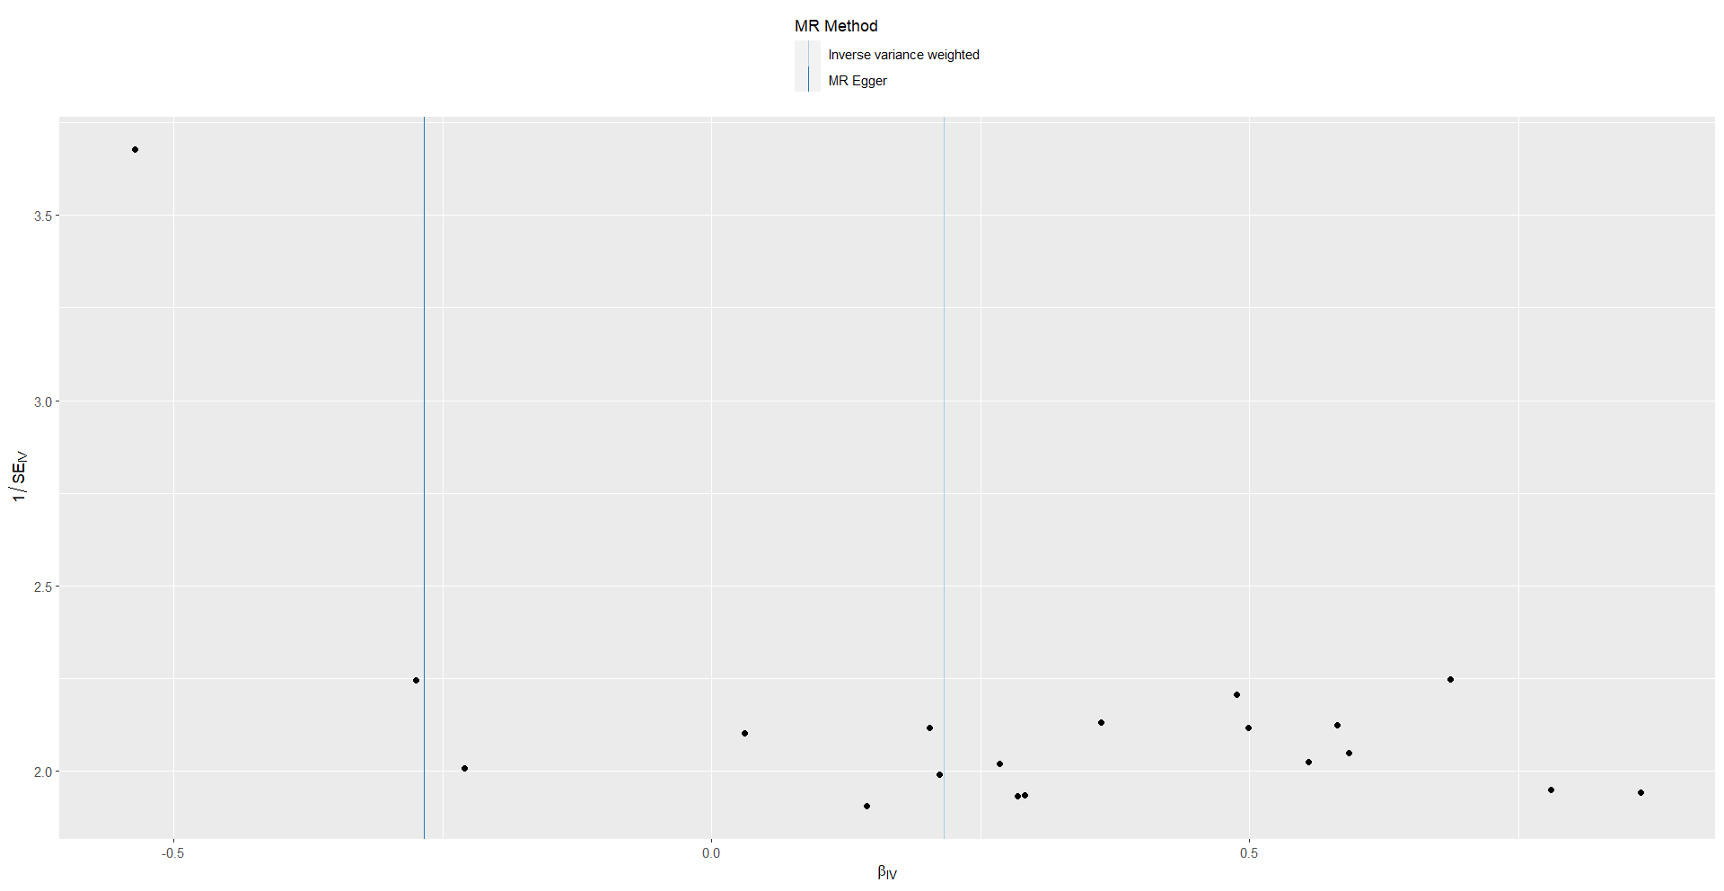
Supplementary Figure 1. The funnel plot to detect whether the protentional heterogeneity of obstructive sleep apnea on temporomandibular disorders.

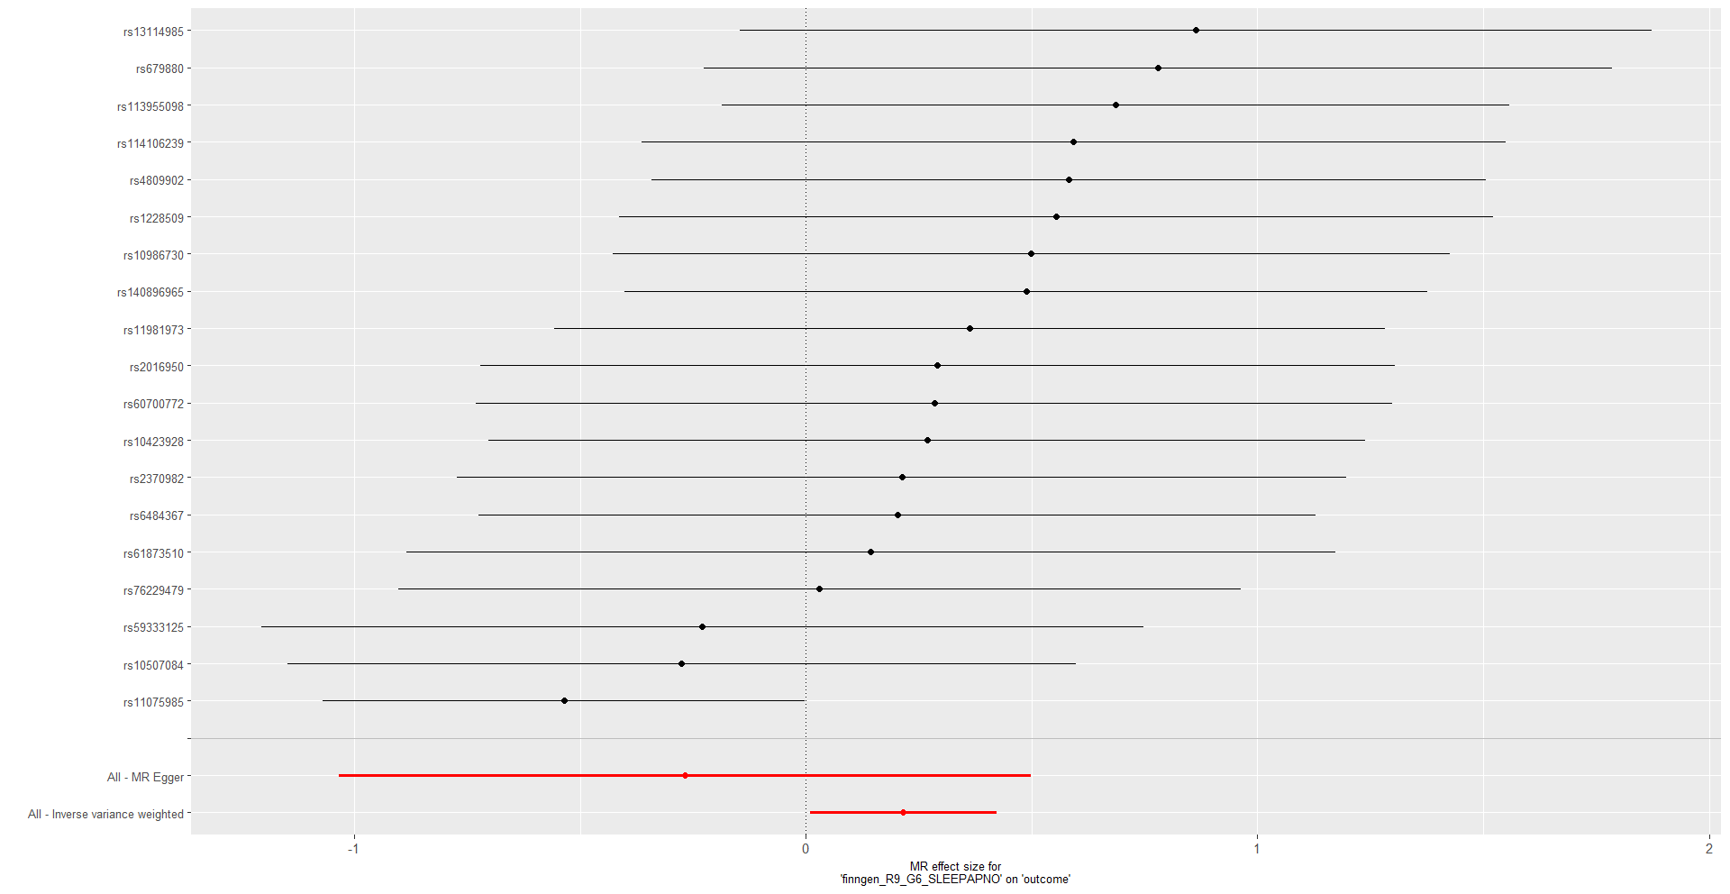
Supplementary Figure 2. The forest plot of causal effect of obstructive sleep apnea on temporomandibular disorders.

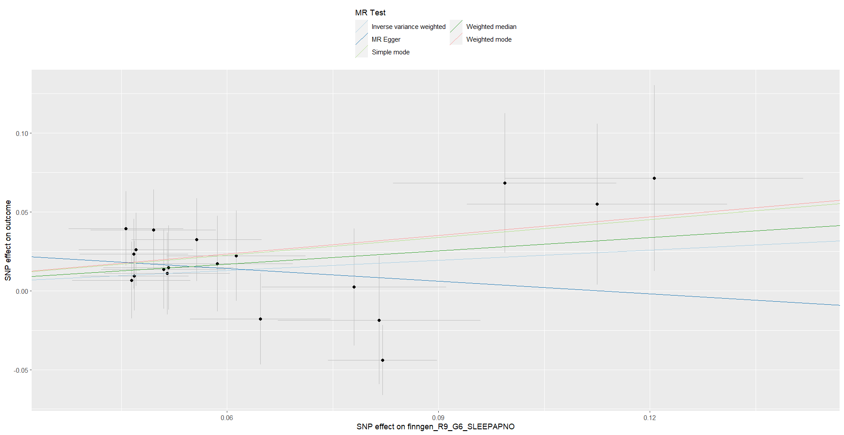
Supplementary Figure 3. The scatter plot of causal effect of obstructive sleep apnea on temporomandibular disorders.

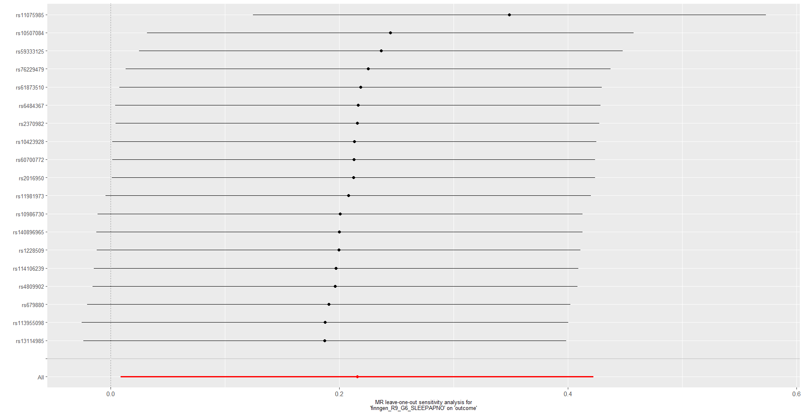
Supplementary Figure 4. The forest plot of “leave-one-out” sensitivity analysis method to show the influence of individual SNPs on the results of obstructive sleep apnea on temporomandibular disorders.

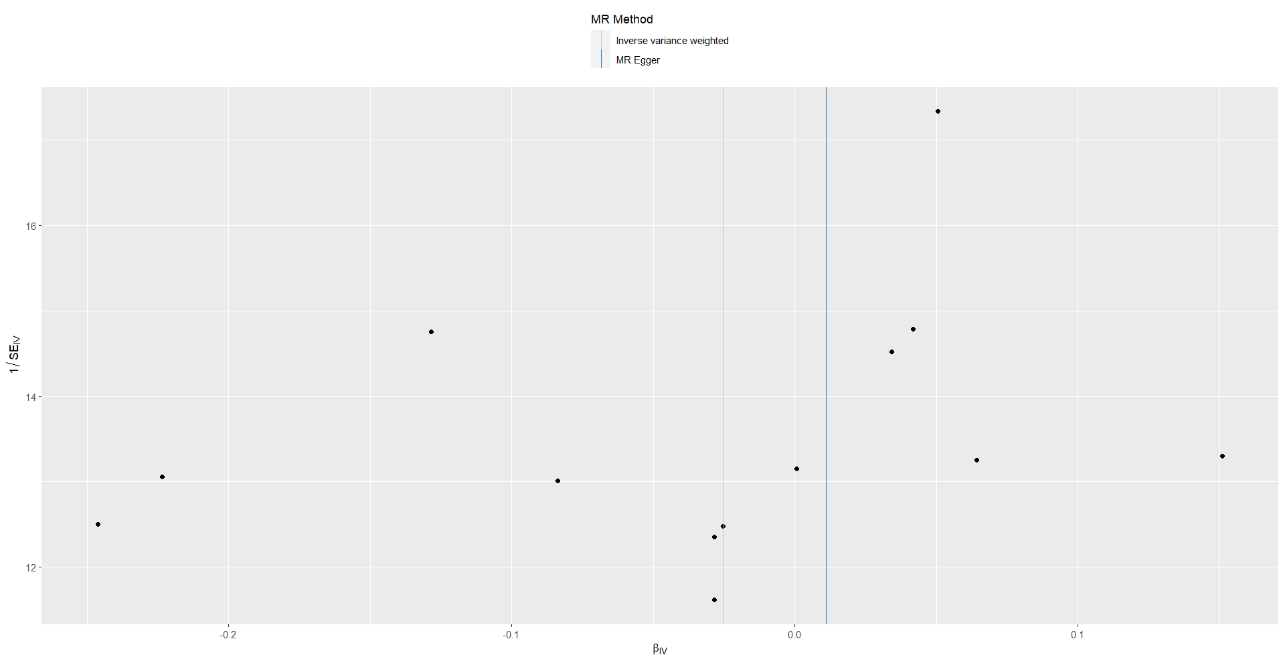
Supplementary Figure 5. The funnel plot to detect whether the protentional heterogeneity of temporomandibular disorders on obstructive sleep apnea.

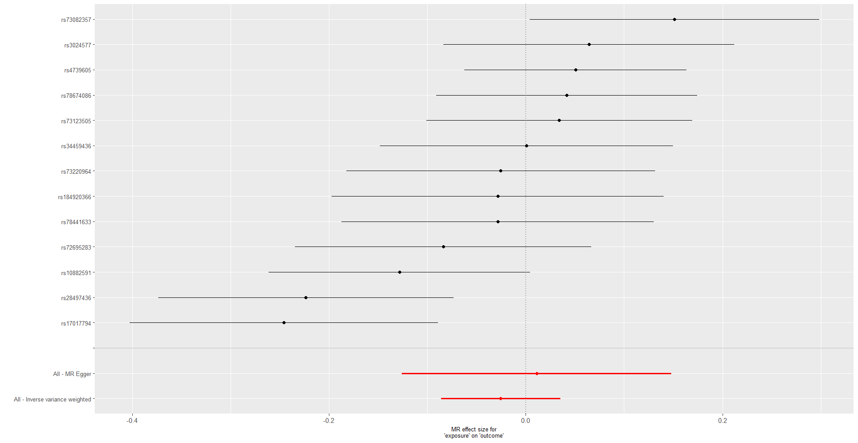
Supplementary Figure 6. The forest plot of causal effect of temporomandibular disorders on obstructive sleep apnea.

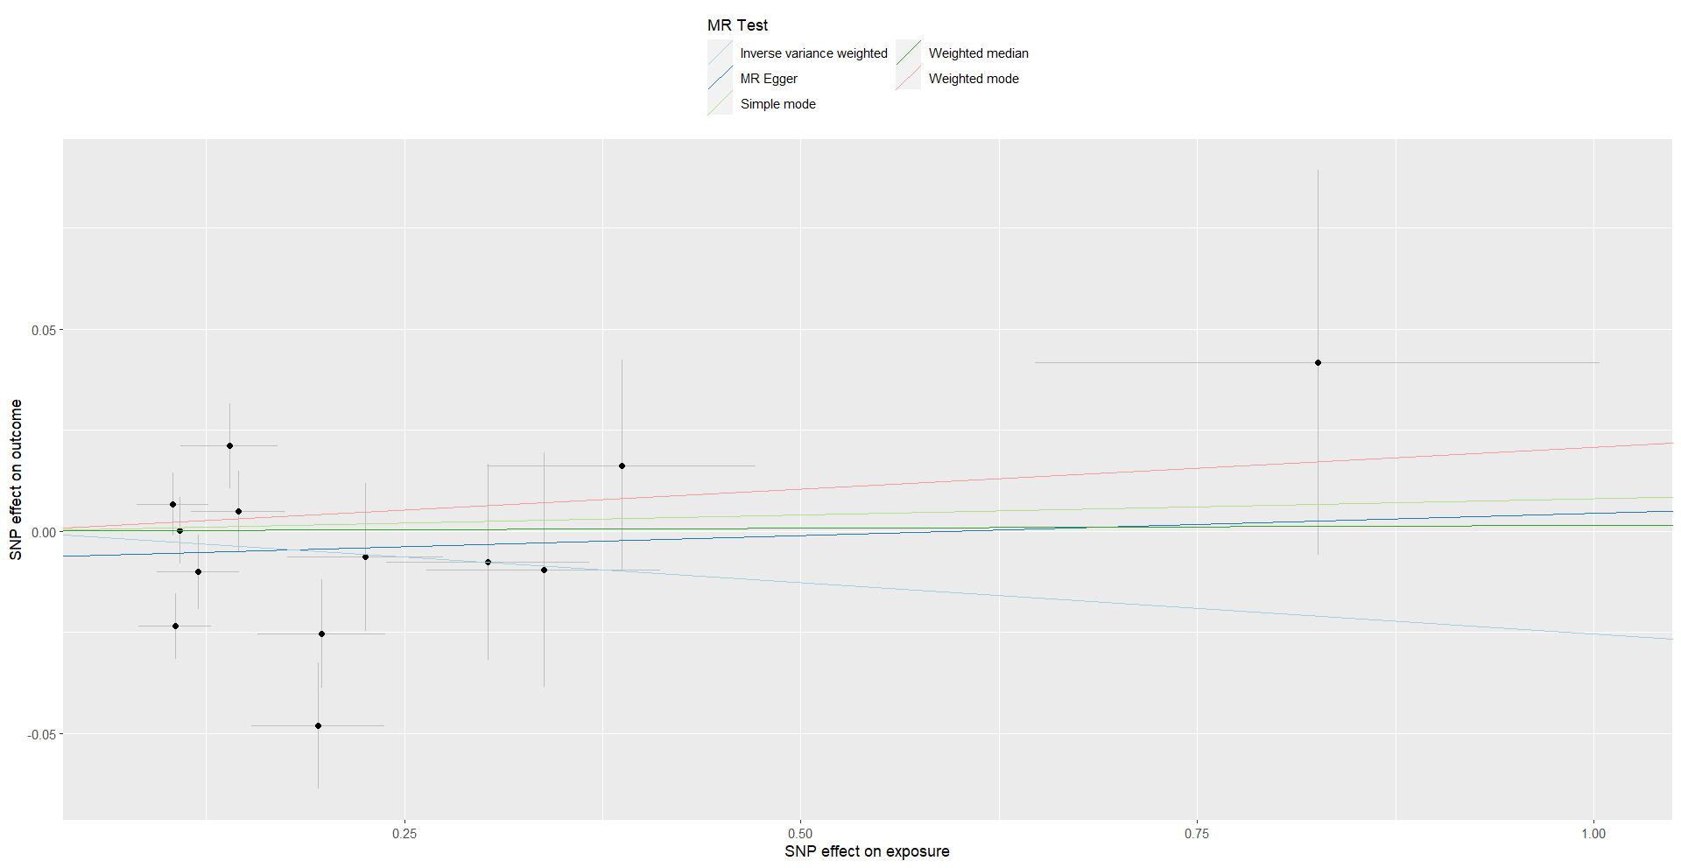
Supplementary Figure 7. The scatter plot of causal effect of temporomandibular disorders on obstructive sleep apnea.

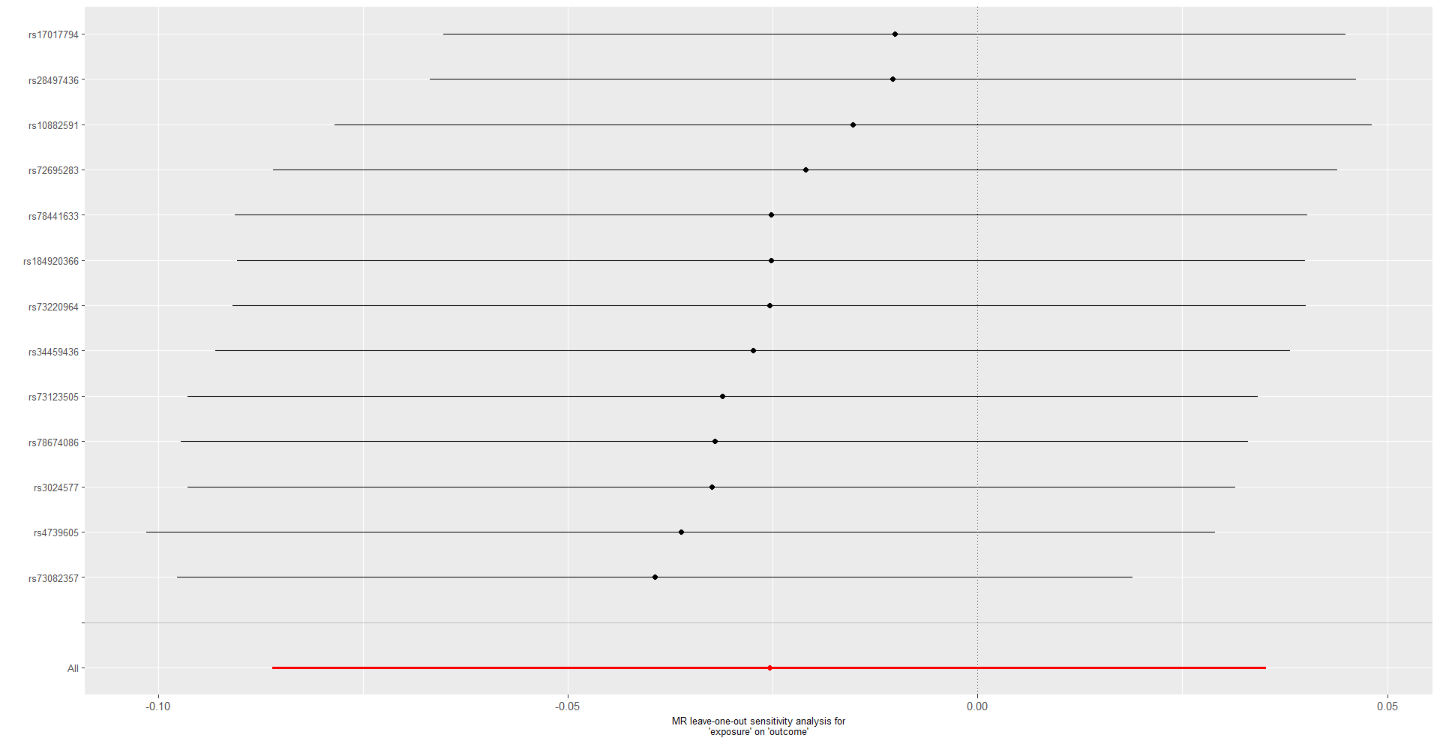
Supplementary Figure 8. The forest plot of “leave-one-out” sensitivity analysis method to show the influence of individual SNPs on the results of temporomandibular disorders on obstructive sleep apnea.

Supplementary Table 1. Detail information of selected SNPs for MR analysis in OSA and TMD.
SNP | EA | OA | Exposure (SA) |  |  |  |  |  | Outcome (TMD)
SNP | EA | OA | F | Beta | Se | P-value | EAF |  | Beta | Se | P-value | EAF
rs10423928 | T | A | 374.8247 | -0.051 | 0.0088 | 7.55E-09 | 0.2586 |  | -0.01367 | 0.025261 | 0.588447 | 0.25916
rs10507084 | C | T | 464.2537 | 0.0647 | 0.01 | 8.23E-11 | 0.1794 |  | -0.01781 | 0.028853 | 0.537045 | 0.177921
rs10986730 | C | T | 410.8218 | -0.0468 | 0.0077 | 1.16E-09 | 0.5242 |  | -0.02334 | 0.022118 | 0.29131 | 0.523598
rs11075985 | C | A | 1243.01 | 0.0821 | 0.0077 | 2.15E-26 | 0.4287 |  | -0.04399 | 0.022316 | 0.048699 | 0.427652
rs113955098 | G | A | 468.0613 | -0.0994 | 0.0158 | 3.38E-10 | 0.0675 |  | -0.06825 | 0.04424 | 0.122907 | 0.067849
rs114106239 | C | T | 390.837 | -0.1206 | 0.0212 | 1.19E-08 | 0.0371 |  | -0.07144 | 0.058874 | 0.224952 | 0.037067
rs11981973 | A | G | 419.8403 | 0.0613 | 0.0098 | 4.72E-10 | 0.1816 |  | 0.022166 | 0.02876 | 0.440878 | 0.180036
rs1228509 | A | C | 376.2625 | 0.0471 | 0.0081 | 6.41E-09 | 0.6562 |  | 0.026113 | 0.023256 | 0.261498 | 0.655586
rs13114985 | T | G | 351.227 | 0.0457 | 0.0081 | 2.01E-08 | 0.3383 |  | 0.039433 | 0.023539 | 0.093895 | 0.336075
rs140896965 | C | T | 444.0063 | -0.1125 | 0.0185 | 1.11E-09 | 0.049 |  | -0.0549 | 0.051018 | 0.281915 | 0.049005
rs2016950 | C | T | 343.8964 | -0.0586 | 0.0107 | 4.13E-08 | 0.158 |  | -0.01707 | 0.0303 | 0.573241 | 0.159399
rs2370982 | C | T | 362.1206 | 0.0515 | 0.0089 | 7.97E-09 | 0.2382 |  | 0.010924 | 0.025896 | 0.673133 | 0.237932
rs4809902 | G | C | 411.133 | -0.0557 | 0.0092 | 1.51E-09 | 0.2285 |  | -0.0324 | 0.026233 | 0.216822 | 0.229649
rs59333125 | A | C | 371.5678 | -0.0816 | 0.0144 | 1.32E-08 | 0.0807 |  | 0.018751 | 0.040657 | 0.644649 | 0.080301
rs60700772 | T | C | 346.2189 | 0.0517 | 0.0092 | 2.20E-08 | 0.2212 |  | 0.014681 | 0.026767 | 0.583356 | 0.220898
rs61873510 | G | T | 341.129 | 0.0464 | 0.0084 | 3.28E-08 | 0.301 |  | 0.006686 | 0.024371 | 0.783809 | 0.300756
rs6484367 | G | A | 412.5966 | 0.0468 | 0.0077 | 1.13E-09 | 0.5027 |  | 0.009491 | 0.022145 | 0.668213 | 0.501124
rs679880 | G | A | 350.7037 | 0.0495 | 0.0089 | 2.53E-08 | 0.745 |  | 0.038638 | 0.025413 | 0.128409 | 0.745962
rs76229479 | A | C | 407.2529 | -0.078 | 0.0131 | 2.64E-09 | 0.0988 |  | -0.00236 | 0.037095 | 9.49E-01 | 0.099151
EA: Effect allele; OA: Other allele; EAF: Effect allele frequency; OSA: Obstructive sleep apnea; TMD: Temporomandibular disorders; MR: Mendelian randomization.

Supplementary Table 2. Detail information of selected SNPs for MR analysis in TMD and OSA.
SNP | EA | OA | Exposure (TMD) |  |  |  |  |  | Outcome (SA)
SNP | EA | OA | F | Beta | Se | P-value | EAF |  | Beta | Se | P-value | EAF
rs10882591 | C | T | 1178.322 | -0.19763 | 0.040222 | 8.95E-07 | 0.090589 |  | 0.025386 | 0.01339 | 0.057979 | 0.091059
rs17017794 | T | C | 872.3498 | 0.195693 | 0.042027 | 3.22E-06 | 0.066762 |  | -0.04815 | 0.015651 | 0.002096 | 0.066571
rs184920366 | G | A | 796.8995 | 0.337796 | 0.073925 | 4.89E-06 | 0.01949 |  | -0.00962 | 0.029076 | 0.740681 | 0.018455
rs28497436 | T | C | 922.6384 | 0.105372 | 0.022817 | 3.87E-06 | 0.349067 |  | -0.02355 | 0.008067 | 0.003505 | 0.350868
rs3024577 | A | G | 945.414 | -0.10393 | 0.022632 | 4.39E-06 | 0.396668 |  | -0.00667 | 0.007841 | 0.395265 | 0.396034
rs34459436 | G | A | 1028.5 | 0.108601 | 0.023777 | 4.94E-06 | 0.391898 |  | 6.33E-05 | 0.008257 | 0.993887 | 0.389523
rs4739605 | C | T | 1653.636 | 0.825826 | 0.177928 | 3.46E-06 | 0.993352 |  | 0.041732 | 0.047638 | 0.381013 | 0.99337
rs72695283 | T | G | 919.8036 | 0.119877 | 0.025934 | 3.79E-06 | 0.22618 |  | -0.01005 | 0.009213 | 0.27543 | 0.225775
rs73082357 | G | A | 967.8302 | -0.13962 | 0.030581 | 4.98E-06 | 0.161943 |  | -0.02109 | 0.010495 | 0.044456 | 0.160793
rs73123505 | G | A | 1140.509 | -0.1451 | 0.029357 | 7.71E-07 | 0.180542 |  | -0.00495 | 0.009993 | 0.620295 | 0.182034
rs73220964 | A | T | 857.5643 | 0.302751 | 0.064244 | 2.45E-06 | 0.026283 |  | -0.00768 | 0.024266 | 0.75158 | 0.026592
rs78441633 | C | T | 829.6879 | 0.225434 | 0.049261 | 4.73E-06 | 0.04686 |  | -0.00643 | 0.018243 | 0.724638 | 0.046539
rs78674086 | A | G | 1213.742 | -0.38693 | 0.084655 | 4.86E-06 | 0.022646 |  | -0.01615 | 0.026171 | 0.53729 | 0.022236
EA: Effect allele; OA: Other allele; EAF: Effect allele frequency; OSA: Obstructive sleep apnea; TMD: Temporomandibular disorders; MR: Mendelian randomization.

