Supplementary material
Supplementary table 1:
NP |  | Shared |  | NP-HSA
Q9BQI0-3 | AIF1L | P60709 | ACTB | Q96P26-2 | 5NT1B
Q9NZN9-2 | AIPL1 | P02768 | ALBU | P02763 | A1AG1
P08519 | APOA | P02647 | APOA1 | P04217-2 | A1BG
P02654 | APOC1 | P02652 | APOA2 | P01023 | A2MG
P54707-2 | AT12A | P02655 | APOC2 | Q8NHS2 | AATC2
Q96L58 | B3GT6 | P02656 | APOC3 | Q8IUA7-3 | ABCA9
Q9C0J9 | BHE41 | P02649 | APOE | Q9H221-2 | ABCG8
O75419-2 | CDC45 | P46100-2 | ATRX | Q09666 | AHNK
O15078 | CE290 | P10909-2 | CLUS | Q9BQI0-2 | AIF1L
P52757-9 | CHIO | P55265-2 | DSRAD | Q8NAG6-1 | ANKL1
Q9UBY8 | CLN8 | Q63HQ2-2 | EGFLA | Q8TER5-2 | ARH40
O76031 | CLPX | Q5W0V3-2 | F16B1 | Q6ZSZ5-2 | ARHGI
Q9Y6Y1-2 | CMTA1 | P02675 | FIBB | Q8N3C0 | ASCC3
P02748 | CO9 | Q7Z2K8-2 | GRIN1 | Q6ZP68 | ATPUN
Q969M2 | CXA10 | P00738-2 | HPT | P04003 | C4BPA
Q96JB1-2 | DYH8 | Q8IZT8 | HS3S5 | P01024 | CO3
A0FGR8-2 | ESYT2 | P0DOX6 | IGM | P0C0L4-2 | CO4A
Q5T1M5-2 | FKB15 | Q14624-2 | ITIH4 | Q03001 | DYST
Q9NP62 | GCM1 | Q9P260-2 | K1468 | Q9UBC2-2 | EP15R
Q12906-7 | ILF3 | P13645 | K1C10 | Q8TBR7-1 | FA57A
A1L0T0 | ILVBL | P35527 | K1C9 | P07148 | FABPL
A6NCM1 | IQCAL | P04264 | K2C1 | P02671 | FIBA
Q9NVX7-2 | KBTB4 | O95096 | NKX22 | Q9P2B2 | FPRP
Q9H0B6 | KLC2 | Q7Z5J4-2 | RAI1 | Q8NA03 | FSIP1
Q9H0U3-2 | MAGT1 | P0DJI9 | SAA2 | Q16695 | H31T
Q685J3-2 | MUC17 | Q8TF72 | SHRM3 | P69905 | HBA
Q9H094-2 | NBPF3 | P46977-2 | STT3A | P68871 | HBB
Q96IV0-2 | NGLY1 | Q9BZF9-2 | UACA | Q9Y450-4 | HBS1L
P14543-2 | NID1 | Q99536-2 | VAT1 | P02790 | HEMO
P54368 | OAZ1 | P49750-3 | YLPM1 | O15347 | HMGB3
Q9Y5G0-2 | PCDGH | P31629 | ZEP2 | P0DOX5 | IGG1
Q9Y6V0-5 | PCLO |  |  | P01876 | IGHA1
Q9H875-2 | PKRI1 |  |  | P01859 | IGHG2
Q9UNP9-2 | PPIE |  |  | P0DOY2 | IGLC2
Q8IYL9 | PSYR |  |  | P40189-3 | IL6RB
Q9H1J1-2 | REN3A |  |  | P52292 | IMA1
Q96FB5 | RRNAD |  |  | P19823 | ITIH2
Q7L099-4 | RUFY3 |  |  | P13647 | K2C5
Q96NL0-4 | RUN3B |  |  | Q4VXA5 | KHDC1
P49589-2 | SYCC |  |  | Q2M1P5 | KIF7
Q9UL54-2 | TAOK2 |  |  | A6PVL3-2 | KNCN
Q8WUA7-3 | TB22A |  |  | P01042-2 | KNG1
O94876 | TMCC1 |  |  | Q8N2S1-4 | LTBP4
O75865-2 | TPC6A |  |  | Q9Y6D9 | MD1L1
Q6P9F5-2 | TRI40 |  |  | O15440-5 | MRP5
Q9P2H5-2 | UBP35 |  |  | P16333 | NCK1
A4UGR9-4 | XIRP2 |  |  | Q969V3-2 | NCLN
Q9H7S9 | ZN703 |  |  | Q9BTX1-4 | NDC1
 |  |  |  | Q86VF7-2 | NRAP
 |  |  |  | Q9UBU9-2 | NXF1
 |  |  |  | Q6ZVC0-2 | NYAP1
 |  |  |  | Q9Y3B8 | ORN
 |  |  |  | Q58A45-2 | PAN3
 |  |  |  | P00747 | PLMN
 |  |  |  | Q01860-2 | PO5F1
 |  |  |  | O75400-2 | PR40A
 |  |  |  | Q05209-2 | PTN12
 |  |  |  | Q8NC74 | RB8NL
 |  |  |  | Q7Z4M0 | RE114
 |  |  |  | Q9BZE1 | RM37
 |  |  |  | Q4U2R6 | RM51
 |  |  |  | P35542 | SAA4
 |  |  |  | Q8IYX7 | SAXO1
 |  |  |  | Q9NQW1-5 | SC31B
 |  |  |  | Q96FS4 | SIPA1
 |  |  |  | Q8WWL2-2 | SPIR2
 |  |  |  | Q9UQ35-2 | SRRM2
 |  |  |  | Q7RTT3 | SSX9
 |  |  |  | Q9NRC1-2 | ST7
 |  |  |  | Q9BXT5 | TEX15
 |  |  |  | A6NCK2 | TR43B
 |  |  |  | O75962-2 | TRIO
 |  |  |  | Q9P2H5 | UBP35
 |  |  |  | A6NCI4-2 | VWA3A

Data analysis from mass spectrometry.
NPs were incubated with Normal Human Serum (NHS) for 1h and analyzed. Mass spectrometry analysis highlighted 48 proteins specific for NP (left column), 74 proteins specific for NP-HSA (right column), and 31 proteins that are present on both NPs (central column).

Supplementary table 2:
NP-HSA |  | Shared |  | t-NP-HSA
Q96P26-2 | 5NT1B | Q8NHS2 | AATC2 | P52209-2 | 6PGD
P02763 | A1AG1 | P60709 | ACTB | Q8N0Z2 | ABRA
P04217-2 | A1BG | Q9BQI0-2 | AIF1L | P53396-2 | ACLY
P01023 | A2MG | P02768 | ALBU | Q08043 | ACTN3
Q8IUA7-3 | ABCA9 | P02647 | APOA1 | P40394 | ADH7
Q9H221-2 | ABCG8 | P02652 | APOA2 | Q7Z7M1 | AGRD2
Q09666 | AHNK | P02655 | APOC2 | Q8N7Z5 | ANR31
Q8NAG6-1 | ANKL1 | P02656 | APOC3 | P02654 | APOC1
Q8TER5-2 | ARH40 | P02649 | APOE | P05090 | APOD
Q6ZSZ5-2 | ARHGI | P46100-2 | ATRX | Q8WXK1 | ASB15
Q8N3C0 | ASCC3 | P10909-2 | CLUS | O75185-2 | AT2C2
Q6ZP68 | ATPUN | P01024 | CO3 | Q8TE59 | ATS19
P04003 | C4BPA | P0C0L4-2 | CO4A | P02745 | C1QA
P55265-2 | DSRAD | Q7Z2K8-2 | GRIN1 | P02747 | C1QC
Q03001 | DYST | P69905 | HBA | P09871 | C1S
Q63HQ2-2 | EGFLA | P68871 | HBB | O14523 | C2C2L
Q9UBC2-2 | EP15R | P00738-2 | HPT | Q9Y6J0-2 | CABIN
Q5W0V3-2 | F16B1 | Q8IZT8 | HS3S5 | Q15878-2 | CAC1E
Q8TBR7-1 | FA57A | P01876 | IGHA1 | O43866 | CD5L
P07148 | FABPL | P01859 | IGHG2 | B2RD01 | CENP1
P02671 | FIBA | P0DOY2 | IGLC2 | O95813 | CER1
P02675 | FIBB | P52292 | IMA1 | Q9H2X0-5 | CHRD
Q9P2B2 | FPRP | Q14624-2 | ITIH4 | Q96SZ6-2 | CK5P1
Q8NA03 | FSIP1 | P13645 | K1C10 | P20908 | CO5A1
Q16695 | H31T | P35527 | K1C9 | P23528 | COF1
Q9Y450-4 | HBS1L | P04264 | K2C1 | P38432 | COIL
P02790 | HEMO | P01042-2 | KNG1 | Q9UBF2-2 | COPG2
O15347 | HMGB3 | Q9UBU9-2 | NXF1 | Q9Y600-2 | CSAD
P0DOX5 | IGG1 | Q05209-2 | PTN12 | O00622 | CYR61
P0DOX6 | IGM | Q4U2R6 | RM51 | P59665 | DEF1
P40189-3 | IL6RB | P0DJI9 | SAA2 | Q5VTE0 | EF1A3
P19823 | ITIH2 | Q8TF72 | SHRM3 | P13639 | EF2
Q9P260-2 | K1468 | Q99536-2 | VAT1 | Q8NDI1 | EHBP1
P13647 | K2C5 | P31629 | ZEP2 | Q96JJ3-3 | ELMO2
Q4VXA5 | KHDC1 |  |  | Q6ZMW3-2 | EMAL6
Q2M1P5 | KIF7 |  |  | Q9BXW9-1 | FACD2
A6PVL3-2 | KNCN |  |  | Q96CS3 | FAF2
Q8N2S1-4 | LTBP4 |  |  | Q15485 | FCN2
Q9Y6D9 | MD1L1 |  |  | O75636-2 | FCN3
O15440-5 | MRP5 |  |  | P04406 | G3P
P16333 | NCK1 |  |  | O14556 | G3PT
Q969V3-2 | NCLN |  |  | P32455 | GBP1
Q9BTX1-4 | NDC1 |  |  | Q99684 | GFI1
O95096 | NKX22 |  |  | Q6PRD1 | GP179
Q86VF7-2 | NRAP |  |  | P16402 | H13
Q6ZVC0-2 | NYAP1 |  |  | P16104 | H2AX
Q9Y3B8 | ORN |  |  | Q5QNW6-2 | H2B2F
Q58A45-2 | PAN3 |  |  | P68431 | H31
P00747 | PLMN |  |  | P62805 | H4
Q01860-2 | PO5F1 |  |  | P61978-2 | HNRPK
O75400-2 | PR40A |  |  | P07900-2 | HS90A
Q7Z5J4-2 | RAI1 |  |  | P08238 | HS90B
Q8NC74 | RB8NL |  |  | P11142-2 | HSP7C
Q7Z4M0 | RE114 |  |  | Q92743 | HTRA1
Q9BZE1 | RM37 |  |  | A0A0A0MS14 | HV145
P35542 | SAA4 |  |  | Q13099-2 | IFT88
Q8IYX7 | SAXO1 |  |  | P0DOX2 | IGA2
Q9NQW1-5 | SC31B |  |  | P01857 | IGHG1
Q96FS4 | SIPA1 |  |  | P01860 | IGHG3
Q8WWL2-2 | SPIR2 |  |  | P01871-2 | IGHM
Q9UQ35-2 | SRRM2 |  |  | P0DOX7 | IGK
Q7RTT3 | SSX9 |  |  | Q5VWK5-7 | IL23R
Q9NRC1-2 | ST7 |  |  | Q9NQ38-3 | ISK5
P46977-2 | STT3A |  |  | P35908 | K22E
Q9BXT5 | TEX15 |  |  | P19013 | K2C4
A6NCK2 | TR43B |  |  | Q9NXV2 | KCTD5
O75962-2 | TRIO |  |  | Q9H0B6 | KLC2
Q9BZF9-2 | UACA |  |  | P14618-2 | KPYM
Q9P2H5 | UBP35 |  |  | A0A0C4DH55 | KVD07
A6NCI4-2 | VWA3A |  |  | P00338-3 | LDHA
P49750-3 | YLPM1 |  |  | P07195 | LDHB
 |  |  |  | P06858 | LIPL
 |  |  |  | Q9NZR2 | LRP1B
 |  |  |  | Q9H0U3-2 | MAGT1
 |  |  |  | Q7Z304-2 | MAMC2
 |  |  |  | Q9UHC1-2 | MLH3
 |  |  |  | P20645 | MPRD
 |  |  |  | Q685J3-2 | MUC17
 |  |  |  | P35579 | MYH9
 |  |  |  | P15172 | MYOD1
 |  |  |  | Q9BXJ9 | NAA15
 |  |  |  | Q8NA29-3 | NLS1
 |  |  |  | Q6IF00 | OR2T2
 |  |  |  | Q9UBL9-6 | P2RX2
 |  |  |  | Q9UQ80 | PA2G4
 |  |  |  | P29122-2 | PCSK6
 |  |  |  | Q504Y2 | PKDCC
 |  |  |  | Q8TCU6-3 | PREX1
 |  |  |  | Q8IYL9 | PSYR
 |  |  |  | Q7Z5J4-3 | RAI1
 |  |  |  | P62826 | RAN
 |  |  |  | P18621-2 | RL17
 |  |  |  | Q02543 | RL18A
 |  |  |  | P35268 | RL22
 |  |  |  | Q9UNX3 | RL26L
 |  |  |  | P46779-2 | RL28
 |  |  |  | P62888 | RL30
 |  |  |  | P49207 | RL34
 |  |  |  | P42766 | RL35
 |  |  |  | P18077 | RL35A
 |  |  |  | P62424 | RL7A
 |  |  |  | Q8NHW5 | RLA0L
 |  |  |  | P09651 | ROA1
 |  |  |  | P62277 | RS13
 |  |  |  | P62244 | RS15A
 |  |  |  | P62249 | RS16
 |  |  |  | P08708 | RS17
 |  |  |  | P62269 | RS18
 |  |  |  | P15880 | RS2
 |  |  |  | P60866-2 | RS20
 |  |  |  | Q71UM5 | RS27L
 |  |  |  | P23396-2 | RS3
 |  |  |  | P61247 | RS3A
 |  |  |  | Q8TD47 | RS4Y2
 |  |  |  | P62753 | RS6
 |  |  |  | P62081 | RS7
 |  |  |  | P62241 | RS8
 |  |  |  | P46781 | RS9
 |  |  |  | P08865 | RSSA
 |  |  |  | Q92503-2 | S14L1
 |  |  |  | Q6U841 | S4A10
 |  |  |  | P84550-3 | SKOR1
 |  |  |  | Q8N0X7 | SPART
 |  |  |  | Q9UM82 | SPAT2
 |  |  |  | Q9BXB7 | SPT16
 |  |  |  | Q07955-3 | SRSF1
 |  |  |  | Q7Z2R9 | SSAS1
 |  |  |  | Q8IX01-3 | SUGP2
 |  |  |  | Q92777-2 | SYN2
 |  |  |  | Q3SY00 | T10IP
 |  |  |  | Q9BQE3 | TBA1C
 |  |  |  | P07437 | TBB5
 |  |  |  | P17987 | TCPA
 |  |  |  | P78371-2 | TCPB
 |  |  |  | O43151-4 | TET3
 |  |  |  | O95932-2 | TGM3L
 |  |  |  | Q8WZ42-8 | TITIN
 |  |  |  | P82094-2 | TMF1
 |  |  |  | P45378-2 | TNNT3
 |  |  |  | Q9NS56-2 | TOPRS
 |  |  |  | Q13061 | TRDN
 |  |  |  | P04004 | VTNC
 |  |  |  | Q9Y3S1-2 | WNK2
 |  |  |  | O14980 | XPO1
 |  |  |  | Q8IZN3-2 | ZDH14
 |  |  |  | Q9H7S9 | ZN703
 |  |  |  | Q32MQ0 | ZN750

Data analysis from mass spectrometry.
NPs were incubated with Normal Human Serum (NHS) for 1h and analyzed. Mass spectrometry analysis highlighted 105 proteins specific for NP-HSA (left column), 181 proteins specific for t-NP-HSA (right column), and 34 proteins that are present on both NPs (central column).

Supplementary Figure 1: 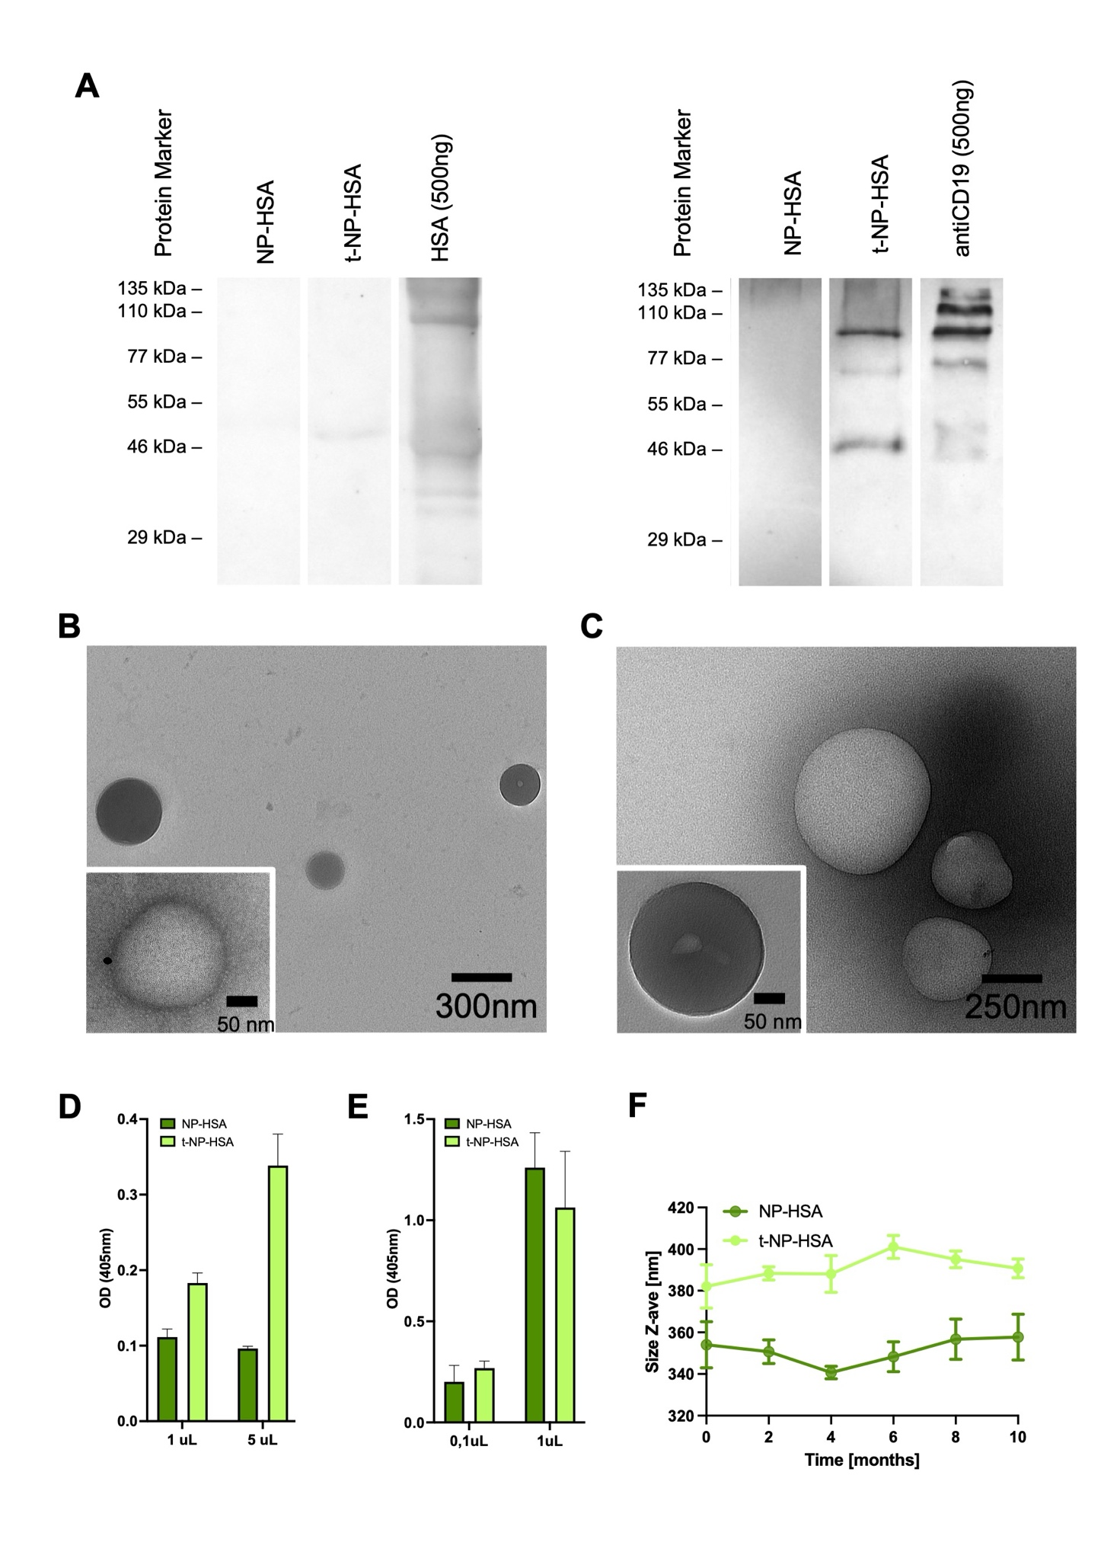
Characterization of targeted-nanoparticles.
(A) Western blot analysis conducted in non-reducing conditions of NP-HSA and t-NP-HSA. The left panel shows HSA (500 ng) and NP-HSA, while the right panel compares NP-HSA, t-NP-HSA, and antiCD19 (500 ng) as positive control. The presence of bands at the expected molecular weights confirms the successful conjugation and integrity of the nanoparticles.
(B) Transmission electron microscopy (TEM) image of NP-HSA nanoparticles, showing spherical particles with an approximate diameter of 50 nm (inset). The scale bar represents 300 nm.
(C) TEM image of NP-HSA and t-NP-HSA nanoparticles, showing round-shaped particles, with the inset highlighting the structure of individual particles at 50 nm scale.
(D-E) Results of the comparison between NP-HSA (untargeted-NPs) and t-NP-HSA (targeted-NPs) in ELISA tests. The different values of OD establish the differences in the presence of antiCD19 protein (D) only in t-NP-HSA and HSA coating (E) in both samples. Data have been reported as the mean ± SD. (F) Stability analysis of NP-HSA and t-NP-HSA particles over 10 months, showing a slight variation in size distribution with time, measured by dynamic light scattering (DLS). Data have been reported as the mean ± SD.

Supplementary Figure 2: 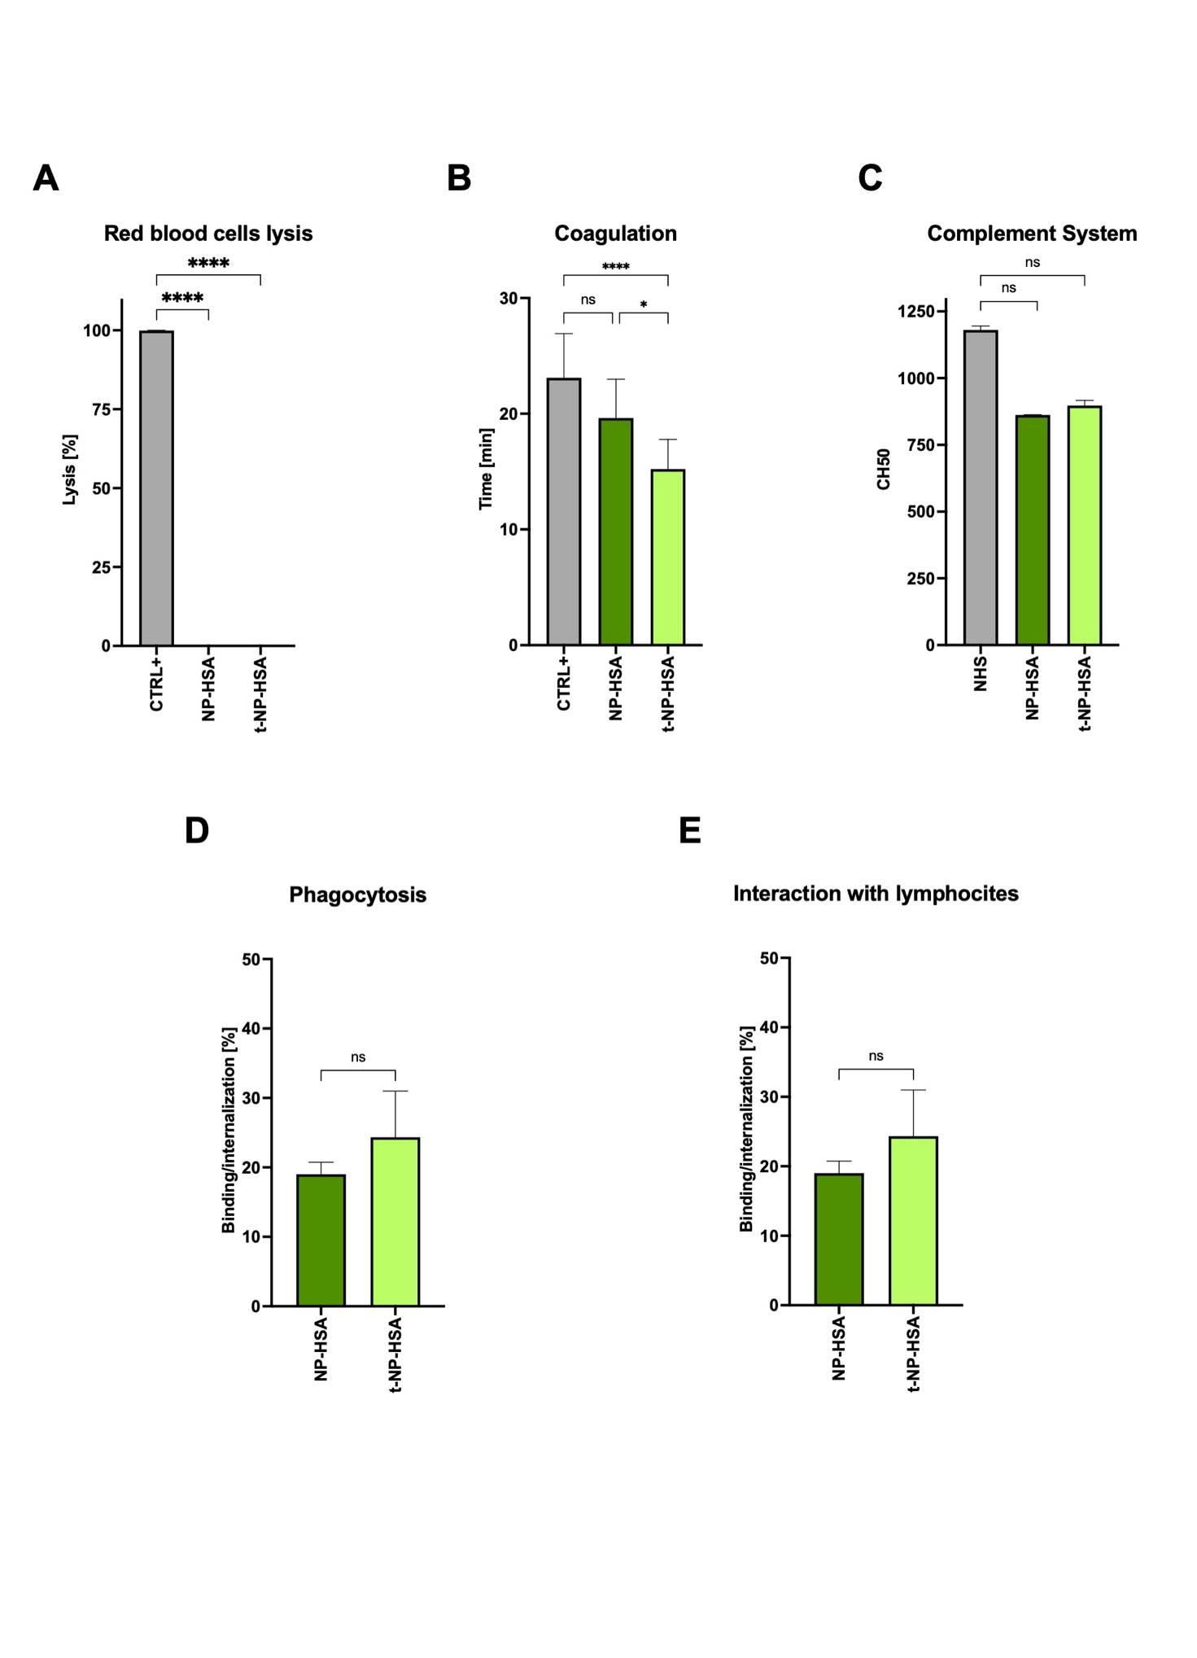
In vitro test for nanoparticle functionality.
(A) In vitro analysis of the direct lysis of the red blood cells. The in vitro turbidity curve trend of NP-HSA and t-NP-HSA in activated plasma during the time was employed to extrapolate (B) the fifty percent coagulation time. Data are shown as potential NPs' effect on the coagulation system. (C) CH50 hemolytic activity was evaluated in NHS, as a control, and in the same NHS after 2 hours of incubation with NP-HSA or t-NP-HSA. White cells were isolated from an healthy donor; 100,000 cells (monocytes or lymphocytes) were incubated in the presence of NHS with 4μL of coated NPs (NP-HSA) and targeted-NPs (t-NP-HSA) at 37° for 1 hour and analyzed by flow cytometry to evaluate the percentage of (D) phagocytosis or (E) the interaction of nanosystems with lymphocytes. The targeting mechanism on the surface of nanosystems does not alter the interaction with these cells. Data are reported as the mean ± SD. Statistical analysis: t-test. P ≤ 0.1 = *; P ≤ 0.0001 = ****. P≥0.05=ns.

