Catalogue

Table S1. Relationship between univariate and the risk of any vascular complications……….2
Table S2. Covariance analysis……………………………………………………………………….3
Table S3. Relationship between RAR, leukocyte-derived ratio and eGFR……………...………4
Table S4. Relationship between RAR and diabetic retinopathy……………...…………………..5
Figure S1. ROC curve for RAR prediction of any vascular complication…...……………………6
Figure S2. ROC curves for RAR prediction of atherosclerosis of the lower limbs.……………..7

Table S1. Relationship between univariate and the risk of any vascular complications
Variables | Any vascular complication
Variables | OR | 95%CI | P-value
Male, n (%) | 0.705 | 0.415-1.198 | 0.196
Age(years) | 1.112 | 1.080-1.144 | ＜0.001*
SBP(mmHg) | 1.013 | 0.996-1.031 | 0.131
DBP(mmHg) | 0.982 | 0.952-1.014 | 0.271
BMI(kg/m²) | 0.947 | 0.888-1.009 | 0.092
Hb1c(%) | 0.994 | 0.948-1.043 | 0.819
GLU(mmol/L) | 0.946 | 0.866-1.034 | 0.223
Hgb(g/L) | 0.969 | 0.954-0.984 | ＜0.001*
HsCRP(mg/L) | 1.002 | 0.985-1.019 | 0.843
TCH(mmol/L) | 0.906 | 0.758-1.083 | 0.276
TG(mmol/L) | 0.998 | 0.820-1.214 | 0.984
HDL(mmol/L) | 0.84 | 0.388-1.821 | 0.659
LDL(mmol/L) | 0.847 | 0.655-1.095 | 0.205
URIC(umol/L) | 1.001 | 0.999-1.003 | 0.368
Duration of diabetes(years) | 1.088 | 1.042-1.135 | ＜0.001*
Use of insulin, n (%) | 1.163 | 0.635-2.132 | 0.625
Use of oral hypoglycemic agents or GLP-1RAs, n (%) | 1.735 | 1.017-2.961 | 0.043*
Hypertension, n (%) | 3.857 | 2.242-6.635 | ＜0.001*
Hyperlipidemia, n (%) | 0.552 | 0.329-0.927 | 0.025*
Use of antihypertensive drugs, n (%) | 4.044 | 2.276-7.183 | ＜0.001*
Use of lipid-lowering drugs, n (%) | 2.794 | 1.165-6.703 | 0.021*
Smoking, n (%) | 1.539 | 0.879-2.694 | 0.131
Drinking, n (%) | 1.467 | 0.838-2.569 | 0.18

* P < 0.05
Abbreviations: OR, odds ratio; CI, confidence interval; * P < 0.05,SBP, Systolic blood pressure; DBP, Diastolic blood pressure; HbA1c, Glycated hemoglobin A1c; HsCRP, Human hypersensitive C Reactive Protein; TCH, Total cholesterol; TG, Triglycerides; HDL-C, High-density lipoprotein cholesterol; LDL-C, Low-density lipoprotein cholesterol; URIC, Uric Acid; UACR, urinary albumin/creatinine ratio; RDW, Red blood cell distribution width.

Table S2. Covariance analysis
 | Tolerance | VIF
Sex | 0.757 | 1.322
Age | 0.675 | 1.482
BMI | 0.877 | 1.14
Duration of diabetes | 0.734 | 1.362
Hb1c | 0.947 | 1.056
Hypertension | 0.28 | 3.577
Hyperlipidemia | 0.804 | 1.244
Smoking | 0.884 | 1.132
Drinking | 0.905 | 1.105
Use of antihypertensive drugs | 0.273 | 3.668
Use of lipid-lowering drugs | 0.883 | 1.132
Use of oral hypoglycemic agents or GLP-1RAs | 0.848 | 1.179
Use of insulin | 0.859 | 1.164
TCH | 0.713 | 1.402
TG | 0.761 | 1.314
HsCRP | 0.953 | 1.05
Hgb | 0.85 | 1.177

Abbreviations: VIF, variance inflation factor; HbA1c, Glycated hemoglobin A1c; HsCRP, Human hypersensitive C Reactive Protein; TCH, Total cholesterol; TG, Triglycerides.

Table S3. Relationship between RAR, leukocyte-derived ratio and eGFR
Variables | eGFR
Variables | OR (95% CI)^{d} | P-value
RAR | 1.846(1.122,3.039) | 0.016*
Q1 | Reference
Q2 | 0.594(0.225,1.573) | 0.295
Q3 | 0.909(0.359,2.303) | 0.84
Q4 | 1.231(0.495,3.058) | 0.655
P-trend |  | 0.4
NLR | 1.514(1.235,1.856) | ＜0.001*
PLR | 1.012(1.006,1.017) | ＜0.001*

* P < 0.05
Abbreviations: Odds ratios (OR) ; 95% confidence intervals (95%CI); red cell distribution width/albumin ratio (RAR); neutrophils/lymphocytes (NLR); platelets/lymphocytes (PLR).
d Model 4：Adjusted for sex, age, BMI, duration of diabetes, Hb1c, hypertension, hyperlipidemia, smoking, drinking, use of antihypertensive medications, use of lipid-lowering medications, use of oral hypoglycemic agents or GLP-1RA, use of insulin, TCH, TG, HsCRP, Hgb.

Table S4. Relationship between RAR and diabetic retinopathy
Variables | Diabetic retinopathy
Variables | OR (95% CI)^{d} | P-value
RAR | 1.286(0.864,1.915) | 0.215
Q1 | Reference
Q2 | 0.836(0.448,1.562) | 0.575
Q3 | 0.779(0.409,1.485) | 0.448
Q4 | 1.183(0.633,2.211) | 0.598
P-trend |  | 0.575

* P < 0.05
Abbreviations: Odds ratios (OR) ; 95% confidence intervals (95%CI); red cell distribution width/albumin ratio (RAR).
d Model 4：Adjusted for sex, age, BMI, duration of diabetes, Hb1c, hypertension, hyperlipidemia, smoking, drinking, use of antihypertensive medications, use of lipid-lowering medications, use of oral hypoglycemic agents or GLP-1RA, use of insulin, TCH, TG, HsCRP, Hgb.

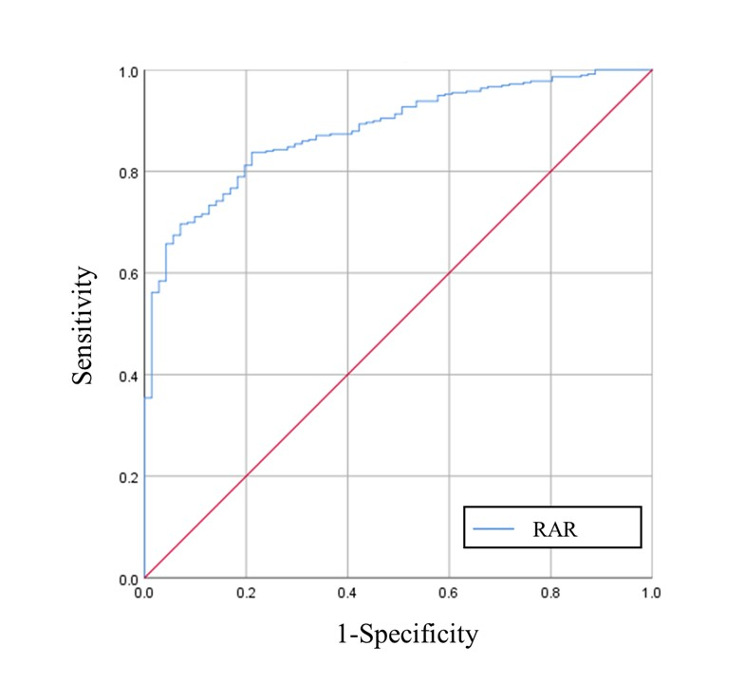
Figure S1. ROC curve for RAR prediction of any vascular complication

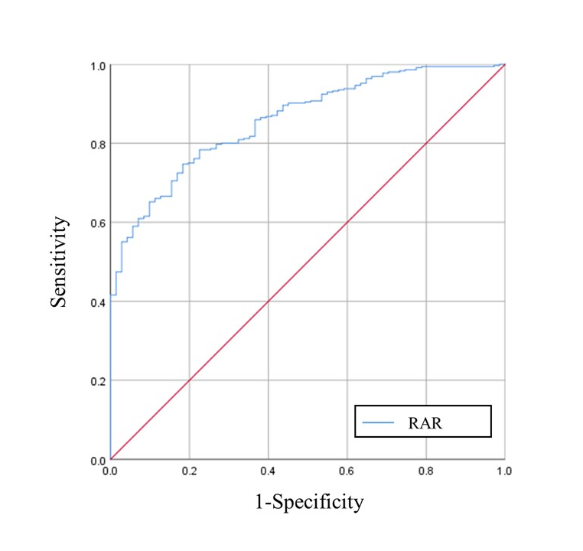
Figure S2. ROC curves for RAR prediction of atherosclerosis of the lower limbs

