Supplementary Materials
S1. Materials
All reagents used in preparation of the NiCuFe-S including trisodium citrate dihydrate (C₆H₅Na₃O₇·2H₂O), potassium ferricyanide (K₃Fe(CN₎₆), copper nitrate trihydrate (Cu(NO₃)₂·3H₂O), nickel(II) nitrate hexahydrate (Ni(NO₃)₂·6H₂O), sodium sulfide (Na₂S·9H₂O) were purchased from Sinopharm Chemical Reagent Co., Ltd. (Shanghai, China). Doxorubicin hydrochloride (DOX), calcein acetoxymethyl ester (calcein AM), and propidium iodide (PI) were provided by Aladdin Biochemical Technology Co.,Ltd. (Shanghai, China). Thiol PEG amine (SH-PEG-NH₂) was obtained from Chemgen Pharma Biochemical Technology Co.,Ltd (Beijing, China). Fetal bovine serum (FBS) Alpha minimum essential medium, and Dulbecco's Modified Eagle's Medium (DMEM) were obtained from KeyGEN BioTECH Co., Ltd. (Jiangsu, China). CCK8 assay was purchased from Vicmed Bioengineering Co., Ltd. (Jiangsu, China). Mouse monoclonal antibody (Abs) against Bcl-2, mouse monoclonal antibody against β- tubulin were purchased from Proteintech. Caspase-3 was purchased from AB clone.
S2. Characterization
The characterization instruments included transmission electron microscopy (TEM, TecnaiTM G² TWIN, FEI, USA)), field-emission transmission electron microscopy (FETEM, Tecnai G2 F30 S-TWIN, FEI, USA), scanning electron microscopy (SEM, Teneos VS, FEI, USA), ultraviolet spectrometer (UV-vis, AOE, UV-1902, China), X-ray diffractometer (XRD, D8 ADVANCE, Bruker, Germany), electron paramagnetic resonance spectrometer (EPR, JESFA200, JEOL, Japan). An 808 nm and 1064 nm NIR laser (Beijing Laserwave OptoElectronics Technology Co., Ltd, China) and an IR camera (Shanghai Rexiang Technology Co., Ltd, Fotric 225, China) were used to evaluate the photothermal performance of the as-prepared nanomaterials. In cells and animal experiments, microplate Reader (Bio-rad, Mode 680, USA), fluorescent microscope (Olympus, RX73, Japan) and confocal laser scanning microscope (CLSM, Leica, STELLARIS 5, Germany) was used. Blood routine indexes and blood biochemistry (ALT-alanine aminotransferase; AST: aspartate aminotransferase; T-BIL-total bilirubin; ALB-albumin; WBC-white blood cells; RBC-red blood cells; PLT- platelet) were tested by automatic biochemical analyzer (Chemray 800, Rayto, China) and hematology analyzer (BC-2800vet, Mindray, China).
S3. Photothermal and catalytic experiments
The photothermal performance of NiCuFe-S was evaluated using 1064 nm and 808 nm laser irradiation. Specifically, 1.0 mL dispersions of NiCuFe (200 μg/mL) and NiCuFe-S (200 μg/mL) in plastic EP tubes were irradiated by lasers (808 nm and 1064 nm, Beijing Laserwave Optoelectronics Technology Co., Ltd). Deionized water (1.0 mL) served as a control. Photothermal images of various concentrations of NiCuFe-S dispersions under different output power densities and IR (Fotric 225) camera was used to obtained laser powers. The photostability and of NiCuFe-S were investigated through five "laser on-off" cycle experiments.
Calculation of the photothermal conversion efficiency ():
The photothermal conversion efficiency () was calculated by following eqn:
S is the surface area of the container; h is the heat transfer coefficient, T_{max} is the equilibrium temperature; T_{surr} is the ambient temperature of the surroundings, Q _{dis} expresses the heat associated with the light absorbance; A is the absorption intensity of NiCuFe-S at 808 nm, and I is the incident laser power (1.5 W/cm²). The photothermal conversion efficiency () was also calculated by the similar equation using 1064 nm laser (1.0 W/cm²).
Catalytic performance of NiCuFe-S
To assess the catalytic performance and the capability to generate free radicals of NiCuFe-S, 3,3′,5,5′-tetramethylbenzidine (TMB) was employed as a probe. Sequentially, various nanomaterials (NiCuFe and NiCuFe-S) and H₂O₂ (30 μL, w.t. 30%) were added to a TMB buffer solution (30 μL of 0.1 M) with a final concentration of 5 μg/mL for these nanomaterials. UV-vis absorption spectra were utilized to record the characteristic absorption of oxTMB.
S4. Synthesis of NiCuFe PBA
0.5 mmol of copper nitrate and 1.5mmol nickel (II) nitrate hexahydrate and 2.5 mmol of trisodium citrate were dissolved in 50 mL deionized water at room temperature and stirred until clarified to obtain solution A. In addition, 2 mmol of potassium ferricyanide was dissolved in 50 mL deionized water to obtain solution B. Solution A was mixed with solution B and stirred continuously for ten minutes with a magnetic stirrer, after which it was left at room temperature for 24 h, centrifuged and washed with deionized water three times. The Prussian blue analogue NiCuFe PBA was obtained.
S5. The detail of anti-cancer experiments of hollow NiCuFe-S in vitro
The P-NiCuFe-S were foremost diluted to specific concentration (0, 6.25, 12.5, 25, 50, 100, 200μg/mL) using DMEM medium with 10% FBS. Normal rat proximal renal tubular epithelial cell line (NRK-52E) was seeded with an initial density of 1 × 10⁴ cells/mL in a 96 well plate and cultured in an incubator. After the cells adhere to the wall, incubate them with fresh DMEM samples of different concentrations for 24 h. Then, fresh Cell Counting Kit (CCK8) solution was added and incubated for 3 h. Cell viability was measured at 450 nm absorbance, with each concentration repeated 3 times. Then, anti-cancer performance of P-NiCuFe-S and DP-NiCuFe-S was also studied using the same procedure. Hela cells were selected and co-incubated with P-NiCuFe-S and DP-NiCuFe-S with different concentrations in 96-well plates. The results are expressed as % cell viability, with cells without added nanoparticles as the control. Cell viability (%) =A (Treatment group)/B (Control group)×100%.
S6. Intracellular reactive oxygen species (ROS) assay, flow cytometry assay, and western blot experiments
For intracellular reactive oxygen species (ROS) assay, Hela cells (1×10⁵ cells) were seeded into a confocal dish for 12 hours, and treated with fresh DMEM containing nanomaterials (100 μg/mL) with or without 1064 nm irradiation. Then, 2 mL of DCFH-DA (10 μM/L) was added and the observations was made under a confocal laser scanning microscope (CLSM, Leica, STELLARIS 5). For flow cytometry, cells (1×10⁶ cells) were seeded into a 6-well plate overnight for cell attachment. After treated with P-NiCuFe-S and DP-NiCuFe-S of 100 μg/mL in different groups for 12 hours, Annexin V-FITC and PI were added. Each group was detected by flow cytometer (Becton Dickinson FACSCanto II) for three times. The western blot technique was used to detect the protein expression of the Hela cells treated with modified and drug-loaded NiCuFe-S (P-NiCuFe-S and DP-NiCuFe-S, 100 μg/mL). Firstly, the cells were lysed via whole cell lysates, then the overall protein was separated electrophoretically through SDS-PAGE (10% gel), and transferred to nitrocellulose filter membranes. The membrane was blocked with nonfat dry milk (5%) and incubated with primary polyclonal antibodies (Bcl-2, caspase-3, and β-tublin) overnight and subsequently incubated with the secondary antibody for 1 h at room temperature. Finally, antibody binding was detected by Infrared Imaging System (Odyssey CLX).

Fig.S1. Diffuse reflectance spectra of NiCuFe and hollow NiCuFe-S.

Fig.S2. Heating curves NiCuFe-S solutions (200 μg/mL) under 808 nm NIR laser irradiation (5 min) with different laser powers.

Fig.S3. (a, b) Calculation of the band gap (Eg value) of NiCuFe and NiCuFe-S using the Kubelka-Munk function

Fig.S4. FTIR spectrum of NiCuFe-S and P-NiCuFe-S

Fig.S5. Zeta potential P-NiCuFe-S and DP-NiCuFe-S
Fig.S6. TEM images of (a) P-NiCuFe-S and (b) DP-NiCuFe-S.

Fig.S7. Photothermal conversion curves of P-NiCuFe-S, DP-NiCuFe-S (200 μg/mL) under 808 nm NIR laser irradiation (1.5 W/cm²).

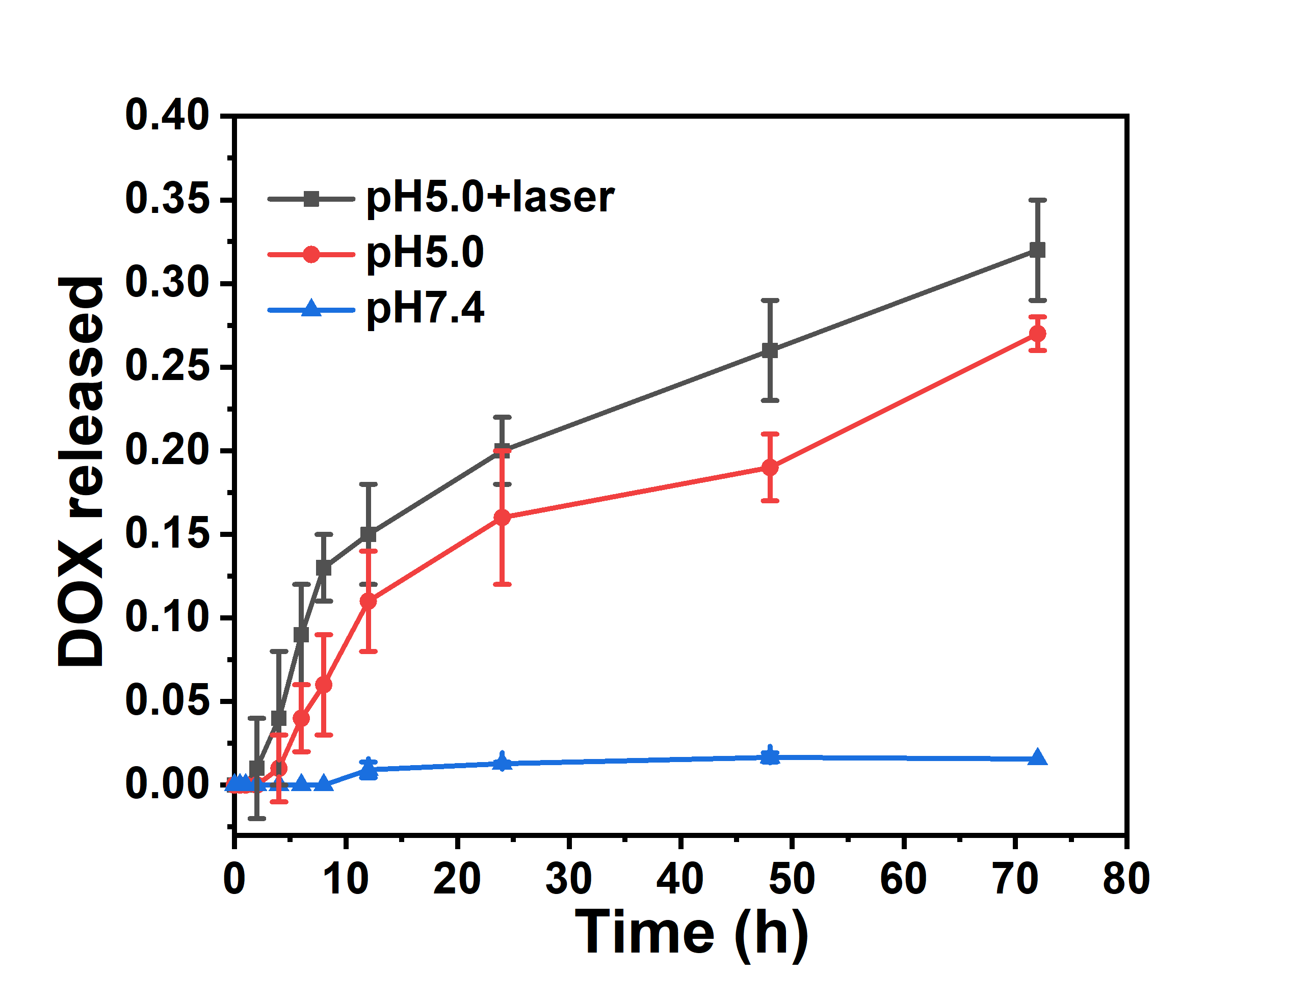
Fig.S8. DOX release behavior of DP-NiCuFe-S at different PH.

