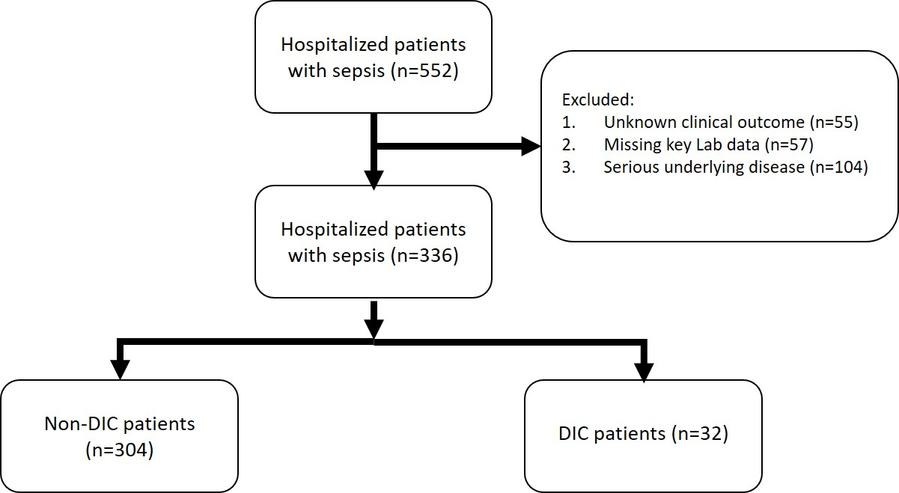

Supplementary figure 1. The flow chart of the study.

