Title: EIF4A3 enhances the proliferation and cell cycle progression of keloid fibroblasts by inducing the Hsa_circ_0002198 expression

Table S1

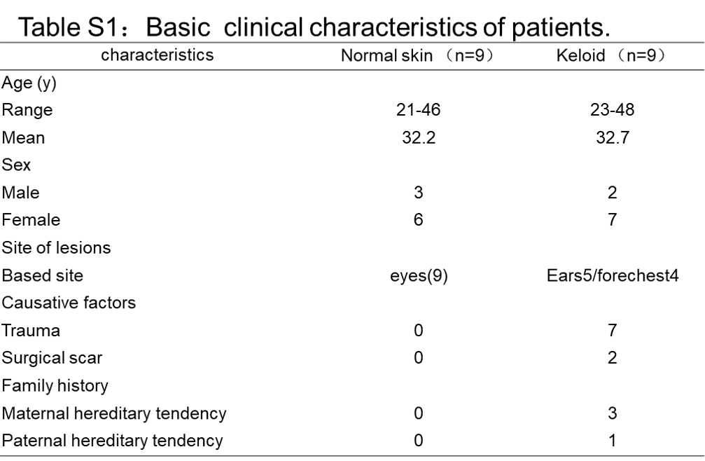

Table S2
