Supplementary Online Content
Association between blood-brain barrier disruption and stroke-associated pneumonia in acute ischemic stroke patients after endovascular therapy: a retrospective cohort study
Figure S1 Examples of HALs in patients with acute large vessel occlusion in anterior circulation.
Table S1 Effect of CT value Level on SAP: Adjusted odds ratios from egmented logistic regression analysis.
Table S2 The Role of SAP in Mediating the Relationship Between BBB distuption and Functional outcome at 3 months: Mediation analysis
Table S3 Comparative analysis of demographic and clinical variables in patients with BBB disruption and without BBB disruption before and after IPTW adjustment.
Table S4 Associations of BBB disruption and SAP using the propensity scores of IPTW .
Figure S2 LASSO regression analysis was used to select characteristic factors.
Table S5 Before and after adjusted by logistic regression analyses of the associations between BBB disruption and SAP.
Figure S3 E-values for the OR of SAP in patients with BBB disruption.

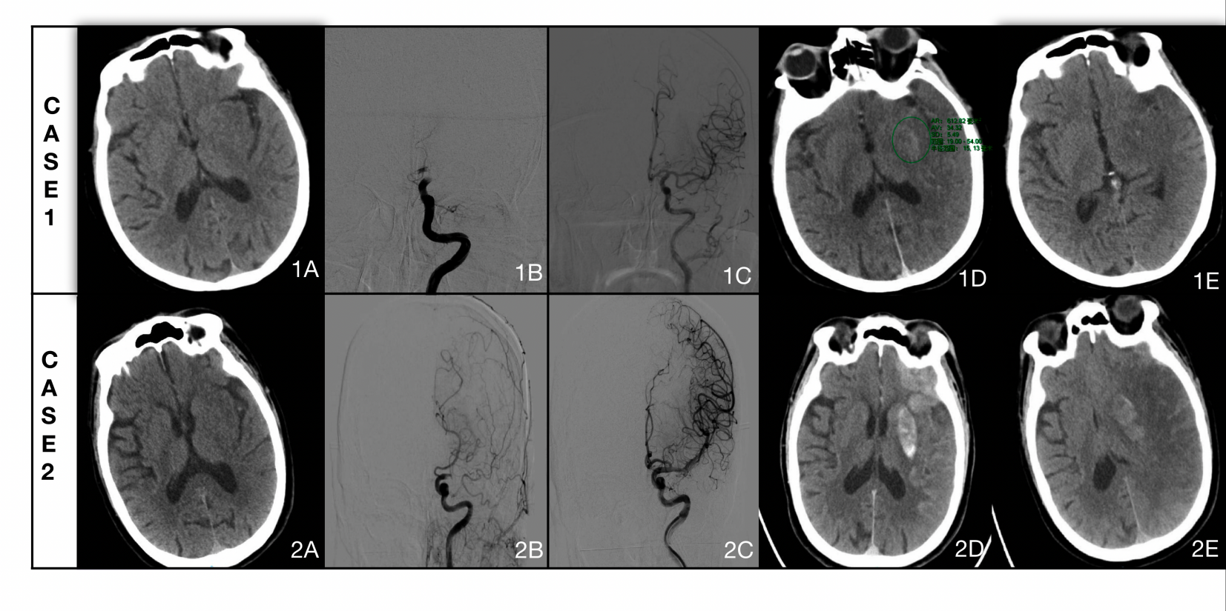

Figure S1 Examples of HALs in patients with acute large vessel occlusion in anterior circulation. CASE-1 a 79- year-old women:(1A) Head CT on admission,(1B)Emergency DSA showed occlusion of the left internal carotid artery and was successfully recanalized (1C).A small amount of HALs in the left basal ganglia area can be seen on immediate CT after endovascular therapy(1D) and the highest CT vlaue was 54HU. The HALs on follow-up CT performed at 24 h (1E) had vanished. CASE-2 a 77-year-old men:The admission CT showed no abnormality(2A). Emergency DSA showed occlusion of the left middle cerebral artery M1-segment. After successful recanalized(2C), the immediate CT showed a large range of HALs in the left cerebral hemisphere and the the highest CT vlaue was 232HU (2D). 24 hours after surgery, the head CT showed most of HALs area was absorbed, however, there were extensive edema in the area with a small amount of hemorrhagic transformation in the left basal ganglia(2E). Abbreviations: DSA, digital subtraction angiography; HALs, hyperattenuated intracerebral lesions.

Table S1 Effect of CT value Level on SAP: Adjusted odds ratios from egmented logistic regression analysis
Characteristic | OR | 95% CI | p-value
CT value (< 114 HUmax) | 1.03 | 1.02, 1.04 | <0.001
CT value (≥ 114 HUmax) | 1.00 | 1.0, 1.00 | 0.63
Note: ORs were adjusted for age, sex, diabetes mellitus, previous stroke, preoperative NIHSS score, preoperative GCS score, dysphagia, anesthesia method, occlusion site, time from onset to groin puncture, and modified TICI score.
Abbreviations: CI, confidence interval; HUmax, maximum hounsfield units; OR, Odds Ratio.

Table S2 The Role of SAP in Mediating the Relationship Between BBB disruption and Functional outcome at 3 months: Mediation analysis

Independent variable | Mediator | Total effect |  | Indirect effect |  | Direct effect |  | Proportion mediated, % (95% CI)
Independent variable | Mediator | Coefficient  (95% CI) | P value | Coefficient  (95% CI) | P value | Coefficient  (95% CI) | P value | Proportion mediated, % (95% CI)
BBB disruption | SAP | 0.15 (0.05, 0.30) | <0.001 | 0.01 (0.00, 0.07) | 0.048 | 0.13 (0.01, 0.26) | 0.020 | 9.8 (0.4, 76.7)
Note: The mediation analyses were adjusted for age, sex, modified TICI score, dysphagia, previous stroke, atrial fibrillation, preoperative NIHSS, groin puncture to recanalization time, onset to groin puncture time and preoperative GCS≤8.
Abbreviations: BBB, blood-brain barrier; GCS, glasgow coma scale; SAP, stroke-associated pneumonia; TICI, treatment in cerebral ischemia.

Table S3 Comparative analysis of demographic and clinical variables in patients with BBB disruption and without BBB disruption before and after IPTW adjustment.
Variables | Before IPTW |  |  |  | After IPTW
Variables | BBB disruption |  | SMD |  | BBB disruption |  | SMD
Variables | Yes (n=155) | No (n=99) | SMD |  | Yes (n=250.5) | No (n=250.4) | SMD
Age, mean ± SD, y | 67.32 (12.78) | 63.75 (14.13) | 0.265* |  | 66.34 (12.81) | 67.26 (14.30) | 0.067
Male, n (%) | 89 (57.4) | 57 (57.6) | 0.003* |  | 146.5 (58.5) | 145.7 (56.6) | 0.038
Diabetes mellitus, n (%) | 27 (17.4) | 30 (30.3) | 0.306* |  | 56.9 (22.7) | 60.7 (23.6) | 0.021
Previous stroke, n (%) | 30 (19.4) | 13 (13.1) | 0.169* |  | 44.2 (17.6) | 42.4 (16.5) | 0.031
Preoperative NIHSS, mean ± SD | 15.83 (6.01) | 11.62 (6.13) | 0.695* |  | 14.50 (6.03) | 14.40 (6.62) | 0.016
Preoperative GCS≤8, n (%) | 18 (11.6) | 3 ( 3.0) | 0.334* |  | 21.0 ( 8.4) | 16.7 ( 6.5) | 0.071
Dysphagia, n (%) | 89 (57.4) | 57 (57.6) | 0.003* |  | 146.5 (58.5) | 145.7 (56.6) | 0.038
Occlusion site, n (%) |  |  | 0.192* |  |  |  | 0.040
Internal carotid artery | 59 (38.1) | 35 (35.4) |  |  | 142.8 (57.0) | 141.7 (55.1)
M1 segment of MCA | 87 (56.1) | 53 (53.5) |  |  | 91.7 (36.6) | 97.9 (38.0)
M2 segment of MCA | 9 ( 5.8) | 11 (11.1) |  |  | 16.0 ( 6.4) | 17.7 ( 6.9)
Anesthesia method, n (%) |  |  | 0.526* |  |  |  | 0.019
Local anesthesia | 29 (18.7) | 37 (37.4) |  |  | 65.0 (26.0) | 68.8 (26.7)
Conscious sedation | 115 (74.2) | 49 (49.5) |  |  | 160.3 (64.0) | 163.4 (63.5)
General anesthesia | 11 (7.1) | 13 (13.1) |  |  | 25.2 (10.1) | 25.2 (9.8)
Onset to groin puncture time,mean ± SD, min | 413.02 (268.98) | 542.39 (447.44) | 0.350* |  | 454.46 (317.45) | 447.31 (358.02) | 0.021
Modified TICI score < 2b, n (%) | 9 ( 9.1) | 19 (12.3) | 0.103* |  | 27.3 (10.9) | 26.8 (10.4) | 0.016

Note: All variables above are selected based on the DAG(Figure 2).
*A Standardized mean difference > 0.1 indicates a difference between groups.
The calculation method of weighting coefficient proposed by Robins et al.: Weight of patients with BBB disruption: Wt=1/P_{S}; Weight of patients without BBB disruption: Wc=1 /(1-PS). PS represents the propensity score of each study object.
Abbreviations: BBB, blood-brain barrier; CI, confidence interval; GCS, glasgow coma scale; IPTW, inverse probability of treatment weighting; MCA, middle Cerebral Artery; NIHSS, national Institutes of Health Stroke Scale; SAP, stroke-associated pneumonia; SMD, standardized mean difference; TICI , treatment in cerebral ischemia score.

Variable | Before IPTW |  |  | After IPTW
 | OR (95% CI)¹ | P |  | OR (95% CI) ² | P
BBB disruption | 4.419 (2.478-8.111) | <0.001 |  | 2.697 (1.121-4.785) | 0.01
Table S4 Associations of BBB disruption and SAP using the propensity scores of IPTW (Robins et al.)

Note: 1. OR were calculated using logistic regression model without any adjustment
2. OR were calculated using logistic regression model after giving weight to each research object. The calculation method of weighting coefficient proposed by Robins et al.: Weight of HALs: Wt=1/P_{S}; Weight of Non-HALs: Wc=1 /(1-PS). PS represents the propensity score of each study object.
Abbreviations: BBB, blood-brain barrier; CI, Confidence Interval; IPTW, Inverse probability of treatment weighting; OR, odds ratio; SAP, stroke-associated pneumonia.

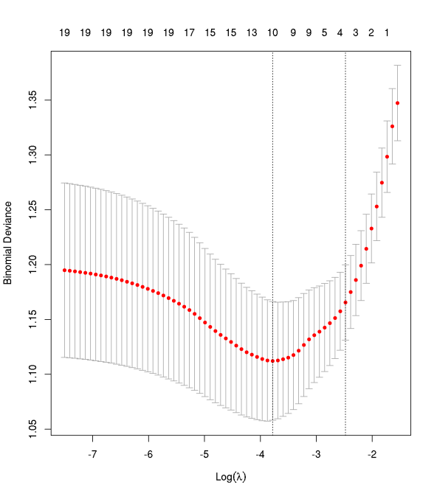
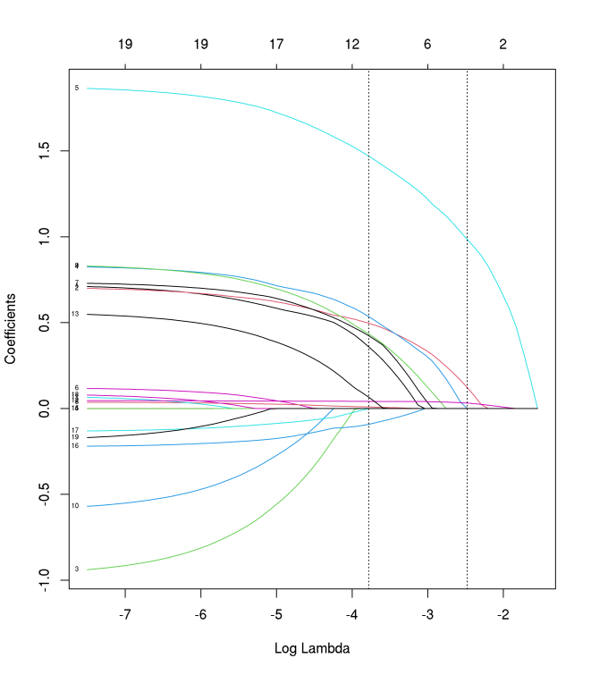

- (b)
Figure S2 LASSO regression analysis was used to select characteristic factors. (a) The use of 10-foldcross-validation to draw vertical lines at selected values, where the optimal lambda produces ninenonzero coefficients.(b) In the LASSO model, the coefficient profiles of 20 variable (age, sex, hypertension, diabetes mellitus, atrialn fibrillation, COPD, previous stroke, smoking, preoperative NIHSS, preoperative GCS≤8, dysphagia, proton pump inhibitors, occlusion site, stroke side, anesthesia method, endovascular therapy method, onset to groin puncture time, groin puncture to recanalization time, modified TICI score, HALs) were drawn from the log (λ) sequence. Vertical dotted lines are drawn at the minimum mean square error (λ = 0.023) .The variables selected for the corresponding model are: BBB disruption, Age, Sex, Previous stroke, Smoking, Preoperative NIHSS, Preoperative GCS≤8, Dysphagia, Endovascular therapy method, Modified TICI score. Abbreviations: BBB, blood-brain barrier; COPD, chronic obstructive pulmonary disease; GCS, glasgow coma scale; NIHSS, national institutes of health stroke scale; TICI, treatment in cerebral ischemia.

Variables | Unadjusted |  |  | Adjusted¹
 | OR (95% CI) | P |  | OR (95% CI) | P
HALs | 4.419 (2.478-8.111) | <0.001 |  | 2.196 (1.093-4.784) | 0.028
Table S5 Before and after adjusted by logistic regression analyses of the associations between BBB disruption and SAP.

Note:1.The logistic analyses were adjusted for Age, Sex, Previous stroke, Smoking, Preoperative NIHSS, Preoperative GCS≤8, Dysphagia, Endovascular therapy method, Modified TICI score.
Abbreviations: BBB, blood-brain barrier; CI, confidence interval; GCS, glasgow coma scale; NIHSS, national institutes of health stroke scale; OR, odds ratio; SAP , stroke-associated pneumonia; TICI, treatment in cerebral ischemia score.

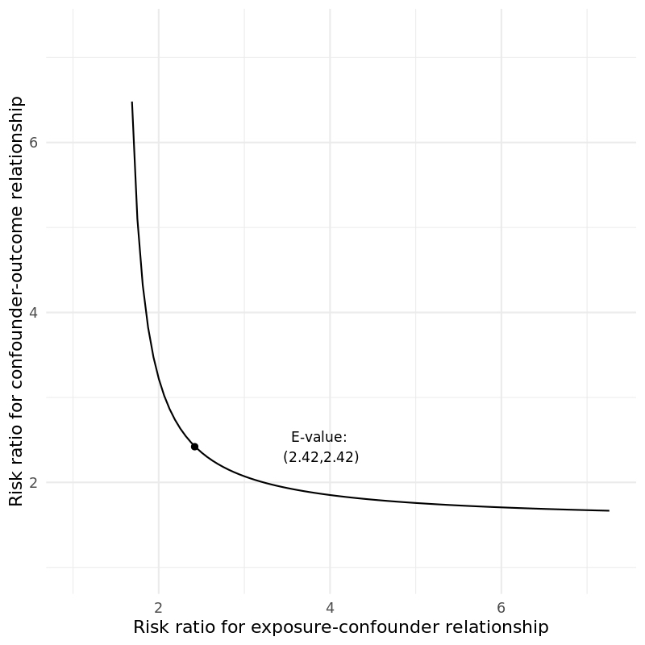

Figure S3 E-values for the OR of SAP in patients with BBB disruption. E-value for point estimate: 2.42 and for confidence interval: 1.31. The calculation of E value is based on the OR and 95% CI of modle 4 in Table 2.
Abbreviations: BBB, blood-brain barrier; CI, confidence interval; OR, odds ratio; SAP, stroke-associated pneumonia.
Calculation tool:E-value calculator (https://www.evalue-calculator.com/evalue/).

