Appendix A. Supplementary data
● Figure S1A Lequesne MG
group | n | Before intervention | After intervention
Control | 6 | 0.0 (0.0) | 0.0 (0.0)
KOA | 6 | 7.5 (1.125) ** | 7.25(0.625) **
KOA+Apo | 6 | 7.25 (0.75) ** | 3.75 (1.125) ##

● Figure S1B PROM
group | n | Before intervention | After intervention
Control | 6 | 142.68 ± 3.89 | 142.30 ± 3.05
KOA | 6 | 48.83 ± 3.31** | 58.50 ±2.22**
KOA+Apo | 6 | 48.28 ± 3.55** | 100.20 ± 4.49##

● Figure S2B Mankin's score
group | n | Mankin's score
Control | 6 | 0.83 ± 0.67
KOA | 6 | 8.50 ± 0.80**
KOA+Apo | 6 | 5.67 ± 0.91**

● Figure S3B Col-II and aggrecan
group | n | Col-II | aggrecan
Control | 6 | 0.829 ± 0.049 | 0.640 ± 0.034
KOA | 6 | 0.326 ± 0.018** | 0.154 ± 0.014**
KOA+Apo | 6 | 0.619 ± 0.018## | 0.414 ± 0.022##

● Figure S4B IL-7 and MMP-13
group | n | IL-7 | MMP-13
Control | 6 | 24.71 ± 1.10 | 67.63 ± 3.64
KOA | 6 | 46.01 ± 2.64** | 201.58 ± 9.13**
KOA+Apo | 6 | 30.42 ± 1.54## | 119.6 ± 13.19##

● Figure S4C Western blots
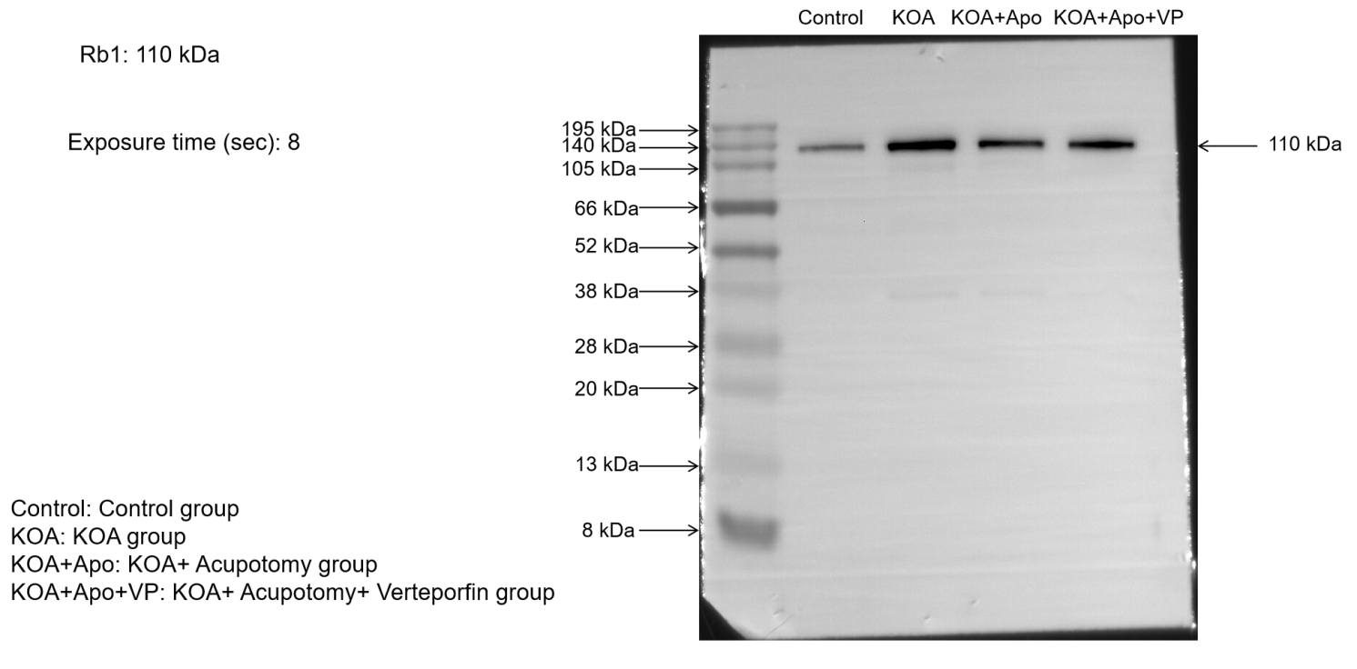
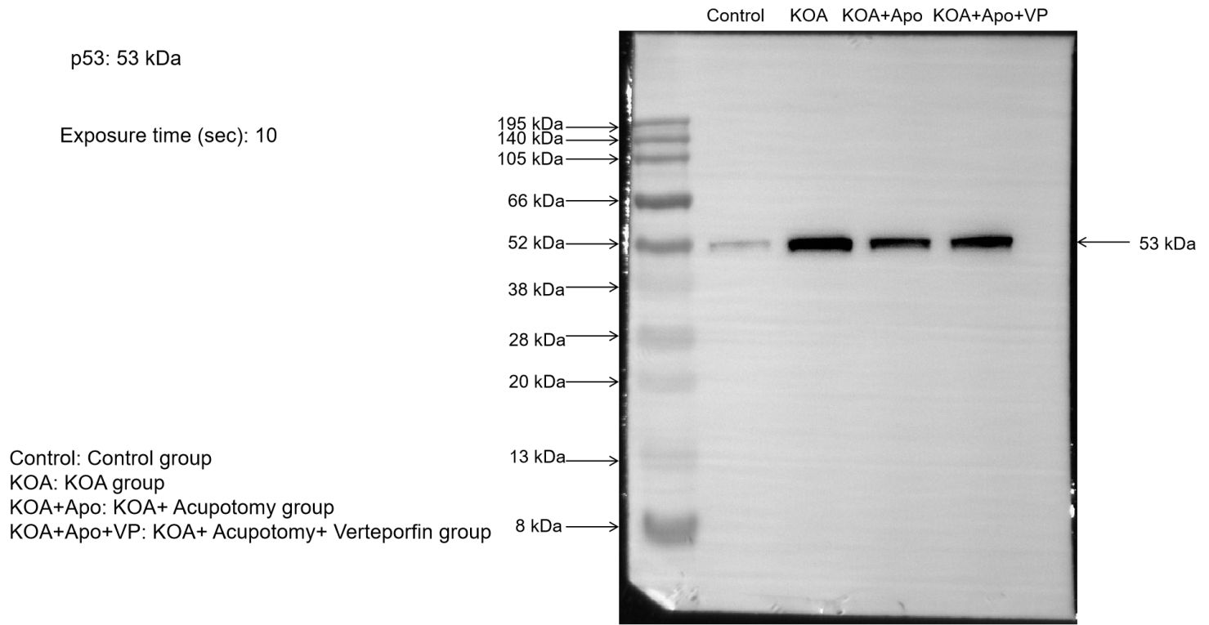
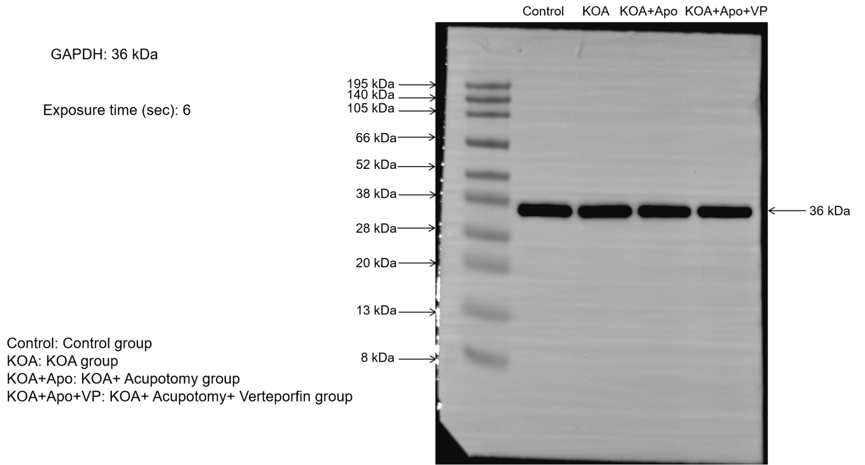
● Figure S4D p53 and Rb1
group | n | p53 | Rb1
Control | 6 | 0.10 ± 0.03 | 0.15 ± 0.03
KOA | 6 | 0.60 ± 0.03** | 0.50 ± 0.03**
KOA+Apo | 6 | 0.40± 0.02## | 0.28 ± 0.03##

● Figure S5A Western blots
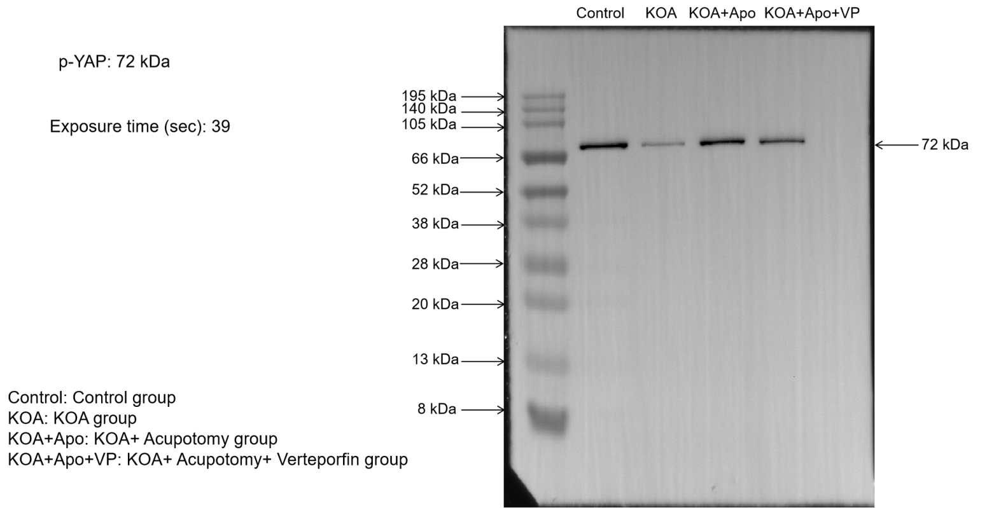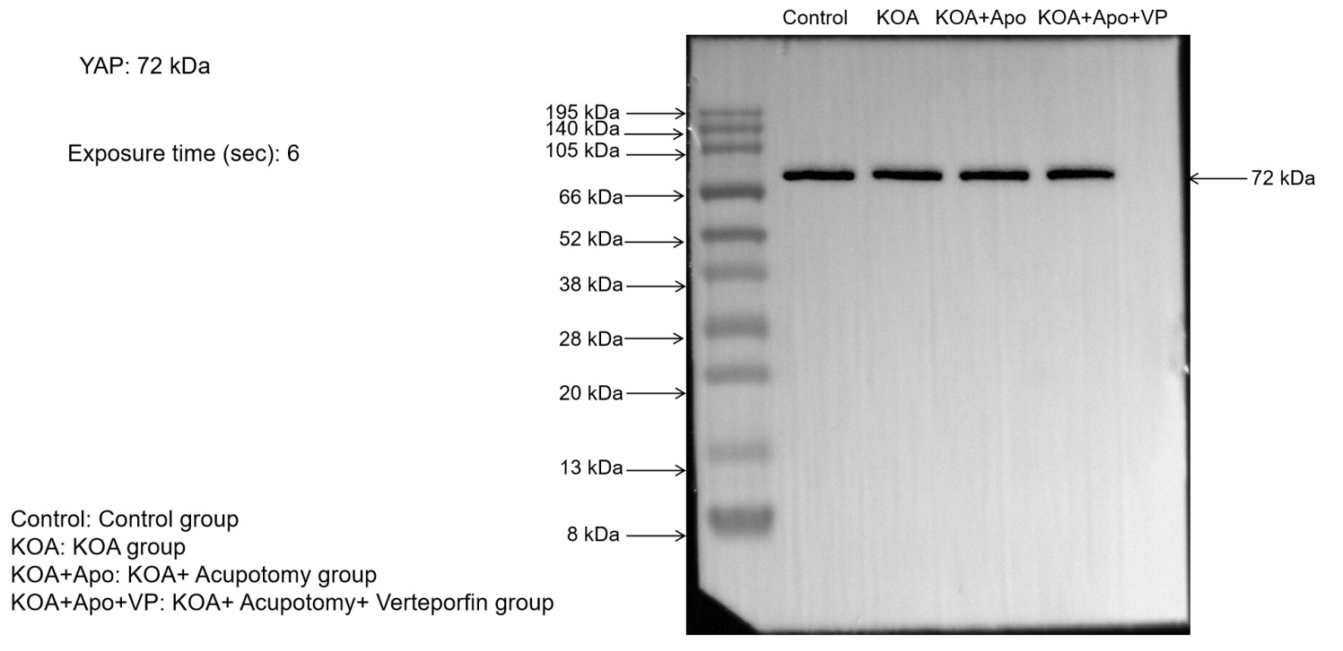
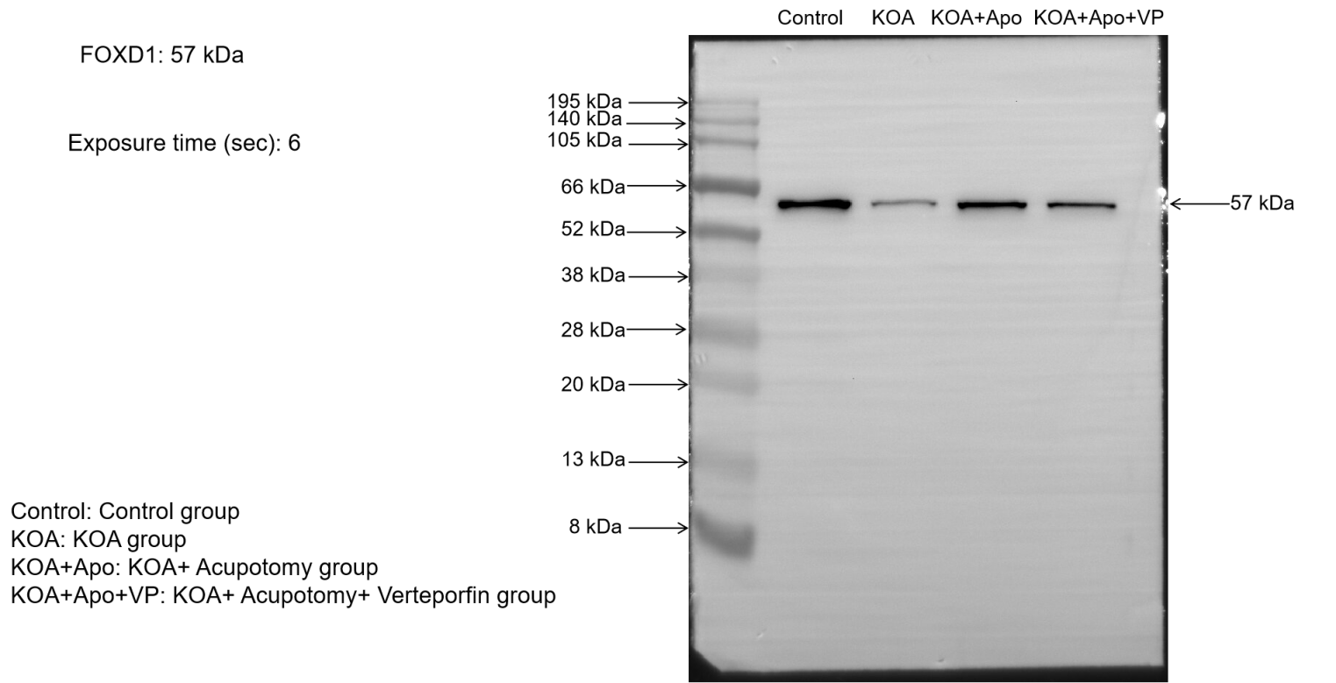
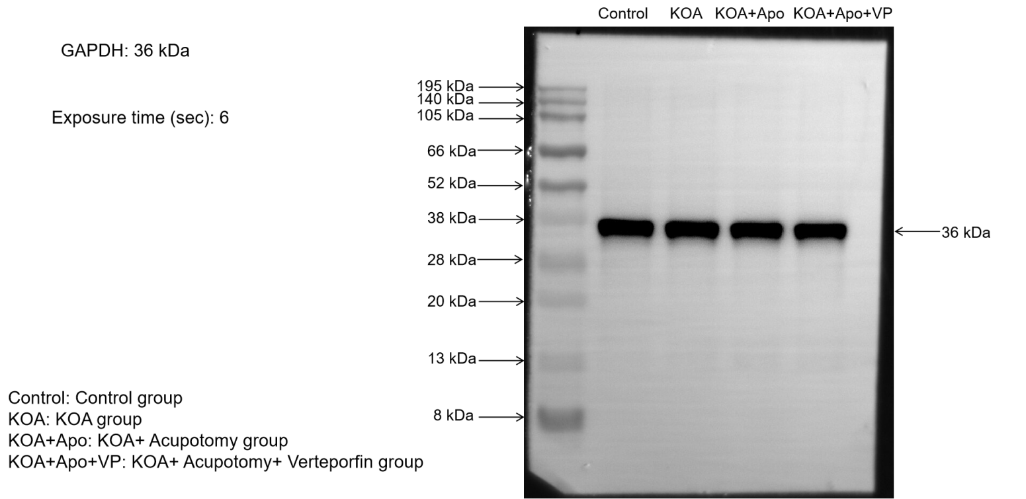

● Figure S5B p-YAP and FOXD1
group | n | p-YAP/YAP | FOXD1 / GAPDH
Control | 6 | 0.677 ± 0.021 | 0.416 ± 0.010
KOA | 6 | 0.148 ± 0.012** | 0.140 ± 0.017**
KOA+Apo | 6 | 0.526 ± 0.025## | 0.366± 0.012##

● Figure S5C mRNA expression levels comparison of p-YAP and FOXD1
group | n | Relative mRNA expression of p-YAP | Relative mRNA expression of FOXD1
Control | 6 | 1.58 ± 0.24 | 0.95 ± 0.18
KOA | 6 | 0.43 ± 0.10** | 0.28 ± 0.10**
KOA+Apo | 6 | 0.71 ± 0.23# | 0.55 ± 0.17##

● Instructions S6: Supplementary Information on Biological Replicate Experiments

1.Sample Source Information
The 18 male New Zealand rabbits used in this experiment were all purchased from Beijing Fulong Tengfei Laboratory Animal Research Institute Co., Ltd. These rabbits had a body weight of (2.50 ± 0.2) kg. After arriving at the laboratory, the animals were housed in standard animal cages, with each rabbit in a separate cage to avoid interference. The breeding environment had a temperature controlled at (22 ± 2) °C, a relative humidity maintained at 40% - 60%, and a 12 - hour light/12 - hour dark cycle lighting mode with natural light illumination. The animals had free access to standard rabbit feed and water, and the breeding environment was regularly disinfected with ultraviolet light. One week was given for the rabbits to acclimatize to the environment before the formal experiment.

2.Number of Replicates
To ensure the reliability and reproducibility of the experimental results, 6 independent biological replicates were conducted for each treatment group, with 6 New Zealand rabbits in each group.

3.Grouping
The 18 male New Zealand rabbits were randomly divided into 3 groups: the control group, the knee osteoarthritis (KOA) group, and the knee osteoarthritis + acupotomy (KOA + Apo) group, with 6 rabbits in each group. The rabbits in the KOA and KOA + Apo groups were modeled using the modified Videman method for 6 weeks. After the modeling, the rabbits in the KOA + Apo group received acupotomy once a week for 3 weeks on the muscles around the left hind knee. After the treatment, the rabbits were sacrificed under anesthesia. The left knee joint was surgically incised under aseptic conditions, the joint cavity was opened, and sufficient cartilage was scraped off with a surgical blade and placed in a cryotube. The cryotube was then transferred to a - 80 °C refrigerator using a liquid nitrogen tank for subsequent Western blot analysis.

4. Experimental Operation Procedures
4.1 Tissue Collection
At the predetermined end - point of the experiment, in strict accordance with aseptic operation procedures, the rabbits were anesthetized, and the left knee joint was surgically incised to fully expose the joint cavity. A surgically sterilized blade was used to carefully and accurately scrape sufficient cartilage tissue, ensuring the integrity and good purity of the collected cartilage tissue. The collected cartilage tissue was immediately placed in a pre - labeled cryotube, which was then quickly transferred to a liquid nitrogen tank and finally stored in a - 80 °C refrigerator to maximize the preservation of the activity and stability of the proteins in the sample.

4.2 Protein Extraction
The frozen cartilage tissue was taken out from the - 80 °C refrigerator. Approximately 40 mg of the cartilage tissue was weighed, cut into pieces, and placed in a pre - cooled grinding tube. At the same time, 3 grinding beads with a diameter of 3 mm were added. Lysis buffer was added according to 10 times the volume of the tissue (with the ratio of RIPA lysis buffer to PMSF being 100:1), and the grinding instrument was programmed to grind the tissue. After grinding, the grinding tube was taken out and placed on ice or at 4 °C for 30 minutes for the tissue to lyse in the lysis buffer. Then, the sample was centrifuged at 12000 rpm and 4 °C for 10 minutes. After centrifugation, the supernatant was carefully aspirated, and this supernatant was the total protein solution.

4.3 Protein Quantification
An appropriate amount of the non - denatured protein solution was taken, and the protein concentration was measured using a BCA protein concentration assay kit in strict accordance with the kit instructions. The protein content in each sample was calculated based on the measurement results.

4.4 Protein Denaturation
The protein solution was mixed with 5* reducing protein loading buffer at a ratio of 4:1. The mixture was placed in a metal bath and heated at 95 °C for 10 minutes for denaturation. After denaturation, it was stored in a - 20 °C or - 80 °C refrigerator for future use.

4.5 Gel Preparation Loading, and Electrophoresis
Two gel - making glass plates were taken, cleaned with an appropriate cleaning agent, and then clamped vertically. According to the experimental requirements, a suitable gel - making kit was selected, and solutions A and B were mixed in equal proportions to prepare a 12% separating gel solution. The well - mixed separating gel solution was carefully pipetted along the gap between the glass plates for gel - casting, and isopropanol was used for capping after casting. After the separating gel had fully solidified at room temperature, the isopropanol was poured out. Subsequently, a 5% stacking gel solution was prepared in the same way, quickly poured onto the solidified separating gel, and a sample comb was inserted. After the stacking gel had solidified, the gel - making glass plates were carefully transferred to the electrophoresis tank. Appropriate amounts of electrophoresis buffer were added to the inner and outer sides of the tank, with the inner side filled to the brim and the outer side filled to one - third. Protein samples from each group and the colored pre - stained protein marker were loaded using a pipette. The loading volume for each protein sample well was 10 μl, and that for the protein marker was 4 μl. Electrophoresis was first carried out on the stacking gel at a voltage of 60 V for 20 minutes, and then the voltage was adjusted to 80 V for electrophoresis on the separating gel for 90 minutes. The electrophoresis was terminated when the protein marker was fully separated in the separating gel.

4.6 Electro - transfer
Based on the molecular weights of the target protein and the internal reference protein, the region of the target protein was determined with reference to the protein marker (gloves must be worn throughout the operation to avoid protein contamination from hands). In a container filled with electro - transfer buffer, the transfer clip was opened, and components were placed in the following order: sponge, filter paper, gel, nitrocellulose membrane (PVDF membrane), filter paper, sponge. Pay attention to the placement order of the transfer clip, with the left side being red and the right side being black. The separated gel after electrophoresis was slowly taken out from the glass plate and carefully placed on the filter paper (ensuring that the gel was placed on the black side of the transfer clip). The bubbles on the gel were rinsed with transfer buffer, and the PVDF membrane, which had been pre - activated with ethanol for 2 minutes, was slowly attached to the gel, making sure no bubbles were trapped. Then, the transfer filter paper and transfer sponge were placed in sequence. The clamped "sandwich" structure was placed in the electro - transfer tank filled with rapid transfer buffer, and electro - transfer was carried out at a constant current of 300 mA for half an hour.

4.7 Incubation with Primary and Secondary Antibodies
The PVDF membrane after electro - transfer was placed in an incubation box filled with TBST, quickly rinsed once, and then 5 ml of a 5% skim milk solution was added. The box was placed on a shaking incubator at room temperature for 30 minutes for blocking. According to the antibody instructions, the primary antibody was diluted. After dilution, the blocking solution in the incubation box was poured out, and the prepared primary antibody was added. The incubation box was placed in a 4 °C incubator shaker for overnight incubation (with the shaker running at a slow speed). The primary antibody was recovered, and the membrane was quickly rinsed three times with TBST. After each rinse, the membrane was placed in a container filled with TBST and quickly eluted on a shaking incubator for 5 minutes each time. The secondary antibody was diluted with TBST at a ratio of 1:5000, and the diluted secondary antibody was added to the incubation box. The box was placed on a shaker and incubated at room temperature for 30 minutes with slow shaking. The membrane was quickly rinsed three times again with TBST. After each rinse, the membrane was placed in a container filled with TBST and quickly eluted on a shaking incubator for 5 minutes each time.

4.8 ECL Color Development
The ECL luminescent solution A and B were mixed evenly at a ratio of 1:1 for standby. The PVDF membrane after elution was taken out from the incubation box, placed on absorbent paper, and the liquid on the membrane surface was gently blotted dry. Then, the membrane was placed in the mixed ECL luminescent solution to ensure that the liquid completely covered the membrane. After a 1 - minute reaction, the membrane was taken out and placed on the tray of a chemiluminescence instrument. The chemiluminescence operation was started according to the preset program. After exposure, the original image was saved in TIFF format.

- Measurement of Western Blot Band Gray Values
The gray values of the protein bands were analyzed using Image J software. GAPDH and YAP were used as internal references, and the ratio of the gray value of the target band to that of the internal reference band was taken as the relative expression level of the target protein.

6. Statistical Analysis Methods
6.1 Statistical Software GraphPad Prism software was selected for statistical analysis.
6.2 Statistical Tests One - way analysis of variance (ANOVA) was performed on the experimental data of the three groups. If significant differences were found among the groups, Least significant difference test was further used for pairwise comparisons. A P value < 0.05 was set as the criterion for statistical significance to evaluate the differences in protein expression levels among different treatment groups.

