Materials
Distearoylphospha-tidylcholine (DSPC), 1,2-distearoyl-sn-glycero-3-phosphoethanolamine-N-(methoxy(polyethylene glycol)-2000 (DSPE-PEG2000), 3-(N-(N′,N′-dimethyl-laminoethane)-carbamoyl-cholesterol (DC-CHOL), Perfluoropentane (PFP), and 1,1-dioctadecyl-3,3,3,3-tetramethylindocarbocyanine perchlorate (DiI) were purchased from Avanti Polar Lipids (Alabaster, USA). Tannic acid (TA), Iron (III) chloride hexahydrate (FeCl₃·6H₂O), and Hyaluronic acid (HA) were from Sigma-Aldrich (St. Louis, MO, USA). Sodium dodecyl sulfate (SDS), Diethyl pyrocarbonate (DEPC), glutathione (GSH), methylene blue (MB), and hydrogen peroxide (H₂O₂, 30 wt%) were from Aladdin Biochemical Technology Co., Ltd. (Shanghai, China). High pure RNA isolation kit, All-in-one First Strand cDNA Synthesis Kit, SYBR Master Mix, Cell counting kit-8 (CCK-8) assay, and agarose were from Seven Biotechnology Co., Ltd. (Beijing, China). 5,5′-dithiobis (2-nitrobenzoic acid) (DTNB), Bicinchoninic acid (BCA) assay kit, 4’,6-Diamidino-2-phenylindole (DAPI), LysoTracker Red, paraformaldehyde, GelRed, 2′,7′-dichlorodihydrofluorescein diacetate (DCFH-DA), Calcein-AM, PI, Glutathione (GSH)/oxidized glutathione disulfide (GSSG) assay kit, Glutathione peroxidase assay kit, and Malondialdehyde (MDA) assay kit were from Beyotime Biotechnology Co., Ltd. (Shanghai, China). TRIM37 and GAPDH antibodies were from Immunoway Biotechnology Co., Ltd. (Plano, USA). MDA-MB-231 cells (triple negative breast cancer cells), MCF-10A cells (breast normal cells), DMEM medium, fetal bovine serum (FBS), and phosphate-buffered saline (PBS) were from Pricella Biotechnology Co., Ltd. (Wuhan, China).
Calculation of Photothermal Conversion Efficiency
In order to measure the photothermal conversion efficiency (η), the PTFTH dispersion (400 µg/mL, 200 µL) was irradiated with 808 nm laser (2 W/cm²) for 600 s, followed by naturally cooling for the next 600 s. The changes of dispersion temperature were recorded by a NIR camera (E6, FL-IR Systems, Inc, USA). The photothermal conversion efficiency was calculated by the following formula:
(1) $η=\frac{hA{ΔT}_{Max}-Qs}{I(1-{10}^{-A808})}$
(2) $hA=\frac{∑_{i}m_{i}C_{p,i}}{τ_{S}}$
Where η was the conversion efficiency value, ∆T_{max} was the temperature change between the highest and lowest equilibrium temperature, Qs was the heat energy produced by the distilled water, I was the laser power density, A₈₀₈ was the absorbance of the dispersion at 808nm, m was the mass of solution, C was the heat capacity of water, and τ_{s} was calculated by using the linear fit time-dependent data obtained during the cooling period.
Figure S1. (a) Agarose gel retardation assay of PFC/TRIM37 complexes under various volume ratios and treatment with 2% SDS. (b) Agarose gel analysis of PFC/TRIM37 exposed to RNase. siRNA was released from the carrier in the presence of SDS. Naked siRNA was used as a control.

Figure S2. Fluorescence images of DiI-PFC/FAM-TRIM37 (scale bar: 10 μm).

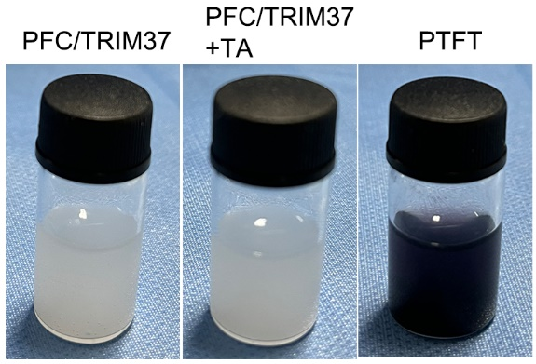
Figure S3. Digital photos of PFC/TRIM37, PFC/TRIM37 + TA, and PTFT.
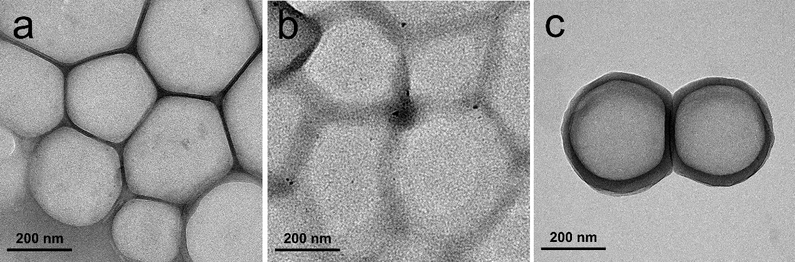

Figure S4. TEM images of (a) PFC, (b) PFC/TRIM37 and (c) PTFT.
Figure S5. The particle size changes of PTFTH in PBS for 9 days.
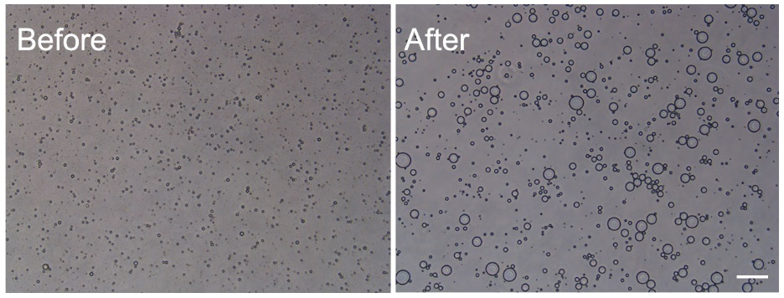
Figure S6. Light microscope images of PTFTH before and after laser irradiation (808nm, 1 W/cm², 5min) (scale bar: 10 μm).

Figure S7. Photoacoustic signal changes of PTFTH irradiation by laser at the wavelength range of 680-970 nm.

Table S1. Sequences of TRIM37-siRNA
Gene | Sequences
TRIM37 | Sense: 5'-GCUAAGAAGUCUGCAUGCUCU TT-3'  Antisense: 5'-AGAGCAUGCAGACUUCUUAGC TT-3'

Table S2. Sequences of TRIM37 and β-actin primers
Primer | Sequences
TRIM37 | Forward: 5＇- GCTCTGACATGCTTCTCGAAGG-3＇  Reverse: 5＇- CCAGATCTCCATCTGAAAGCTCG-3＇
β-actin | Forward 5＇- GGGAAATCGTGCGTGACATT-3＇  Reverse: 5＇- GGAACCGCTCATTGCCAAT-3＇

