Table S1. List of Abbreviations
ABBREVIATIONS | DETAILS
Ag-NPs | Silver Nanoparticles
AMR | Anti-Microbial Resistance
°C | Degree Centigrade
EDXA | Energy-Dispersive X-Ray Spectroscopy Analysis
FTIR | Fourier-Transform Infrared Spectroscopy
H | Hours
HCl | Hydrochloric acid
MDR | Multidrug Resistance
Mg | Milligram
MICs | Minimum Inhibitory Concentration
mL | Milliliter
mM | Milli-Mole
PBS | Phosphate Buffer Saline
OD | Optical Density
Rpm | Revolution Per Minutes
SDS | Sodium Dodecyl Sulfate
SEM | Scanning Electron Microscopy
µL | Microliter
UV–visible spectrophotometry | Visible Ultra Violet Spectroscopy
v/v | Volume By Volume
w/v | Weight By Volume
XRD | X-Ray Diffraction
ZOAE | Aqueous Extract of Z. officinale
ZOEE | Organic Or Ethanol Extract of Z. officinale
ZO-Ag-NPs | Biosynthesized Silver Nanoparticles Using Extract of Z. offocinale
ZOAE-Ag-NPs | Synthesized Silver Nanoparticles Using Aqueous Extract of Z. officinale
ZOEE-Ag-NPs | Synthesized Silver Nanoparticles Using Organic Or Ethanol Extract of Z. officinale
+ | Positive
- | Negative

Table S2. EDX Result shows the percentage of element in ZOAE-AgNPs
Element | Line Type | Apparent Concentration | k Ratio | Wt% | Wt% Sigma
C | K series | 1.86 | 0.01864 | 4.94 | 0.57
O | K series | 0.93 | 0.00313 | 4.08 | 1.2
Ag | L series | 42.57 | 0.4257 | 90.97 | 1.27
Total: |  |  |  | 100
Table S3. EDX Result shows the percentage of element in ZOEE-AgNPs.
Element | Line Type | Apparent Concentration | k Ratio | Wt% | Wt% Sigma
C | K series | 8.92 | 0.08919 | 21.42 | 0.69
O | K series | 0.29 | 0.00098 | 1.23 | 1.24
Ag | L series | 36.16 | 0.36162 | 77.34 | 1.16
Total |  |  |  | 100

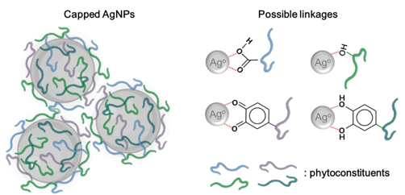
Figure S1: Schematic illustration of biosynthesized AgNPs capped by photoconstituents carboxyl, hydroxyl, and silver interactions.
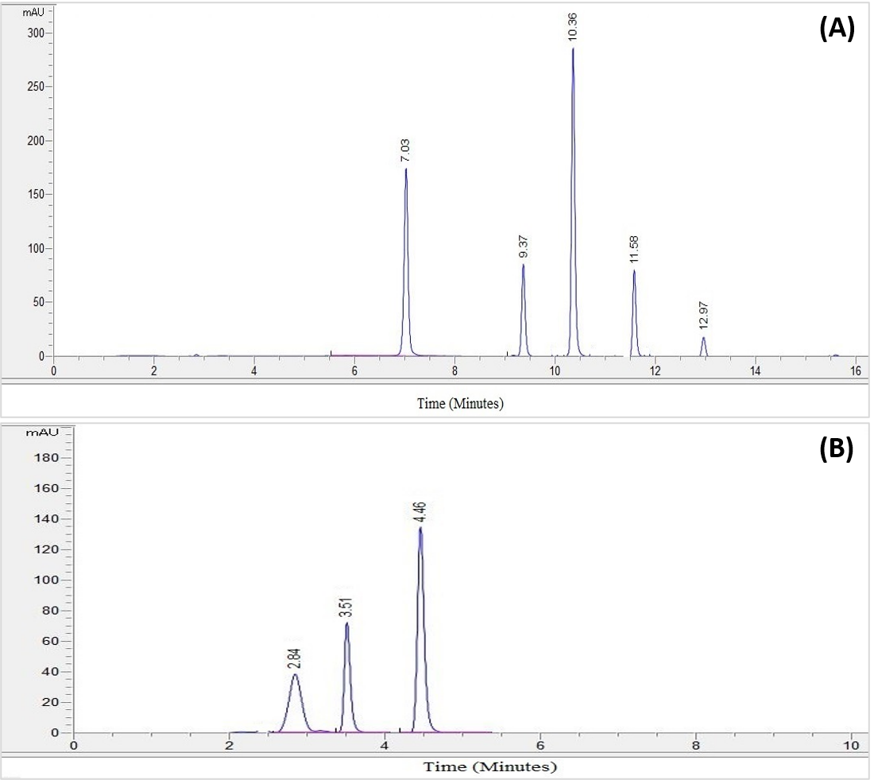
Figure S2 (A) The chromatogram of the standard phenolic compounds. (B) The chromatogram of the standard flavonoid compounds
Key: AuU= absorbance unit, mAU- mili absorbance unit
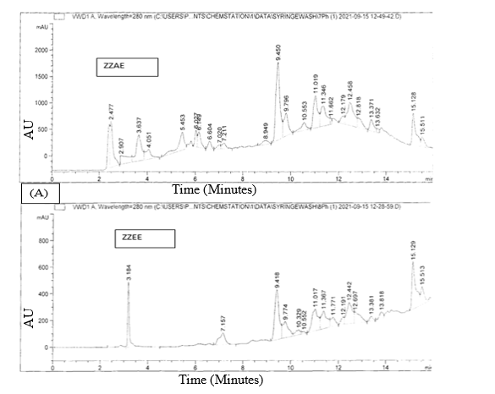
Figure S3 The chromatogram of the phenolic and flavonoid compounds from Z. officinale (organic extract) detection at 280 nm and 360 nm respectively

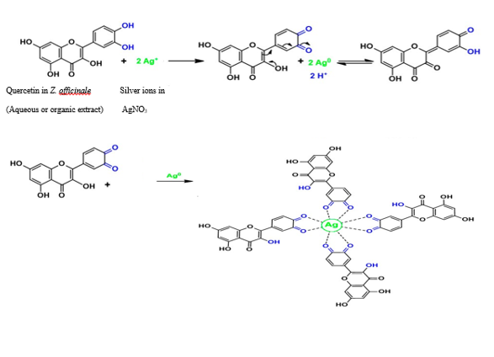
Figure S4 Mechanism of the silver ions reduction to metallic AgNPs via quercitin as reducing agent in Z. officinale rhizome extract solution.
Figure S5 Structure of phenolic constituents

