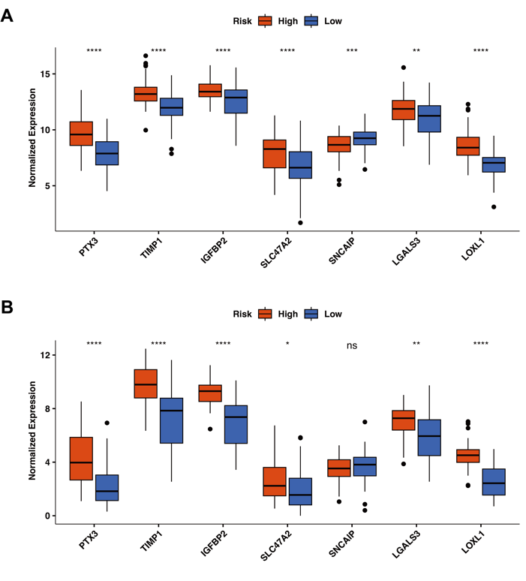
Supplementary Figure S1 The expressions of seven key cell-in-cell related genes (CICRGs) in the high- and low-risk groups. (A) Glioblastoma (GBM) cohort from TCGA database. (B) GBM cohort from CGGA database. PTX3: pentraxin 3, TIMP1: TIMP metallopeptidase inhibitor 1, IGFBP2: insulin like growth factor binding protein 2, SLC47A2: solute carrier family 47 member 2, SNCAIP: synuclein alpha interacting protein, LGALS3: galectin 3, LOXL1: lysyl oxidase like 1. *p-value <0.05, **p-value <0.01, ***p-value <0.001, ****p-value <0.0001, ^{ns}p-value >0.05.

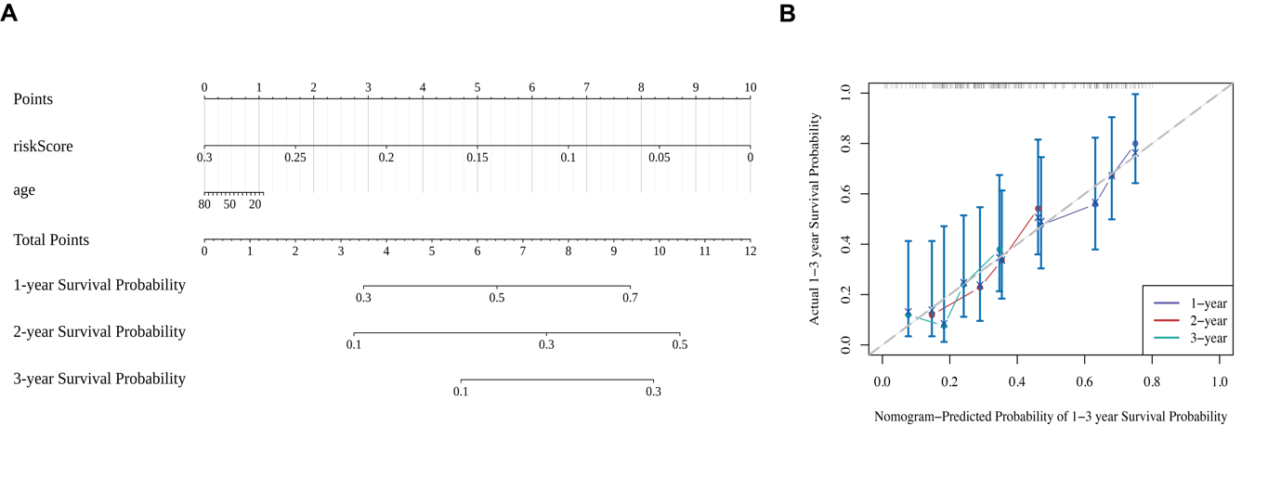Supplementary Figure S2 Validation of the nomogram in CGGA-GBM-dataset. (A) Construction of the nomogram based on risk score and age using CGGA-GBM dataset. (B) Calibration curves of the nomogram for predicting 1-, 2-, 3-year overall survival using CGGA-GBM database.

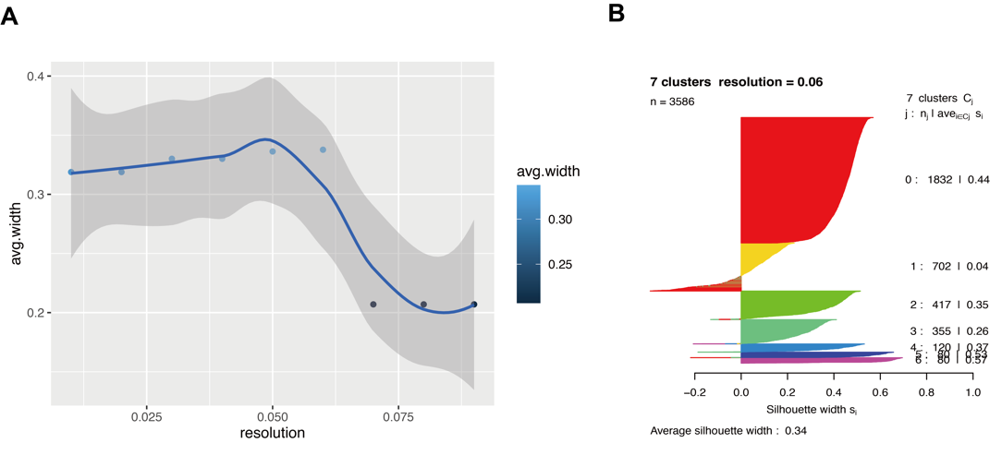
Supplementary Figure S3 Unsupervised clustering analysis of single cell populations. (A) The scatter plot of average silhouette width against resolution. When the resolution is 0.06, the silhouette width reaches the highest point 0.34. (B) The silhouette width values ​​of cells in each cell cluster at a resolution of 0.06.

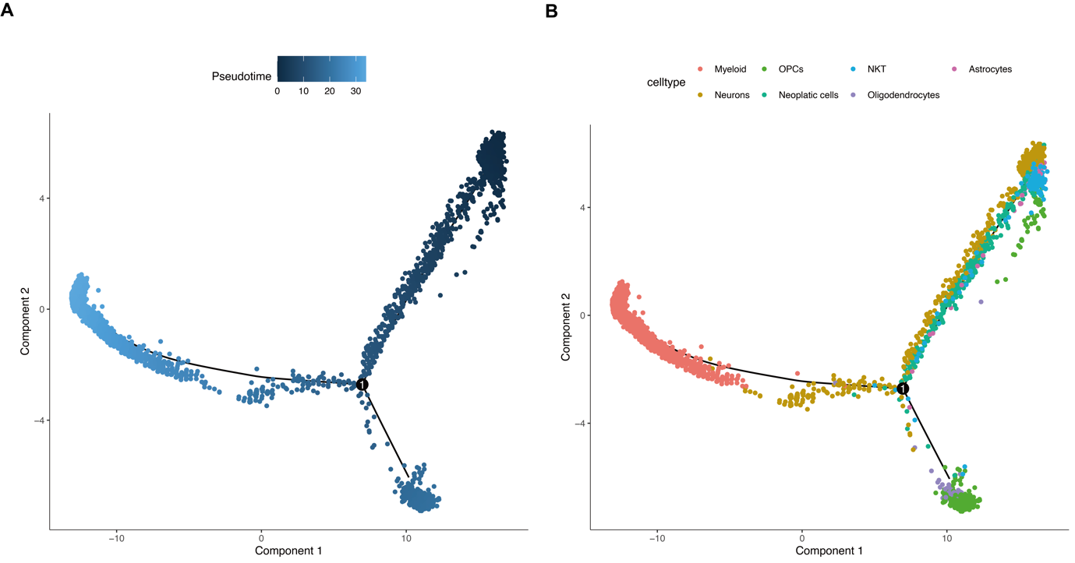
Supplementary Figure S4 Trajectory analysis of GBM single-cell sequencing data. (A) The cells are coloured by pseudotime. (B) The cells are coloured by cell types.

Supplementary Table S1 Primer sequences used in the current study.
primer | sequence
PTX3 F | CGTGCATCCAGTGAGACCAAT
PTX3 R | CCACCCACCACAAACACTATG
TIMP1 F | GCTTCTGGCATCCTGTTGTTG
TIMP1 R | CATAACGCTGGTATAAGGTGGTC
IGFBP2 F | AGTCCTCGCGAACTGAACTG
IGFBP2 R | TGGTCATCGCCATTGTCTCC
SLC47A2 F | AATGTCTGCGGAGTTTCTGTAGG
SLC47A2 R | AGGATGTGCTGGGTGTTGAGG
SNCAIP F | AGTCAGTCCCTTCGCGCTC
SNCAIP R | GATTCCTGTGGGCTTTTGCG
LGALS3 F | CAGCCAACGAGCGGAAAATGG
LGALS3 R | GCTGTCCAGAAGATGGGTAGG
LOXL1 F | ACAGCATGGACGAGTTCAGC
LOXL1 R | CAGTCGATGTCCGCATTGTA
GAPDH F | CGAAGGTGGAGTCAACGGATTT
GAPDH R | ATGGGTGGAATCATATTGGAAC

Supplementary Table S2 The risk score of each patient from TCGA-GBM cohort.
 | fustat | futime | PTX3 | TIMP1 | IGFBP2 | SLC47A2 | SNCAIP | LGALS3 | LOXL1 | riskScore
TCGA-26-1442-01 | 0 | 953 | 5.1542 | 8.2779 | 8.5783 | 3.922 | 9.5813 | 8.3723 | 5.3708 | 0.0516558484739145
TCGA-06-0129-01 | 1 | 1024 | 6.0734 | 7.8666 | 8.7215 | 4.9191 | 10.8673 | 8.3601 | 6.6776 | 0.0870747680011331
TCGA-15-1444-01 | 1 | 1537 | 4.8773 | 9.198 | 8.9654 | 6.559 | 10.2644 | 8.0429 | 5.0043 | 0.0998316776472562
TCGA-19-1787-01 | 1 | 385 | 7.7281 | 12.2593 | 9.8388 | 6.5079 | 8.9969 | 12.4521 | 5.6712 | 0.104303249617021
TCGA-06-0178-01 | 1 | 2681 | 5.8743 | 10.7826 | 9.7243 | 5.9659 | 9.3844 | 10.8144 | 6.406 | 0.108849276905077
TCGA-06-0221-02 | 1 | 603 | 5.1734 | 9.1723 | 10.5139 | 3.3956 | 10.7647 | 8.723 | 6.6256 | 0.116303283555095
TCGA-06-5417-01 | 0 | 155 | 7.1902 | 9.8646 | 10.2305 | 6.8987 | 10.8873 | 8.4123 | 3.11 | 0.134028669418713
TCGA-16-0846-01 | 1 | 119 | 5.2135 | 11.3729 | 10.5152 | 7.4292 | 9.249 | 10.9931 | 5.7628 | 0.152065157697289
TCGA-27-1835-01 | 1 | 648 | 7.8205 | 12.7345 | 12.9953 | 2.6686 | 10.215 | 10.9249 | 4.3987 | 0.177202238720296
TCGA-06-2570-01 | 0 | 958 | 6.6097 | 10.6263 | 11.1978 | 2.8708 | 10.1369 | 8.4054 | 6.1387 | 0.198714066108016
TCGA-06-5859-01 | 0 | 139 | 4.6477 | 11.4953 | 9.5511 | 10.8229 | 10.4411 | 9.8187 | 5.4076 | 0.226707818252551
TCGA-06-5416-01 | 0 | 204 | 6.5443 | 12.935 | 13.352 | 1.6932 | 8.0517 | 11.98 | 7.0531 | 0.231201974237256
TCGA-19-2629-01 | 1 | 737 | 5.9777 | 9.5766 | 9.3524 | 8.0102 | 9.2327 | 8.0055 | 6.006 | 0.244868584480485
TCGA-06-0749-01 | 1 | 82 | 4.9074 | 11.6359 | 10.5247 | 9.1515 | 8.7402 | 11.2534 | 6.9259 | 0.260658381598268
TCGA-06-1804-01 | 1 | 414 | 5.2247 | 10.2499 | 9.5517 | 7.5045 | 11.4081 | 8.2958 | 8.6519 | 0.354823170212498
TCGA-41-5651-01 | 1 | 460 | 7.4234 | 10.3223 | 12.7411 | 4.2694 | 9.801 | 9.9138 | 7.1163 | 0.386902754393696
TCGA-06-2567-01 | 1 | 133 | 8.0379 | 11.5389 | 10.114 | 9.5909 | 9.8137 | 10.2652 | 6.3976 | 0.397139071207121
TCGA-06-0238-01 | 1 | 405 | 7.2706 | 11.5795 | 12.161 | 6.743 | 8.8884 | 11.2495 | 7.2759 | 0.430295565863506
TCGA-06-0184-01 | 1 | 2126 | 6.5649 | 14.2481 | 13.702 | 6.6163 | 8.8579 | 13.3043 | 6.7406 | 0.456695328296984
TCGA-28-5207-01 | 1 | 343 | 6.9928 | 10.9432 | 11.3814 | 8.2656 | 10.2538 | 9.5445 | 6.3093 | 0.456812480544899
TCGA-14-1034-02 | 1 | 485 | 8.7096 | 11.8425 | 13.817 | 4.9793 | 8.0835 | 13.0288 | 7.5412 | 0.465006870519838
TCGA-28-5204-01 | 1 | 454 | 8.161 | 12.0319 | 13.8647 | 3.9482 | 7.6695 | 12.0441 | 7.1484 | 0.465080296408545
TCGA-32-2616-01 | 1 | 224 | 7.0239 | 11.7352 | 14.0393 | 7.3607 | 8.9856 | 14.0892 | 7.9188 | 0.465610771189299
TCGA-26-5133-01 | 0 | 452 | 4.5281 | 10.354 | 11.6765 | 6.243 | 8.0187 | 8.1846 | 6.9819 | 0.469224475909292
TCGA-14-1823-01 | 1 | 543 | 10.9896 | 14.2834 | 10.8239 | 9.3189 | 8.7283 | 13.0589 | 6.2483 | 0.474156598897296
TCGA-14-1825-01 | 1 | 232 | 6.374 | 11.5987 | 13.034 | 5.1746 | 9.5251 | 9.1872 | 5.8955 | 0.489715607050387
TCGA-19-5960-01 | 1 | 455 | 8.2741 | 10.5777 | 11.2155 | 7.6103 | 11.4435 | 8.6891 | 6.1986 | 0.497835683065157
TCGA-06-0744-01 | 1 | 1426 | 8.8642 | 11.7299 | 13.4583 | 6.1541 | 7.8556 | 11.538 | 5.753 | 0.520922729360952
TCGA-14-1829-01 | 0 | 218 | 9.8572 | 12.653 | 12.2371 | 8.5904 | 7.9303 | 12.6816 | 6.1205 | 0.53405083099333
TCGA-06-5411-01 | 1 | 254 | 8.566 | 12.5366 | 12.9586 | 5.7535 | 8.7377 | 11.2618 | 6.5404 | 0.538508068429935
TCGA-32-1980-01 | 1 | 36 | 9.551 | 13.0554 | 12.3284 | 6.6003 | 6.4596 | 12.1565 | 6.4596 | 0.538999147208551
TCGA-14-0871-01 | 1 | 880 | 6.4992 | 12.0609 | 13.1638 | 3.4039 | 8.7016 | 9.113 | 6.8974 | 0.547648779465103
TCGA-32-5222-01 | 1 | 585 | 9.3522 | 12.2336 | 13.5538 | 6.0953 | 9.6527 | 12.7203 | 7.3025 | 0.556159832403264
TCGA-27-1834-01 | 1 | 1233 | 6.7539 | 11.3513 | 10.4281 | 10.5794 | 9.2259 | 9.5261 | 6.4316 | 0.563845104693798
TCGA-32-1970-01 | 1 | 468 | 7.8374 | 11.6238 | 12.8854 | 7.9009 | 9.4936 | 9.9693 | 4.804 | 0.571552502553101
TCGA-06-2569-01 | 0 | 13 | 7.4833 | 11.8396 | 11.5945 | 2.1056 | 9.6499 | 6.8833 | 7.5647 | 0.581028739666322
TCGA-12-5295-01 | 1 | 454 | 7.6107 | 12.8615 | 14.1417 | 7.0553 | 8.5363 | 11.7027 | 5.0247 | 0.589899624628873
TCGA-12-1597-01 | 1 | 675 | 7.5254 | 10.9027 | 14.3342 | 5.1213 | 9.5471 | 10.552 | 6.3116 | 0.598167946203918
TCGA-06-0219-01 | 1 | 22 | 8.8808 | 13.225 | 13.4151 | 6.9502 | 9.2704 | 13.4315 | 7.7305 | 0.613573907748869
TCGA-06-2558-01 | 1 | 380 | 7.309 | 11.4439 | 12.6237 | 7.9333 | 9.5292 | 10.4292 | 6.449 | 0.616710944713962
TCGA-28-5209-01 | 0 | 442 | 9.4448 | 12.0735 | 13.4978 | 5.6041 | 10.7705 | 11.9922 | 7.7905 | 0.636770443448901
TCGA-19-2620-01 | 1 | 148 | 9.5736 | 13.632 | 12.5295 | 7.2137 | 8.4432 | 12.7663 | 7.4512 | 0.653701624269546
TCGA-27-2519-01 | 1 | 550 | 10.296 | 12.7771 | 11.3829 | 10.4714 | 9.6482 | 10.523 | 4.3864 | 0.665331402413478
TCGA-06-5414-01 | 0 | 273 | 10.6393 | 12.7329 | 12.5797 | 6.4737 | 7.0188 | 12.614 | 7.4973 | 0.684703093468372
TCGA-06-2563-01 | 0 | 932 | 8.0795 | 12.6446 | 13.6911 | 6.3607 | 8.8639 | 12.0348 | 7.2967 | 0.699106415810169
TCGA-12-0618-01 | 1 | 395 | 7.1216 | 10.3125 | 13.6289 | 6.8975 | 9.7067 | 9.278 | 5.7021 | 0.699992275831322
TCGA-06-0158-01 | 1 | 329 | 7.9647 | 11.5586 | 12.3618 | 8.2331 | 9.3869 | 11.3799 | 7.8944 | 0.709871717864107
TCGA-14-1402-02 | 1 | 975 | 9.7667 | 12.7557 | 13.9054 | 8.0691 | 9.1908 | 14.2223 | 7.5132 | 0.712942410104467
TCGA-26-5136-01 | 1 | 577 | 8.1372 | 12.7854 | 11.6821 | 10.6958 | 10.6491 | 11.5026 | 6.8534 | 0.736094325925267
TCGA-06-0132-01 | 1 | 771 | 10.3445 | 13.8848 | 10.7974 | 7.9767 | 8.4792 | 11.1565 | 7.4186 | 0.741062914613008
TCGA-28-1747-01 | 1 | 77 | 7.3376 | 11.5756 | 12.1013 | 8.7595 | 9.3772 | 9.7901 | 6.5817 | 0.763526359853672
TCGA-06-5408-01 | 1 | 357 | 9.1999 | 12.5258 | 14.0076 | 6.8942 | 9.7988 | 11.7316 | 6.1635 | 0.769437554294299
TCGA-19-0957-02 | 1 | 666 | 7.2431 | 12.8562 | 12.9472 | 7.6041 | 8.7865 | 11.4086 | 7.4004 | 0.769527223106457
TCGA-06-5858-01 | 0 | 187 | 7.6615 | 11.9519 | 13.5777 | 5.9453 | 9.1381 | 11.465 | 8.2288 | 0.775998681328948
TCGA-28-2514-01 | 0 | 160 | 7.8853 | 11.9744 | 12.9449 | 7.3131 | 9.1905 | 10.5492 | 6.8773 | 0.777307157754552
TCGA-19-4065-01 | 0 | 214 | 9.3746 | 14.88 | 13.2519 | 6.0973 | 8.7798 | 13.7596 | 8.7641 | 0.791138893857746
TCGA-14-0817-01 | 1 | 164 | 7.6275 | 13.0985 | 13.5043 | 8.6155 | 9.351 | 12.7779 | 7.4138 | 0.794461046880835
TCGA-28-5208-01 | 1 | 544 | 9.1179 | 12.9094 | 13.3348 | 6.1286 | 8.5692 | 12.1583 | 8.0149 | 0.818158786357838
TCGA-06-5418-01 | 1 | 83 | 10.7018 | 13.0259 | 13.5045 | 7.6546 | 9.1224 | 14.154 | 8.2467 | 0.820592568626755
TCGA-06-0882-01 | 1 | 632 | 10.3955 | 13.9071 | 12.4411 | 4.9989 | 8.6604 | 12.5803 | 9.4701 | 0.82069004214681
TCGA-27-2523-01 | 1 | 489 | 8.73 | 13.0736 | 14.1681 | 5.4552 | 8.738 | 11.9146 | 7.2027 | 0.822400325883995
TCGA-27-2526-01 | 1 | 87 | 9.0007 | 13.3578 | 13.1468 | 8.7338 | 8.3148 | 12.2447 | 6.188 | 0.827223444233512
TCGA-28-5220-01 | 1 | 388 | 4.9682 | 10.9145 | 12.398 | 9.2443 | 10.1009 | 9.3817 | 7.4961 | 0.827324875769199
TCGA-28-1753-01 | 0 | 37 | 7.9134 | 13.1172 | 13.9011 | 5.097 | 9.2673 | 11.9565 | 8.5755 | 0.839751056521069
TCGA-02-2485-01 | 0 | 470 | 8.3954 | 11.7145 | 13.0119 | 5.3742 | 10.5717 | 10.3247 | 8.5736 | 0.843047109882642
TCGA-76-4929-01 | 1 | 111 | 5.9767 | 12.5562 | 12.4046 | 10.2571 | 9.898 | 11.0732 | 7.3231 | 0.846011485739927
TCGA-41-2571-01 | 1 | 26 | 6.9753 | 10.8324 | 14.2567 | 6.0522 | 8.3199 | 11.3801 | 8.2518 | 0.854040951070056
TCGA-14-0736-02 | 1 | 460 | 8.2757 | 13.194 | 12.6249 | 8.9605 | 8.3323 | 12.1751 | 7.3617 | 0.861031859614393
TCGA-06-2557-01 | 1 | 33 | 8.4929 | 11.2345 | 13.3751 | 8.0864 | 10.7268 | 10.6643 | 6.729 | 0.861603761812527
TCGA-12-3653-01 | 1 | 442 | 7.4091 | 12.992 | 14.4727 | 7.7525 | 9.5439 | 10.5096 | 4.5081 | 0.868277461072868
TCGA-19-1390-01 | 1 | 772 | 4.7791 | 11.1416 | 14.1461 | 3.7675 | 7.6175 | 8.3658 | 7.4926 | 0.884224431021432
TCGA-76-4932-01 | 1 | 1458 | 8.5797 | 12.7756 | 14.2573 | 6.2875 | 7.8034 | 13.1812 | 8.3237 | 0.892039717004604
TCGA-76-4925-01 | 1 | 146 | 9.8414 | 12.3362 | 15.5699 | 4.8511 | 8.2562 | 13.5525 | 7.6584 | 0.8981874142116
TCGA-14-0790-01 | 1 | 419 | 9.2114 | 11.5116 | 13.6011 | 5.7246 | 9.879 | 12.05 | 9.3746 | 0.915840663968305
TCGA-06-2564-01 | 0 | 181 | 8.711 | 11.9449 | 12.7551 | 8.1871 | 9.3405 | 11.0214 | 7.4905 | 0.944255275377689
TCGA-32-2634-01 | 0 | 693 | 8.5193 | 11.1637 | 12.3742 | 8.5013 | 10.3868 | 10.6007 | 8.218 | 0.9653697047404
TCGA-76-4931-01 | 1 | 279 | 9.0497 | 12.0117 | 13.7023 | 6.4833 | 8.6676 | 11.2756 | 7.4405 | 0.972638923121181
TCGA-06-2565-01 | 1 | 506 | 8.741 | 12.0129 | 13.4342 | 6.4551 | 9.3124 | 11.7296 | 8.751 | 0.973023517620701
TCGA-06-2561-01 | 1 | 537 | 9.0514 | 13.4482 | 12.1152 | 5.8128 | 7.2424 | 9.7691 | 7.2795 | 0.979867738156262
TCGA-41-2572-01 | 1 | 406 | 9.1556 | 13.1363 | 14.6274 | 6.1029 | 9.1463 | 12.8681 | 7.7817 | 0.980277528986148
TCGA-16-1045-01 | 1 | 883 | 9.5661 | 13.3885 | 12.1024 | 8.5762 | 8.5525 | 10.5303 | 6.267 | 0.993700707827588
TCGA-06-0152-02 | 1 | 375 | 10.1765 | 12.5892 | 13.164 | 5.9806 | 6.8483 | 12.3888 | 8.6332 | 0.99582094035968
TCGA-27-2528-01 | 1 | 480 | 8.2284 | 13.2483 | 14.087 | 6.9519 | 8.1165 | 13.0466 | 8.4507 | 1.01277728511783
TCGA-15-0742-01 | 1 | 419 | 9.6014 | 12.8032 | 14.3382 | 7.5207 | 9.9131 | 11.6056 | 5.9431 | 1.030538968622
TCGA-12-0616-01 | 1 | 448 | 7.3791 | 12.4767 | 13.618 | 7.883 | 7.683 | 11.489 | 7.4154 | 1.03626242404418
TCGA-06-0168-01 | 1 | 598 | 11.0328 | 13.1953 | 11.6254 | 8.8446 | 8.5764 | 11.5368 | 7.491 | 1.04137313297227
TCGA-28-5215-01 | 1 | 335 | 8.8397 | 11.8341 | 11.7067 | 8.5002 | 8.6867 | 10.3179 | 8.1805 | 1.04562810456191
TCGA-06-0125-02 | 1 | 1448 | 9.954 | 12.7873 | 12.9835 | 8.2614 | 9.2281 | 12.7021 | 8.4599 | 1.06388552036873
TCGA-32-1982-01 | 1 | 142 | 7.3206 | 12.8542 | 14.7108 | 5.9893 | 6.8357 | 12.7645 | 8.529 | 1.06538169444088
TCGA-27-1831-01 | 1 | 505 | 10.2977 | 13.3617 | 13.3396 | 8.8656 | 8.0989 | 14.0976 | 8.4171 | 1.07910848973855
TCGA-19-2619-01 | 0 | 294 | 10.252 | 13.0314 | 13.4207 | 6.0756 | 8.5767 | 11.8072 | 7.9929 | 1.07996619179364
TCGA-26-5134-01 | 0 | 167 | 6.3384 | 12.5075 | 13.2173 | 6.4097 | 9.3991 | 10.2211 | 8.813 | 1.08832818062738
TCGA-06-5413-01 | 0 | 268 | 8.3087 | 12.8409 | 13.5752 | 8.0311 | 10.1232 | 11.2256 | 7.2344 | 1.10052683466594
TCGA-06-0646-01 | 1 | 175 | 10.6823 | 12.4894 | 12.7035 | 8.5974 | 9.3246 | 10.9379 | 6.4395 | 1.11015086993354
TCGA-06-5856-01 | 1 | 114 | 9.7404 | 12.5723 | 13.3452 | 7.882 | 10.3423 | 11.2207 | 7.1934 | 1.12478415675942
TCGA-06-0138-01 | 1 | 737 | 9.5616 | 12.985 | 12.6758 | 8.7487 | 9.0108 | 11.5756 | 7.4582 | 1.12711372443428
TCGA-06-0686-01 | 1 | 432 | 8.0687 | 12.0261 | 14.1315 | 5.8481 | 8.1722 | 11.1369 | 8.1722 | 1.13066753873621
TCGA-08-0386-01 | 1 | 548 | 6.3871 | 11.6164 | 12.542 | 8.3338 | 10.0418 | 9.3995 | 8.2168 | 1.15130029715405
TCGA-06-0649-01 | 1 | 64 | 8.5965 | 12.491 | 11.7989 | 9.8108 | 9.467 | 10.5973 | 7.8474 | 1.17455999025622
TCGA-02-2486-01 | 1 | 618 | 10.6622 | 13.6737 | 12.9503 | 11.2837 | 8.4147 | 14.3022 | 7.4644 | 1.17837470305588
TCGA-32-2638-01 | 1 | 766 | 10.0162 | 12.8754 | 12.8422 | 9.1672 | 9.7454 | 12.4924 | 8.2741 | 1.19704222716058
TCGA-06-0743-01 | 1 | 803 | 8.6516 | 12.0793 | 12.4445 | 8.883 | 9.4836 | 11.109 | 8.5755 | 1.21151889080273
TCGA-06-0645-01 | 1 | 175 | 12.087 | 13.7473 | 13.0542 | 7.9094 | 8.8682 | 13.3148 | 8.1487 | 1.22294115921943
TCGA-26-5132-01 | 0 | 286 | 9.0316 | 12.1708 | 13.1563 | 9.2832 | 9.1346 | 11.7228 | 7.7051 | 1.23627832052024
TCGA-32-2615-01 | 1 | 485 | 10.7243 | 13.5305 | 12.4548 | 9.6198 | 9.3429 | 12.1276 | 7.3448 | 1.24400009435022
TCGA-02-2483-01 | 0 | 466 | 8.0165 | 11.8916 | 14.1291 | 5.6791 | 8.6797 | 9.2249 | 6.671 | 1.2571358083214
TCGA-19-2625-01 | 1 | 124 | 9.2979 | 13.1162 | 12.553 | 9.567 | 9.4312 | 11.4073 | 7.4857 | 1.26625670968861
TCGA-06-0171-02 | 1 | 399 | 10.1356 | 14.5623 | 11.6197 | 9.0837 | 7.4446 | 11.4793 | 7.5293 | 1.27596404243642
TCGA-27-2521-01 | 1 | 510 | 6.6521 | 9.9712 | 13.1154 | 7.127 | 10.3794 | 8.5373 | 8.6236 | 1.29285627500587
TCGA-28-2509-01 | 0 | 145 | 8.4947 | 13.4642 | 14.0065 | 8.5343 | 8.5765 | 13.1091 | 8.3626 | 1.30394252360952
TCGA-06-0130-01 | 1 | 394 | 7.8679 | 13.65 | 11.9007 | 6.163 | 6.7585 | 12.0629 | 11.7583 | 1.30852150049424
TCGA-12-0821-01 | 1 | 323 | 8.2265 | 12.1445 | 13.5418 | 6.9652 | 9.7603 | 8.9797 | 6.4985 | 1.32428541988244
TCGA-06-0141-01 | 1 | 313 | 10.7047 | 15.7404 | 12.7515 | 6.8256 | 8.0823 | 12.148 | 7.8027 | 1.33619327528127
TCGA-76-4926-01 | 1 | 138 | 8.2354 | 12.4095 | 12.3532 | 9.0958 | 9.8711 | 10.7778 | 8.8792 | 1.39141615877026
TCGA-06-0745-01 | 1 | 239 | 8.6169 | 13.5163 | 14.6932 | 8.9545 | 8.4606 | 12.1399 | 6.0701 | 1.41300191999301
TCGA-02-0047-01 | 1 | 448 | 9.0132 | 12.6873 | 12.2075 | 9.1062 | 8.8029 | 10.1328 | 7.5722 | 1.43958867877283
TCGA-12-0619-01 | 1 | 1062 | 8.7637 | 13.8159 | 13.1158 | 9.7854 | 8.9049 | 12.1085 | 7.6911 | 1.45290470662598
TCGA-12-3652-01 | 1 | 1062 | 9.1607 | 14.0313 | 15.7719 | 4.473 | 8.4053 | 13.3771 | 8.9575 | 1.45768354256851
TCGA-19-2624-01 | 1 | 5 | 7.5443 | 12.0955 | 14.1984 | 6.691 | 9.5865 | 10.1946 | 8.2175 | 1.53668264967578
TCGA-06-0174-01 | 1 | 98 | 8.2021 | 11.9502 | 14.5199 | 6.5279 | 9.5582 | 10.7508 | 8.3023 | 1.55177225175498
TCGA-12-5299-01 | 1 | 98 | 10.2911 | 13.2064 | 14.4847 | 8.002 | 7.5572 | 13.9225 | 8.725 | 1.56666609161059
TCGA-27-1837-01 | 1 | 427 | 8.7944 | 12.6569 | 13.9035 | 6.4968 | 9.466 | 10.8891 | 8.728 | 1.58230689060435
TCGA-06-0187-01 | 1 | 828 | 11.0659 | 12.7997 | 13.0014 | 7.2636 | 9.399 | 10.902 | 8.1299 | 1.58422994933303
TCGA-12-3650-01 | 1 | 333 | 8.1166 | 12.1128 | 14.9564 | 6.5726 | 9.5576 | 10.788 | 7.7311 | 1.58932989080574
TCGA-28-5216-01 | 0 | 415 | 9.2912 | 13.2838 | 14.0873 | 7.5697 | 9.2406 | 11.4376 | 7.73 | 1.62575425602815
TCGA-76-4927-01 | 1 | 535 | 9.9094 | 13.0935 | 13.8542 | 8.3465 | 8.6675 | 12.2404 | 8.3141 | 1.723084286453
TCGA-06-2562-01 | 1 | 382 | 11.6864 | 13.8906 | 13.2887 | 6.0624 | 6.7433 | 13.0588 | 9.9445 | 1.72425869464598
TCGA-06-0211-02 | 1 | 360 | 11.3506 | 13.7551 | 13.4044 | 7.7764 | 7.442 | 12.638 | 8.3997 | 1.72479283692911
TCGA-26-5139-01 | 0 | 48 | 11.1935 | 12.9723 | 13.9836 | 8.3041 | 8.7174 | 12.8568 | 8.6539 | 1.88064093731483
TCGA-06-0156-01 | 1 | 178 | 10.49265 | 12.8707 | 12.5933 | 9.7413 | 9.60885 | 10.62345 | 7.68345 | 1.93935637880169
TCGA-14-2554-01 | 1 | 532 | 11.1519 | 13.5871 | 12.627 | 9.1956 | 8.1838 | 11.4765 | 7.959 | 1.94825248748441
TCGA-27-2524-01 | 1 | 231 | 13.1766 | 14.6858 | 15.3678 | 4.9516 | 6.3336 | 15.5686 | 10.0513 | 1.99750473089496
TCGA-28-2513-01 | 0 | 222 | 12.2557 | 14.2093 | 13.1226 | 9.1495 | 9.1631 | 13.4376 | 9.108 | 2.01890539229208
TCGA-06-0157-01 | 1 | 97 | 8.0781 | 11.8987 | 12.9806 | 8.6878 | 9.0858 | 10.3749 | 9.6113 | 2.05516741804768
TCGA-06-5410-01 | 1 | 108 | 13.5598 | 15.9495 | 13.1834 | 6.1509 | 5.0976 | 13.2344 | 8.3899 | 2.07346024754838
TCGA-14-0789-01 | 1 | 342 | 11.776 | 15.4559 | 13.4826 | 6.2867 | 6.8339 | 13.3273 | 9.8368 | 2.1464740007047
TCGA-06-0644-01 | 1 | 384 | 9.0608 | 14.895 | 13.9589 | 4.1843 | 5.5102 | 12.3263 | 11.1325 | 2.21741002359303
TCGA-06-2559-01 | 1 | 150 | 9.2788 | 12.0942 | 13.418 | 8.4955 | 9.1999 | 11.24 | 9.8759 | 2.28258706854344
TCGA-06-0878-01 | 0 | 218 | 12.6085 | 13.4019 | 13.3927 | 9.5837 | 9.7739 | 12.5765 | 8.45 | 2.3747311197898
TCGA-14-0787-01 | 1 | 68 | 10.4119 | 13.5469 | 13.5588 | 8.8168 | 8.409 | 12.0122 | 9.4068 | 2.69220738877938
TCGA-41-3915-01 | 1 | 360 | 9.344 | 12.8432 | 13.5919 | 10.8086 | 7.8346 | 11.5897 | 8.2851 | 2.77784031073269
TCGA-76-4928-01 | 1 | 94 | 8.9471 | 16.6197 | 14.7652 | 6.8827 | 6.9197 | 13.6489 | 10.0848 | 2.88963215333284
TCGA-32-2632-01 | 1 | 269 | 8.1211 | 13.3389 | 13.8033 | 9.217 | 6.5265 | 12.3251 | 10.521 | 3.04187451044029
TCGA-06-0210-02 | 1 | 225 | 10.9584 | 12.9997 | 13 | 10.229 | 9.6279 | 11.1107 | 8.9652 | 3.08833827891932
TCGA-41-4097-01 | 1 | 6 | 9.7696 | 15.0245 | 13.9091 | 7.2857 | 8.0911 | 11.9612 | 10.1133 | 3.15494593538345
TCGA-32-4213-01 | 0 | 604 | 10.3227 | 13.781 | 14.1921 | 8.6221 | 8.0966 | 12.284 | 9.7664 | 3.38330876885692
TCGA-28-5218-01 | 1 | 157 | 7.2883 | 14.4109 | 14.2099 | 7.4244 | 8.6528 | 10.7179 | 10.4346 | 3.55959561714288
TCGA-06-0750-01 | 1 | 28 | 9.9436 | 13.8258 | 14.1055 | 10.2801 | 8.0203 | 12.288 | 9.0944 | 3.63328467145083
TCGA-06-0747-01 | 1 | 82 | 11.7802 | 13.4739 | 13.0085 | 8.9047 | 8.3301 | 11.4219 | 9.9997 | 3.65903749630423
TCGA-06-5412-01 | 1 | 138 | 11.0651 | 15.7775 | 14.3455 | 6.0014 | 7.4366 | 12.1836 | 10.0859 | 3.69464142175336
TCGA-26-5135-01 | 1 | 270 | 9.4662 | 13.366 | 13.8317 | 8.9072 | 8.6337 | 10.207 | 8.8939 | 3.79982028085383
TCGA-14-0781-01 | 1 | 29 | 11.1477 | 15.2316 | 14.0404 | 7.4267 | 8.4636 | 12.2641 | 10.2691 | 3.8651985138418
TCGA-02-0055-01 | 1 | 76 | 11.5201 | 15.704 | 13.6313 | 6.1168 | 6.8001 | 12.8378 | 11.87 | 4.06828681837082
TCGA-27-1830-01 | 1 | 154 | 9.5676 | 12.445 | 12.5211 | 10.4458 | 8.6698 | 8.8995 | 8.8401 | 4.09850879699257
TCGA-06-0190-02 | 1 | 317 | 10.5984 | 15.1181 | 14.5864 | 5.6375 | 7.1192 | 13.0848 | 12.2906 | 4.28884177002832
TCGA-27-1832-01 | 1 | 300 | 11.3111 | 14.0504 | 13.2335 | 10.7317 | 9.8002 | 11.9382 | 10.5675 | 5.01510592092804
TCGA-19-1389-02 | 1 | 141 | 12.3649 | 15.2066 | 14.8033 | 11.1892 | 7.0253 | 12.235 | 9.7762 | 11.3357406139883

Supplementary Table S3 The risk score of each patient from CCGA-GBM cohort.
 | fustat | futime | PTX3 | TIMP1 | IGFBP2 | SLC47A2 | SNCAIP | LGALS3 | LOXL1 | riskScore
CGGA_1001 | 0 | 3817 | 5.282069075 | 11.63049921 | 6.92943596 | 1.516015147 | 0.855989697 | 8.185420589 | 4.053111336 | 0.040447854
CGGA_1007 | 1 | 345 | 1.646162657 | 9.058127054 | 7.366584499 | 3.129283017 | 3.253989266 | 4.628773595 | 2.266036894 | 0.043527346
CGGA_1008 | 1 | 315 | 3.075532631 | 8.110405007 | 8.652737439 | 2.324810603 | 4.129283017 | 6.588114949 | 3.671293372 | 0.046747219
CGGA_1011 | 1 | 109 | 3.068670811 | 10.56140252 | 6.472812666 | 2.169925001 | 1.769771739 | 4.339137385 | 4.34553831 | 0.07684097
CGGA_1015 | 1 | 164 | 2.44625623 | 11.72958676 | 9.76851518 | 0.773996325 | 3.364572432 | 7.351115917 | 6.99830835 | 0.142553509
CGGA_1023 | 1 | 681 | 1.09085343 | 7.850874416 | 9.698027431 | 3.524815928 | 4.296457407 | 6.30103885 | 5.290203205 | 0.097474718
CGGA_1024 | 1 | 3074 | 2.59454855 | 9.031080852 | 8.156083076 | 1.10433666 | 2.650764559 | 8.589239157 | 4.976821852 | 0.028291042
CGGA_1026 | 1 | 1570 | 1.827819025 | 8.458160504 | 8.072802535 | 1.650764559 | 4.308156975 | 4.907371414 | 1.09085343 | 0.02637166
CGGA_1035 | 1 | 567 | 8.528297818 | 11.84111221 | 9.695802471 | 1.443606651 | 1.678071905 | 7.693277856 | 4.481557281 | 0.195373388
CGGA_1039 | 1 | 727 | 2.077242999 | 6.902556005 | 8.206526016 | 0.35614381 | 7.001014038 | 7.272489824 | 4.732811872 | 0.018557655
CGGA_1045 | 1 | 348 | 7.497213158 | 10.69761051 | 9.711563736 | 2.298658316 | 3 | 9.017560076 | 4.934988202 | 0.120757288
CGGA_1049 | 1 | 809 | 5.943218087 | 9.509913528 | 8.326159799 | 4.047887329 | 4.036503334 | 7.116447936 | 2.283921772 | 0.062124045
CGGA_1053 | 1 | 370 | 2.526068812 | 8.644469205 | 8.366103608 | 3.220329955 | 3.815575429 | 6.405141463 | 3.129283017 | 0.047087447
CGGA_1070 | 1 | 333 | 2.10433666 | 8.965293685 | 9.695210889 | 1.269033146 | 2.974529312 | 7.265661925 | 4.552131108 | 0.059540876
CGGA_1072 | 1 | 1090 | 1.40599236 | 7.837123296 | 9.036640695 | 0.111031312 | 4.145677455 | 5.682292371 | 2.350497247 | 0.026410855
CGGA_1073 | 1 | 270 | 2.392317423 | 9.877437522 | 10.24658623 | 1.480265122 | 4.185073638 | 6.810057442 | 3.196921734 | 0.067268111
CGGA_1074 | 1 | 86 | 3.486714373 | 9.069181209 | 8.239503062 | 3.989139007 | 4.231893162 | 6.965553435 | 4.15704371 | 0.065534633
CGGA_1077 | 1 | 591 | 5.866907978 | 10.9155209 | 9.951707261 | 2.678071905 | 3.068670811 | 8.596860621 | 4.873321063 | 0.129517163
CGGA_1083 | 1 | 450 | 3.599317794 | 10.6505402 | 8.532161085 | 1.704871964 | 2.201633861 | 6.984703267 | 4.5360529 | 0.074300554
CGGA_1091 | 1 | 1116 | 4.965784285 | 9.128252152 | 10.14400812 | 1.646162657 | 3.782408565 | 8.927007529 | 4.936873462 | 0.071222491
CGGA_1109 | 1 | 1348 | 4.323370069 | 6.344828497 | 8.532862387 | 3.161887682 | 5.019701914 | 4.534808661 | 2.241840184 | 0.058904144
CGGA_1114 | 1 | 460 | 2.163498732 | 8.954487147 | 9.060560842 | 3.142413438 | 4.693208149 | 7.514280096 | 3.321928095 | 0.042274094
CGGA_1124 | 1 | 484 | 6.754085782 | 9.889534384 | 8.262282806 | 3.122672719 | 3.357552005 | 7.293701542 | 3.781359714 | 0.084743802
CGGA_1139 | 1 | 1196 | 0.464668267 | 7.977050906 | 6.335569006 | 4.770829046 | 4.495695163 | 5.348019909 | 4.290571851 | 0.036945476
CGGA_1171 | 1 | 412 | 4.037382222 | 8.194362891 | 4.984133595 | 5.841218374 | 3.678071905 | 5.696272084 | 3.385431037 | 0.035465919
CGGA_1180 | 0 | 1226 | 5.243745235 | 8.905086099 | 10.07757682 | 4.074676686 | 4.487357715 | 8.275938239 | 4.120186028 | 0.103137718
CGGA_1214 | 1 | 604 | 2.606442228 | 8.24797497 | 9.539643506 | 4.06608919 | 4.396433531 | 7.672708196 | 4.060047384 | 0.065684047
CGGA_1216 | 1 | 312 | 1.292781749 | 8.141289724 | 7.04592344 | 5.18705509 | 4.286881148 | 6.990728004 | 3.073820233 | 0.027545158
CGGA_1219 | 1 | 2120 | 0.310340121 | 5.588264894 | 5.253611152 | 0.275007047 | 4.350497247 | 3.221877081 | 0.773996325 | 0.006571624
CGGA_1224 | 1 | 271 | 3.152183419 | 10.99763819 | 10.33765535 | 1.992768431 | 3.124328135 | 6.316688823 | 4.670727054 | 0.169489665
CGGA_1234 | 1 | 705 | 2.493134922 | 11.75211717 | 9.191824171 | 1.35614381 | 1.778208576 | 8.770961155 | 4.793375711 | 0.057520943
CGGA_1237 | 1 | 296 | 3.472487771 | 8.537490215 | 9.555758649 | 3 | 4.379898164 | 5.866413481 | 3.925049965 | 0.102971652
CGGA_1240 | 1 | 19 | 8.32210842 | 11.92668886 | 9.22602678 | 0.5360529 | 1.432959407 | 8.120704442 | 3.959770155 | 0.110598261
CGGA_1251 | 1 | 272 | 0.925999419 | 4.584962501 | 7.185172775 | 0.565597176 | 5.000901403 | 5.68846014 | 3.508428653 | 0.011487012
CGGA_1258 | 1 | 114 | 2.831877241 | 9.42399828 | 10.1333349 | 2.771885579 | 4.13422094 | 6.23227701 | 3.64038956 | 0.106797601
CGGA_1270 | 1 | 188 | 5.014355293 | 12.12690447 | 7.66860138 | 1.922197848 | 3.092545742 | 7.901711654 | 4.284662185 | 0.057581616
CGGA_1275 | 1 | 183 | 1.207892852 | 11.24599828 | 8.248117329 | 0 | 0.40053793 | 9.734794283 | 3.948600847 | 0.017522355
CGGA_1287 | 1 | 533 | 0.86393845 | 3.507160349 | 5.175923742 | 2.084064265 | 3.825785627 | 4.009884589 | 0.86393845 | 0.006082399
CGGA_1299 | 1 | 550 | 5.819157224 | 8.594697827 | 10.20878304 | 3.426264755 | 4.333423734 | 7.901228945 | 3.681449265 | 0.100631042
CGGA_1313 | 1 | 379 | 6.931683057 | 9.281582348 | 8.309157994 | 1.963474124 | 2.462052319 | 8.113429635 | 3.439623138 | 0.050977018
CGGA_1314 | 1 | 172 | 4.025028794 | 5.523875551 | 7.008764745 | 2.469885976 | 2.782408565 | 4.352617299 | 3.042644337 | 0.038884803
CGGA_1320 | 1 | 59 | 1.263034406 | 7.738835377 | 7.653203362 | 6.738632747 | 5.137093609 | 5.554895775 | 4.701549057 | 0.088650612
CGGA_1332 | 0 | 510 | 2.310340121 | 7.464014725 | 11.24077345 | 1.959770155 | 5.254745198 | 8.178316272 | 4.326968712 | 0.061079317
CGGA_1338 | 1 | 1122 | 5.659639187 | 9.780851402 | 8.741231012 | 4.372255648 | 2.992768431 | 6.888134388 | 4.705977902 | 0.152698453
CGGA_1342 | 1 | 186 | 6.87491989 | 11.26102535 | 8.486312138 | 4.735522177 | 4.336997417 | 6.632559052 | 2.994579724 | 0.14079665
CGGA_1384 | 1 | 191 | 1.163498732 | 5.805808349 | 5.341630009 | 0.641546029 | 4.606442228 | 3.498250868 | 1.560714954 | 0.009096402
CGGA_1409 | 0 | 2727 | 1.10433666 | 3.286881148 | 3.428946345 | 0.286881148 | 4.874305166 | 3.529820947 | 1.475084883 | 0.002999828
CGGA_274 | 0 | 610 | 4.080657663 | 10.21662462 | 9.405503155 | 1.700439718 | 3.810443104 | 5.80451827 | 4.501439145 | 0.126443751
CGGA_342 | 1 | 500 | 5.003152449 | 8.524580892 | 7.705148528 | 0.678071905 | 3.189033824 | 7.712320641 | 1.929790998 | 0.01740986
CGGA_413 | 0 | 183 | 1.389566812 | 8.463646977 | 9.426767933 | 3.184280294 | 3.03562391 | 6.111031312 | 1.304511042 | 0.042246103
CGGA_483 | 1 | 277 | 3.880685525 | 8.417725957 | 8.540360556 | 0.799087306 | 2.454175893 | 3.869871406 | 6.872089989 | 0.202227163
CGGA_491 | 1 | 1074 | 1.422233001 | 4.151371776 | 4.34269696 | 2.427606173 | 4.672425342 | 3.649615459 | 0.704871964 | 0.005761888
CGGA_494 | 0 | 4435 | 0.641546029 | 4.481557281 | 4.528571319 | 0.250961574 | 1.799087306 | 5.166313748 | 1 | 0.003264472
CGGA_499 | 1 | 122 | 2.543495883 | 8.918773811 | 9.181152257 | 1.372952098 | 3.469885976 | 7.976821852 | 2.15704371 | 0.024124121
CGGA_525 | 1 | 138 | 3.388189537 | 9.742494709 | 9.171452047 | 2.336283388 | 4.033863452 | 7.602513297 | 5.451870479 | 0.082814243
CGGA_604 | 1 | 381 | 7.606220121 | 10.90291018 | 8.887555733 | 1.063502942 | 2.722466024 | 8.305240966 | 4.225737653 | 0.080192038
CGGA_658 | 1 | 372 | 1.803227036 | 7.298658316 | 7.651769271 | 1.124328135 | 4.128458384 | 5.811214118 | 2.169925001 | 0.017850089
CGGA_676 | 1 | 376 | 4.244887059 | 8.343096863 | 7.787184297 | 2.35614381 | 2.916476644 | 8.440910683 | 3.672425342 | 0.02664739
CGGA_679 | 1 | 263 | 2.910732662 | 7.836934011 | 7.729960561 | 4.615887074 | 3.695993813 | 6.76540214 | 3.821710215 | 0.049106709
CGGA_680 | 1 | 2373 | 2.084064265 | 6.006522446 | 5.160274831 | 0.432959407 | 2.773996325 | 5.946496941 | 1.150559677 | 0.004824004
CGGA_700 | 0 | 170 | 1.257010618 | 2.541019153 | 3.837943242 | 1.550900665 | 4.105175192 | 3.736604875 | 1.735522177 | 0.004209462
CGGA_710 | 1 | 660 | 0.90303827 | 5.318678374 | 5.413120146 | 3.498250868 | 2.560714954 | 5.902314812 | 2.166715445 | 0.009317181
CGGA_731 | 1 | 503 | 4.234194723 | 9.480527685 | 8.607256327 | 2.09423607 | 4.307428525 | 7.064042126 | 3.9800253 | 0.057120251
CGGA_747 | 1 | 970 | 0.807354922 | 4.800641097 | 6.063934306 | 1.15704371 | 5.527946099 | 3.552131108 | 0.887525271 | 0.008480149
CGGA_759 | 1 | 1263 | 1.871843649 | 5.48058827 | 7.355439197 | 0.941106311 | 4.383358695 | 4.032982417 | 1.959770155 | 0.019238421
CGGA_761 | 1 | 1840 | 1.304511042 | 5.359310317 | 7.374517881 | 0.650764559 | 4.438292852 | 2.543495883 | 2 | 0.025868774
CGGA_782 | 1 | 289 | 3.008988783 | 8.012736263 | 6.857483428 | 5.80451827 | 3.327687364 | 5.842727469 | 3.397802962 | 0.056334551
CGGA_789 | 1 | 345 | 3.805292456 | 9.03968676 | 7.576219781 | 3.860962798 | 2.498250868 | 6.780178844 | 3.365972428 | 0.051686539
CGGA_802 | 1 | 681 | 7.507160349 | 9.498869147 | 8.264020286 | 1.50589093 | 2.9202933 | 7.429866991 | 3.650764559 | 0.063620104
CGGA_804 | 0 | 614 | 0.432959407 | 4.95930649 | 5.269781238 | 0.933572638 | 2.381283373 | 4.326249701 | 0.98550043 | 0.006031107
CGGA_808 | 0 | 1167 | 0.847996907 | 5.099715999 | 5.384395238 | 2.46727948 | 3.629939409 | 6.68846014 | 1.526068812 | 0.004750978
CGGA_837 | 1 | 432 | 4.836934011 | 7.848435159 | 9.732235276 | 1.438292852 | 3.943921327 | 8.10213319 | 2.427606173 | 0.034354935
CGGA_842 | 1 | 204 | 7.869748051 | 9.802370957 | 9.382105211 | 1.316145742 | 3.694880193 | 6.308703071 | 7.03265189 | 0.285790984
CGGA_848 | 0 | 239 | 2.671293372 | 9.589875819 | 9.422905743 | 1.627606838 | 3.769771739 | 6.887890772 | 4.680324357 | 0.073851685
CGGA_850 | 0 | 564 | 3.517275693 | 8.260260941 | 10.15266512 | 1.22650853 | 3.760220946 | 7.70120248 | 5.074676686 | 0.071822207
CGGA_859 | 1 | 387 | 7.158862106 | 12.47210186 | 10.11635696 | 3.63691458 | 3.17951105 | 8.322694323 | 3.615887074 | 0.189291176
CGGA_876 | 1 | 159 | 4.512226887 | 11.33163916 | 8.669097651 | 2.140778656 | 1.599317794 | 6.846117173 | 5.795195491 | 0.15067859
CGGA_878 | 1 | 863 | 2.23572706 | 9.04420284 | 10.10141108 | 2.40599236 | 3.634593268 | 7.891540703 | 3.475084883 | 0.053798574
CGGA_902 | 1 | 193 | 5.774259951 | 9.321973178 | 8.187203589 | 1.35614381 | 4.932155684 | 6.683134985 | 3.871843649 | 0.054084359
CGGA_D03 | 1 | 423 | 2.666756592 | 10.22756781 | 8.645982597 | 3.711494907 | 2.422233001 | 7.407182772 | 4.926473911 | 0.088965921
CGGA_D09 | 1 | 233 | 2.477677328 | 8.757089938 | 9.614746647 | 3.049630768 | 3.776103988 | 7.194165869 | 4.493134922 | 0.077954346
CGGA_D30 | 1 | 215 | 0.321928095 | 7.743353391 | 5.844486088 | 0.956056652 | 3.368768349 | 6.331812684 | 3.432959407 | 0.009911838
CGGA_D35 | 1 | 661 | 5.279099802 | 11.48885941 | 9.175973627 | 0.669026766 | 1.049630768 | 7.486875235 | 6.546585829 | 0.159589498
CGGA_D37 | 1 | 965 | 4.053111336 | 10.06982567 | 7.928133408 | 4.336283388 | 2.963474124 | 7.585037639 | 4.618238656 | 0.077897416
CGGA_D57 | 1 | 766 | 2.166715445 | 8.085180305 | 7.774589417 | 4.247168 | 4.172327492 | 6.178913785 | 4.937815169 | 0.065312314

Supplementary Table S4 Univariate cox regression analysis of risk score and clinical features.
id | HR | HR.95L | HR.95H | pvalue
age | 1.020169763 | 1.000861739 | 1.039850266 | 0.040528804
gender | 1.35441199 | 0.825539609 | 2.222100331 | 0.229757804
IDH status | 1.752243522 | 0.863257259 | 3.556711896 | 0.120454247
MGMT status | 1.404521407 | 0.868373131 | 2.271696708 | 0.166152313
riskScore | 3.02754417 | 1.241724658 | 4.813363682 | 0.000891266

Supplementary Table S5 Multivariate cox regression analysis of risk score and clinical features.
id | HR | HR.95L | HR.95H | pvalue
age | 1.010615129 | 0.99045611 | 1.031184449 | 0.304357576
riskScore | 2.604372646 | 0.650363386 | 4.558381906 | 0.008993285

