Economic Evaluation of Adding Daratumumab to Carfilzomib and Dexamethasone for Relapsed or Refractory Multiple Myeloma

Supplementary Files

Supplementary Figure S1. Markov model for patients with relapsed/refractory multiple myeloma. RRMM, relapsed/refractory multiple myeloma; KdD, carfizomib, daratumumab and dexamethasone; Kd, carfizomib and dexamethasone.
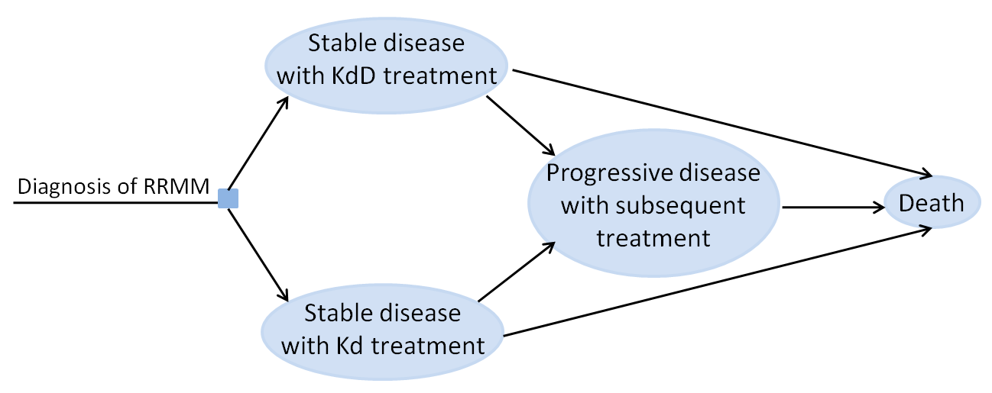

Supplementary Figure S2. Survival curves in patients with Relapsed/refractory multiple myeloma. The original curves from the clinical trial are shown, together with the Exponential and Log-normal survival estimated for overall survival and progression-free survival separately. KdD, carfizomib, daratumumab and dexamethasone; Kd, carfizomib and dexamethasone.

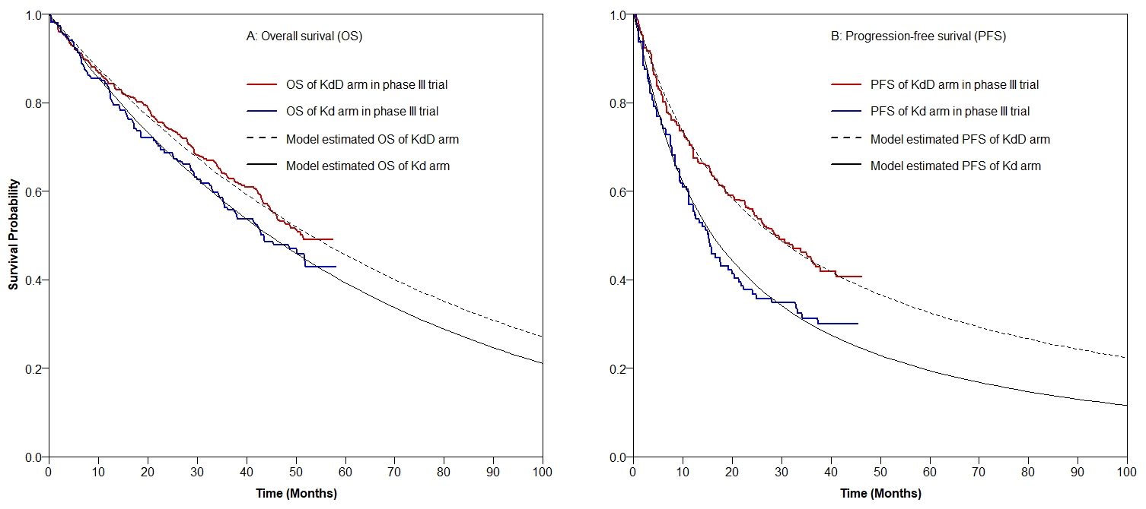

Supplementary Table S1. Baseline patient characteristics of the CANDOR trial.
Characteristics | KdD (n=312) | Kd (n=154)
Median age, years | 64·0 (57–70) | 64·5 (59–71)
18-64 | 163 (52%) | 77 (50%)
65-74 | 121 (39%) | 55 (38%)
≥75 | 28 (9%) | 22 (14%)
Sex | 177 (57%) | 91 (59%)
Male | 135 (43%) | 63 (41%)
Female
Baseline ECOG performance status
0-1 | 295 (95%) | 147 (95%)
2 | 15 (5%) | 7 (5%)
ISS stage at baseline
Ⅰ | 147 (47%) | 79 (51%)
Ⅱ | 103 (33%) | 48 (31%)
Ⅲ | 61 (20%) | 27 (18%)
Unknown | 1 (<1%) | 0
Cytogenetic risk group by FISH
High | 48 (15%) | 26 (17%)
Standard | 108 (35%) | 56 (36%)
Unknown | 156 (50%) | 72 (47%)
Number of prior therapies
1 | 144 (46%) | 70 (45%)
2-3 | 168 (54%) | 84 (55%)
Previous lines of therapy
Bortezomib | 287 (92%) | 134 (87%)
Lenalidomide | 123 (39%) | 74 (48%)
Pomalidomide | 14 (4%) | 10 (6%)
Refractory to bortezomib and lenalidomide | 37 (12%) | 18 (12%)
Refractory to previous bortezomib | 88 (28%) | 47 (31%)
As last line of prior therapy | 47 (15%) | 31 (20%)
Refractory to previous lenalidomide | 99 (32%) | 55 (36%)
As last line of prior therapy | 74 (24%) | 38 (25%)
After 1 prior line of therapy | 19 (6%) | 6 (4%)
After 2-3 prior line of therapy | 80 (26%) | 49 (32%)
Refractory to pomalidomide | 10 (3%) | 9 (6%)
KdD, daratumumab plus carfilzomid and dexamethasone; Kd, carfilzomid plus dexamethosone; ECOG, Eastern Cooperative Oncology Group; ISS, International Staging System; FISH, fluorescent in situ hybridization;

Supplementary Table S2. AIC statistics for survival curves data.
AIC value | Parametric survival distribution
AIC value | Exponential | Weibull | Log-normal | Log-logistic
Overall survival
KdD | 1560.365 | 1562.332 | 1575.363 | 1566.559
Kd | 828.012 | 830.003 | 834.401 | 830.622
Progression-free survival
KdD | 1499.754 | 1496.347 | 1483.675 | 1489.464
Kd | 755.099 | 753.336 | 742.345 | 745.061
AIC, Akaike information criterion; KdD, daratumumab plus carfilzomid and dexamethasone; Kd, carfilzomid plus dexamethosone.

Supplementary Table S3. Background mortality rate.
Age Group | Background mortality rate*
Age Group | Male | Female
60-64 years | 0.013 | 0.007
65-69 years | 0.021 | 0.012
70-74 years | 0.038 | 0.022
75-79 years | 0.063 | 0.038
80-84 years | 0.114 | 0.074
85+ years | 0.265 | 0.163
*Source of background mortality rate: World Health Organization. Global Health Observatory data repository: Life tables by country China. Available from: https://apps.who.int/gho/data/view.main.60340. Accessed December 10, 2023.
Supplementary Table S4. Proportion, costs and disutility of adverse events (AEs) of grade ≥3 that occurred more than 5% or with a difference of >2%.
AEs (%) | Proportion [1] |  | Cost per incidence, $  [2-5] | Disutility [2,6,7] | Duration (days) [2,6,7] | Duration-adjusted utility decrement per cycle (28 days)
AEs (%) | KdD | Kd
Thrombocytopenia | 24.68 | 16.34 | 241.9 | 0.008 | 14.1 | 0.004
Anemia | 17.53 | 16.35 | 531.7 | 0.250 | 10.7 | 0.096
Neutropemia | 10.06 | 6.54 | 466.0 | 0.145 | 13.2 | 0.068
Lymphopenia | 7.14 | 7.19 | 1099.4 | 0.000 | 15.0 | 0.000
Diarrhea | 5.84 | 0.65 | 44.3 | 0.103 | 12.0 | 0.044
Hypertension | 23.38 | 17.65 | 16.6 | 0.000 | 28.0 | 0.000
Fatigue | 8.12 | 4.58 | 116.2 | 0.000 | 14.6 | 0.000
Pneumonia | 18.51 | 9.15 | 652.0 | 0.140 | 12.0 | 0.060
Dyspnea | 5.19 | 2.61 | 590.3 | 0.000 | 11 | 0.000
Insomnia | 5.19 | 1.96 | 4.50 | 0.065 | 8.0 | 0.019
Respiratory tract infection | 37.99 | 17.65 | 588.0 | 0.140 | 12.0 | 0.060
Infusion reaction | 15.26 | 7.84 | 75.0 | 0.020 | 6.0 | 0.004
Cardiac failure | 3.90 | 8.50 | 2729.5 | 0.063 | 21.0 | 0.047
Actue renal failure | 3.57 | 6.54 | 1634.5 | 0.110 | 29.8 | 0.117
Estimated AEs costs and disutility
AEs cost of KdD, $ |  |  | 845.33
AEs cost of Kd, $ |  |  | 768.02
Disutility for KdD, one cycle |  |  |  | 0.069
Disutility for Kd, one cycle |  |  |  | 0.049
KdD, daratumumab plus carfilzomid and dexamethasone; Kd, carfilzomid plus dexamethasone.
[1] Usmani SZ, Quach H, Mateos MV, Landgren O, Leleu X, Siegel DS, et al. Final Analysis of Carfilzomib, Dexamethasone, and Daratumumab Versus Carfilzomib and Dexamethasone in the CANDOR Study. Blood Adv. 2023;7(14):3739-3748.
[2] Zeng X, Peng L, Peng Y, Tan C, Wan X. Economic Evaluation of Adding Daratumumab to a Regimen of Bortezomib + Dexamethasone in Relapsed or Refractory Multiple Myeloma: Based on the Latest Updated Analysis of CASTOR. Clin Ther. 2020;42(2):251-62 e5.
[3] Li S, Peng L, Tan C, Zeng X, Wan X, Luo X, et al. Cost-Effectiveness of ramucirumab plus paclitaxel as a second-line therapy for advanced gastric or gastro-oesophageal cancer in China. PLoS One. 2020;15(5):e0232240.
[4] Peng J, Tan C, Zeng X, Liu S. Cost-effectiveness analysis of capecitabine monotherapy versus capecitabine plus oxaliplatin in elderly patients with advanced gastric cancer. PLoS One. 2018;13(6):e0199553.
[5] Yan J, Li C, Zhang X, Cheng L, Ding R, Zhang L. Degarelix vs. leuprorelin for the treatment of prostate cancer in China: A cost-utility analysis. Front Public Health. 2022;10:942800.
[6] Jakubowiak AJ, Campioni M, Benedict A, Houisse I, Tichy E, Giannopoulou A, et al. Cost-effectiveness of adding carfilzomib to lenalidomide and dexamethasone in relapsed multiple myeloma from a US perspective. J Med Econ. 2016;19(11):1061-74.
[7] Lloyd AJ, Gallop K, Ali S, Hughes D, MacCulloch A. Social preference weights for treatments in Fabry disease in the UK: a discrete choice experiment. Curr Med Res Opin. 2017;33(1):23-9.

Supplementary Table S5. Reassigned percentages of subsequent treatment regimens for initial treatment received. Data are given as %.
Initial treatment | POM-d | KRd | VCd | VRd | Rd | Vd | DARA-M
Post-KdD | 50.45 | 13.28 | 5.31 | 5.31 | 5.31 | 5.31 | 15.03
Post-Kd | 35.06 | 9.23 | 3.69 | 3.69 | 3.69 | 3.69 | 40.95
KdD, daratumumab plus carfilzomid and dexamethasone; Kd, carfilzomid plus dexamethosone; POM-d,pomalidomide plus dexamethasone; KRd, carfilzomid plus lenalidomid and dexamethasone; VCd, bortezomib plus cyclophosphamide and dexamethasone; VRd, bortezomib plus lenalidomid and dexamethasone; Rd, lenalidomide plus dexamethasone; Vd, bortezomib plus dexamethasone; DARA-M, daratumumab monotherapy.

Supplementary Table S6. Treatment regimens and associated costs for patients with relapsed or refractory multiple myeloma. Costs are given as $.
Regimen, cycle length | Drugs and dosing schedule | Unit cost per day* | Cycle cost per agent | Cycle cost /28 days costs
Vd, 21 days [1] | Bortezomib: 1.3 mg/m², on days 1,4,8, and 11 | 354.69 | 1418.78 | 1422.12 /1896.16
 | Dexamethasone: 20mg, on days 1,2,4,5,8,9,11, and 12 | 0.42 | 3.36
Rd, 28 days [2] | Lenalidomide: 25mg, on days 1-21 | 153.14 | 3215.90 | 3219.26 /3219.26
 | Dexamethasone: 40mg, on days 1,8,15, and 22 | 0.84 | 3.36
VRd, 21 days [3] | Bortezomib: 1.3 mg/m², on days 1,4,8, and 11 | 354.69 | 1418.78 | 4638.04 /6184.05
 | Lenalidomide: 25mg, on days 1-14 | 153.14 | 3215.90
 | Dexamethasone: 40mg, on days 1,4,8, and 11 | 0.84 | 3.36
VCd, 28 days [4] | Bortezomib: 1.5 mg/m², on days 1,8,15, and 22 | 409.26 | 1637.04 | 1885.76 /1885.76
 | Cycolphosphamide: 300 mg/m², on days 1,8,15, and 22 | 61.34 | 245.36
 | Dexamethasone: 40mg, on days 1,8,15, and 22 | 0.84 | 3.36
KRd, 28days [2] | Carfilzomib: 27 mg/m² on days 1,2 ,8,9,15 and 16 | 252.63 | 1515.80 | 4735.06 /4735.06
 | Lenalidomide: 25 mg on days 1-21 | 153.14 | 3215.90
 | Dexamethasone: 40mg on days 1, 8, 15, and 22 | 0.84 | 3.36
POM-d, 28days [5] | Pomalidomide: 4mg on days 1-21 | 118.87 | 2496.29 | 2499.65 /2499.65
 | Dexamethasone: 40mg on days 1, 8, 15, and 22 | 0.84 | 3.36
DARA-M, 28days [1] | Daratumumab: 16mg/kg on day 1 | 1809.60 | 1809.60 | 1809.60 /1809.60
POM-d, pomalidomide plus dexamethasone; KRd, carfilzomid plus lenalidomid and dexamethasone; VCd, bortezomib plus cyclophosphamide and dexamethasone; VRd, bortezomib plus lenalidomid and dexamethasone; Rd, lenalidomide plus dexamethasone; Vd, bortezomib plus dexamethasone; DARA-M, daratumumab monotherapy.
* Source of cost: The big data service platform for China’s health industry. https://www.yaozh.com/. Accessed November 16, 2023.
[1] Palumbo A, Chanan-Khan A, Weisel K, et al. 2016. Daratumumab, Bortezomib, and Dexamethasone for Multiple Myeloma. N Engl J Med, 375(8): 754-766.
[2] Stewart AK, Rajkumar SV, Dimopoulos MA, et al. 2015. Carfilzomib, lenalidomide, and dexamethasone for relapsed multiple myeloma. N Engl J Med, 372(2): 142-152.
[3] Richardson PG, Xie W, Jagannath S, et al. A phase 2 trial of lenalidomide, bortezomib, and dexamethasone in patients with relapsed and relapsed/refractory myeloma. Blood. 2014;123:1461e1469
[4] Kumar S, Flinn I, Richardson PG, et al. Randomized, multicenter, phase 2 study (EVOLUTION) of combinations of bortezomib, dexamethasone, cyclophosphamide, and lenalidomide in previously untreated multiple myeloma. Blood. 2012;119:4375e4382.
[5] San Miguel J, Weisel K, Moreau P, et al. Pomalidomide plus low-dose dexamethasone versus high-dose dexamethasone alone for patients with relapsed and refractory multiple myeloma (MM-003): a randomised, open-label, phase 3 trial. Lancet Oncol. 2013;14:1055e1066.

Supplementary Table S7. Cycle cost estimated of subsequent therapies for initial treatment received. Costs are given as $.
Regimen | Regimen cost  （28 days） | Reassigned percentages（%） |  |  | Reassigned cost
Regimen | Regimen cost  （28 days） | Post-KdD | Post-Kd |  | Post-KdD |  | Post-Kd
Vd | 1896.16 | 5.31 | 3.69 |  | 100.69 |  | 69.98
Rd | 3219.26 | 5.31 | 3.69 |  | 170.96 |  | 118.81
VRd | 6184.05 | 5.31 | 3.69 |  | 328.40 |  | 228.22
VCd | 1885.76 | 5.31 | 3.69 |  | 100.14 |  | 69.59
KRd | 4735.06 | 13.28 | 9.23 |  | 628.63 |  | 436.87
POM-d, | 2499.65 | 50.45 | 35.06 |  | 1261.06 |  | 876.37
DARA-M | 1809.60 | 15.03 | 40.95 |  | 272.03 |  | 741.07
 |  | Total weighted cost, /28 days |  |  |  | 2,862 | 2,541

Supplementary Figure S3. Cost-effectiveness acceptability curves.

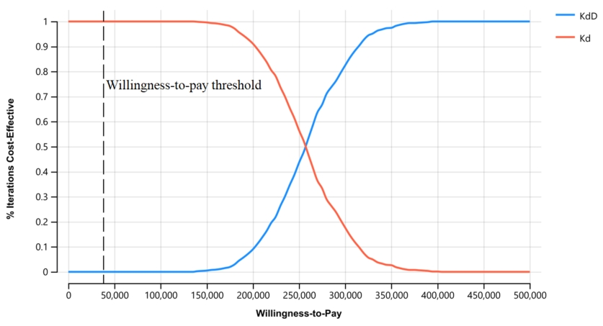

Supplementary Figure S4. Acceptability curves show the effects of prices on the probability of cost-effectiveness. KdD, daratumumab plus carfilzomid and dexamethasone; QALY, quality-adjusted life-year; WTP, willingness to pay.

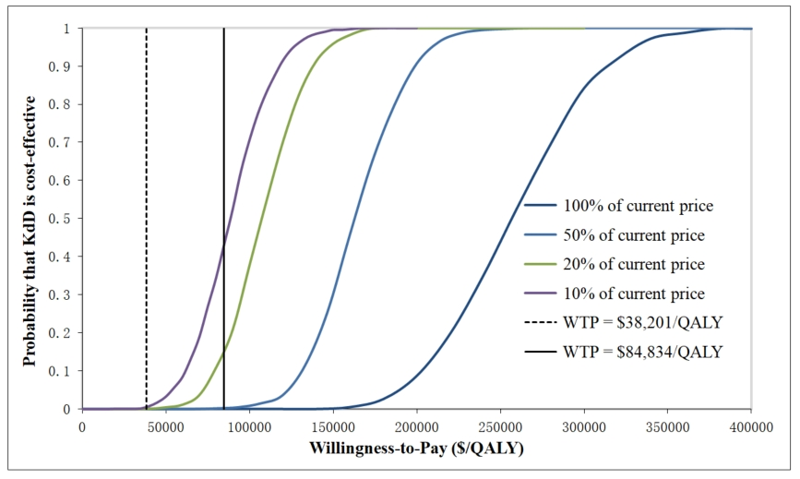
Supplementary Figure S5. Two-way sensitivity analysis on utilities of stable disease and progressed disease

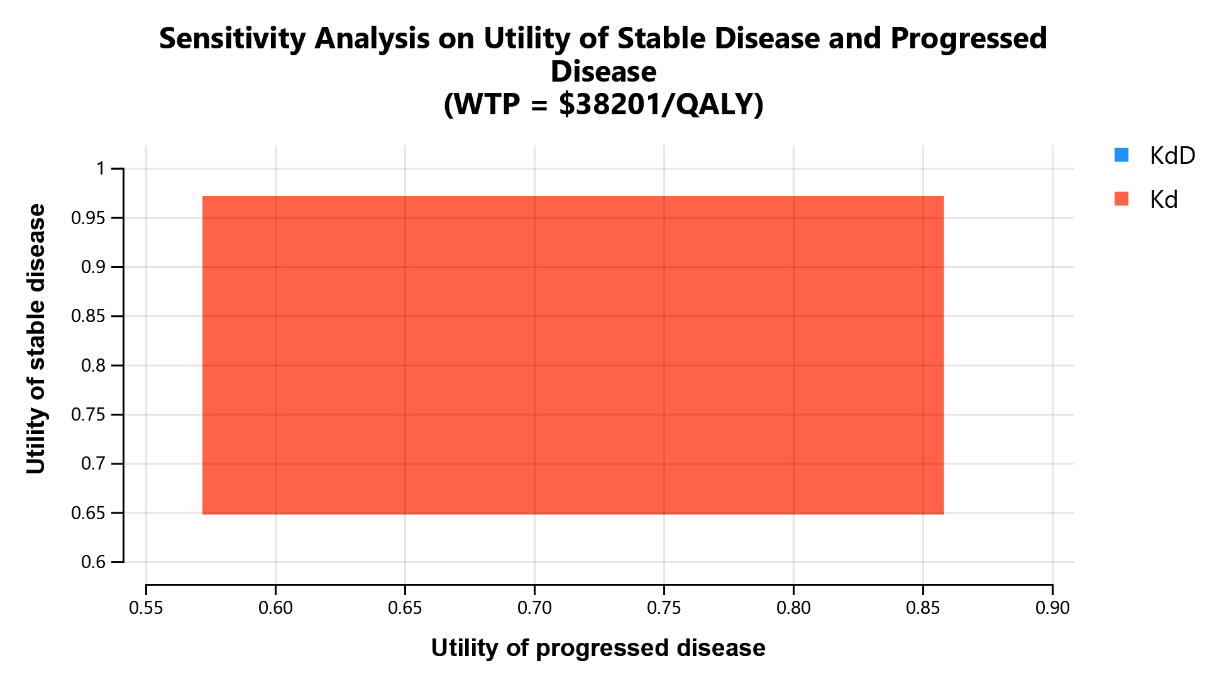

Supplementary Table S8. CHEERS 2022 Checklist
Topic | No. | Item | Location where item is reported
Title
Title | 1 | Identify the study as an economic evaluation and specify the interventions being compared. | Title, Row 1
Abstract
Abstract | 2 | Provide a structured summary that highlights context, key methods, results, and alternative analyses. | Abstract, Row 15-32
Introduction
Background and objectives | 3 | Give the context for the study, the study question, and its practical relevance for decision making in policy or practice. | Introduction, Row 73-75
Methods
Health economic analysis plan | 4 | Indicate whether a health economic analysis plan was developed and where available. | Methodological design section of Material and methods
Study population | 5 | Describe characteristics of the study population (such as age range, demographics, socioeconomic, or clinical characteristics). | Model Patients and intervention section of Material and methods, Supplemental table S1
Setting and location | 6 | Provide relevant contextual information that may influence findings. | Model structure section of Material and methods
Comparators | 7 | Describe the interventions or strategies being compared and why chosen. | Model Patients and intervention section of Material and methods
Perspective | 8 | State the perspective(s) adopted by the study and why chosen. | Model structure section of Material and methods
Time horizon | 9 | State the time horizon for the study and why appropriate. | Model structure section of Material and methods
Discount rate | 10 | Report the discount rate(s) and reason chosen. | Methodological design section of Material and methods
Selection of outcomes | 11 | Describe what outcomes were used as the measure(s) of benefit(s) and harm(s). | Methodological design section of Material and methods
Measurement of outcomes | 12 | Describe how outcomes used to capture benefit(s) and harm(s) were measured. | Methodological design section of Material and methods
Valuation of outcomes | 13 | Describe the population and methods used to measure and value outcomes. | Model Patients and intervention section of Material and methods
Measurement and valuation of resources and costs | 14 | Describe how costs were valued. | Cost estimates section of Material and methods
Currency, price date, and conversion | 15 | Report the dates of the estimated resource quantities and unit costs, plus the currency and year of conversion. | Cost estimates section of Material and methods
Rationale and description of model | 16 | If modelling is used, describe in detail and why used. Report if the model is publicly available and where it can be accessed. | Model structure section of Material and methods
Analytics and assumptions | 17 | Describe any methods for analysing or statistically transforming data, any extrapolation methods, and approaches for validating any model used. | Model structure section of Material and methods
Characterising heterogeneity | 18 | Describe any methods used for estimating how the results of the study vary for subgroups. | Not reported
Characterising distributional effects | 19 | Describe how impacts are distributed across different individuals or adjustments made to reflect priority populations. | Sensitivity analyses section of Material and methods, Table 1
Characterising uncertainty | 20 | Describe methods to characterise any sources of uncertainty in the analysis. | Sensitivity analyses section of Material and methods
Approach to engagement with patients and others affected by the study | 21 | Describe any approaches to engage patients or service recipients, the general public, communities, or stakeholders (such as clinicians or payers) in the design of the study. | Not applicable
Results
Study parameters | 22 | Report all analytic inputs (such as values, ranges, references) including uncertainty or distributional assumptions. | Sensitivity analyses section of Material and methods, Table 1
Summary of main results | 23 | Report the mean values for the main categories of costs and outcomes of interest and summarise them in the most appropriate overall measure. | Base-case results section of Results, Table 2
Effect of uncertainty | 24 | Describe how uncertainty about analytic judgments, inputs, or projections affect findings. Report the effect of choice of discount rate and time horizon, if applicable. | Sensitivity analyses results section of Results
Effect of engagement with patients and others affected by the study | 25 | Report on any difference patient/service recipient, general public, community, or stakeholder involvement made to the approach or findings of the study | Not applicable
Discussion
Study findings, limitations, generalisability, and current knowledge | 26 | Report key findings, limitations, ethical or equity considerations not captured, and how these could affect patients, policy, or practice. | Discussion section
Other relevant information
Source of funding | 27 | Describe how the study was funded and any role of the funder in the identification, design, conduct, and reporting of the analysis | Funding section
Conflicts of interest | 28 | Report authors conflicts of interest according to journal or International Committee of Medical Journal Editors requirements. | Competing interests section

From: Husereau D, Drummond M, Augustovski F, et al. Consolidated Health Economic Evaluation Reporting Standards 2022 (CHEERS 2022) Explanation and Elaboration: A Report of the ISPOR CHEERS II Good Practices Task Force. Value Health 2022;25. doi:10.1016/j.jval.2021.10.008

