Supplement Table 1: Cardiometabolic Risk Factors by BMI Group¹
Women (n=151)
Parameter | Nl Weight  20% (30/151) | Overweight  42% (64/151) | Obesity  38%(57/151) | P-value^{2,3} | F-statistic⁴
Systolic BP (mmHg) | 111±11 | 115±13 | 117±14 | 0.073 | 2.66
Diastolic BP (mmHg) | 70±9 | 70±11 | 73±10 | 0.303 | 1.21
0h glucose (mmol/L) | 4.9±0.4 | 4.9±0.5 | 5.1±0.5 | 0.131 | 2.06
2h glucose (mmol/L) | 6.7±1.8 | 7.3±1.5 | 7.5±2.2 | 0.127 | 2.09
A1C (%) | 5.3±0.4 | 5.3±0.5 | 5.4±0.5 | 0.373 | 0.99
0h insulin (pmol/L) | 35.4±13.8 | 46.8±23.4 | 56.4±30.0 | 0.001 b*** | 7.21
Diabetes | 0% | 2% | 9% | 0.059 | N/A⁵
Matsuda Index | 5.6±3.1 | 4.3±2.2 | 4.4±2.8 | 0.043b* | 3.23
Insulin Secret Index | 0.5±0.3 | 0.6±0.3 | 0.6±0.3 | 0.370 | 1.00
Cholesterol (mmol/L) | 4.3±0.8 | 4.3±0.8 | 4.5±0.9 | 0.473 | 0.75
Triglyceride (mmol/L) | 0.7±0.4 | 0.7±0.3 | 0.8±0.3 | 0.196 | 1.65
HDL-chol (mmol/L) | 1.7±0.5 | 1.5±0.3 | 1.5±0.4 | 0.006 a*, b** | 5.31
LDL-chol (mmol/L) | 2.4±0.8 | 2.6±0.7 | 2.7±0.8 | 0.100 | 2.34
LDL Particle Size (nm) | 21.2±0.5 | 21.1±0.5 | 21.0±0.5 | 0.283 | 1.27
LDL Part No. (nmol/L) | 860±294 | 1020±357 | 1161±389 | 0.001 b** | 7.16
hsCRP (mg/L) | 1.7±2.3 | 2.3±2.7 | 4.3±5.8 | 0.006 b*, c* | 5.23
Fibrinogen (g/L) | 3.0±0.1 | 3.2±0.6 | 3.4±0.6 | 0.036 b* | 3.39
Men (n=229)
Parameter | Nl Weight  32%  (72/229) | Overweight  49% (113/229) | Obesity  19%  (43/229) | P-value^{2,3}
Systolic BP (mmHg) | 117±13 | 123±13 | 126±15 | 0.001 a*b** | 7.12
Diastolic BP (mmHg) | 73±11 | 75±10 | 78±10 | 0.042 b* | 3.21
0h glucose (mmol/L) | 5.0±0.5 | 5.2±0.6 | 5.7±1.6 | <0.001 b***c** | 10.41
2h glucose (mmol/L) | 7.1±1.9 | 7.4±2.4 | 9.0±3.5 | <0.001 b***c** | 9.07
A1C | 5.3±0.5 | 5.4±0.5 | 5.8±1.2 | 0.001 b***c* | 6.74
0h insulin (pmol/L) | 30.0±18.0 | 46.8±27.0 | 80.4±45.0 | <0.001 a***b***c*** | 39.95
Diabetes | 4% | 9% | 19% | 0.034 | N/A
Matsuda Index | 6.6±4.1 | 4.7±2.6 | 2.8±1.7 | <0.001 a***b***c** | 22.52
Insulin Secret Index | 0.4±0.3 | 0.6±0.4 | 0.8±0.6 | <0.001 b*** c* | 9.58
Cholesterol (mmol/L) | 4.2±0.9 | 4.4±0.9 | 4.4±1.0 | 0.162 | 1.83
Triglyceride (mmol/L) | 0.8±0.3 | 0.9±0.4 | 1.2±0.7 | <0.001 b*** c** | 1.65
HDL-chol (mmol/L) | 1.3±0.4 | 1.2±0.3 | 1.2±0.3 | 0.008 a* b* | 4.95
LDL-chol (mmol/L) | 2.5±29 | 2.8±0.9 | 2.7±0.9 | 0.025 a* | 2.34
LDL Particle Size (nm) | 20.9±0.6 | 20.8±0.6 | 20.6±0.6 | 0.117 | 2.17
LDL Part No. (nmol/L) | 1011±383 | 1183±423 | 1176±435 | 0.016 a* | 4.19
hsCRP (mg/L) | 1.1±1.8 | 1.3±2.0 | 2.9±2.8 | <0.001 b*** c*** | 11.66
Fibrinogen (g/L) | 2.5±0.7 | 2.6±0.5 | 2.9±0.6 | <0.001 b*** c** | 7.96
¹Metabolic testing done in the 380 participants who proceed to Visit 2. No enrollees were underweight. ²Comparision by One-way ANOVA ³One-way ANOVA notation: a: difference between Normal Weight & Overweight, b: difference Normal Weight & Obesity, c: difference between Overweight & Obesity *<0.05, **<0.01, ***<0.001 ⁴Provided for continuous variables (Degrees of Freedom=2) ⁵Not applicable

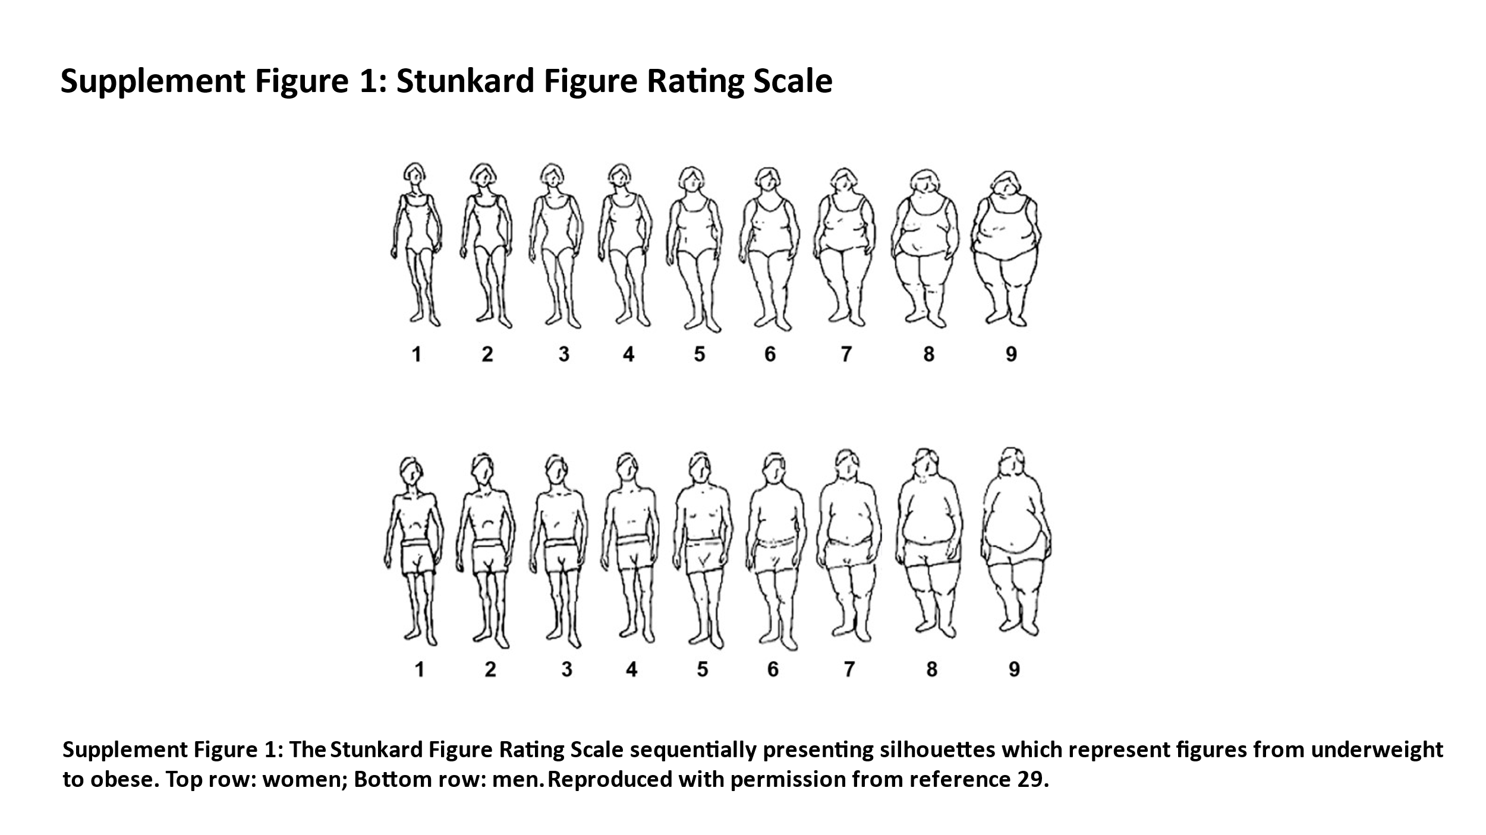

Note: Supplement Figure 1 reproduced with permission from Stunkard AJST, Schulsinger F. Use of the Danish Adoption Register for the study of obesity and thiness. In: Kety S, editor. The Genetics of Neurological and Psychiatric Disorders. New York, NY: Raven Press; 1983:115–120.²⁹

