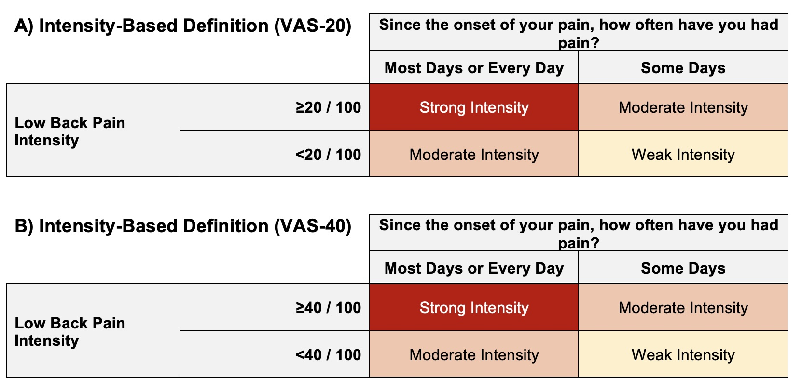

Supplemental Figure 1. Alternative Acute Low Back Pain Severity Categorization Definitions

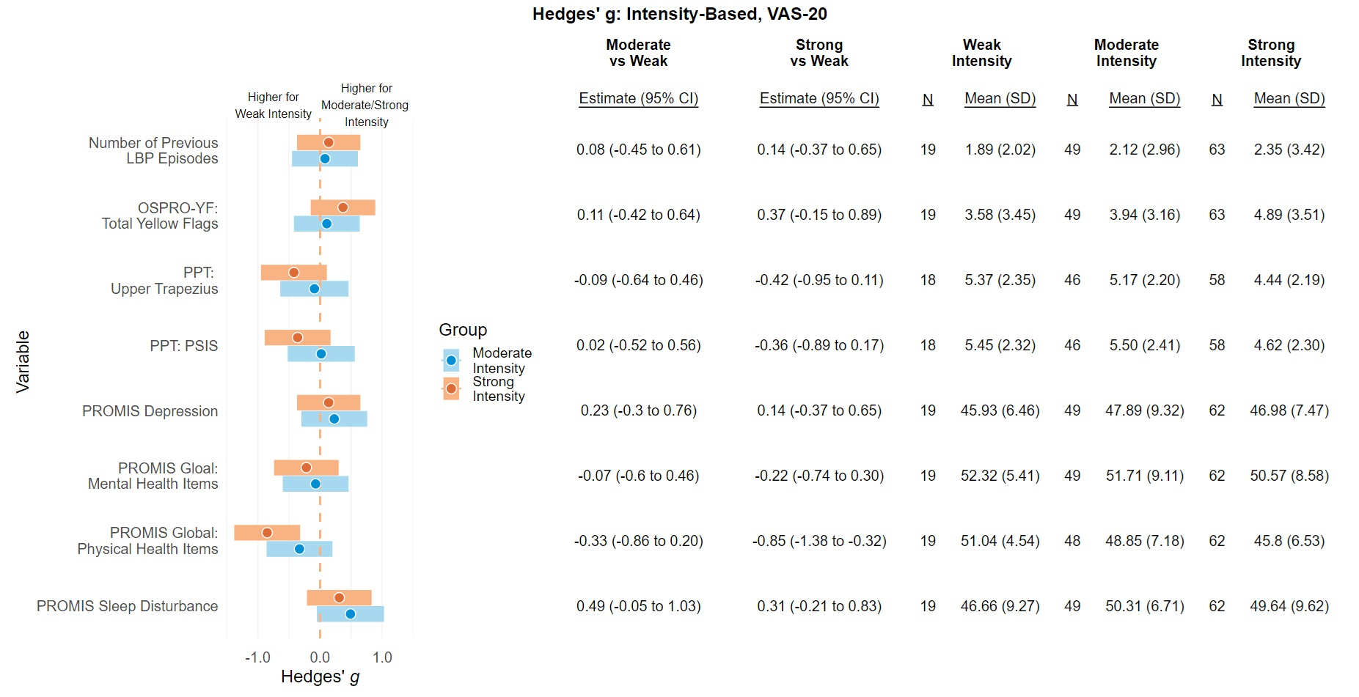

Supplemental Figure 2. Hedges’ g for continuous variables comparing moderate- and strong-intensity to weak-intensity acute LBP categories based on alternative VAS-20 definition.

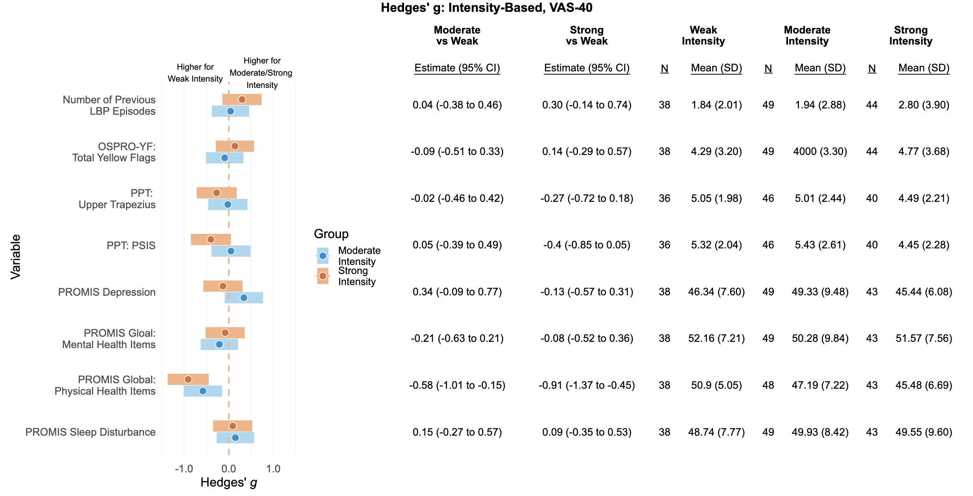

Supplemental Figure 3. Hedges’ g for continuous variables comparing moderate- and strong-intensity to weak-intensity acute LBP categories based on alternative VAS-40 definition.

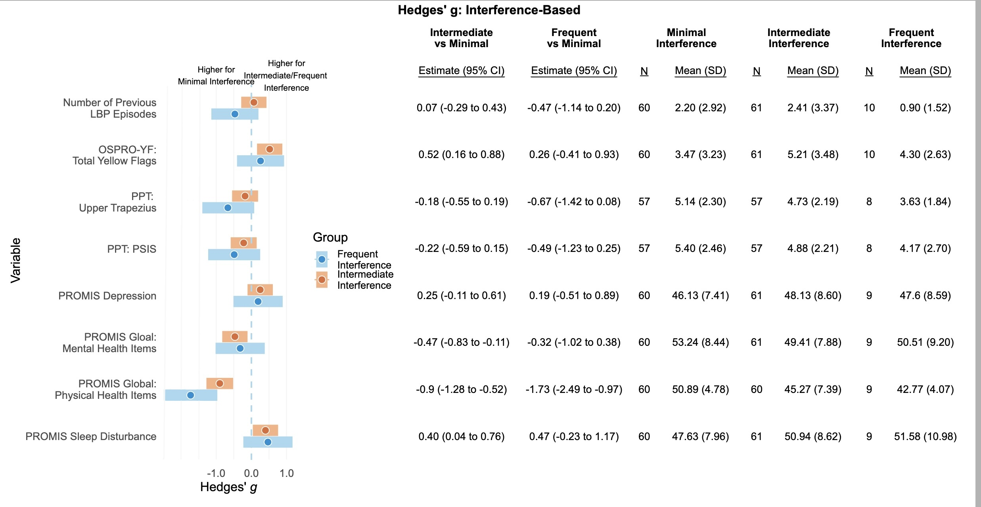

Supplemental Figure 4. Hedges’ g for continuous variables comparing intermediate- and frequent-interference to minimal-interference acute LBP categories

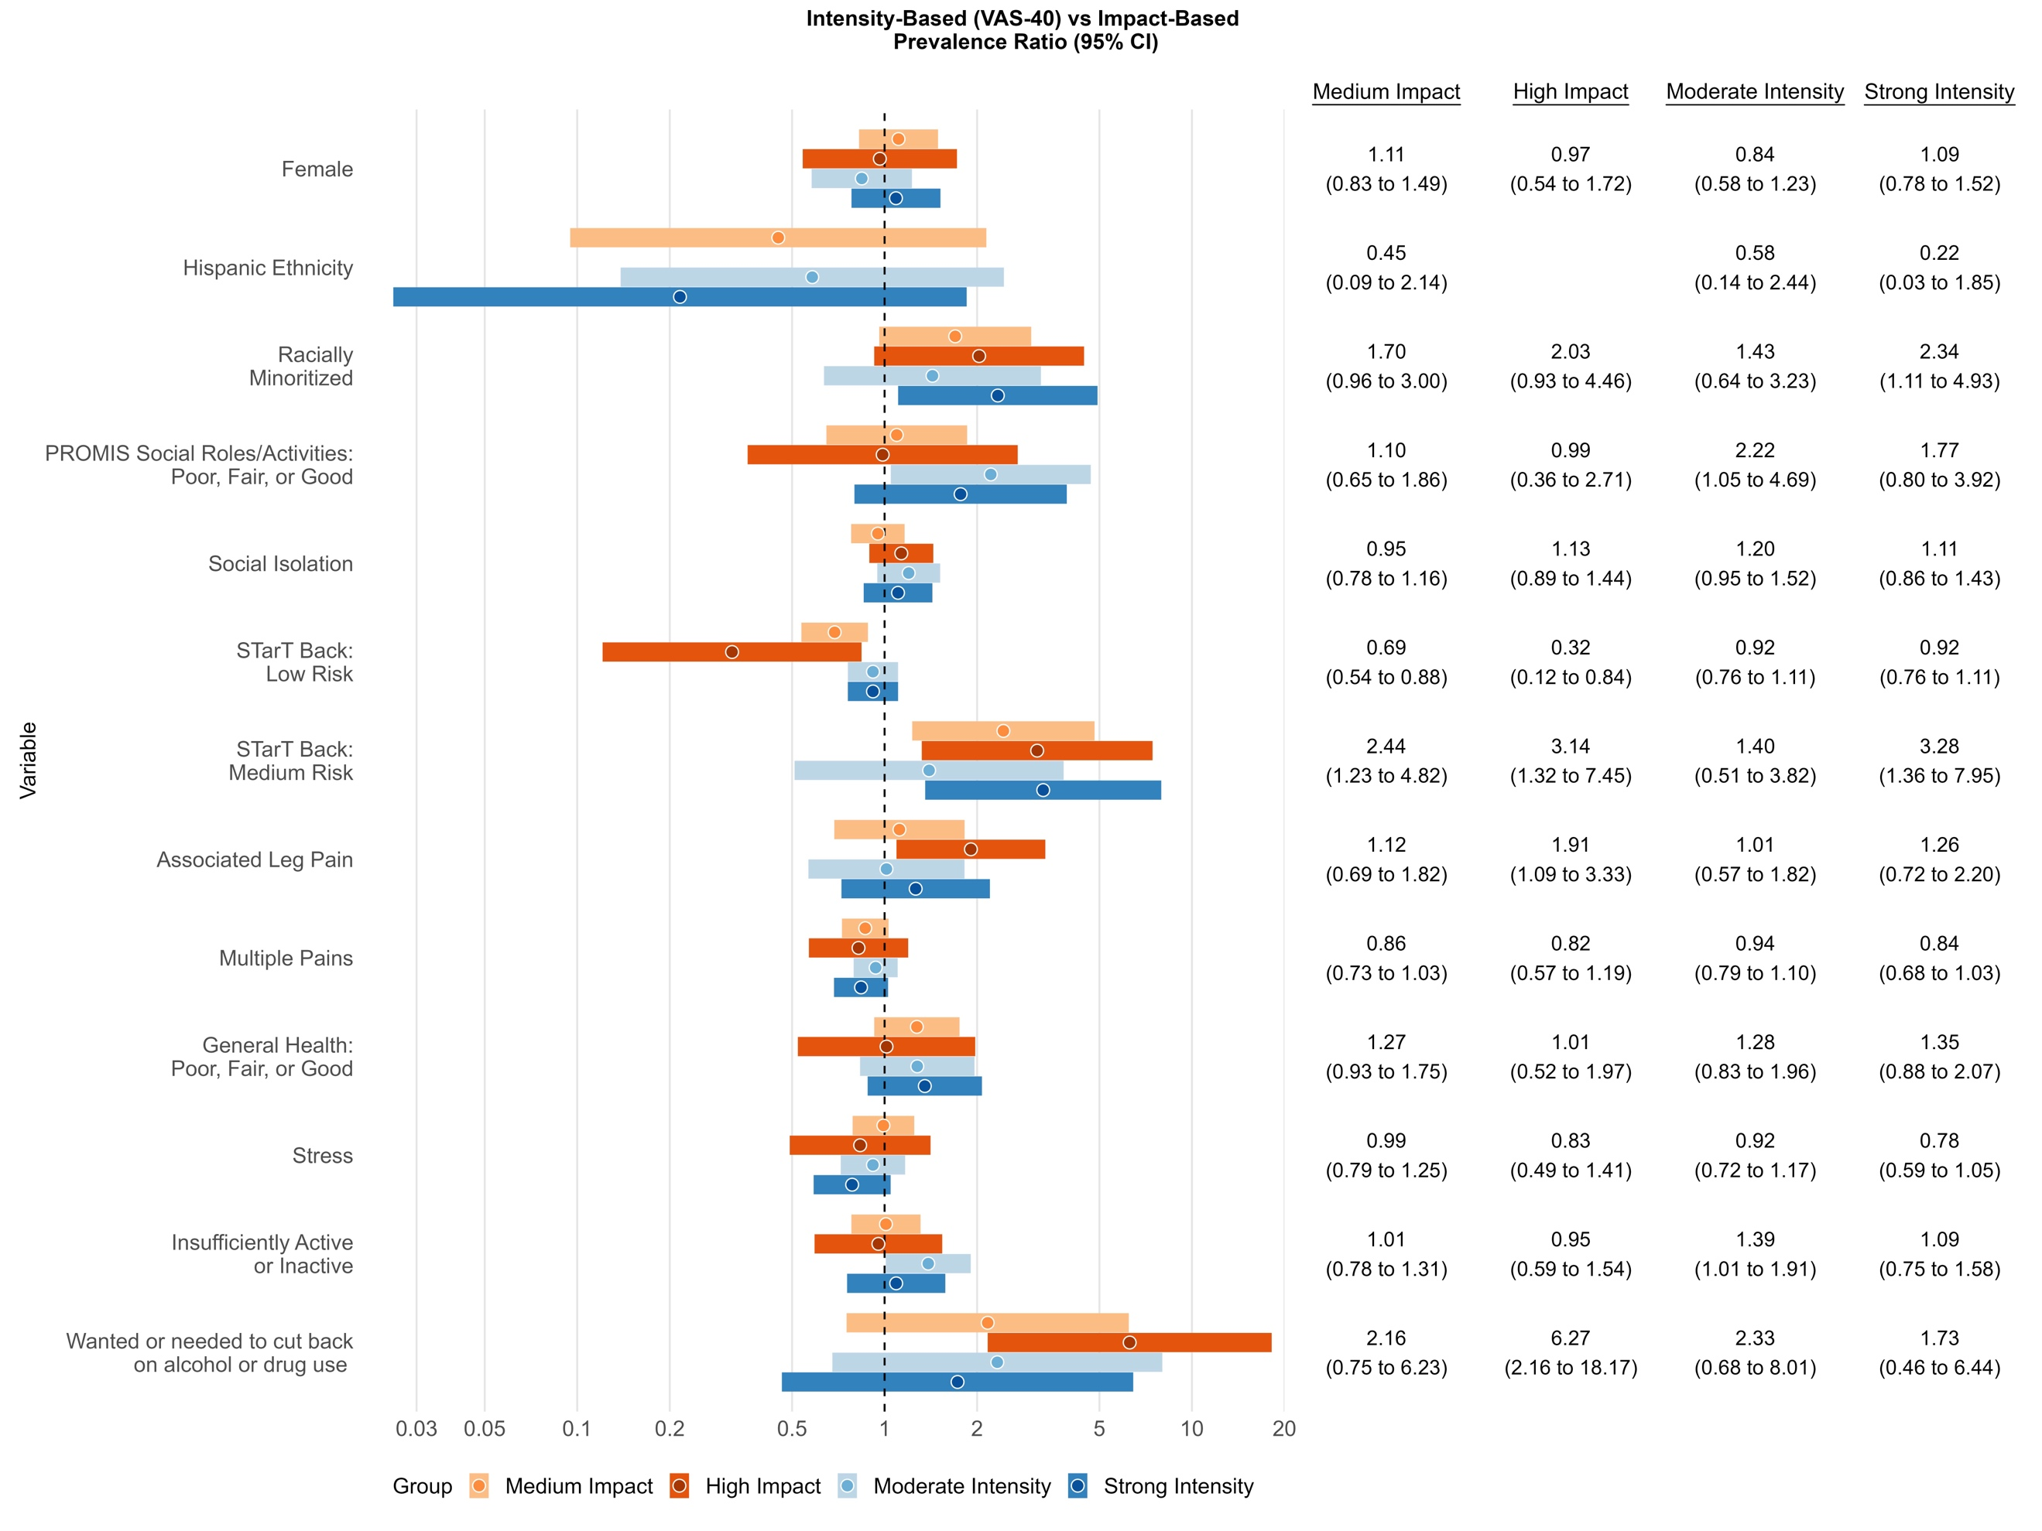
Supplemental Figure 5. Prevalence ratios for categorical variables, comparing impact-based and intensity-based (with VAS-40/100 cut off) acute LBP severity categories acute LBP categories. *Note each category is compared to its own definition’s referent category (i.e., medium- vs. low-impact, and high- vs. low-impact, moderate- vs. weak-intensity, strong- vs. weak-intensity).

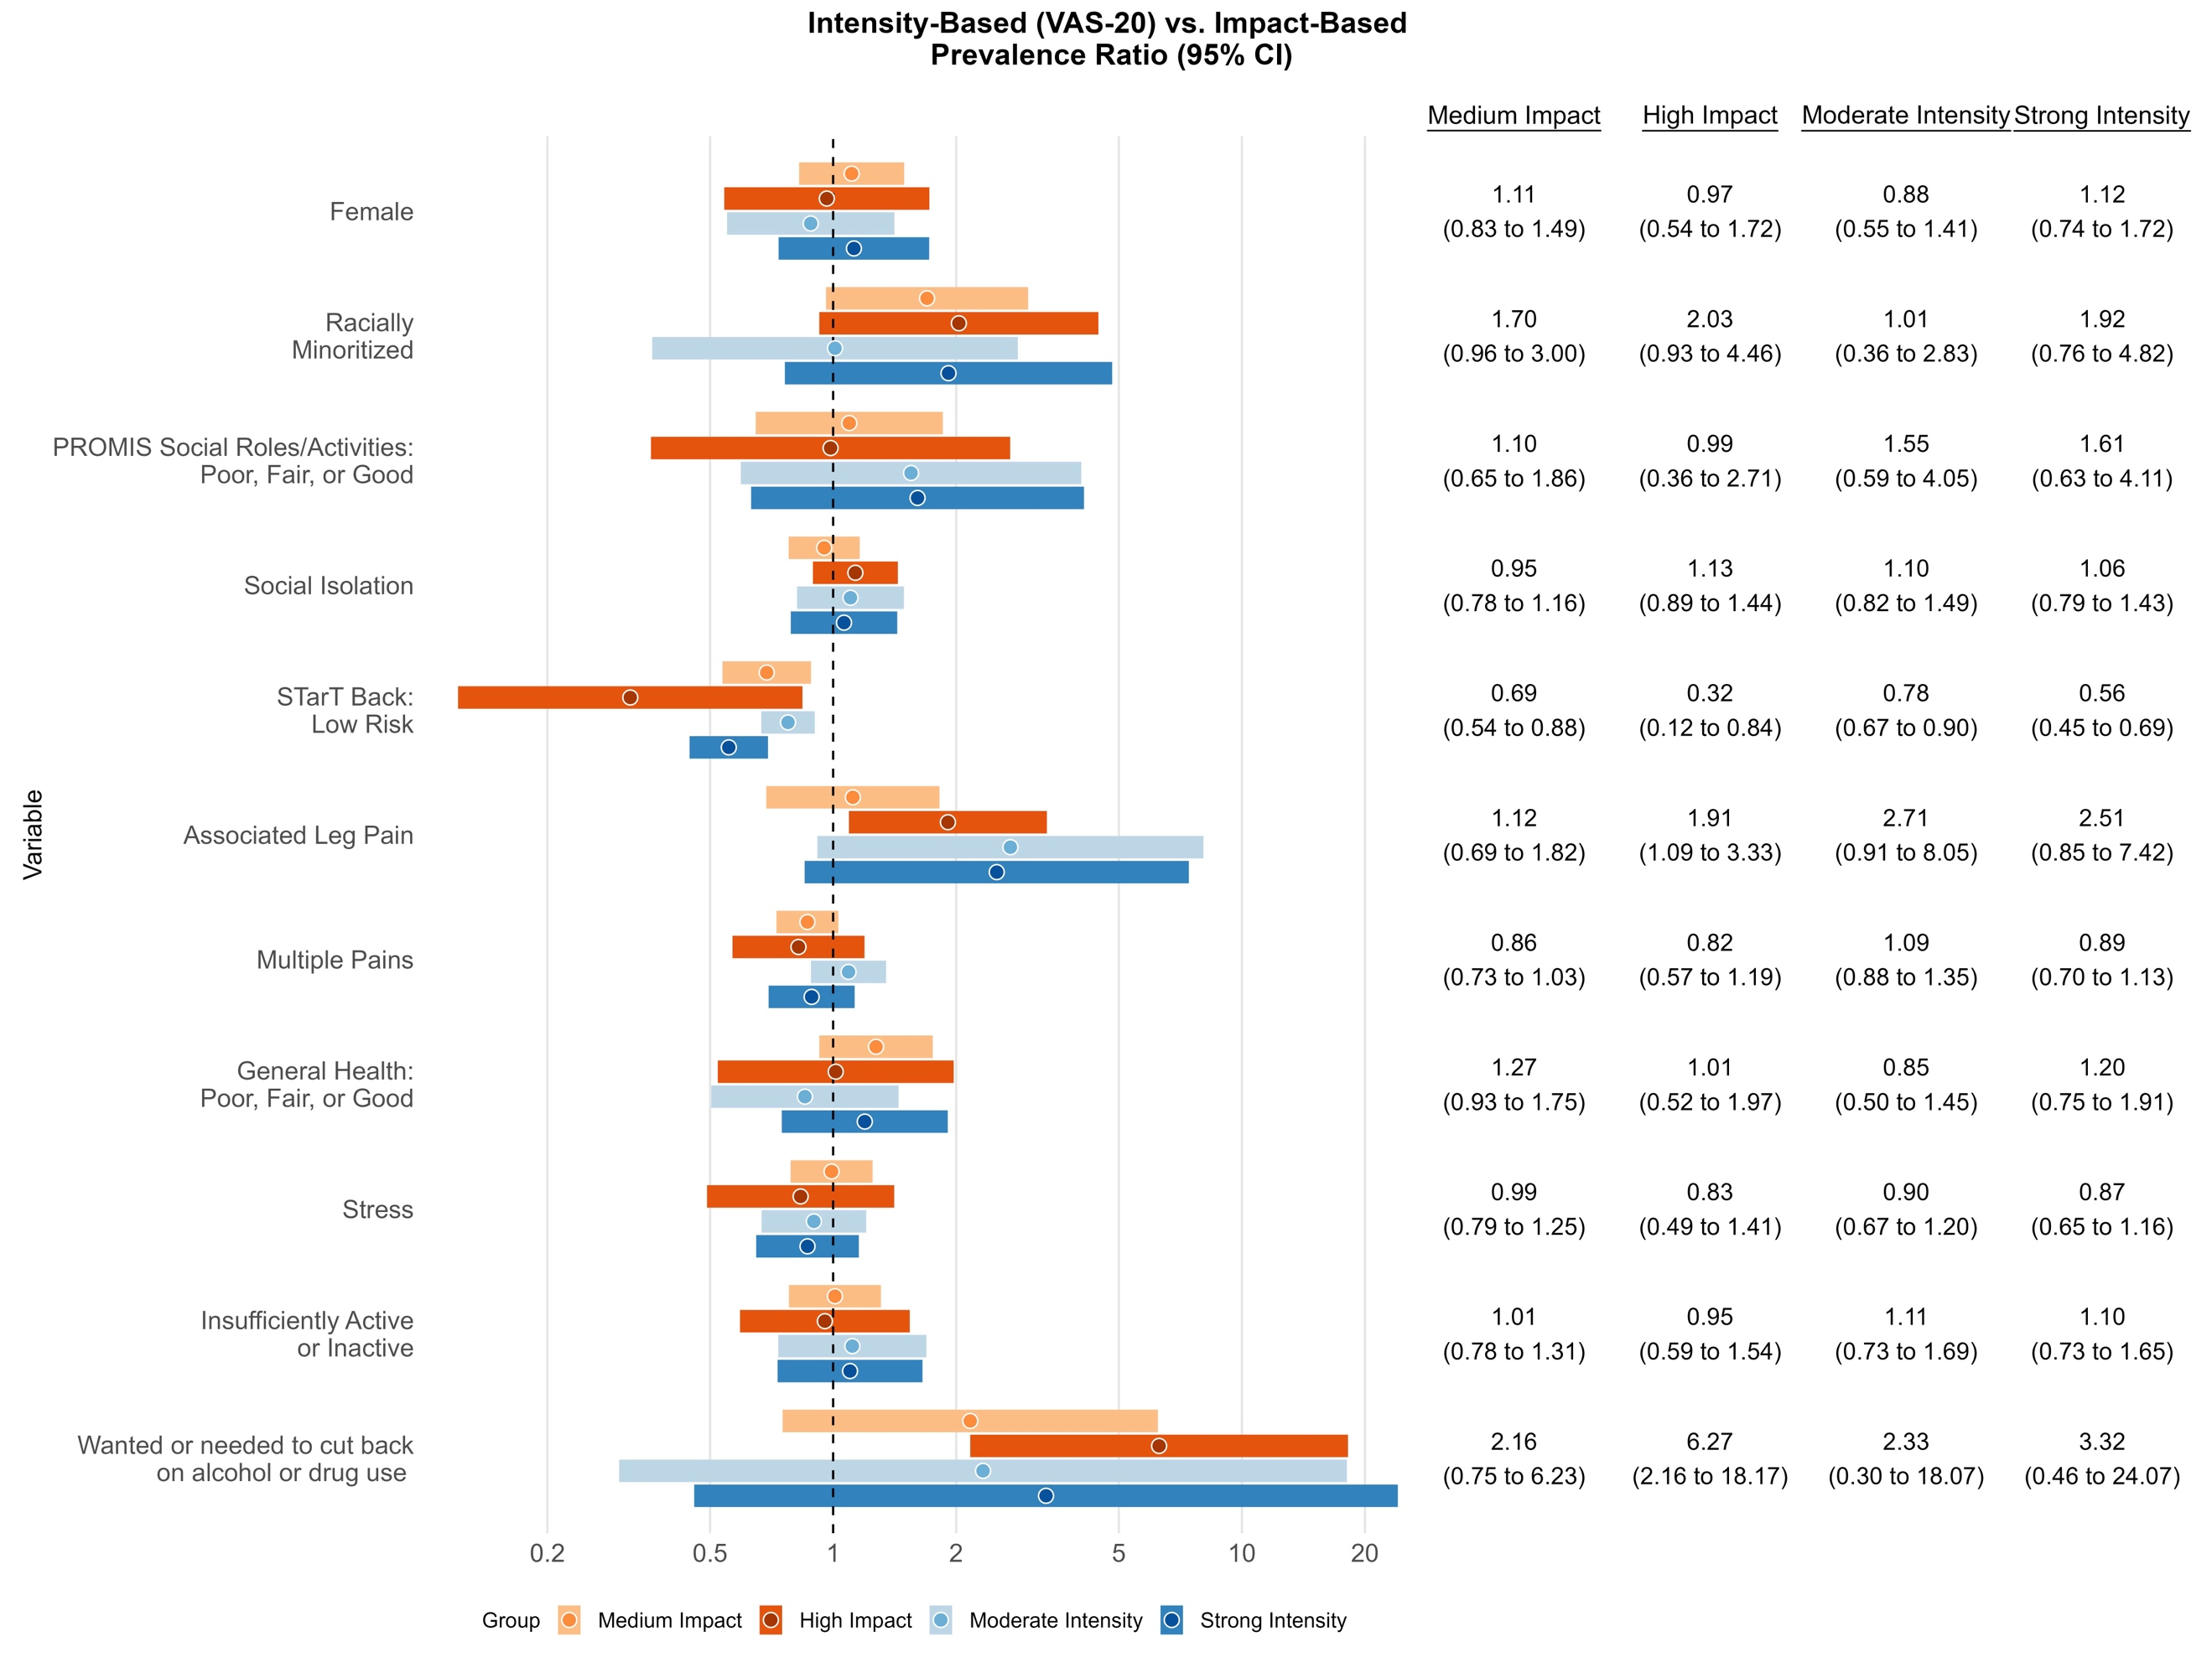
Supplemental Figure 6. Prevalence ratios for categorical variables, comparing impact-based and intensity-based (with VAS-20/100 cut off) acute LBP severity categories acute LBP categories. *Note each category is compared to its own definition’s referent category (i.e., moderate- vs. weak-intensity, strong- vs. weak-intensity, medium- vs. low-impact, and high- vs. low-impact).

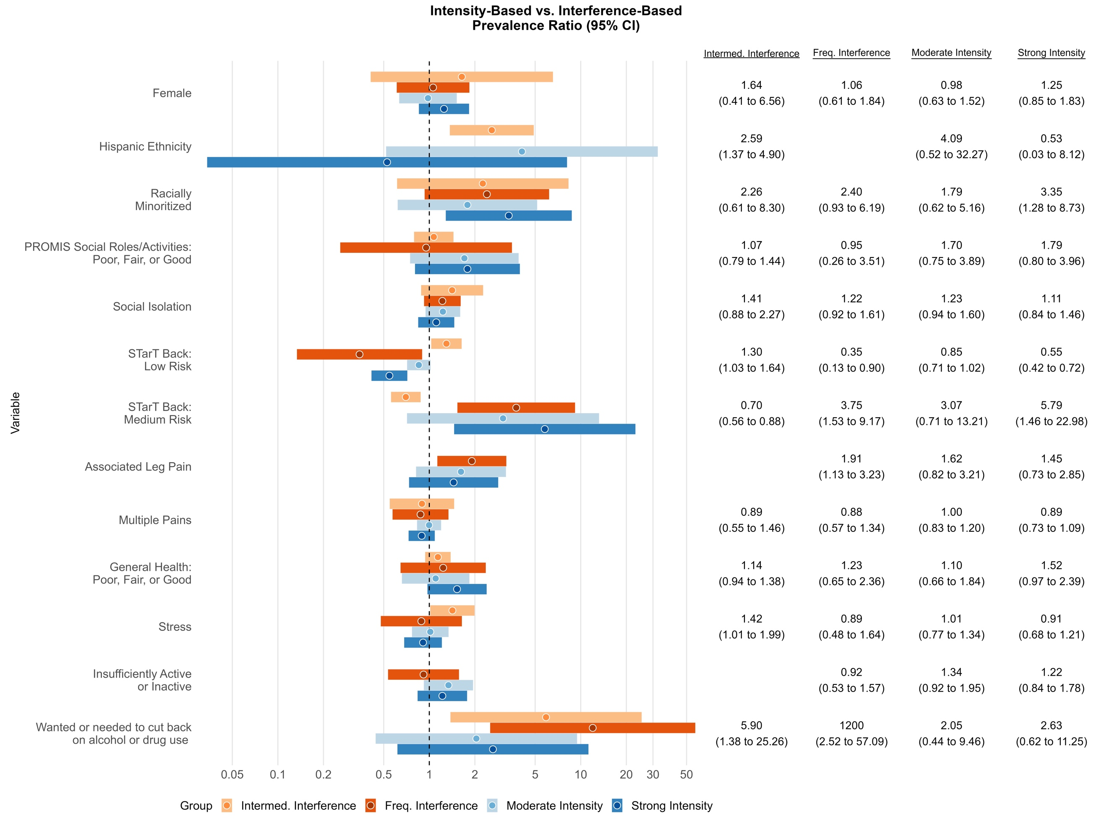
Supplemental Figure 7. Prevalence ratios for categorical variables, comparing interference-based and intensity-based (with VAS-30/100 cut off) acute LBP severity categories. *Note each category is compared to its own definition’s referent category (i.e., intermediate- vs. minimal-interference, frequent- vs. minimal-interference, moderate- vs. weak-intensity, strong- vs. weak-intensity).
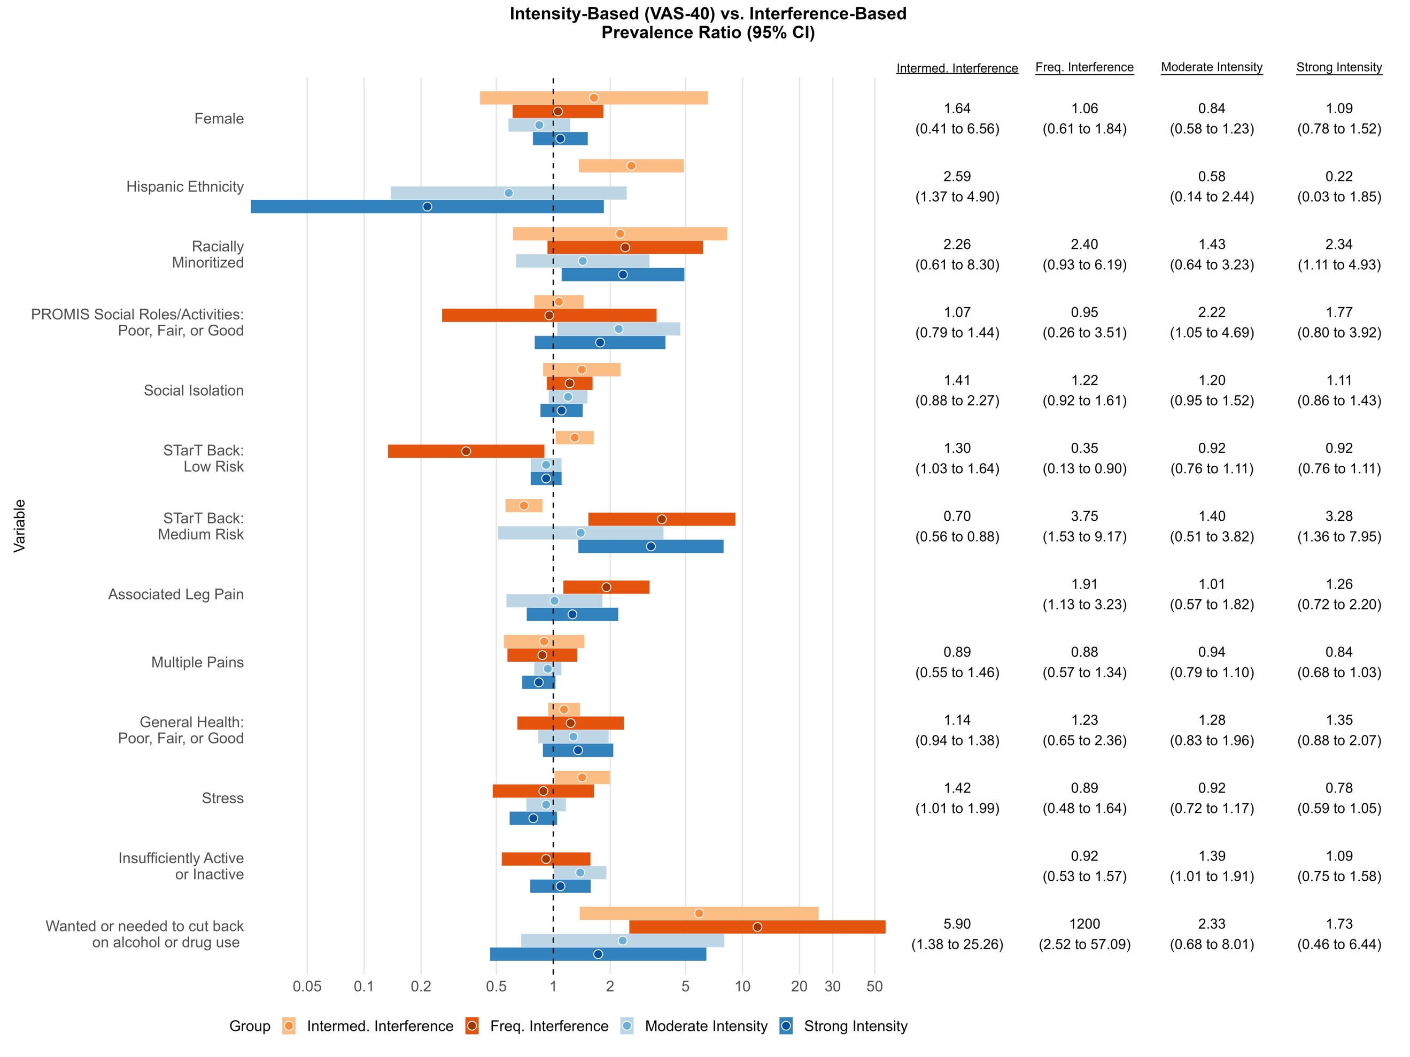

Supplemental Figure 8. Prevalence ratios for categorical variables, comparing interference-based and intensity-based (with VAS-40/100 cut off) acute LBP severity categories. *Note each category is compared to its own definition’s referent category (i.e., intermediate- vs. minimal-interference, frequent- vs. minimal-interference, moderate- vs. weak-intensity, strong- vs. weak-intensity).

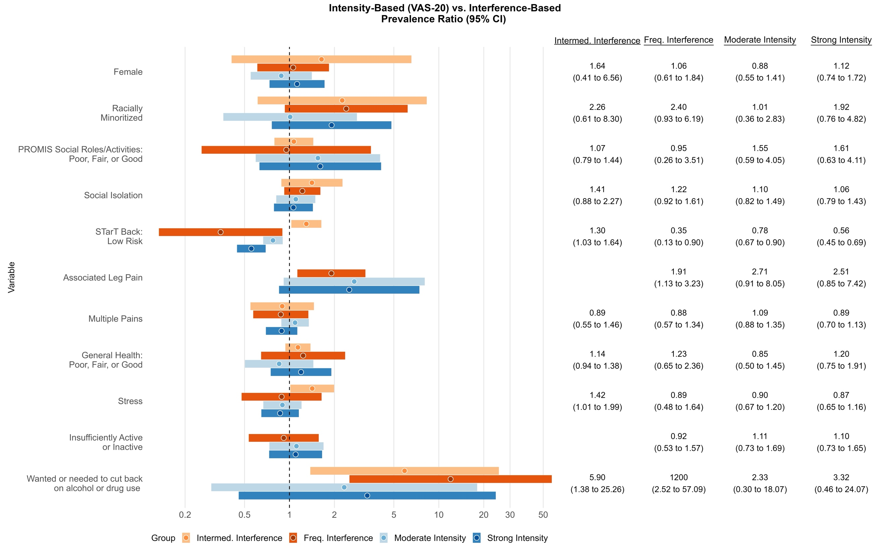
Supplemental Figure 9. Prevalence ratios for categorical variables, comparing interference-based and intensity-based (with VAS-20/100 cut off) acute LBP severity categories. *Note each category is compared to its own definition’s referent category (i.e., intermediate- vs. minimal-interference, frequent- vs. minimal-interference, moderate- vs. weak-intensity, strong- vs. weak-intensity).

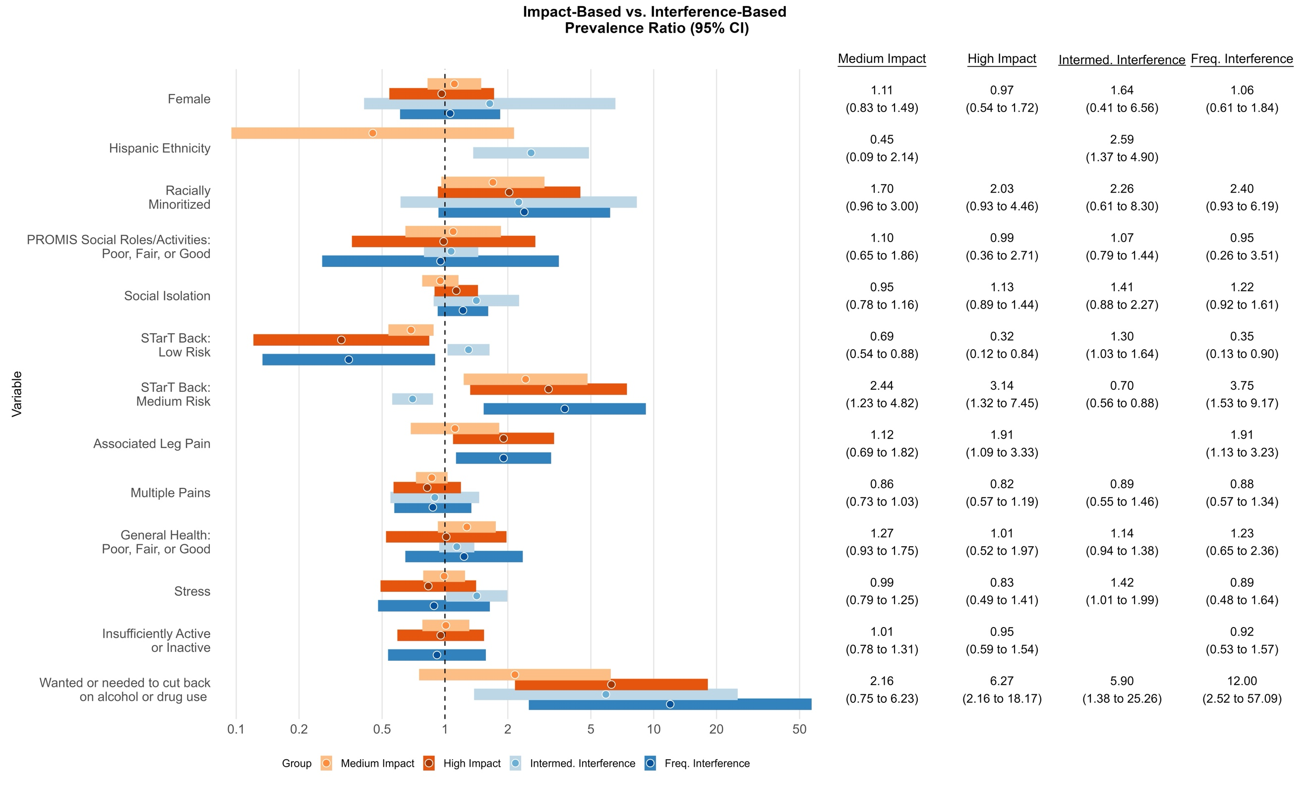
Supplemental Figure 10. Prevalence ratios for categorical variables, comparing impact-based and interference-based acute LBP severity categories. *Note each category is compared to its own definition’s referent category (i.e., medium- vs. low-impact, and high- vs. low-impact, intermediate- vs. minimal-interference, frequent- vs. minimal-interference).

