Supplementary Table 1. Comparison of nutritional changes between the GUSS and non-GUSS groups
 | GUSS | Non-GUSS | t or c² | p-value
Oral diet recovery | 35 (43.2) | 46 (56.8) | 2.58 | 0.108
Albumin change | 0.21 ± 0.40 | 0.20 ± 0.50 | 0.11 | 0.915
BMI change | -0.4 ± 1.26 | -0.4 ± 0.92 | 0.04 | 0.966
NPO days | 1.6 ± 2.7 | 1.6 ± 2.9 | 0 | 1.000
Values are presented as n (%) or mean ± standard deviation.
BMI, body mass index; GUSS, Gugging Swallowing Screen; NPO, nil per os.

Supplementary Table 2. Comparison of Baseline Characteristics between VFSS Performed and Not Performed Groups
 | Matched patients |  |  | VFSS (n = 60) |  |  | Non VFSS (n = 132)
 | GUSS | Non-GUSS | SMD | GUSS | Non-GUSS | SMD | GUSS | Non-GUSS | SMD
 | (n = 96) | (n = 96) | SMD | (n = 34) | (n = 26) | SMD | (n = 62) | (n = 70) | SMD
Sex, male | 63 (65.6) | 66 (68.8) | 0.031 | 24 (70.6) | 17 (65.4) | 0.052 | 39 (62.9) | 49 (70.0) | 0.071
Age (years) | 79.85 ± 8.07 | 80.79 ± 7.11 | 0.116 | 80.71 ± 7.43 | 81.23 ± 7.24 | 0.072 | 79.39 ± 8.43 | 80.63 ± 7.11 | 0.159
Height (cm) | 160.53 ± 10.06 | 160.26 ± 8.89 | 0.026 | 162.25 ± 9.71 | 158.37 ± 10.12 | 0.392 | 159.58 ± 10.20 | 160.97 ± 8.36 | 0.149
Body weight (kg) | 54.01 ± 10.64 | 53.05 ± 10.78 | 0.09 | 53.22 ± 9.93 | 53.61 ± 11.40 | 0.036 | 54.44 ± 11.06 | 52.84 ± 10.62 | 0.147
BMI (kg/m²) | 20.97 ± 3.70 | 20.66 ± 3.89 | 0.085 | 20.22 ± 3.43 | 21.40 ± 4.37 | 0.3 | 21.38 ± 3.80 | 20.38 ± 3.69 | 0.267
Age-adjusted CCI | 7.85 ± 2.30 | 7.48 ± 2.30 | 0.163 | 7.32 ± 2.06 | 7.23 ± 2.18 | 0.044 | 8.15 ± 2.39 | 7.57 ± 2.35 | 0.242
Diabetes mellitus | 36 (37.5) | 37 (38.5) | 0.01 | 14 (41.2) | 10 (38.5) | 0.027 | 22 (35.5) | 27 (38.6) | 0.031
Hypertension | 60 (62.5) | 42 (43.8) | 0.188 | 19 (55.9) | 10 (38.5) | 0.174 | 41 (66.1) | 32 (45.7) | 0.204
CVD | 30 (31.2) | 19 (19.8) | 0.115 | 8 (23.5) | 5 (19.2) | 0.043 | 22 (35.5) | 14 (20.0) | 0.155
COPD | 17 (17.7) | 18 (18.8) | 0.01 | 3 ( 8.8) | 4 (15.4) | 0.066 | 14 (22.6) | 14 (20.0) | 0.026
CVA | 31 (32.3) | 29 (30.2) | 0.021 | 13 (38.2) | 9 (34.6) | 0.036 | 18 (29.0) | 20 (28.6) | 0.005
Solid cancer | 41 (42.7) | 37 (38.5) | 0.042 | 11 (32.4) | 7 (26.9) | 0.054 | 30 (48.4) | 30 (42.9) | 0.055
Dementia | 46 (47.9) | 36 (37.5) | 0.104 | 19 (55.9) | 15 (57.7) | 0.018 | 27 (43.5) | 21 (30.0) | 0.135
MNA-SF total score | 5.09 ± 2.86 | 5.08 ± 2.71 | 0.004 | 4.47 ± 2.73 | 5.81 ± 2.93 | 0.472 | 5.44 ± 2.89 | 4.81 ± 2.60 | 0.226
NST consultation | 40 (41.7) | 38 (39.6) | 0.021 | 15 (44.1) | 15 (57.7) | 0.136 | 25 (40.3) | 23 (32.9) | 0.075
Oral feeding at home | 96 (100.0) | 96 (100.0) | 0 | 34 (100.0) | 26 (100.0) | 0 | 62 (100.0) | 70 (100.0) | 0
Feeding at admission |  |  | 0.083 |  |  | 0.195 |  |  | 0.019
NPO | 36 (37.5) | 34 (35.4) |  | 12 (35.3) | 9 (34.6) |  | 24 (38.7) | 25 (35.7)
Oral diet | 49 (51.0) | 57 (59.4) |  | 13 (38.2) | 15 (57.7) |  | 36 (58.1) | 42 (60.0)
Tube feeding | 11 (11.5) | 5 ( 5.2) |  | 9 (26.5) | 2 ( 7.7) |  | 2 ( 3.2) | 3 ( 4.3)
Aspiration pneumonia history | 6 ( 6.2) | 8 ( 8.3) | 0.021 | 4 (11.8) | 4 (15.4) | 0.036 | 2 ( 3.2) | 4 ( 5.7) | 0.011
Aspiration pneumonia at admission | 27 (28.1) | 28 (29.2) | 0.01 | 14 (41.2) | 12 (46.2) | 0.05 | 13 (21.0) | 16 (22.9) | 0.025
Aspiration symptom | 58 (60.4) | 61 (63.5) | 0.031 | 25 (73.5) | 22 (84.6) | 0.111 | 33 (53.2) | 39 (55.7) | 0.019
ECOG scale |  |  | 0.01 |  |  | 0.023 |  |  | 0.025
2 | 6 ( 6.2) | 7 ( 7.3) |  | 2 ( 5.9) | 1 ( 3.8) |  | 4 ( 6.5) | 6 ( 8.6) | 0.024
3 | 17 (17.7) | 16 (16.7) |  | 4 (11.8) | 3 (11.5) |  | 13 (21.0) | 13 (18.6)
4 | 73 (76.0) | 73 (76.0) |  | 28 (82.4) | 22 (84.6) |  | 45 (72.6) | 51 (72.9)
Values are presented as n (%) or mean ± standard deviation.
BMI, body mass index; CCI, Charlson Comorbidity Index; COPD, chronic obstructive pulmonary disease; CVA, cerebrovascular accident; CVD, coronary vascular disease; ECOG, Eastern Cooperative Oncology Group; GUSS, Gugging Swallowing Screen; MNA-SF, Mini Nutritional Assessment – Short Form; NPO, nil per os; NST, nutritional support team; SMD, standardized mean difference.

Supplementary Figure 1. Balancing plot of the patients before and after propensity score matching
BMI, body mass index; CCI, Charlson Comorbidity Index; ECOG, Eastern Cooperative Oncology Group; MNA-SF, Mini Nutritional Assessment – Short Form; NST, nutritional support team.

Supplementary Figure 2. Analysis of the interactions among age, sex, causes of dysphagia, and the GUSS
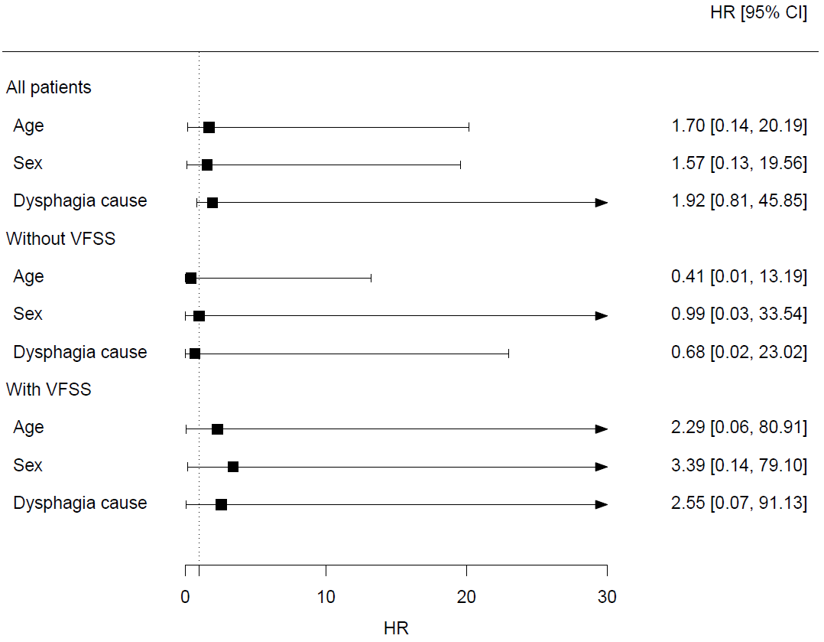
CI, confidence interval; GUSS, Gugging Swallowing Screen; HR, hazard ratio; VFSS, videofluoroscopic swallowing study.

