Supporting Information

Engineering Ag-Decorated Graphene Oxide Nano-Photothermal Platforms with Enhanced Antibacterial Properties for Promoting Infectious Wound Healing

Zhiwei Sun¹, *, Xiangru Chen¹, *, Fang Miao², *, Na Meng³, Keqiang Hu¹, Shaotang Xiong⁴, Ximing Peng¹, Liya Ma⁵, Chuchao Zhou¹, #, Yanqing Yang¹, #

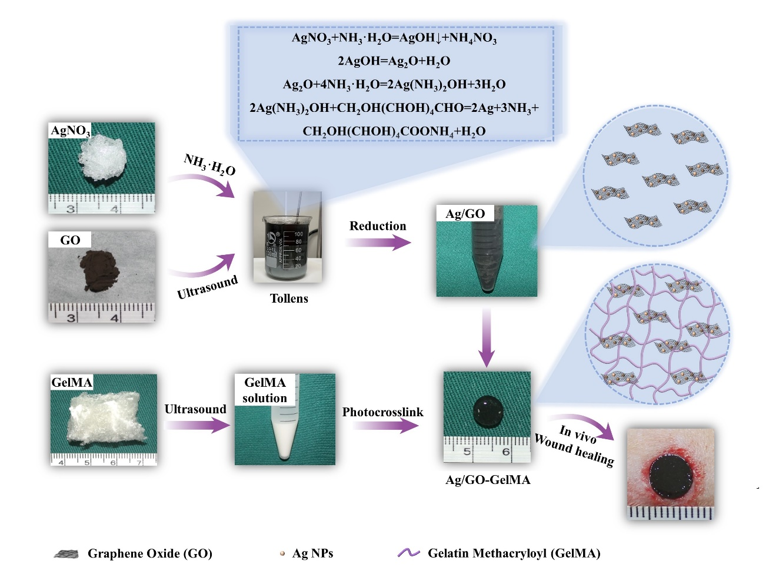
Figure S1. Schematic diagram of Ag/GO-GelMA hydrogel preparation process.

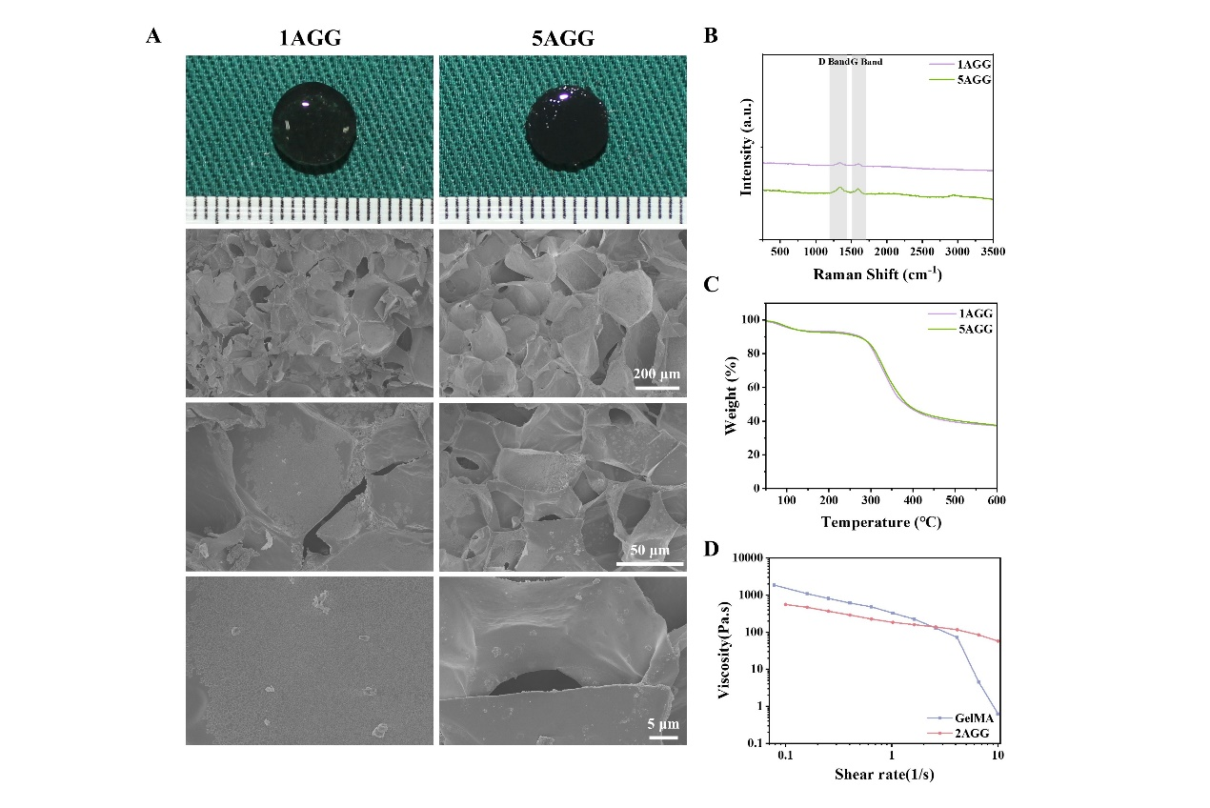
Figure S2. (A) Digital images and SEM images, (B) Raman spectra, and (C) TGA results of 1AGG and 5AGG hydrogels (scale bar = 100 µm, 100 µm, 2 µm, respectively). (D) Viscosity changes with shear rate.

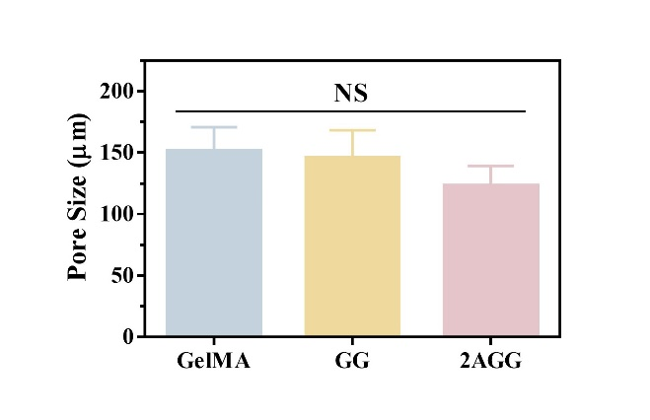
Figure S3. The pore size of the three hydrogels (n = 3). NS means not significant.

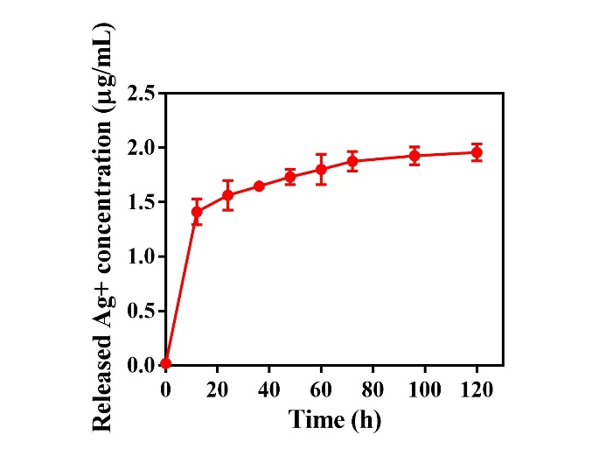
Figure S4. Ag⁺ release profile of Ag/GO NPs (n = 3).

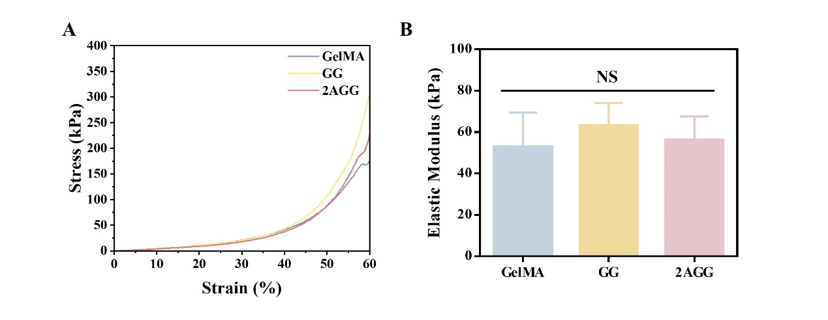
Figure S5. Mechanical properties of prepared hydrogels. A) Compression strain-stress curves. B) The corresponding elastic modulus (n=3). NS means not significant.

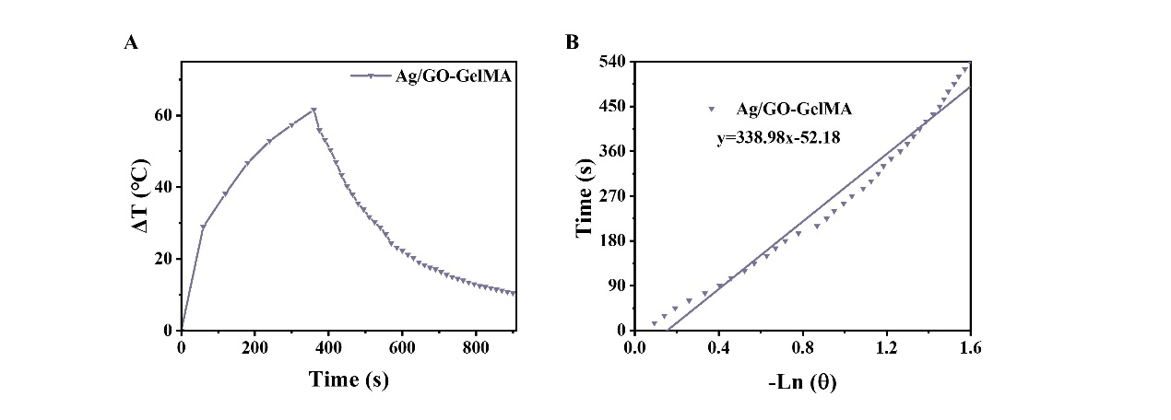
Figure S6. Photothermal effects (A) and plot fitting of cooling time versus the negative natural logarithm of the driving force temperature during the cooling phase (B) of Ag/GO-GelMA hydrogel.

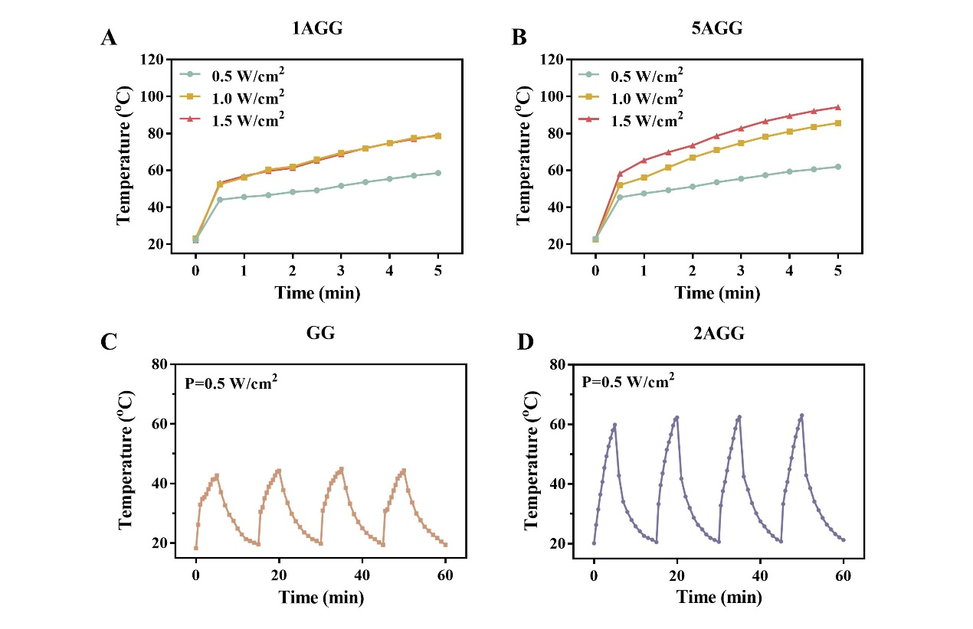
Figure S7. Photothermal temperature rise curves of 1AGG (A) and 5AGG (B) under 808 nm NIR irradiation with different power densities (0.5, 1.0, and 1.5 W cm⁻²). Photothermal stability of 1AGG (C) and 5AGG (D) under four laser on-off of 808 nm NIR irradiation at a power density of 0.5 W cm⁻².

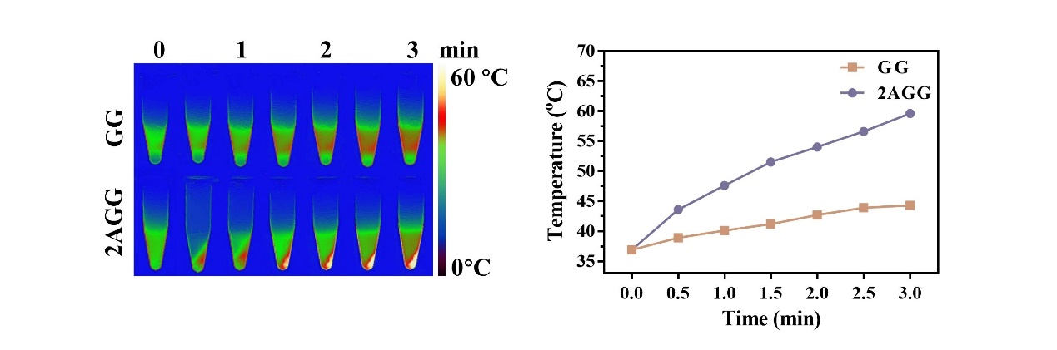
Figure S8. Infrared thermal images (A) and photothermal temperature rise (B) of hydrogel-incorporated bacteria solution under 808 nm NIR laser irradiation (0.5 W cm⁻²).

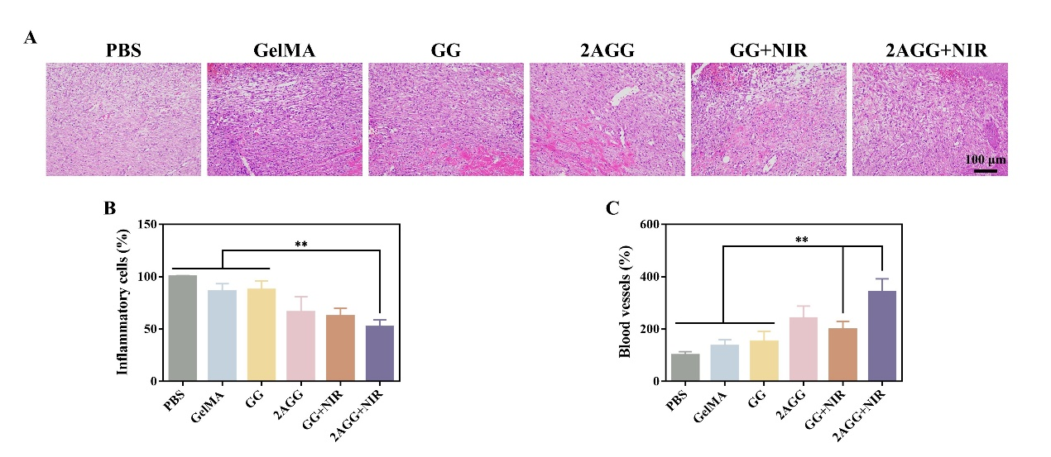
Figure S9. (A) Representative HE staining results of wound tissue on day 7. (B) The relative content of inflammatory cells and (C) The number of blood vessels in different groups on day 7. Scale bar = 100 μm. (n = 3). * Indicates significant difference (** P < 0.01).

