Supplement
Supplementary figure 1: Subject responses to questions about usage frequency of modality in friends and family communication (1) and subject comfort level with modality in friends and family communication (2).
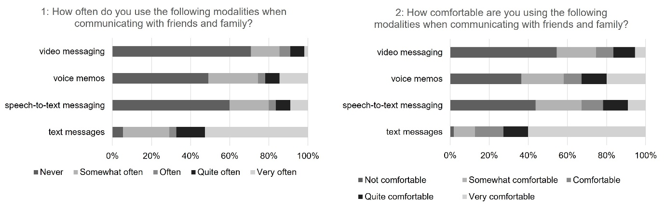Supplementary figure 1

Supplementary figure 2: Subject responses to questions about method preferences for reporting symptoms (1) and device preferences for reporting symptoms (2). Subjects were asked to rank the options.
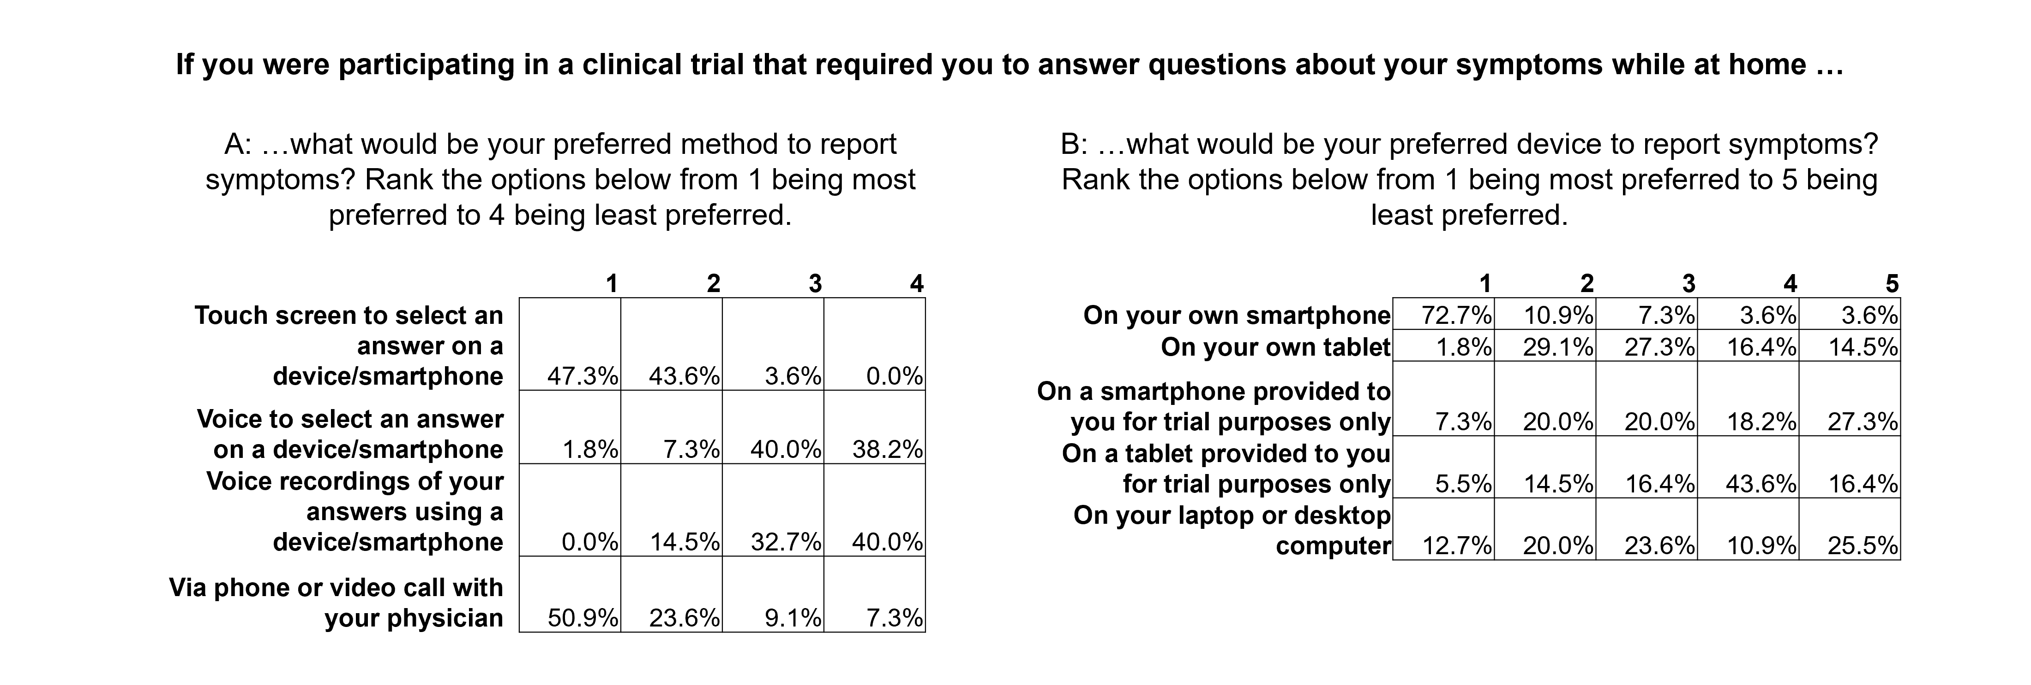
Supplementary figure 2a and 2b

Supplementary figure 3: Subject responses to a question about the preferred method for receiving reminders to report symptoms. Subjects were asked to rank the options.
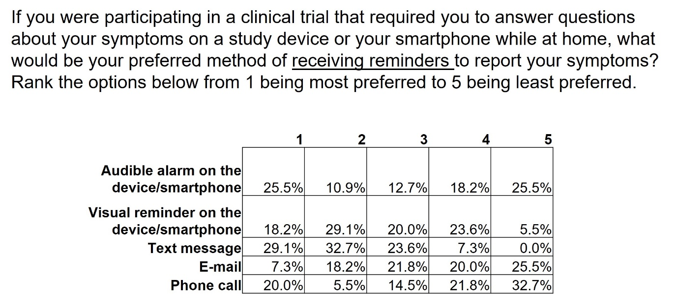Supplementary figure 3

