The association of PLA2G7 Gene Polymorphisms with Serum Lp-PLA2 Activity and Lipid Profile in Han Chinese Patients with Coronary Heart Disease
Running title: PLA2G7 and CHD in Han population

Yanhai Wang¹, Yupeng Shi², Zhongwei Wu¹, Jiangfeng Gao³, Jing Wang³, Lei Li⁴, Yugang Wan⁴, MuGu Lang A¹, Jianwen Zhang¹, Hongbo Wang³, Yu Hou^{3,5,*}
¹Department of Clinical Laboratory, Hohhot First Hospital, Hohhot, 010030, China
²Zhejiang Digena Diagnosis Technology CO., LTD, Zhejiang, 310030, China
³Cardiology Department, Hohhot First Hospital, Hohhot, 010030, China
⁴Network Management, Hohhot First Hospital, Hohhot, 010030, China
⁵Cardiology Department, Inner Mongolia People's Hospital, Hohhot, 010017, China

*Correspondence: Yu Hou
Cardiology Department, Inner Mongolia People's Hospital, No. 26, Zhaoda Road, Saihan District, Hohhot City, Inner Mongolia Autonomous Region, 010017, China.
Tel: +86-471-5281258

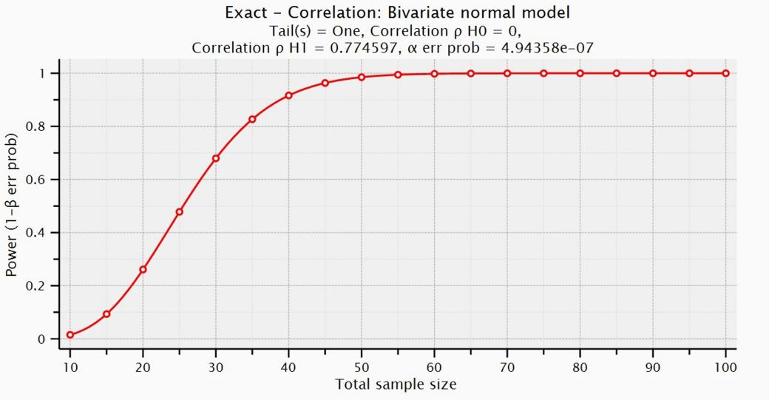
Figure S1. Power analysis of the study.

