Supplementary Material

Supplementary Figures

Figure S1
Figure S1. Abnormal patterns of the endoplasmic reticulum (ER) membrane protein complex (EMC) subunits expression in cancer.
(A) The transcript-level differences of EMC-related molecules between normal samples and cancer samples in TCGA. Normal tissues in both the TCGA and GTEx databases were included as negative controls.
(B) Mutation (single nucleotide variation, SNV) frequency of EMC-related molecules.
(C) The waterfall diagram displays the mutation type and summary of EMC-related molecules with the highest mutation frequency in TCGA pancancer.
(D) The pie chart illustrates the proportion of different types of copy number variaitons (CNVs) in each cancer.
(E) The amplification and deletion percentage of homozygous CNV about each gene in each cancer.
(F) The amplification and deletion percentage of heterozygous CNV about each gene in each cancer.
(G) The bubble plot shows the CNV associates with gene expression of EMC-related molecules.

Figure S2
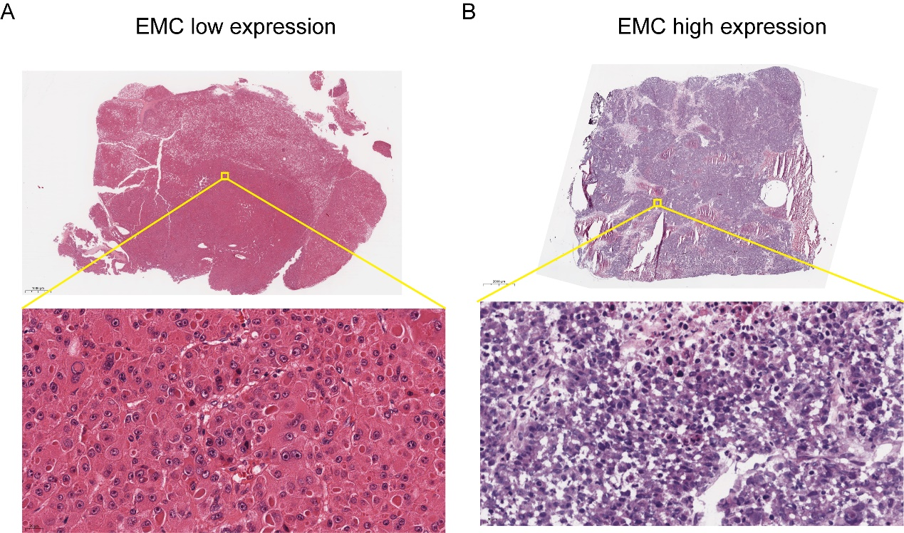
Figure S2. Representative Hematoxylin and eosin (HE) staining for high and low EMC expression levels in HCC tissues.
(A) HE staining for high-EMC HCC tissues.
(B) HE staining for low-EMC HCC tissues.

Figure S3

Figure S3. Violin plots showing the smoothed expression distribution of corresponding markers for different cell types.

Figure S4

Figure S4. The protein–protein interaction (PPI) network of EMC based on the STRING database. EMC1 is highlighted with a red circle.

Figure S5
Figure S5. Correlation between EMC expression and immune cells as analyzed through BEST.
(A) The heatmap shows the correlation between EMC and immune cells estimated by eight algorithms. M2 macrophages are highlighted with red boxes.
(B) The heatmap shows the correlation between EMC and immune components. C-C Motif Chemokine Ligand 15 (CCL15) and Beta-2-Microglobulin (B2M) are highlighted with red boxes.

Supplementary Tables

Table S1
Information on Antibodies and Reagents Used in This Study
Antibodies and Reagents | Manufacturer, Country, Cat number | Concentration
HE staining kit | Beyotime Biotechnology, China, #C0105 | -
Plasmid vectors for ECM1 | GeneChem, China, #10021850 | -
Puromycin | Beyotime Biotechnology, China, # 041321210517 | 1.5 μg/mL
0.2% TritonX-100 | Proteintech, China, #61202011 | -
Nuclei were stained using 4',6-diamidino-2-phenylindole (DAPI) | Beyotime Biotechnology, China, #091620210520 | -
phorbol 12-myristate 13-acetate (PMA) | Sigma-Aldrich, USA, #63597-44-4 | 20 ng/mL
Bicinchoninic acid (BCA) Assay Kit | Vazyme, China, #E112-02 | 1.5 μg/mL
ATP Assay Kit | Beyotime Biotechnology, China, #S0026 | -
Penicillin/streptomycin | Gibco, USA, #15070063 | -
Protease and phosphatase inhibitor cocktail for genneraluse, 50X | Beyotime Biotechnology, China, #P1045 | -
Loading buffer | Epizyme, China, #LT103s | -
Radioimmunoprecipitation assay buffer (RIPA buffer) | Beyotime Biotechnology, China, #P0013B | -
anti-CD163 polyclonal antibodies | Proteintech, USA, #HPA046404 | IF: 1:500  IHC 1:500
Anti-β-actin Mouse polyclonal antibodies | Proteintech, USA, #6609-1-Ig | WB 1:5000
Aconitase 2 polyclonal antibodies | Peprotech, USA, #11134-1-AP | WB 1:5000
OGDH polyclonal antibodies | Peprotech, USA, #15212-1-AP | WB 1:1000
Beta Catenin polyclonal antibodies | Peprotech, USA, #51067-2-AP | WB 1:1000
EMC1 polyclonal antibodies | Peprotech, USA, #26017-1-AP | WB 1:1000，IF: 1:300
Anti-CK Rabbit polyclonal antibodies | Cell Signaling Technology, USA, #12509 | IF 1:200
Goat Anti-Rabbit IgG H&L (HRP) | Abcam, UK, #ab205718 | IHC 1:2000
Alexa Fluor 488 AffiniPure goat anti-mouse IgG (H+L) | FcMACS, China, #136908 | IF1:500
Goat anti-mouse IgG (H+L) CoraLite594 | Proteintech, China, #SA00013-4 | IF 1:500
Fluorescein (FITC) conjugated Affinipure Goat Anti-Rabbit IgG(H+L) | Proteintech, China, #SA00003-2 | IF 1:500
Goat Anti-Rabbit IgG H&L (HRP) | Abcam, UK, #ab205718 | IHC 1:2000
Highly Cross-Adsorbed Goat (Polyclonal) Anti-Mouse IgG(H+L) Antibody | LI-COR, USA, #926-68070 | WB 1:1000
Highly Cross-Adsorbed Goat (Polyclonal) Anti-Rabbit IgG(H+L) Antibody | LI-COR, USA, #926-68071 | WB 1:1000
Dulbecco’s modified Eagle’s medium (DMEM) | Gibco, USA, #11965092 | -
Fetal bovine serum (FBS) | Gibco, USA, #10091148 | -
Roswell Park Memorial Institute 1640 (RPMI-1640) | Gibco, USA, #11875119 | -
Recombinant Human FGF-basic (154 a.a.) | Peprotech, USA, #100-18B-100 | 20ng/ml
B27 supplement | Gibco, USA, #17504044 | 2%
Matrigel | Corning, USA, #356234 | -
D‐luciferin potassium salt | BLT, China, #LS003 | 15mg/ml
Note: This table provides detailed information on the antibodies and reagents used in the study, including the manufacturer, country of origin, catalog number, and concentration used.

Table S2
Information of the lentivirus vector
Human | Lentivirus carrying sh-EMC1 sequence: 5′-GCAGAGCGATTCATCAACTAT-3′
Human | negative control: 5′-TTCTCCGAACGTGCTCACGT-3′
Mouse | Lentivirus carrying sh-EMC1 sequence: 5′-TGGACCATAATAGCTACTCTGCAA-3′
Mouse | negative control: 5′-UUCUCCGAACGUGUCACGUTT-3′
Note: This table provides detailed information about the sequences used in the lentivirus vectors for both human and mouse studies, including the sh-EMC1 and negative control sequences.

Table S3
The clinicopathological characteristics of 80 HCC samples
Characteristics | (n = 80) | EMC1 low expression | EMC1 high expression | P-value
Age (years) |  |  |  | 1
≥50 | 53 (66.25%) | 25 | 28 | 1
<50 | 27 (33.75%) | 12 | 15 | 1
Gender, n (%) |  |  |  | 0.404
Female | 36 (45%) | 19 | 17 | 0.404
Male | 44 (55%) | 18 | 26 | 0.404
Histologic grade |  |  |  | 0.547
G1 | 7 (8.75%) | 5 | 2 | 0.547
G2 | 25 (31.25%) | 11 | 14 | 0.547
G3 | 29 (36.25%) | 12 | 17 | 0.547
G4 | 19 (23.75%) | 9 | 10 | 0.547
TNM stage |  |  |  | 0.034
I-II | 13 (31.25%) | 10 | 3 | 0.034
III-IV | 67 (68.75%) | 27 | 40 | 0.034
Differentiated degree |  |  |  | 0.137
Low | 17 (21.25%) | 6 | 11 | 0.137
Moderate | 43 (53.75%) | 18 | 25 | 0.137
High | 20 (25%) | 13 | 7 | 0.137
Note: The P-value results indicate that there is a significant difference in the TNM Stage distribution between the EMC1 low expression and high expression groups (P = 0.034). For other characteristics, there are no significant differences between the groups (P-values are greater than 0.05).

Table S4
The clinicopathological characteristics of 20 HCC cases
Characteristics | (n = 20) | EMC1 low expression | EMC1 high expression | P-value
Age (years) |  |  |  | 0.626
≥50 | 14 | 8 | 6 | 0.626
<50 | 6 | 2 | 4 | 0.626
Gender, n (%) |  |  |  | 0.648
Female | 8 (40%) | 3 | 5 | 0.648
Male | 12 (60%) | 7 | 5 | 0.648
Histologic grade |  |  |  | 0.799
G1 | 2 (10%) | 1 | 1 | 0.799
G2 | 7 (35%) | 3 | 4 | 0.799
G3 | 6 (30%) | 4 | 2 | 0.799
G4 | 5 (25%) | 2 | 3 | 0.799
TNM stage |  |  |  | 0.576
III | 4 (30%) | 3 | 1 | 0.576
IV | 16 (70%) | 7 | 9 | 0.576
Differentiated degree |  |  |  | 0.648
Low | 3 (15%) | 1 | 2 | 0.648
Moderate | 12 (60%) | 7 | 5 | 0.648
High | 5 (25%) | 2 | 3 | 0.648
Note: P-values calculated using the chi-square test, assessing the significance of differences between EMC1 low expression and high expression groups for each characteristic. There are no significant differences between the EMC1 low expression and high expression groups for all characteristics (all P-values are greater than 0.05).

Table S5
Details of Genes Related to EMC Complex
Gene symbol | Approved name | Previous symbols | Aliases | Chromosome
EMC1 | ER membrane protein complex subunit 1 | KIAA0090 |  | 1p36.13
EMC2 | ER membrane protein complex subunit 2 | KIAA0103,TTC35 |  | 8q23.1
EMC3 | ER membrane protein complex subunit 3 | TMEM111 |  | 3p25.3
EMC4 | ER membrane protein complex subunit 4 | TMEM85 | FLJ90746,MGC24415,PIG17 | 15q14
MMGT1 | membrane magnesium transporter 1 | TMEM32 | EMC5 | Xq26.3
EMC6 | ER membrane protein complex subunit 6 | TMEM93 | MGC2963,RAB5IFL | 17p13.2
EMC7 | ER membrane protein complex subunit 7 | C15orf24 | C11orf3 | 15q14
EMC8 | ER membrane protein complex subunit 8 | C16orf4,NOC4,C16orf2,COX4NB | FAM158B | 16q24.1
EMC9 | ER membrane protein complex subunit 9 | C14orf122,FAM158A | CGI-112 | 14q12
EMC10 | ER membrane protein complex subunit 10 | C19orf63 | INM02,HSS1,HSM1 | 19q13.33
Note: This table provides detailed information on the genes associated with the EMC complex, including their approved names, previous symbols, aliases, and chromosomal locations.

Table S6
Top 50 Differentially Expressed Genes in Malignant Cell Subgroup C1
Gene | p_val | avg_log2FC | pct.1 | pct.2 | p_val_adj | cluster
APOA2 | 0 | 2.219256149 | 1 | 0.194 | 0 | Malignant C1
ALB | 0 | 2.171745057 | 1 | 0.205 | 0 | Malignant C1
APOA1 | 0 | 2.126910284 | 1 | 0.2 | 0 | Malignant C1
FABP1 | 0 | 2.121865792 | 0.997 | 0.192 | 0 | Malignant C1
APOE | 0 | 2.119066159 | 1 | 0.206 | 0 | Malignant C1
AHSG | 0 | 2.09606041 | 0.992 | 0.2 | 0 | Malignant C1
VTN | 0 | 2.051045404 | 0.999 | 0.2 | 0 | Malignant C1
AFP | 0 | 2.036846333 | 0.996 | 0.202 | 0 | Malignant C1
TF | 0 | 2.0323747 | 0.999 | 0.196 | 0 | Malignant C1
AMBP | 0 | 2.020974698 | 1 | 0.213 | 0 | Malignant C1
AGT | 0 | 2.004672117 | 0.999 | 0.2 | 0 | Malignant C1
RBP4 | 0 | 2.004519534 | 1 | 0.196 | 0 | Malignant C1
TTR | 0 | 2.001838605 | 0.999 | 0.23 | 0 | Malignant C1
NTS | 0 | 1.984627953 | 0.993 | 0.191 | 0 | Malignant C1
APOM | 0 | 1.974586249 | 0.998 | 0.303 | 0 | Malignant C1
APOB | 0 | 1.948025807 | 0.997 | 0.196 | 0 | Malignant C1
APOH | 0 | 1.928740433 | 0.998 | 0.199 | 0 | Malignant C1
AKR1C4 | 0 | 1.911514931 | 0.998 | 0.196 | 0 | Malignant C1
APOC1 | 0 | 1.88824775 | 1 | 0.458 | 0 | Malignant C1
GAGE2A | 0 | 1.870882123 | 0.997 | 0.191 | 0 | Malignant C1
AKR1C1 | 0 | 1.865187323 | 1 | 0.38 | 0 | Malignant C1
GPC3 | 0 | 1.844738327 | 0.999 | 0.237 | 0 | Malignant C1
APOC3 | 0 | 1.841012746 | 0.941 | 0.18 | 0 | Malignant C1
ANGPTL8 | 0 | 1.823987195 | 0.968 | 0.187 | 0 | Malignant C1
FGB | 0 | 1.811314423 | 0.995 | 0.192 | 0 | Malignant C1
NPW | 0 | 1.81050406 | 0.992 | 0.205 | 0 | Malignant C1
F2 | 0 | 1.792848197 | 0.995 | 0.191 | 0 | Malignant C1
S100A9 | 0 | 1.770182707 | 0.979 | 0.238 | 0 | Malignant C1
FGL1 | 0 | 1.770098475 | 0.993 | 0.198 | 0 | Malignant C1
PRAP1 | 0 | 1.767883471 | 0.997 | 0.248 | 0 | Malignant C1
BCHE | 0 | 1.754362842 | 0.993 | 0.191 | 0 | Malignant C1
GC | 0 | 1.752257973 | 0.998 | 0.201 | 0 | Malignant C1
FGG | 0 | 1.738304542 | 0.995 | 0.193 | 0 | Malignant C1
ASGR1 | 0 | 1.732841268 | 0.99 | 0.195 | 0 | Malignant C1
ORM1 | 0 | 1.730211481 | 0.978 | 0.187 | 0 | Malignant C1
LBP | 0 | 1.714016617 | 0.994 | 0.191 | 0 | Malignant C1
C2 | 0 | 1.684821164 | 0.992 | 0.231 | 0 | Malignant C1
SERPINF1 | 0 | 1.684759613 | 0.992 | 0.199 | 0 | Malignant C1
A1BG | 0 | 1.654201511 | 0.97 | 0.202 | 0 | Malignant C1
FGA | 0 | 1.65324932 | 0.986 | 0.194 | 0 | Malignant C1
ORM2 | 0 | 1.61025072 | 0.972 | 0.186 | 0 | Malignant C1
ANGPTL3 | 0 | 1.61009129 | 0.985 | 0.188 | 0 | Malignant C1
FXYD2 | 0 | 1.608238568 | 0.988 | 0.209 | 0 | Malignant C1
SEPP1 | 0 | 1.587494576 | 0.998 | 0.545 | 0 | Malignant C1
RARRES2 | 0 | 1.587422391 | 0.997 | 0.495 | 0 | Malignant C1
HPX | 0 | 1.577875431 | 0.988 | 0.193 | 0 | Malignant C1
SPP1 | 0 | 1.572912921 | 0.997 | 0.215 | 0 | Malignant C1
TMEM176A | 0 | 1.569868301 | 0.995 | 0.38 | 0 | Malignant C1
PLG | 0 | 1.562666586 | 0.985 | 0.186 | 0 | Malignant C1
GPX3 | 0 | 1.534902828 | 0.978 | 0.24 | 0 | Malignant C1
Note: This table lists the top 50 differentially expressed genes in malignant cell subgroup C1, including their p-values, average log2 fold changes (avg_log2FC), percentage of cells in which the gene is detected in each subgroup (pct.1 and pct.2), adjusted p-values (p_val_adj), and the identified cluster. The information provided helps to elucidate the molecular characteristics and potential functional roles of these genes within the malignant C1 population.

