Supporting information
Comparative study and transcriptomic analysis on the antifungal mechanism of Ag nanoparticles and nanowires against Trichosporon asahii
Minna Han,^{a,b,1} Zhikuan Xia,^{b,1} Yuekun Zou,^{c} Ping Hu,^{d} Mingwang Zhang,^{e} Xin Yang,^{c} Ming-Guo Ma,^{f,∗} Rongya Yang^{b,*}
ªChinese PLA Medical School, Beijing 100072, PR China;
^{b}Department of Dermatology, The Seventh Medical Center of PLA General Hospital, Beijing 100072, PR China;
^{c}Department of Geriatrics, The Sixth Medical Center of PLA General Hospital, Beijing 100072, PR China;
^{d}Southern Medical Branch of PLA General Hospital, Beijing 100072, PR China;
^{e}Department of Dermatology, Southwest Hospital, Army Medical University, Chongqing, China;
^{f}College of Materials Science and Technology, Beijing Forestry University, Beijing 100083, PR China.
¹Authors have contributed equally to this work.

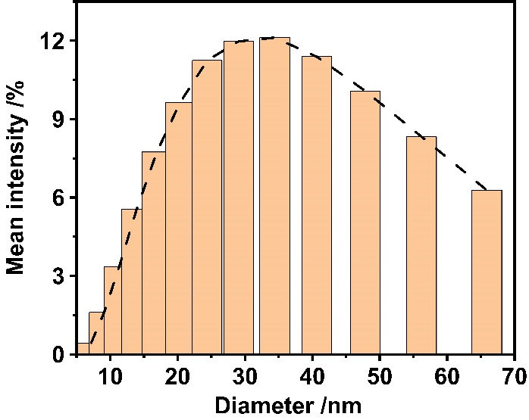
Figure S1. Size distribution of silver nanoparticles.
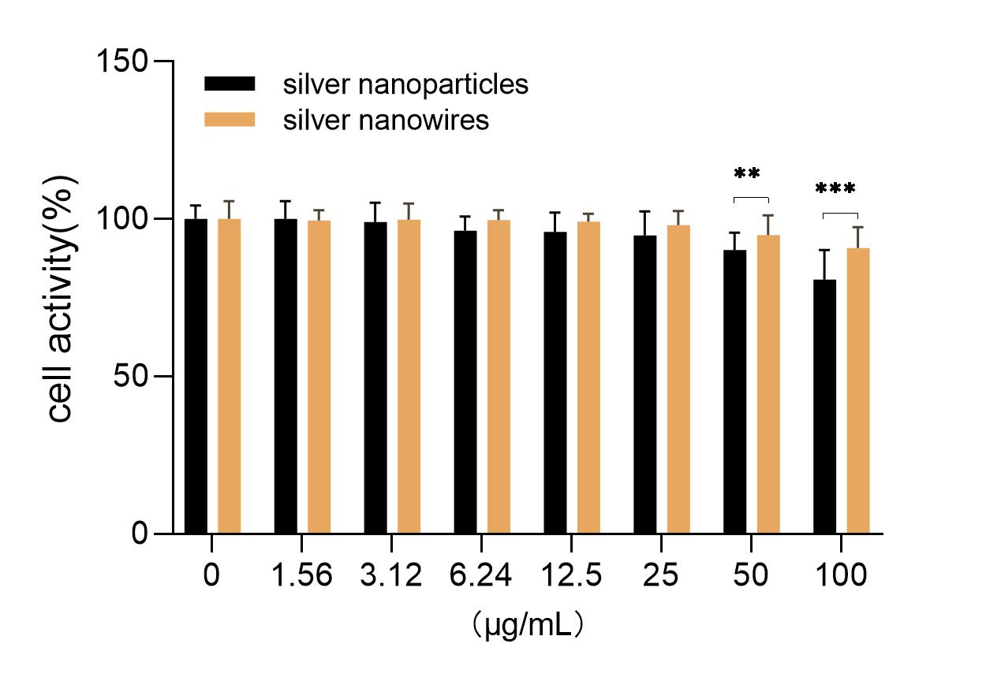
Figure S2. Viabilities of non-malignant fibroblast cells incubated with the silver nanomaterials. ** indicate P < 0.01, *** indicate P < 0.001.

Figure S3. (a) PPI network of DEGs in treat 1vs control; (b) PPI network of DEGs in treat 2 vs control; (c) PPI network of DEGs in treat 2 vs treat 1.

 | N | Mean | Std. Deviation | Std. Error  Mean
Nanowires | 6 | 2.6000 | 0.80558 | 0.32888
Nanoparticles | 6 | 0.3267 | 0.09812 | 0.04006
Table S1. Descriptives of MIC.

 | Sum of Squares | df | Mean Square | F | Sig.
Between Groups | 7713.812 | 2 | 3856.906 | 13.825 | <0.001
Within Groups | 4184.626 | 15 | 278.975
Total | 11898.438 | 17
Table S2. ANOVA of MIC

(I)Group | (J)Group | Mean Difference(I-J) | Std.Error | Sig. | 95% Confidence interval of the Difference
 |  |  |  |  | Lower bound | Upper bound
Nanowires | Nanoparticles | 2.27333* | 0.33131 | 0.002 | 1.1594 | 3.3873
 | FLC | -42.73333* | 11.81042 | 0.04 | -82.8561 | -2.6106
Nanoparticles | Nanowires | -2.27333* | 0.33131 | 0.002 | -3.3873 | -1.1594
 | FLC | -45.00667* | 11.8059 | 0.033 | -85.1374 | -4.8759
FLC | Nanowires | 42.73333* | 11.81042 | 0.04 | 2.6106 | 82.8561
 | Nanoparticles | 45.00667* | 11.8059 | 0.033 | 4.8759 | 85.1374
Table S3. Multiple of Comparisons (Dunnett T3)
* The mean difference is significant at the 0.05 level.

Table S4. T-test Independent Samples Test of MFC.
 | Levene's test for equality of variances |  |  |  | t-test for Equality of Means |  |  | 95% Confidence interval of the Difference
 | F | Sig. | t | df | Sig.(2-tailed) | Mean Difference | Std. Error Difference | Lower | Upper
Equal variances assumed | 35.027 | <0.001 | -7.398 | 10 | <0.001 | -78.13333 | 10.56143 | -101.66566 | -54.60101
Equal variances notassumed |  |  | -7.398 | 5.039 | <0.001 | -78.13333 | 10.56143 | 105.21937 | -51.04730

No. | Gene | Composition | Function
1 | A1Q1_01566 | Membrane structure (Multi-pass membrane protein) | Transmembrane transporter activity
2 | A1Q1_00884 | Nucleus | Transmembrane transporter activity
3 | A1Q1_02693 | Ribonucleoprotein complex, ribosome | rRNA binding,structural constituent of ribosome,translation
4 | A1Q1_02927
5 | A1Q1_03625
6 | A1Q1_03974
7 | A1Q1_04006
8 | A1Q1_04455 | RRM domain-containing protein | RNA binding
9 | A1Q1_04505 | Cellular anatomical entity | ATP binding, glutamate-tRNA ligase activity, tRNA binding, zinc ion binding, glytamyl-RNA aminoacylation
10 | A1Q1_04538
11 | A1Q1_05137 | Membrane structure (Multi-pass membrane protein) | Oxidoreductase activity, Pyruvate metabolism
12 | A1Q1_06703 | Plasma membrane | Potassium ion transmembrane transporter activity
13 | A1Q1_07887
14 | A1Q1_08175 | Membrane | Oxidoreductase activity, sphingolipid metabolic process
15 | A1Q1_02992 | Membrane | Potassium ion transmembrane transporter activity
Table S5. Primers for RT-qPCR.

∗Corresponding author. Tel.: +0086-10-62337250. E-mail address: mg_ma@bjfu.edu.cn (M.-G. Ma), sum7@sina.com (Z.-K. Xia), yangrya@sina.com (R.-Y. Yang).

