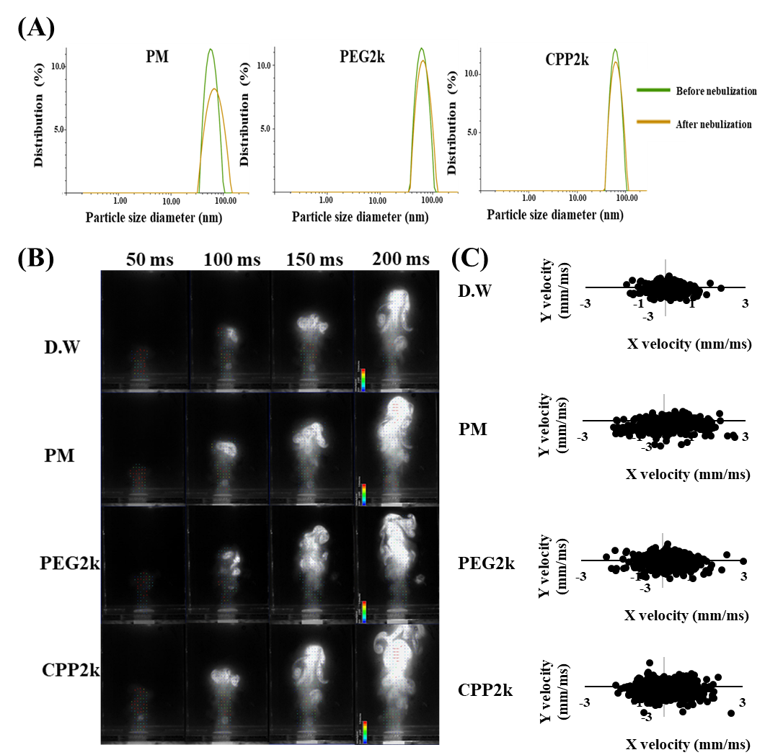
Figure S1 (A) Particle size distribution of micelles before and after nebulization. (B) Vector and particle images of droplet flow fields of D.W, PM, PEG2k, and CPP2k from 50 to 200 ms; (C) X-Y velocity distribution of D.W, PM, PEG2k, and CPP2k.
Figure S2 A549 cells were incubated with micelles with insulin concentration range of 0.01–1.0 mg/mL for 24 h. Cell viability was measured using the MTT assay (mean ± standard deviation, n = 3).
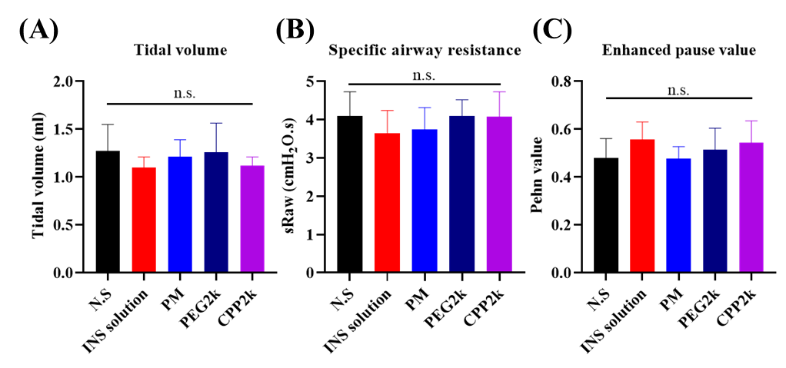
Figure S3 Lung function was assessed by double chamber plethysmography (DCP) in rats treated with normal saline and each of the micelle formulations (mean ± standard deviation, n = 4). N.S, normal saline; n.s., not significant.

