Supplementary Materials
Harnessing the Systemic Immunoinflammatory Index as a Potential Prognostic Tool for Recurrent or Metastatic Nasopharyngeal Carcinoma Undergoing PD-L1 inhibitor
1.1 Patients
KL1672-05-CTP is an open-label, multicenter, single-arm, phase 2 study of KL-A167 in patients with R/M nasopharyngeal cancer. The study was conducted in 42 hospitals in China and included a total of eligible patients with histologically confirmed recurrent or metastatic non-keratinising nasopharyngeal cancer between 2019 and 2021. Eligible patients had histologically confirmed non­keratinising NPC that was recurrent or metastatic.
1.2 Inclusion and exclusion criteria
Inclusion criteria: Stage IVb recurrent or metastatic nasopharyngeal carcinoma (R/M NPC), defined by the eighth edition of the American Joint Committee on Cancer/International Union Against Cancer staging system, with at least two prior chemotherapy failures. The first-line chemotherapy must have included a platinum-based regimen. Additional key eligibility criteria comprise age ≥18 years, Eastern Cooperative Oncology Group performance status (ECOG PS) of 0–1, at least one measurable lesion assessed by Response Evaluation Criteria in Solid Tumors 1.1 (RECIST V1.1), estimated life expectancy ≥12 weeks, and sufficient organ function.

Patients with the following clinical features were excluded from our study: patients previously treated with anti-PD-1, anti-PD-L1, anti-PD-L2, and/or anti-cytotoxic T-lymphocyte-associated antigen antibodies, chimeric antigen receptor T-cell immunotherapy, or any other agents targeting T-cell co-stimulation or checkpoint pathways. Other exclusion criteria include receiving anti-tumor antibody therapy within 12 weeks before the first dose of KL-A167, receiving any other anti-tumor therapy within 4 weeks before the first dose of KL-A167, central nervous system metastasis, active autoimmune diseases or a history thereof, active infections, and the need for systemic corticosteroids (equivalent to 10 mg of prednisone per day or more) or other immunosuppressive drugs within 14 days after the first dose of KL-A167.

This study adheres to the principles of the Declaration of Helsinki and the International Council for Harmonisation of Technical Requirements for Pharmaceuticals for Human Use (ICH) Good Clinical Practice guidelines. The research protocol has received independent approval from the ethics committees at each participating site. Written informed consent has been obtained from all patients prior to enrollment. The flowchart of the patient selection process is presented in Supplementary Figure 1.

1.3 Treatment programmes and assessment of their effectiveness
A dose of 900 mg every 2 weeks was established based on the KL-A167 in Lymphoma and Solid Tumors phase 1 study (unpublished data). Patients in the treatment group received PDL1 inhibitors such as pembrolizumab and nilenumab every 3 weeks for 4 cycles. Efficacy was classified as CR (complete remission), PR (partial remission), SD (stable) and& PD (progression) based on RECIST 1.1 criteria.

Patients received 900 mg of KL-A167 intravenously every fortnight until disease progression, intolerable toxicity or withdrawal of consent. Progressive disease (PD) was confirmed 4 weeks or more after the first response criteria were met, at the discretion of the investigator. For those discontinuing treatment for other reasons, tumor assessment continued until disease progression, initiation of new anti-tumor therapy, loss to follow-up or death. Dose reductions were not permitted. KL-A167 was discontinued if adverse events (AEs) did not resolve to grade 0-1 within 12 weeks of the last dose.

Baseline biopsy specimens were obtained for exploratory biomarker analysis. Blood samples were collected for exploratory biomarker assessment at baseline, i.e., before starting immunotherapy. The baseline level SII was used in this study to assess the efficacy of immunotherapy.

Supplementary Fig 1. Trial profiles
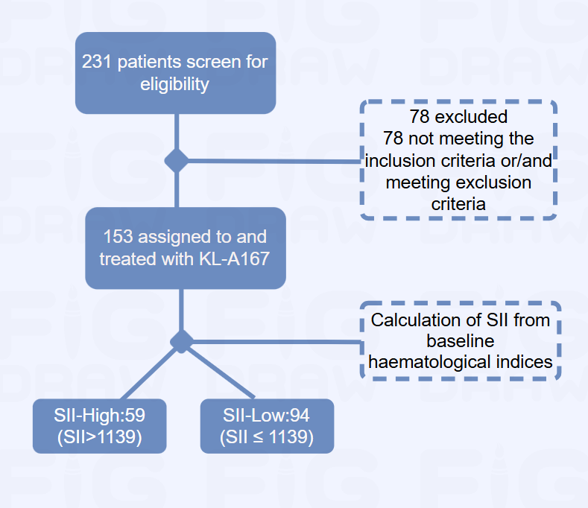

Supplementary Fig.2 Select the optimal cut-off value.

Supplementary Fig.3 Subgroup analysis of Disease Control Rate.

Supplementary Fig.4 Subgroup analysis of Progression-free survival.

Supplementary Table.1 Comparison of outcomes in study populations with different SII status.
Outcomes | SII-low (n=94) | SII-high (n=59) | Overall | p Value
Outcomes | N(%) | N(%) | (N=153) | p Value
Response |  |  |  | 0.074
CR | 0 (0%) | 1 (1.7%) | 1 (0.7%)
NE | 3 (3.2%) | 4 (6.8%) | 7 (4.6%)
PD | 35 (37.2%) | 32 (54.2%) | 67 (43.8%)
PR | 23 (24.5%) | 9 (15.3%) | 32 (20.9%)
SD | 33 (35.1%) | 13 (22.0%) | 46 (30.1%)
DCR |  |  |  | 0.021
Yes | 56 (59.6%) | 23 (39.0%) | 79 (51.6%)
No | 38 (40.4%) | 36 (61.0%) | 74 (48.4%)
ORR |  |  |  | 0.369
Yes | 23 (24.5%) | 10 (16.9%) | 33 (21.6%)
No | 71 (75.5%) | 49 (83.1%) | 120 (78.4%)
PFS(days) |  |  |  | 0.002
Median(range) | 126 [0, 866] | 43.0 [0, 847] | 83.0 [0, 866]
OS(days) |  |  |  | 0.001
Median(range) | 471 [73.0, 975] | 303 [25.0, 948] | 413 [25.0, 975]
PFS status |  |  |  | 0.274
Yes | 83 (88.3%) | 56 (94.9%) | 139 (90.8%)
No | 11 (11.7%) | 3 (5.1%) | 14 (9.2%)
OS status |  |  |  | 0.069
Yes | 57 (60.6%) | 45 (76.3%) | 102 (66.7%)
No | 37 (39.4%) | 14 (23.7%) | 51 (33.3%)
(* p-value was conducted with the chi-square test (categorical variables) and Mann–Whitney U test (continuous variables), respectively. Abbreviations: CR, complete response; PR, partial response; SD, stable disease; PD, progressive disease; NE, not evaluate; DCR, disease control rate; ORR, objective response rate; PFS, progression-free survival; OS, overall survival)

Supplementary Table.2 Univariate logistic regression models for patients' disease control rate (DCR) and objective remission rate (ORR).
Variables | Disease control rate |  |  | Objective response rate
Variables | HR (95%CI) | P |  | HR (95%CI) | P
Age (years) | 1.02(0.99-1.06) | 0.160 |  | 1.02 (0.98 - 1.06) | 0.284
SII
Low | 1.00 (Reference) |  |  | 1.00 (Reference)
High | 0.43(0.22-0.84) | 0.010 |  | 1.59 (0.69 - 3.63) | 0.273
Gender
Male | 1.00 (Reference) |  |  | 1.00 (Reference)
Female | 1.57(0.68-3.62) | 0.292 |  | 0.62 (0.25 - 1.58) | 0.322
BMI
Underweight |  |  |  | 1.00 (Reference)
Normal | 1.99(0.85-4.67) | 0.123 |  | 3.01 (0.94 - 9.61) | 0.772
Overweight and obese | 1.99(0.71-5.57) | 0.196 |  | 1.83 (0.58 - 6.20) | 0.314
Tumor Stage
T0~2 |  |  |  | 1.00 (Reference)
T3~4 | 1.61(0.74-3.52) | 0.238 |  | 1.74 (0.65 - 4.86) | 0.277
Tx | 1.21(0.56-2.63) | 0.621 |  | 1.88 (0.72 - 5.21) | 0.207
Node Stage
N0~2 |  |  |  | 1.00 (Reference)
N3 | 0.49(0.2-1.21) | 0.129 |  | 0.67 (0.18 - 2.02) | 0.503
Nx | 0.82(0.39-1.72) | 0.612 |  | 1.26 (0.52 - 2.96) | 0.598
Smoking History
Current and former smoker |  |  |  | 1.00 (Reference)
Non-smoker | 0.74(0.38-1.44) | 0.385 |  | 0.98 (0.44 - 2.23) | 0.955
Alcohol History
Current and former drinker |  |  |  | 1.00 (Reference)
Non-drinker | 1.42(0.7-2.91) | 0.331 |  | 0.84 (0.37 - 2.01) | 0.678
Prior radiotherapy
Yes |  |  |  | 1.00 (Reference)
No | 0.79(0.17-3.67) | 0.779 |  | 0.67 (0.12 - 3.64) | 0.647
ECOG PS
0 |  |  |  | 1.00 (Reference)
1 | 0.43(0.22-0.84) | 0.010 |  | 0.37 (0.17 - 0.81) | 0.013
Liver Metastasis
No |  |  |  | 1.00 (Reference)
Yes | 0.25(0.13-0.49) | <.001 |  | 0.42 (0.18 - 0.94) | 0.039

Supplementary Table.3 Univariate Cox regression models for patient overall survival and progression-free survival.
Variables | Overall Survival |  |  | Progression-free survival
Variables | HR (95%CI) | P |  | HR (95%CI) | P
Age (years) | 0.99 (0.97-1.01) | 0.412 |  | 0.99 (0.97-1) | 0.113
SII
High | 1.00 (Reference) |  |  | 1.00 (Reference)
Low | 1.92 (1.29-2.85) | 0.001 |  | 1.85 (1.31-2.62) | <.001
Gender
Male | 1.00 (Reference) |  |  | 1.00 (Reference)
Female | 0.83 (0.5-1.38) | 0.462 |  | 0.88 (0.58-1.35) | 0.570
BMI
Underweight | 1.00 (Reference) |  |  | 1.00 (Reference)
Normal | 0.44 (0.27-0.7) | 0.001 |  | 0.7 (0.45-1.09) | 0.111
Overweight and obese | 0.46 (0.25-0.82) | 0.008 |  | 0.56 (0.32-0.97) | 0.038
Tumor Stage
T0~2 | 1.00 (Reference) |  |  | 1.00 (Reference)
T3~4 | 1.12 (0.71-1.78) | 0.617 |  | 0.81 (0.54-1.21) | 0.297
Tx | 0.74 (0.45-1.2) | 0.220 |  | 0.78 (0.52-1.17) | 0.235
Node Stage
N0~2 | 1.00 (Reference) |  |  | 1.00 (Reference)
N3 | 1.24 (0.75-2.06) | 0.402 |  | 1.07 (0.67-1.7) | 0.788
Nx | 0.63 (0.39-1.03) | 0.064 |  | 0.95 (0.65-1.4) | 0.792
Smoking History
Current and former smoker | 1.00 (Reference) |  |  | 1.00 (Reference)
Non-smoker | 0.99 (0.66-1.49) | 0.969 |  | 1.24 (0.87-1.76) | 0.238
Alcohol History
Current and former drinker | 1.00 (Reference) |  |  | 1.00 (Reference)
Non-drinker | 0.9 (0.59-1.38) | 0.635 |  | 0.83 (0.57-1.21) | 0.328
Prior radiotherapy
Yes | 1.00 (Reference) |  |  | 1.00 (Reference)
No | 1.08 (0.4-2.95) | 0.876 |  | 1.12 (0.49-2.55) | 0.785
ECOG PS
0 | 1.00 (Reference) |  |  | 1.00 (Reference)
1 | 2.79 (1.79-4.33) | <.001 |  | 1.61 (1.14-2.28) | 0.007
Liver Metastasis
YES | 1.00 (Reference) |  |  | 1.00 (Reference)
NO | 2.57 (1.73-3.81) | <.001 |  | 1.99 (1.42-2.79) | <.001
LYMPH (10^9/L) | 0.52 (0.29-0.93) | 0.028 |  | 0.38 (0.22-0.66) | <.001
PLT (10^9/L) | 1.12 (1.01-1.17) | 0.569 |  | 1.02 (1.01-1.05) | 0.190
NEUT (10^9/L) | 1.11 (1.02-1.21) | 0.022 |  | 1.07 (0.98-1.16) | 0.123

