Supplementary Figure Legend
Figure S1 Localization of dual-carbapenamse through S1-PFGE and Southern blot analysis. A was the localization of bla_{KPC} gene with S1-PFGE and bla_{KPC} probe. B was the localization of bla_{NDM} gene with S1-PFGE and bla_{NDM} probe. C was the localization of bla_{IMP} gene with S1-PFGE and bla_{IMP} probe. The numerical codes represent strain numbers, as detailed below:
1, strain FYH-SY carrying the carbapenem resistant genes bla_{KPC-2} and bla_{IMP-4};
2, strain Kpn-98 carrying the carbapenem resistant genes bla_{KPC-2} and bla_{IMP-26};
3, strain XL-200731214 carrying the carbapenem resistant genes bla_{KPC-2} and bla_{NDM-5};
4, strain XL-20059286 carrying the carbapenem resistant genes bla_{KPC-2} and bla_{NDM-5};
5, strain FSQ carrying with carbapenem resistant genes bla_{KPC-2} and bla_{NDM-5};
6, strain 20040580 carrying with carbapenem resistant genes bla_{KPC-2} and bla_{NDM-5};
7, strain Kpn-96 carrying the carbapenem resistant genes bla_{KPC-2} and bla_{IMP-26};
8, strain LAS-AR4324 carrying the duplicated carbapenem resistant genes bla_{KPC-2};
9, strain Kpn-103 carrying the carbapenem resistant genes bla_{KPC-2} and bla_{IMP-26};
10, strain 21030615019 carrying with carbapenem resistant genes bla_{KPC-2} and bla_{NDM-1};
11, strain 21030415031 carrying with carbapenem resistant genes bla_{KPC-2} and bla_{NDM-1};
12, strain ZHH carrying the carbapenem resistant genes bla_{NDM-1} and bla_{IMP-4}
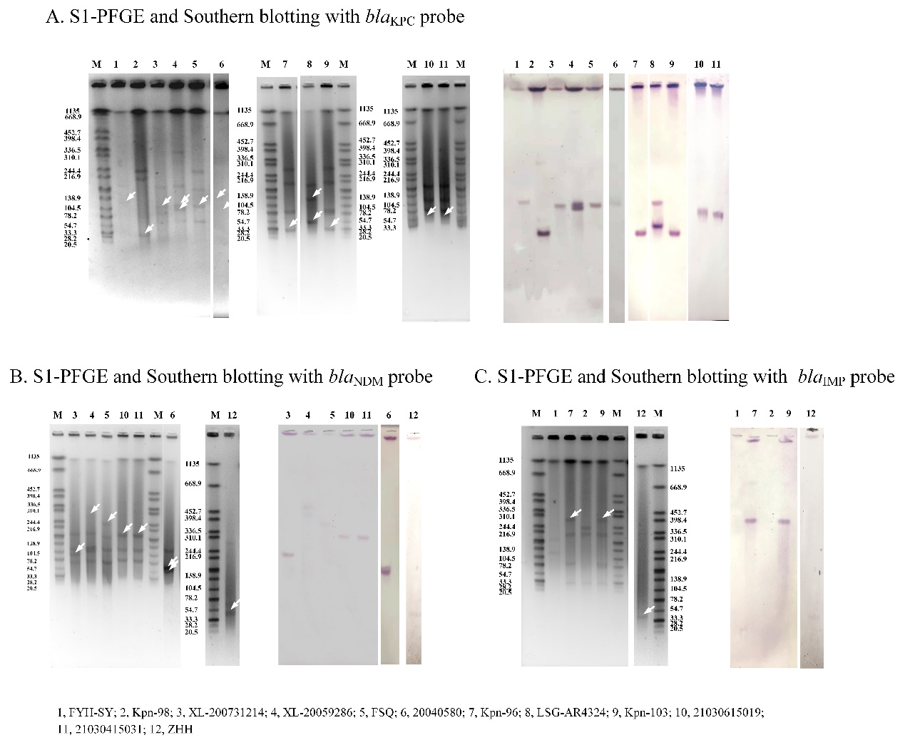
Figure S1 Localization of dual-carbapenamse through S1-PFGE and Southern blot analysis.

