Supporting Information:

TME-activated MnO₂/Pt nanoplatform of hydroxyl radical and oxygen generation to synergistically promote radiotherapy and MR imaging of glioblastoma
Lijuan Chen^{1, a}, Mingbo Liu^{2, a}, Yunjuan Wang^{3,4, a}, Wei Wei¹, Yaqiong Li ⁵, Yan Bai¹, Xuan Yu¹, Lei Jiao^{6,} *, Meiyun Wang^{1,4}*

- Department of Medical Imaging, Henan Provincial People’s Hospital & the People’s Hospital of Zhengzhou University, 450003, Zhengzhou, Henan, China.
- Department of Radiotherapy, Henan Provincial People’s Hospital & the People’s Hospital of Zhengzhou University, 450003, Zhengzhou, Henan, China.
- School of life sciences, Henan University, North section of Jinming Avenue, 475004, Kaifeng, Henan, China.
- Institute of Biomedicine, Henan Academy of Sciences, Chongshili Road, 450046, Zhengzhou, Henan, China.
- Department of Pharmacy, Henan Provincial People’s Hospital & the People’s Hospital of Zhengzhou University, 450003, Zhengzhou, Henan, China.
- Institute of Molecular Metrology, College of Chemistry and Chemical Engineering, Qingdao University, 266071, Qingdao, Shandong, China.

Figure S1. The monitoring of reactants by UV-Vis absorption spectra.

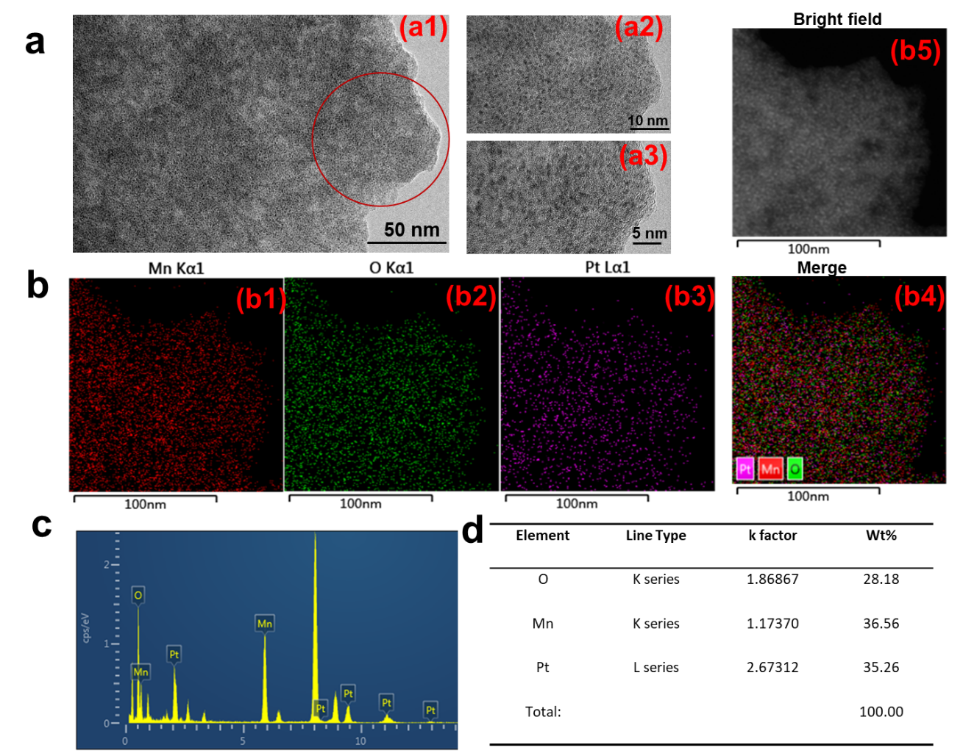
Figure S2. (a) TEM of MnO₂/Pt@BSA nanoplatform at the different magnification(a1-a3), respectively, (b) the mapping based on the composite of MnO₂/Pt@BSA; (b1) -(b3) Mn, O, Pt and the merge photo (b4), bright field (b5); (c) EDS were characterized by TEM and corresponding semi-quantitative analysis(d).

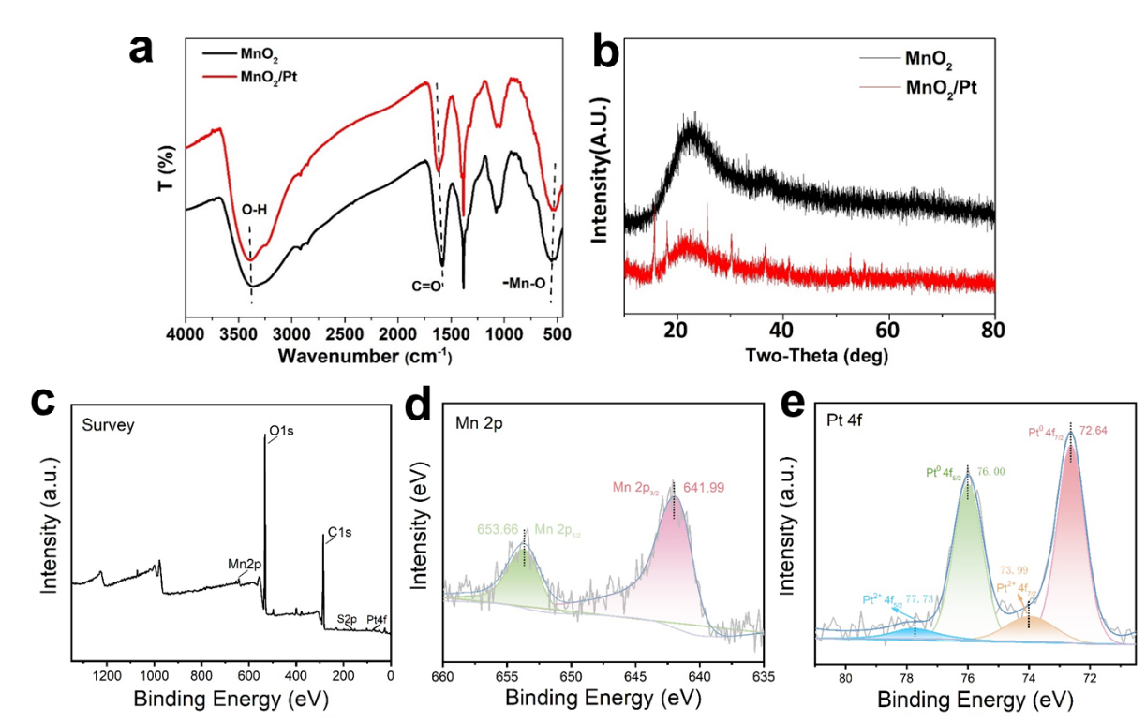

Figure S3. (a) The FTIR of MnO₂ and MnO₂/Pt, (b) XRD patterns of the as-prepared MnO₂ and MnO₂/Pt samples, (c) the full XPS spectra of MnO₂/Pt, and the Mn(d), Pt (e) spectra of MnO₂/Pt.

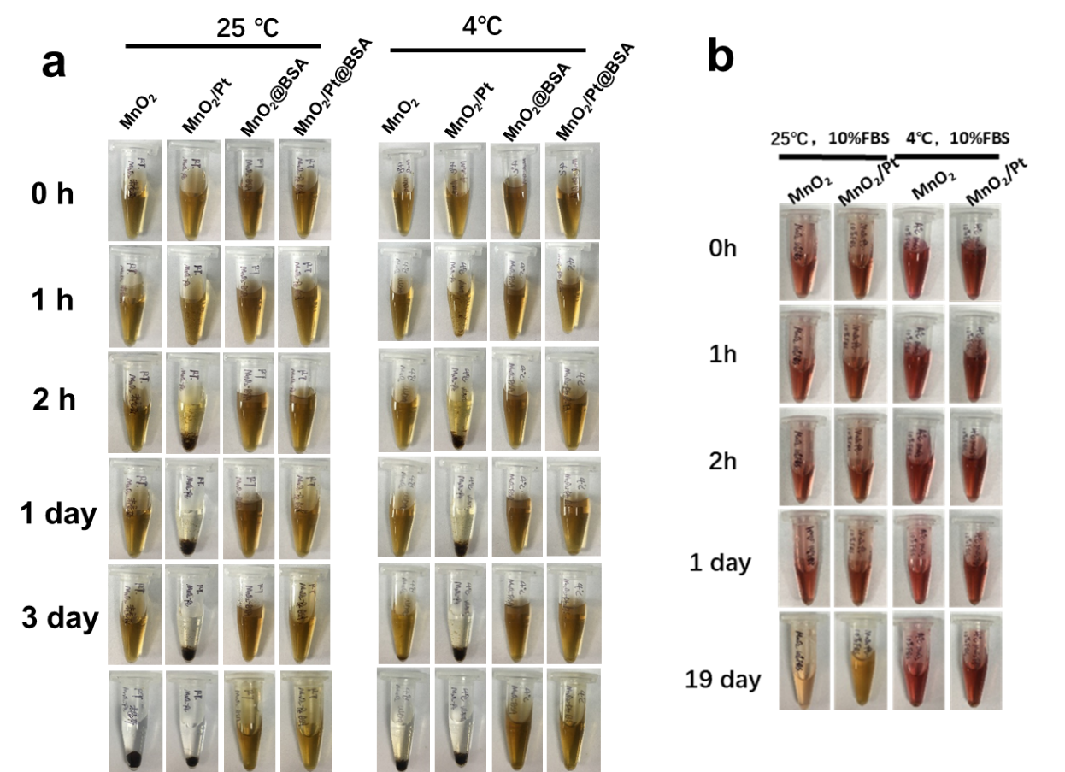

Figure S4. The storage stability of MnO₂ and MnO₂/Pt based nanoplatform at different temperature, timepoints and dispersion medium. (a) MnO₂, MnO₂/Pt, MnO₂@BSA, MnO₂/Pt@BSA at room temperature (RT) and 4ºC conditions at 0h, 1h, 2h, 1day, 3day and 19day; (b) The stability of MnO₂, MnO₂/Pt dispersion in 10% FBS at 4 ºC and RT at 0h, 1h, 2h, 1day and 19day.

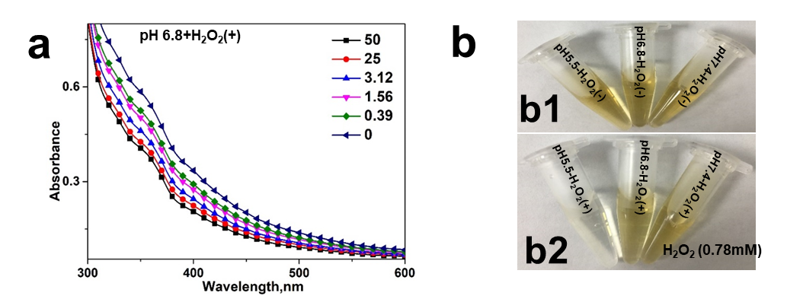
Figure S5. (a) the absorbance of MnO₂/Pt@BSA after treatment with the pH 6.8 at different H₂O₂ concertation (50, 25, 3.12, 1.56, 0.39, 0); (b) the corresponding photos of MnO₂/Pt@BSA after treatment with different pH buffer solution and (b2)/or not (b1) H₂O₂.

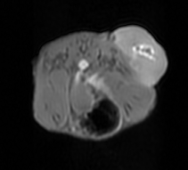
Figure S6. In vivo T1-weighted MR imaging of the in U87 tumor-bearing mice after intravenous injection. Images were acquired using a 3.0 T (GE, USA) clinical MRI scanner equipped with animal coil.

Figure S7. The relative tumor T1-weighted SNR (%) of MnO₂/Pt@BSA, MnCl₂ on U87 tumor-bearing mice model C[Mn] (0.25 mmol·kg⁻¹) with N.S as control.

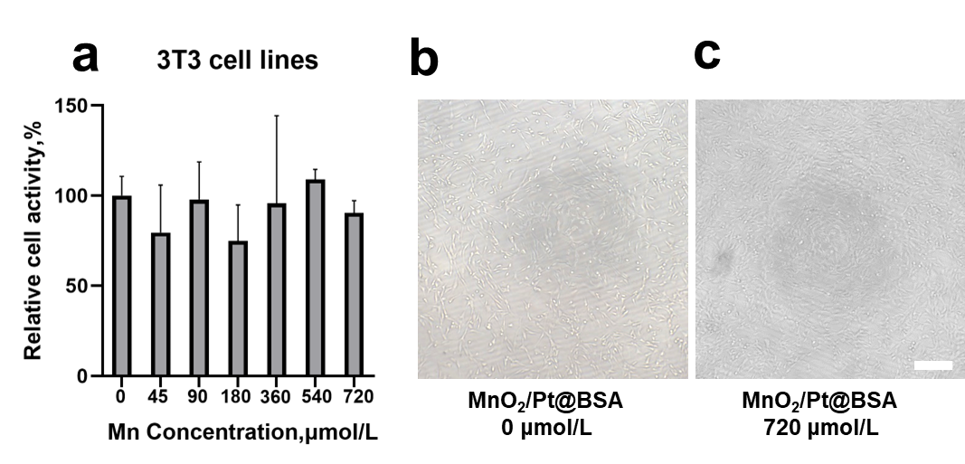
Figure S8. (a)The relative cell activity (%) of the MnO₂/Pt@BSA in different concentration on 3T3 cell lines were primarily test for cytotoxicity evaluation. (b, c) The morphology of 3T3 cell lines treated with/without MnO₂/Pt@BSA in the brightfield of optical microscope. (bar: 20μm)

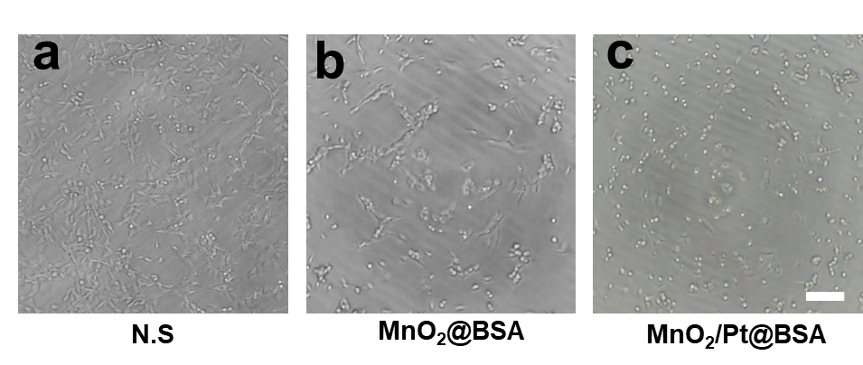
Figure S9. the morphology of U87 cells under corresponding nanoplatforms treatments (a,PBS; MnO₂@BSA; b, MnO₂/Pt@BSA) in the brightfield of optical microscope (bar: 20μm)

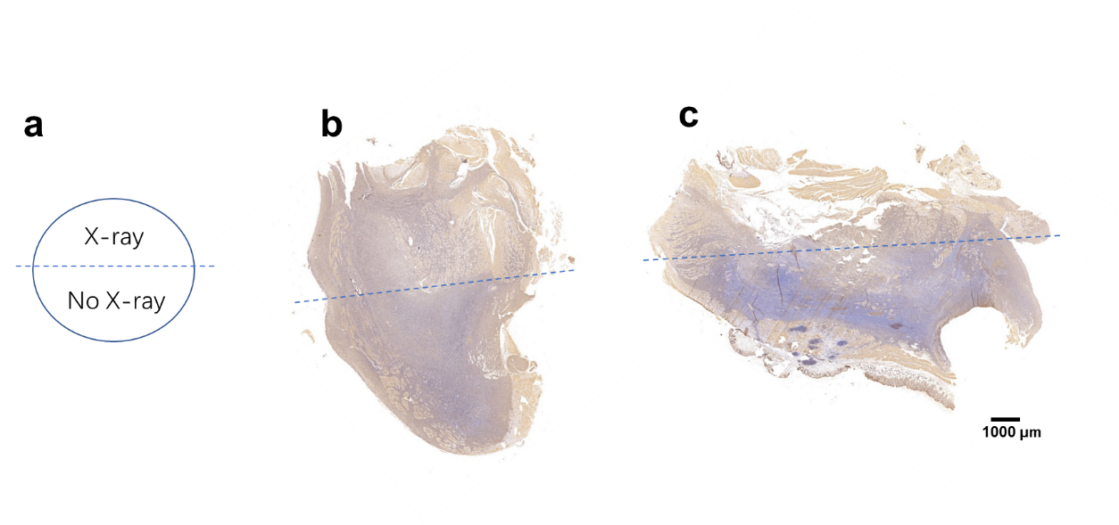
Figure S10. (a) Diagram of radiation distribution. (b) Scan view of the continuous sections of excised tumor tissue treated with N.S (B) and MnO₂@BSA (c), and the boundary of X-ray irradiation (8 Gy). Scale bars: 1000 μm.

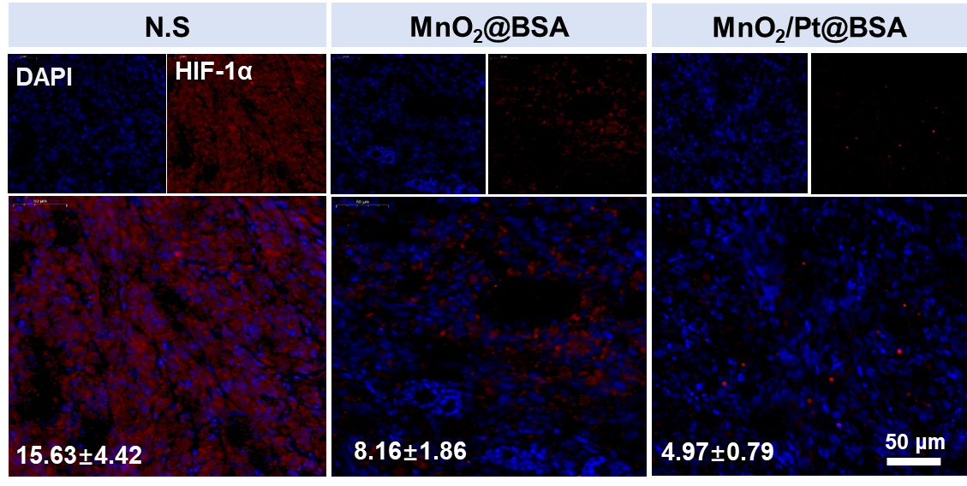

Figure S11. Representative immunofluorescence images analysis of HIF-1α protein in U87 cells. And the corresponding quantitative fluorescence intensity analysis of HIF-1α.

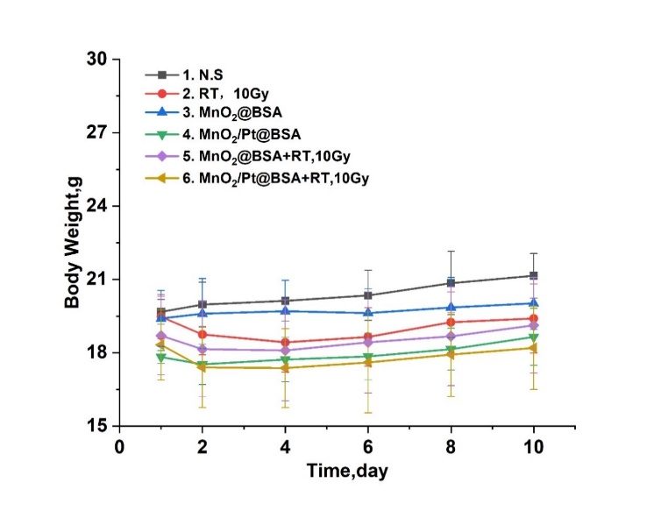
Figure S12. Body weights changes during the course of treatments.

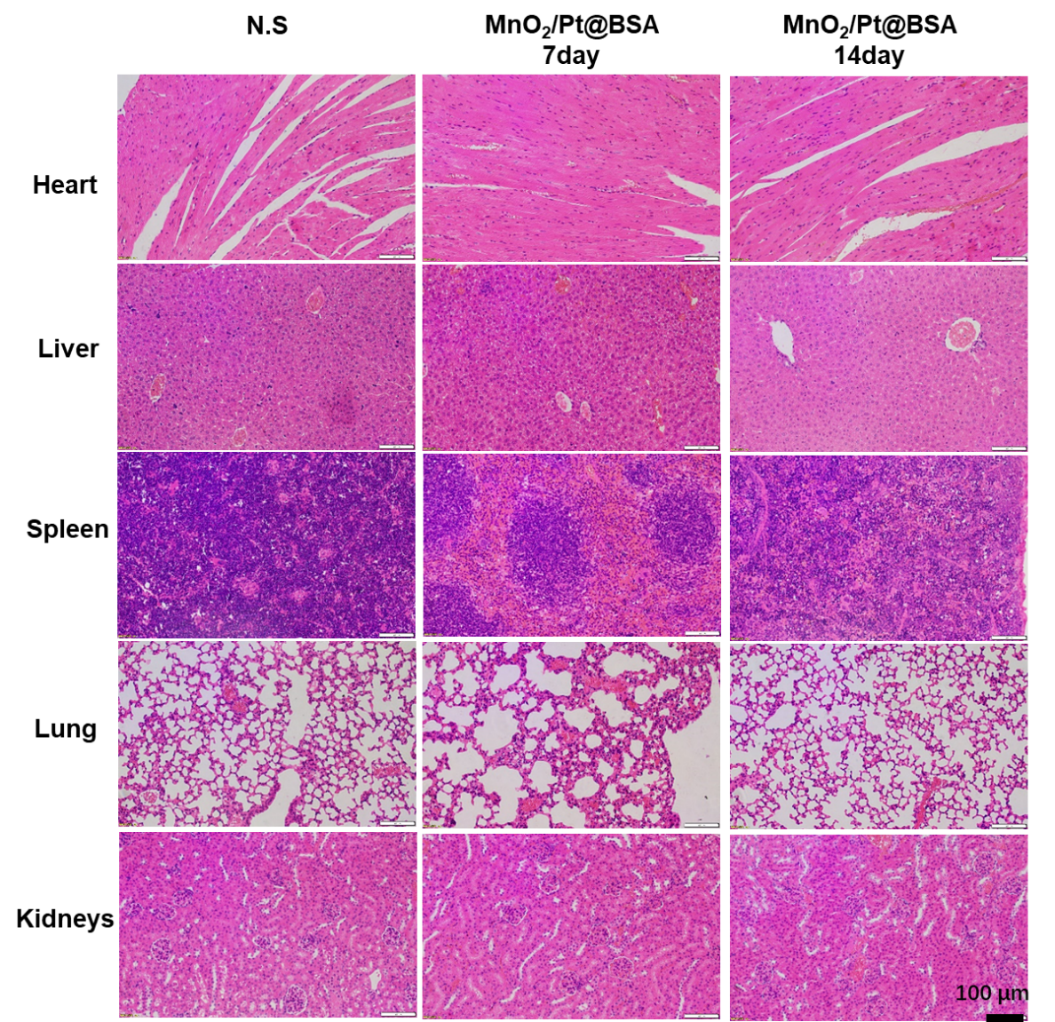
Figure S13. The hematoxylin and eosin-stained microscopy images of the corresponding groups of major organs (heart, liver, spleen, lung and kidneys) of mice after their injection of MnO₂/Pt@BSA at different timepoint (7day, 14 day), saline as control. (Scan Bar:100 μm)

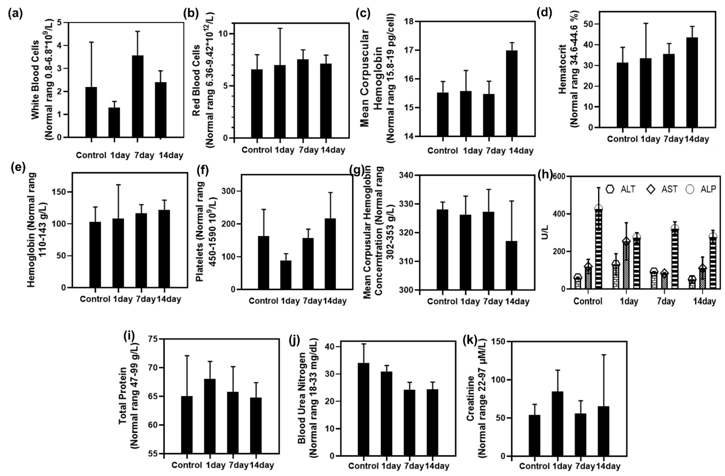
Figure S14. The complete blood counts (CBC) (a)-(h), the hepatic (i-j) and renal functions(k-l) of mice after their injection of MnO₂/Pt@BSA at different timepoint (1 day, 7day, 14 day) saline as control. Results are presented as means ± standard deviation (SD) (n=3)

