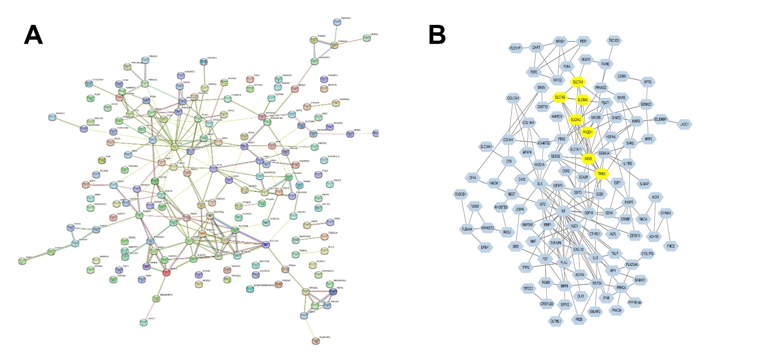
Supplementary Figure 1. The protein-protein interaction (PPI) network and hub gene analysis of DEGs. (A) The PPI network of DEGs. (B) Hub genes in the PPI network.

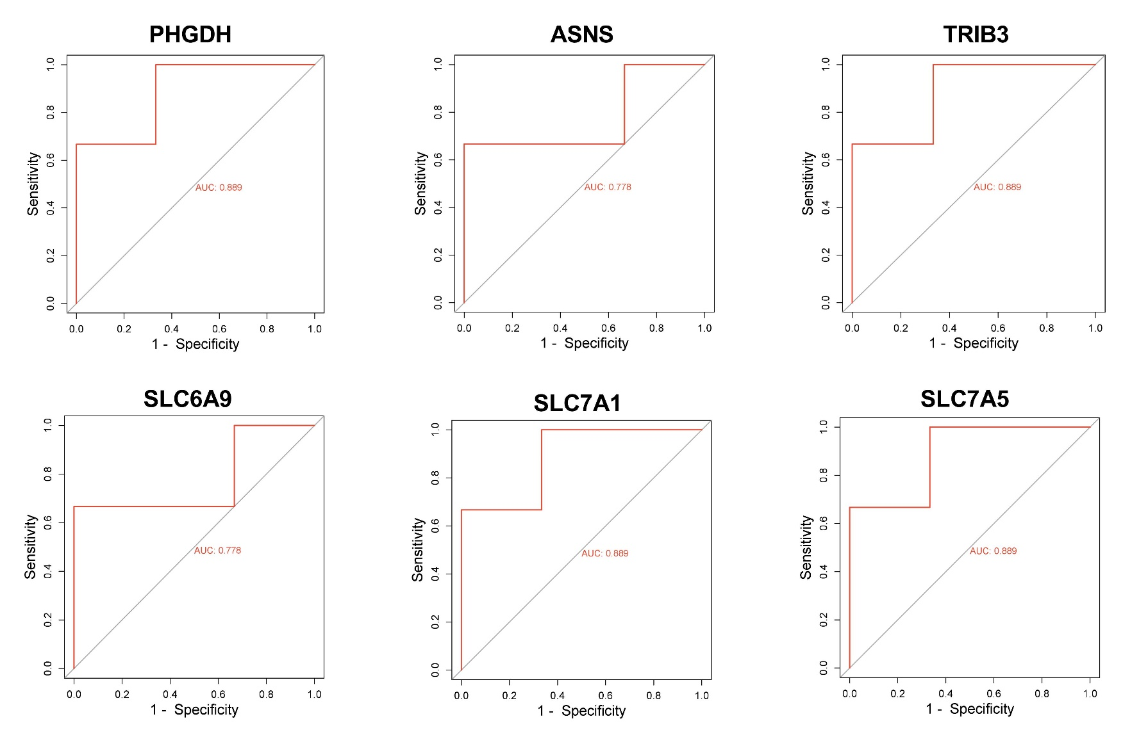
Supplementary Figure2. The receiver operating characteristic curves.
Supplementary Table 1. The sequences of primers used for RT-qPCR
Primers | Sequences (5’-3’)
GAPDH-F | GAGTCAACGGATTTGGTCGT
GAPDH-R | TTGATTTTGGAGGGATCTCG
PHGDH-F | CTCACCAGTGCCTTCTCTCC
PHGDH-R | TCTCTCAGAAGGCCGACAAT
SLC6A9-F | TCAGGAACCCTGGATCTGAC
SLC6A9-R | AAGCCCAGGATGGAGAAGAT
ASNS-F | CTGAAGCATCGAGAGGGAAC
ASNS-R | AATGCAAACACACCATCCAA
TRIB3-F | ACTTGGCTGTGGGATTCAAG
TRIB3-R | CTGTGGGCCTGGGTACTAAA
SLC7A5-F | GCCCTGTCATTCCTGTTTGT
SLC7A5-R | CTATCTCAGGTGGCACAGCA
SLC7A1-F | GGGTTTATGCCCTTTGGATT
SLC7A1-R | TAAGGCATCATGAGCGTGAG

Supplementary Table 2. The top 15 up-regulated DEGs and down-regulated DEGs
Name | Description | log2FoldChange | pval | up/down
OMD | osteomodulin | 6.29 | 1.10E-08 | up
FKBP5 | FK506 binding protein 5 | 4.40 | 1.34E-06 | up
CPM | carboxypeptidase M | 4.32 | 6.20E-06 | up
CORIN | corin, serine peptidase | 3.71 | 3.50E-02 | up
FRZB | frizzled-related protein | 3.65 | 2.62E-03 | up
LMO3 | LIM domain only 3 (rhombotin-like 2) | 3.50 | 2.73E-03 | up
SRGN | Memczak2013 ANTISENSE, coding, INTERNAL, UTR3 best transcript NM_002727 | 3.28 | 5.69E-03 | up
SAMHD1 | SAM domain and HD domain 1 | 3.23 | 8.88E-06 | up
MAOA | monoamine oxidase A | 3.22 | 3.54E-04 | up
ART4 | ADP-ribosyltransferase 4 (Dombrock blood group) | 3.18 | 4.87E-05 | up
OLR1 | oxidized low density lipoprotein (lectin-like) receptor 1 | 3.16 | 8.46E-03 | up
LINC01088 | long intergenic non-protein coding RNA 1088 | 3.04 | 1.91E-03 | up
CTHRC1 | collagen triple helix repeat containing 1 | 2.82 | 1.87E-02 | up
ANGPTL1 | angiopoietin like 1 | 2.81 | 1.02E-03 | up
PLCE1-AS1 | PLCE1 antisense RNA 1 | 2.78 | 5.90E-03 | up
CA12 | carbonic anhydrase XII | -3.02 | 5.01E-05 | down
LACC1 | laccase (multicopper oxidoreductase) domain containing 1 | -3.03 | 4.06E-05 | down
CLDN11 | claudin 11 | -3.03 | 1.51E-03 | down
FAIM2 | Fas apoptotic inhibitory molecule 2 | -3.05 | 1.31E-02 | down
ARL4C | ADP-ribosylation factor like GTPase 4C | -3.15 | 8.18E-05 | down
LDB2 | LIM domain binding 2 | -3.17 | 2.39E-03 | down
ACKR4 | atypical chemokine receptor 4 | -3.43 | 8.10E-04 | down
SLC7A11 | solute carrier family 7 (anionic amino acid transporter light chain, xc- system), member 11 | -3.49 | 1.32E-03 | down
SLC14A1 | solute carrier family 14 (urea transporter), member 1 (Kidd blood group) | -3.57 | 4.80E-04 | down
CRHBP | corticotropin releasing hormone binding protein | -3.57 | 4.29E-02 | down
PHGDH | phosphoglycerate dehydrogenase | -3.63 | 1.61E-02 | down
NDUFA4L2 | NADH dehydrogenase (ubiquinone) 1 alpha subcomplex, 4-like 2 | -3.67 | 5.41E-07 | down
PSAT1 | phosphoserine aminotransferase 1 | -3.68 | 4.33E-03 | down
FST | follistatin | -4.10 | 1.37E-04 | down
MEST | mesoderm specific transcript | -4.11 | 1.55E-03 | down

