Figure S1 K-M analysis of overall survival in different subgroups

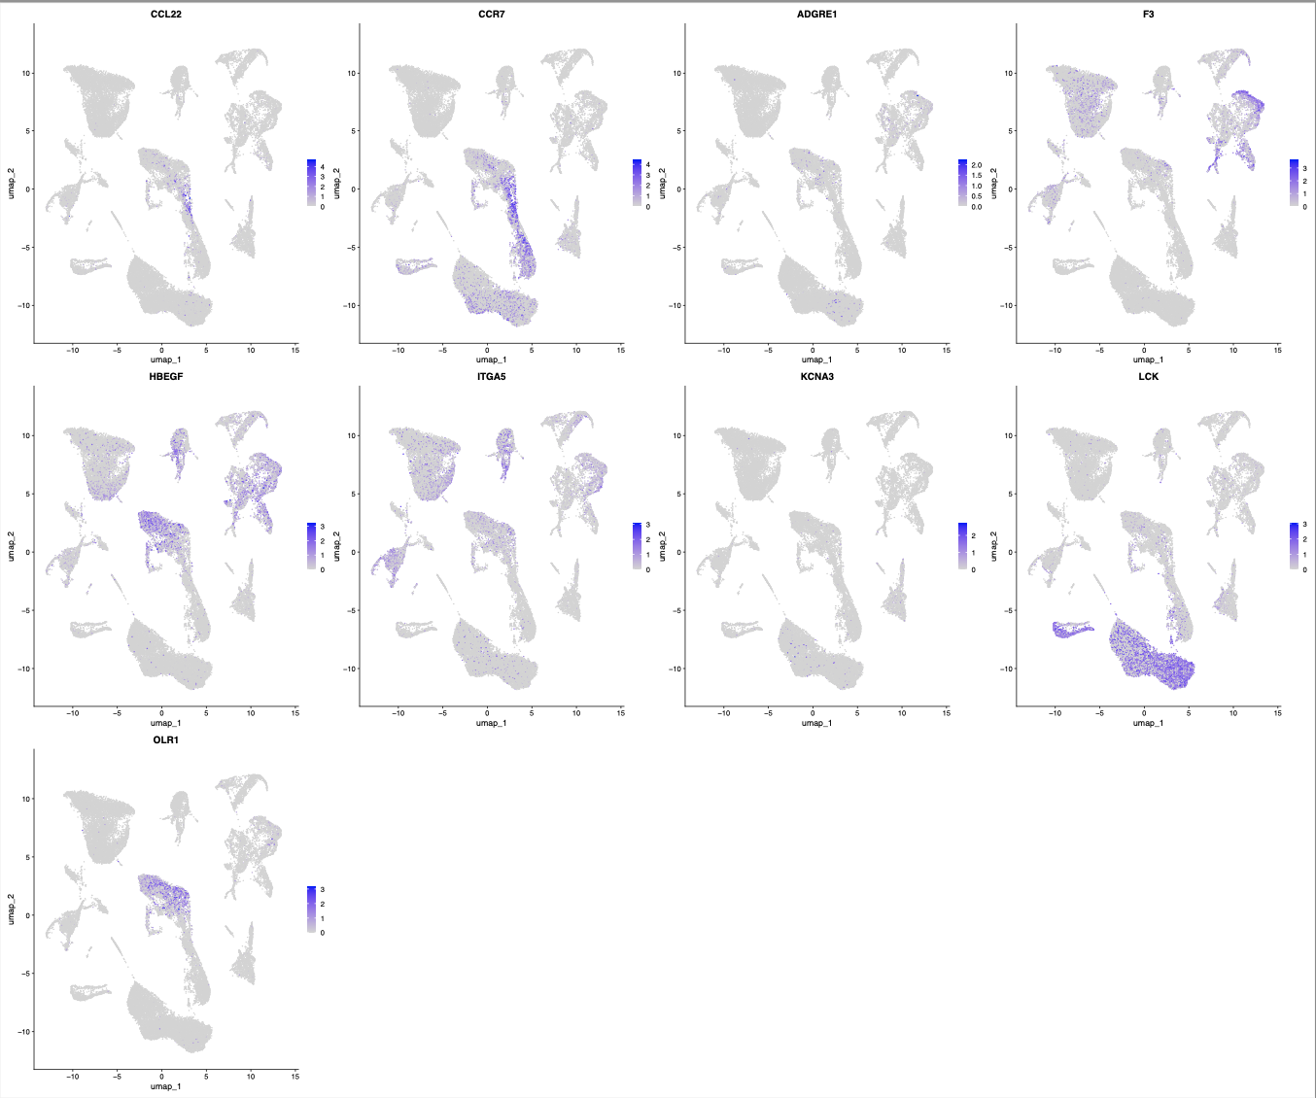
Figure S2 UMAP plot showing the expression of the marker genes of the nine cell types.

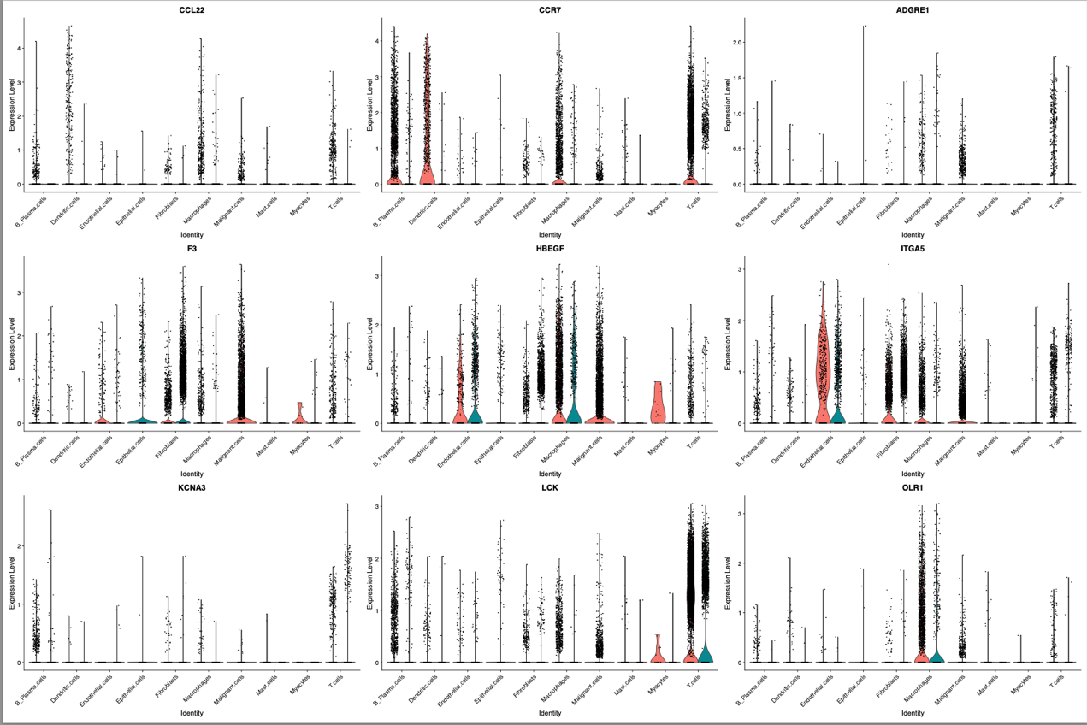
Figure S3 Violin plot showing the expression of the marker genes of the nine cell types.

Table S1. Clinical Patient Information

Patient | Normal | Tumor | Histological type | Gender | Age | T | N | M
P1 | P1-NL | P1-CA | Oral cancer | F | 34 | T3 | N1 | M0
P2 | P2-NL | P2-CA | Oral cancer | M | 48 | T2 | N2 | M0
P3 | P3-NL | P3-CA | Oral cancer | F | 44 | T4 | N1 | M0
P4 | P4-NL | P4-CA | Oral cancer | M | 52 | T3 | N2 | M0
P5 | P5-NL | P5-CA | Oral cancer | M | 39 | T3 | N2 | M0

