Supplementary Materials:
Supplementary Table 1. The quantitative detemination of five components in QCWZD by HPLC analysis.
NO. | Components | Quantitative Detemination (mg/g)
1 | ginsenoside Rb1 | 6.2884
2 | gallic acid | 0.7178
3 | berberine hydrochloride | 4.6455
4 | ginsenoside Rg1 | 8.3506
5 | liquiritin | 0.9661
Supplementary Table 2. Binding energy of key components of QCWZD with core targets.
Components | Binding energy (kcal/mol)
Components | quercetin | beta-sitosterol | kaempferol
IL-6 (4O9H) | -7.8 | -6.8 | -7.6
TNF-α (7KPA) | -10.4 | -12.5 | -10.1
IL-17 (7AMG) | -7.9 | -8.5 | -7.8

Supplementary Table 3. The average number of raw reads and clean reads by RNA-Seq analyses
Sample | Raw reads | Raw bases | Clean reads | Clean bases | Error rate(%) | Q20(%) | Q30(%) | GC content(%)
A1 | 55679390 | 8407587890 | 55298428 | 8253225711 | 0.0242 | 98.4 | 94.93 | 50.02
A2 | 51629294 | 7796023394 | 51315404 | 7666176887 | 0.0241 | 98.43 | 94.99 | 49.92
A3 | 52817944 | 7975509544 | 52439814 | 7817517158 | 0.0241 | 98.43 | 95 | 50.22
A4 | 60979156 | 9207852556 | 60609562 | 9039721966 | 0.0238 | 98.55 | 95.27 | 50.12
A5 | 56727484 | 8565850084 | 56356254 | 8405878735 | 0.024 | 98.48 | 95.08 | 50.19
B1 | 58486454 | 8831454554 | 58102378 | 8658733734 | 0.0241 | 98.44 | 94.98 | 50.45
B2 | 51256318 | 7739704018 | 50915336 | 7600218940 | 0.0242 | 98.38 | 94.86 | 50.27
B3 | 53552174 | 8086378274 | 53149272 | 7916176231 | 0.0245 | 98.27 | 94.59 | 50.07
B4 | 63290772 | 9556906572 | 62868094 | 9354167268 | 0.0241 | 98.43 | 94.99 | 50.18
B5 | 53777542 | 8120408842 | 53448320 | 7981226400 | 0.0241 | 98.43 | 94.98 | 50.11
C1 | 59738266 | 9020478166 | 59335408 | 8831084234 | 0.0242 | 98.41 | 94.93 | 50.22
C2 | 55681828 | 8407956028 | 55296870 | 8245640549 | 0.0242 | 98.37 | 94.85 | 50.35
C3 | 52329202 | 7901709502 | 51951308 | 7747029330 | 0.0243 | 98.33 | 94.74 | 50.26
C4 | 53409394 | 8064818494 | 53047950 | 7915411722 | 0.0241 | 98.44 | 94.98 | 50.21
C5 | 53683942 | 8106275242 | 53319868 | 7965458753 | 0.0242 | 98.4 | 94.91 | 50.19
Supplementary Figure 1

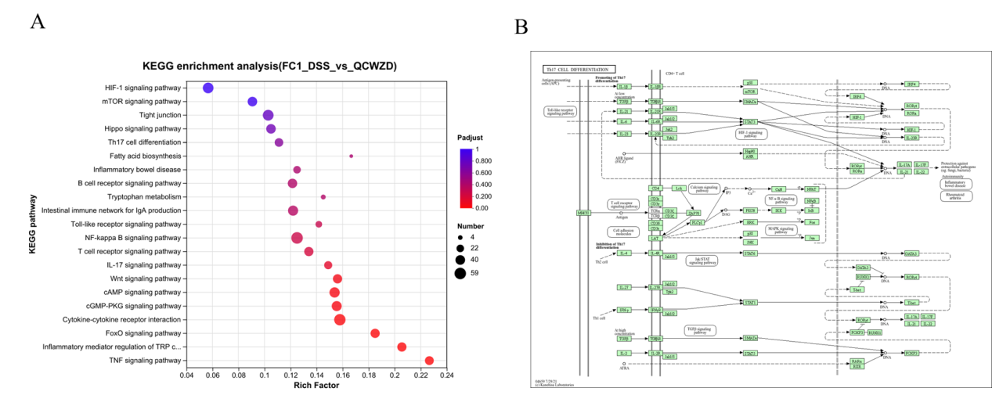
Figure. S1. (A) KEGG analysis of significantly enriched signal pathways from RNA-seq. (B) Differential genes enriched in Th17 cell differentiation.

