Supplementary materials
Part 1：Willingness-to-pay estimation for subgroup population
In this section, you can see the differences in preferences and payment intentions of different subgroups for various attributes and their different levels
Supplementary Table 1: Sub-group analysis_Gender
Attributes | Male (n=87) |  |  |  | Female (n=93)
 | Coefficients | SE | P-value | WTP | Coefficients | SE | P-value | WTP
Salary subsidies (unit: 100 CNY) | 1.154 | 0.189 | ＜0.001 |  | 0.687 | 0.146 | ＜0.001
Leadership attention (ref: Neglect)
Emphasize | 2.500 | 0.325 | ＜0.001 | -2.167 | 2.382 | 0.284 | ＜0.001 | -3.468
Patient participation (ref: No participation in MDT)
Participation in MDT | 0.741 | 0.264 | 0.005 | -0.642 | 0.545 | 0.215 | 0.011 | -0.794
Quality assessment (ref: None)
Assess quality | 1.108 | 0.271 | ＜0.001 | -0.960 | 0.832 | 0.215 | ＜0.001 | -1.211
Working intensity (ref: Meeting duration <0.5h)
Meeting duration 0.5–1h | -0.840 | 0.321 | ＜0.001 | 0.728 | -0.640 | 0.290 | 0.027 | 0.931
Meeting duration 1–1.5h | -1.764 | 0.363 | ＜0.001 | 1.529 | -1.669 | 0.323 | ＜0.001 | 2.430
Meeting duration >1.5h | -2.463 | 0.429 | ＜0.001 | 2.134 | -1.192 | 0.342 | ＜0.001 | 1.736
Case complexity (ref: Generally complex)
Extremely complex | -0.604 | 0.293 | 0.003 | 0.524 | -0.491 | 0.242 | 0.043 | 0.714
Note: SE-standard error, CNY-Chinese yuan, ref-reference.

Supplementary Table 2: Sub-group analysis_Age
Attributes | Age 30-40 years old (n=85) |  |  |  | Age 41-50 years old (n=64) |  |  |  | Over 50 years old (n=31)
 | Coefficients | SE | P-value | WTP | Coefficients | SE | P-value | WTP | Coefficients | SE | P-value | WTP
Salary subsidies (unit: 100 CNY) | 1.065 | 0.174 | ＜0.001 |  | 0.688 | 0.199 | 0.001 |  | 0.793 | 0.270 | 0.003
Leadership attention (ref: Neglect)
Emphasize | 3.038 | 0.341 | ＜0.001 | -2.853 | 1.991 | 0.349 | ＜0.001 | -2.893 | 1.818 | 0.465 | ＜0.001 | -2.294
Patient participation (ref: No participation in MDT)
Participation in MDT | 0.369 | 0.257 | 0.152 | -0.346 | 0.701 | 0.281 | 0.013 | -1.019 | 0.864 | 0.386 | 0.025 | -1.090
Quality assessment (ref: None)
Assess quality | 1.350 | 0.276 | ＜0.001 | -1.268 | 0.820 | 0.291 | 0.005 | -1.192 | 0.752 | 0.388 | 0.052 | -0.949
Working intensity (ref: Meeting duration <0.5h)
Meeting duration 0.5–1h | -1.457 | 0.338 | ＜0.001 | 1.368 | -0.451 | 0.390 | 0.247 | 0.655 | 0.113 | 0.519 | 0.827 | -0.143
Meeting duration 1–1.5h | -2.031 | 0.363 | ＜0.001 | 1.907 | -1.688 | 0.426 | ＜0.001 | 2.452 | -0.824 | 0.561 | 0.142 | 1.040
Meeting duration >1.5h | -1.925 | 0.421 | ＜0.001 | 1.807 | -2.054 | 0.450 | ＜0.001 | 2.984 | -0.575 | 0.632 | 0.363 | 0.726
Case complexity (ref: Generally complex)
Extremely complex | 0.283 | 0.287 | 0.323 | -2.662 | -1.437 | 0.340 | ＜0.001 | 2.088 | -0.727 | 0.441 | 0.099 | 0.917
Note: SE-standard error, CNY-Chinese yuan, ref-reference.
Supplementary Table 3: Sub-group analysis_Occupational groups
Attributes | Doctor (n=142) |  |  |  | Nurses and medical technicians (n=38)
 | Coefficients | SE | P-value | WTP | Coefficients | SE | P-value | WTP
Salary subsidies (unit: 100 CNY) | 0.846 | 0.126 | ＜0.001 |  | 1.056 | 0.278 | ＜0.001
Leadership attention (ref: Neglect)
Emphasize | 2.322 | 0.239 | ＜0.001 | -2.745 | 2.875 | 0.474 | ＜0.001 | -2.723
Patient participation (ref: No participation in MDT)
Participation in MDT | 0.578 | 0.181 | 0.001 | -0.684 | 0.554 | 0.392 | 0.158 | -0.525
Quality assessment (ref: None)
Assess quality | 0.811 | 0.183 | ＜0.001 | -0.959 | 1.398 | 0.413 | 0.001 | -1.324
Working intensity (ref: Meeting duration <0.5h)
Meeting duration 0.5–1h | -0.558 | 0.238 | 0.019 | 0.660 | -1.611 | 0.511 | 0.002 | 1.526
Meeting duration 1–1.5h | -1.585 | 0.268 | ＜0.001 | 1.874 | -2.304 | 0.562 | ＜0.001 | 2.183
Meeting duration >1.5h | -1.609 | 0.293 | ＜0.001 | 1.902 | -2.305 | 0.635 | ＜0.001 | 2.184
Case complexity (ref: Generally complex)
Extremely complex | -0.833 | 0.206 | ＜0.001 | 0.985 | 0.711 | 0.448 | 0.112 | -0.673
Note: SE-standard error, CNY-Chinese yuan, ref-reference.

Supplementary Table 4: Sub-group analysis_Professional Title
Attributes | Intermediate title (n=56) |  |  |  | Deputy senior professional title (n=62) |  |  |  | Senior professional title (n=62)
 | Coefficients | SE | P-value | WTP | Coefficients | SE | P-value | WTP | Coefficients | SE | P-value | WTP
Salary subsidies (unit: 100 CNY) | 1.084 | 0.214 | ＜0.001 |  | 0.865 | 0.191 | 0.001 |  | 0.746 | 0.207 | ＜0.001
Leadership attention (ref: Neglect)
Emphasize | 2.264 | 0.395 | ＜0.001 | -2.088 | 3.205 | 0.386 | ＜0.001 | -3.704 | 1.745 | 0.354 | ＜0.001 | -2.338
Patient participation (ref: No participation in MDT)
Participation in MDT | 0.117 | 0.307 | 0.704 | -0.108 | 0.757 | 0.289 | 0.009 | -0.875 | 0.892 | 0.302 | 0.003 | -1.196
Quality assessment (ref: None)
Assess quality | 1.486 | 0.345 | ＜0.001 | -1.370 | 0.867 | 0.281 | 0.002 | -1.002 | 0.727 | 0.313 | 0.020 | -0.975
Working intensity (ref: Meeting duration <0.5h)
Meeting duration 0.5–1h | -0.857 | 0.401 | 0.033 | 0.790 | -0.995 | 0.373 | 0.008 | 1.151 | -0.601 | 0.414 | 0.146 | 0.805
Meeting duration 1–1.5h | -1.632 | 0.434 | ＜0.001 | 1.505 | -1.967 | 0.424 | ＜0.001 | 2.273 | -1.477 | 0.442 | 0.001 | 1.980
Meeting duration >1.5h | -1.953 | 0.519 | ＜0.001 | 1.801 | -1.239 | 0.467 | 0.008 | 1.432 | -2.115 | 0.472 | ＜0.001 | 2.835
Case complexity (ref: Generally complex)
Extremely complex | 0.272 | 0.350 | 0.436 | -0.251 | -0.372 | 0.316 | 0.239 | 0.431 | -1.452 | 0.359 | ＜0.001 | 1.946
Note: SE-standard error, CNY-Chinese yuan, ref-reference.
Supplementary Table 5: Sub-group analysis_Years of participation in MDT
Attributes | ＜1 year (n=32) |  |  |  | 1-2 years (n=34)
 | Coefficients | SE | P-value | WTP | Coefficients | SE | P-value | WTP
Salary subsidies (unit: 100 CNY) | 1.194 | 0.275 | ＜0.001 |  | 1.113 | 0.256 | ＜0.001
Leadership attention (ref: Neglect)
Emphasize | 2.601 | 0.526 | ＜0.001 | -2.178 | 3.477 | 0.556 | ＜0.001 | -3.124
Patient participation (ref: No participation in MDT)
Participation in MDT | 0.549 | 0.400 | 0.170 | -0.460 | 0.691 | 0.431 | 0.109 | -0.621
Quality assessment (ref: None)
Assess quality | 1.155 | 0.415 | 0.005 | -0.967 | 1.401 | 0.433 | 0.001 | -1.259
Working intensity (ref: Meeting duration <0.5h)
Meeting duration 0.5–1h | -1.055 | 0.514 | 0.040 | 0.884 | -1.485 | 0.541 | 0.006 | 1.334
Meeting duration 1–1.5h | -2.262 | 0.602 | ＜0.001 | 1.894 | -3.269 | 0.634 | ＜0.001 | 2.938
Meeting duration >1.5h | -1.625 | 0.628 | 0.010 | 1.360 | -2.144 | 0.642 | 0.001 | 1.927
Case complexity (ref: Generally complex)
Extremely complex | -0.488 | 0.438 | 0.265 | 0.409 | -0.102 | 0.437 | 0.816 | 0.091
Attributes | 3-4 years (n=30) |  |  |  | Over 5 years (n=84)
 | Coefficients | SE | P-value | WTP | Coefficients | SE | P-value | WTP
Salary subsidies (unit: 100 CNY) | 0.507 | 0.319 | 0.111 |  | 0.806 | 0.172 | ＜0.001
Leadership attention (ref: Neglect)
Emphasize | 1.354 | 0.458 | 0.003 | -2.671 | 2.582 | 0.323 | ＜0.001 | -3.203
Patient participation (ref: No participation in MDT)
Participation in MDT | 0.264 | 0.421 | 0.531 | -0.520 | 0.786 | 0.247 | 0.001 | -0.975
Quality assessment (ref: None)
Assess quality | 1.159 | 0.431 | 0.007 | -2.285 | 0.652 | 0.243 | 0.007 | -0.809
Working intensity (ref: Meeting duration <0.5h)
Meeting duration 0.5–1h | 0.163 | 0.570 | 0.776 | -0.320 | -0.622 | 0.324 | 0.055 | 0.771
Meeting duration 1–1.5h | -0.318 | 0.596 | 0.594 | 0.626 | -1.413 | 0.358 | ＜0.001 | 1.753
Meeting duration >1.5h | -1.115 | 0.718 | 0.121 | 2.198 | -1.649 | 0.396 | ＜0.001 | 2.045
Case complexity (ref: Generally complex)
Extremely complex | -0.245 | 0.492 | 0.619 | 0.482 | -0.994 | 0.283 | ＜0.001 | 1.233
Note: SE-standard error, CNY-Chinese yuan, ref-reference.

Part 2：Choice experiment
In this part, the participant must select one preferable profile among those available (options).
Supplementary Figure 1: Choice task 1
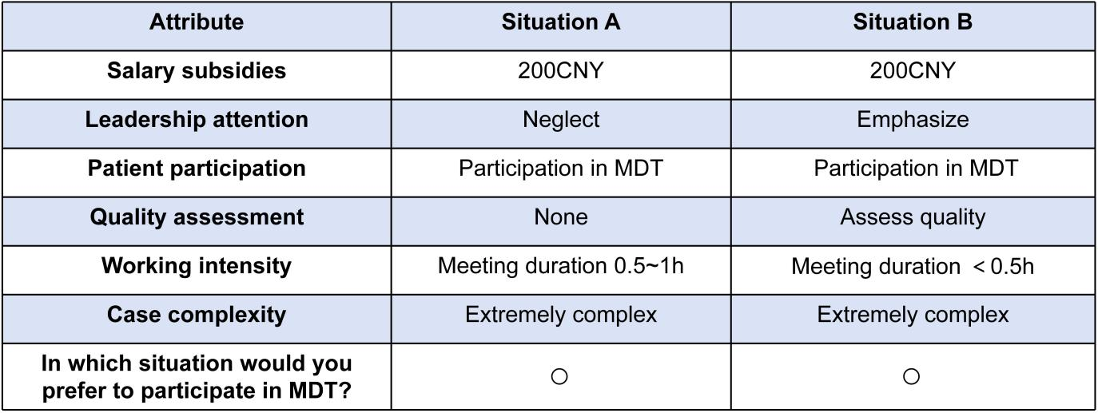

Supplementary Figure 2: Choice task 2
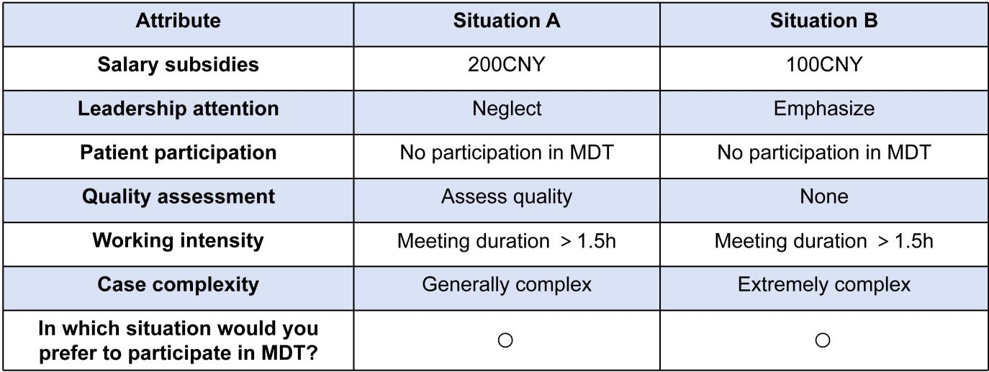

Supplementary Figure 3: Choice task 3
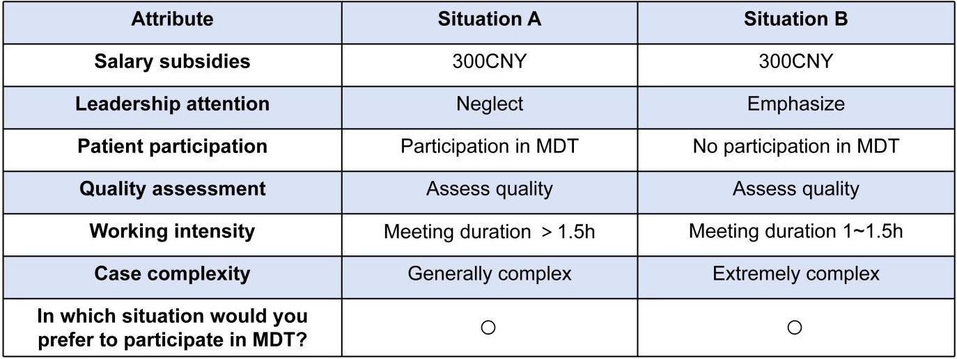

Supplementary Figure 4: Choice task 4
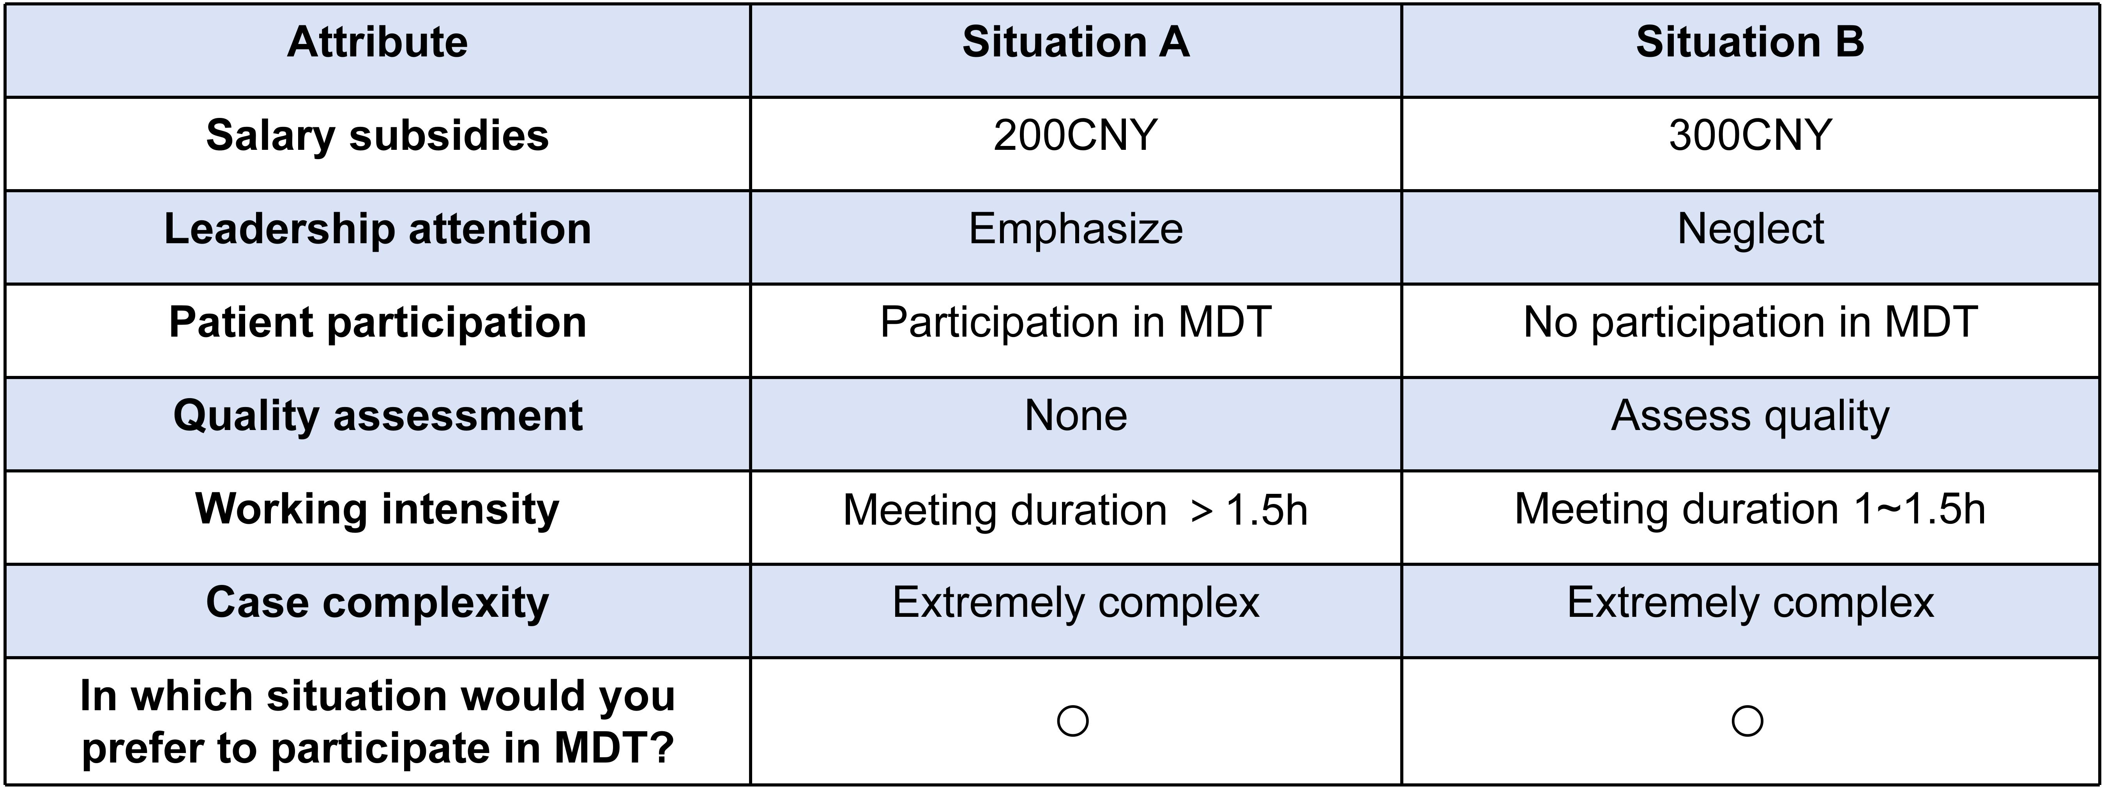

Supplementary Figure 5: Choice task 5
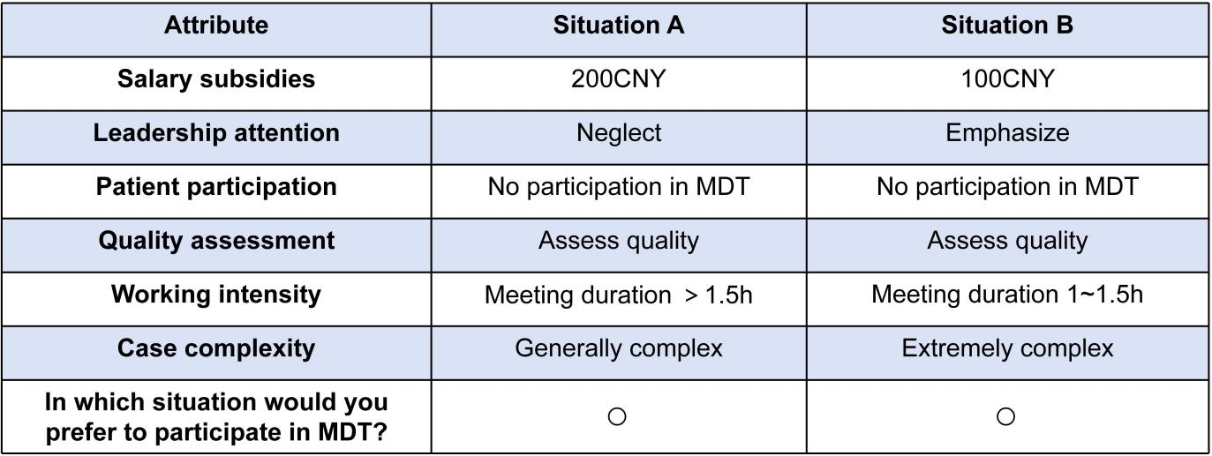

Supplementary Figure 6: Choice task 6
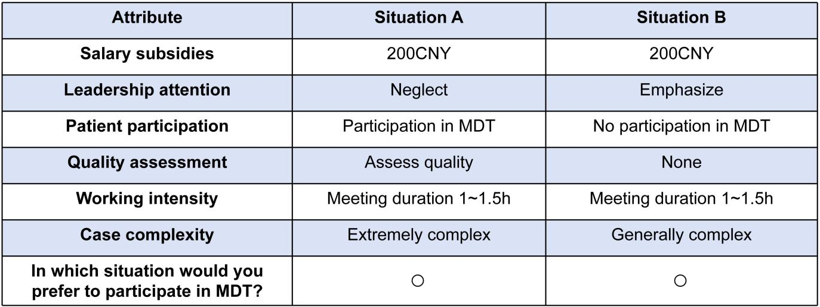

Supplementary Figure 7: Choice task 7
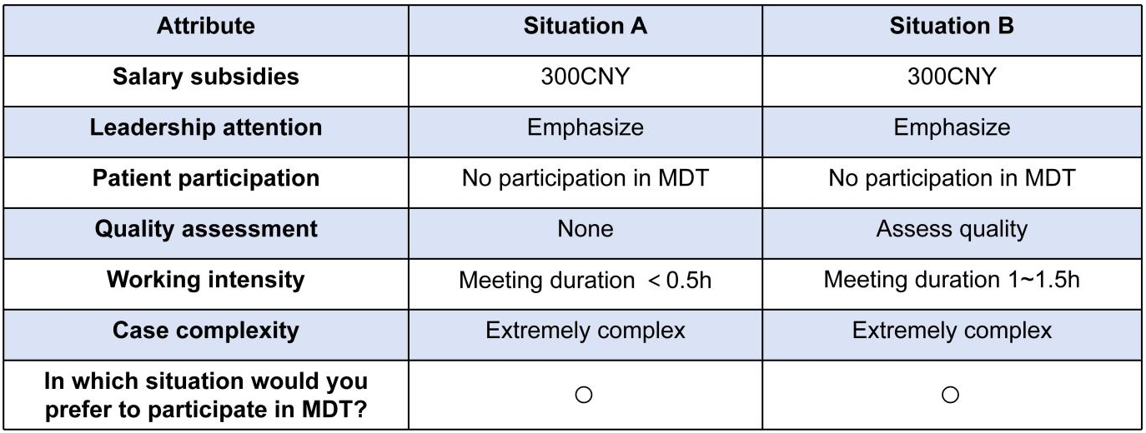

Supplementary Figure 8: Choice task 8
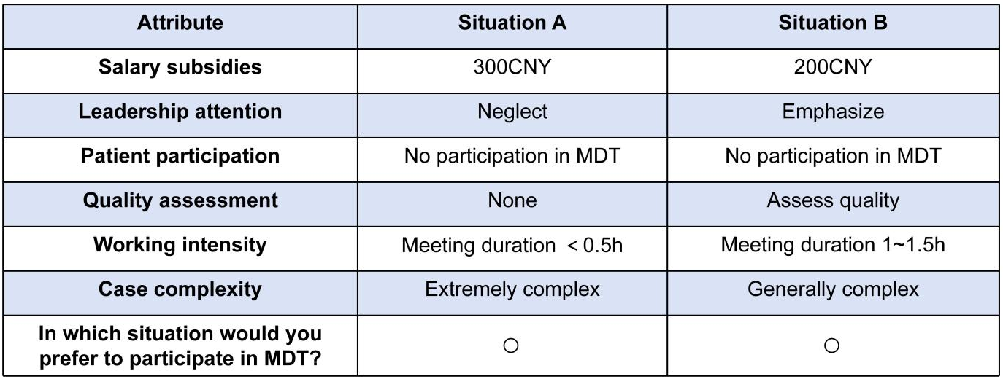

Supplementary Figure 9: Choice task 9
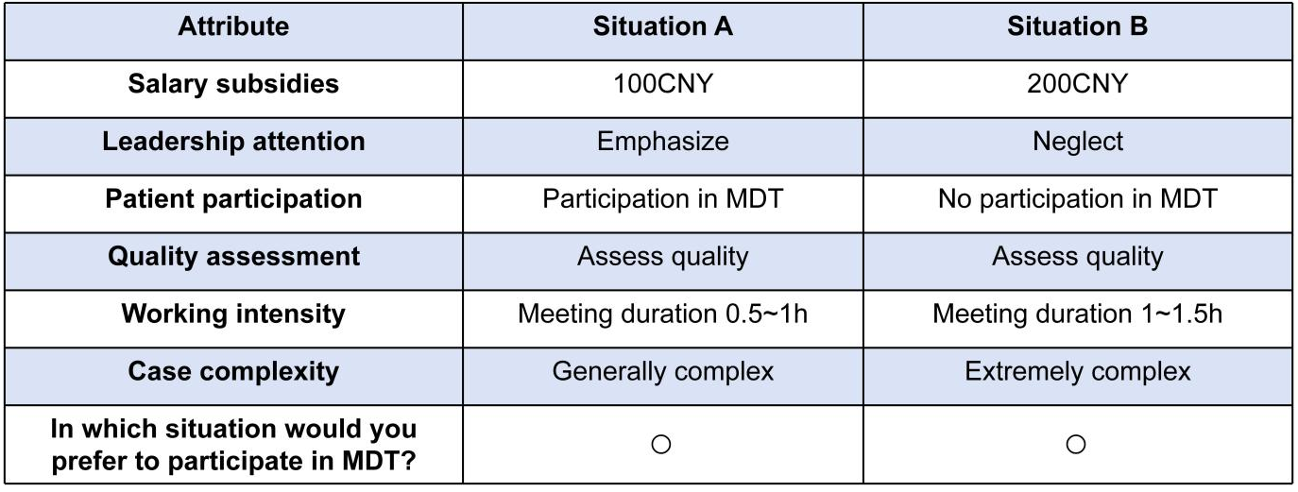

Supplementary Figure 10: Choice task 10
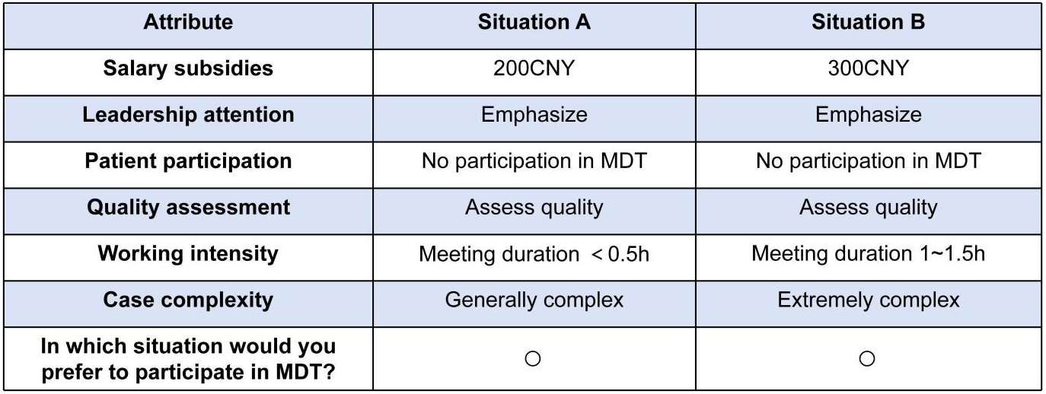

Supplementary Figure 11: Choice task 11
